Table of Contents

UNITED STATES

SECURITIES AND EXCHANGE COMMISSION

Washington, D.C. 20549

Form 10-K

(Mark One)

- ANNUAL REPORT PURSUANT TO SECTION 13 OR 15(d) OF THE SECURITIES EXCHANGE ACT OF 1934 For the fiscal year ended December 31, 2018

- TRANSITION REPORT PURSUANT TO SECTION 13 OR 15(d) OF THE SECURITIES EXCHANGE ACT OF 1934

For the transition period from to

Commission File Number: 001-35480
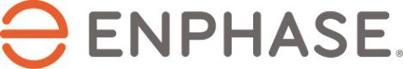

 |  |  | Enphase Energy, Inc.
 |  |  | (Exact name of registrant as specified in its charter)
 | Delaware |  |  | 20-4645388
(State or other jurisdiction of |  |  |  |  |  | (I.R.S. Employer
incorporation or organization) |  |  |  |  |  | Identification No.)
 |  |  |  | 47281 Bayside Parkway
 |  |  |  | Fremont, CA 94538
 |  |  | (Address of principal executive offices) (Zip Code)
 |  |  |  | (707) 774-7000
 |  |  | (Registrant’s telephone number, including area code)
 | Securities registered pursuant to Section 12(b) of the Act:
 | Title of each class: |  |  |  |  | Name of each exchange on which registered
Common Stock, par value $0.00001 per share |  |  |  |  |  | The Nasdaq Stock Market LLC
Securities registered pursuant to Section 12(g) of the Act: None

Indicate by check mark if the registrant is a well-known seasoned issuer, as defined in Rule 405 of the Securities Act. Yes ☐ No x

Indicate by check mark if the registrant is not required to file reports pursuant to Section 13 or Section 15(d) of the Act. Yes ☐ No x

Indicate by check mark whether the registrant (1) has filed all reports required to be filed by Section 13 or 15(d) of the Securities Exchange Act of 1934 during the preceding 12 months (or for such shorter period that the registrant was required to file such reports), and (2) has been subject to such filing requirements for the past 90 days. Yes x No ☐

Indicate by check mark whether the registrant has submitted electronically every Interactive Data File required to be submitted pursuant to Rule 405 of Regulation S-T (§232.405 of this chapter) during the preceding 12 months (or for such shorter period that the registrant was required to submit such files). Yes x No ☐

Table of Contents

Indicate by check mark if disclosure of delinquent filers pursuant to Item 405 of Regulation S-K is not contained herein, and will not be contained, to the best of registrant’s knowledge, in definitive proxy or information statements incorporated by reference in Part III of this Form 10-K or any amendment to this Form 10-
- ☐

Indicate by check mark whether the registrant is a large accelerated filer, an accelerated filer, a non-accelerated filer, a smaller reporting company, or an emerging growth company. See definitions of “large accelerated filer,” “accelerated filer,” “smaller reporting company,” and “emerging growth company” in Rule 12b-2 of the Exchange Act.

Large accelerated filer | ☐ | Accelerated filer | x
Non-accelerated filer | ☐ | Smaller reporting company | ☐
Emerging growth company | ☐

If an emerging growth company, indicate by checkmark if the registrant has elected not to use the extended transition period for complying with any new or revised financial accounting standards provided pursuant to Section 13(a) of the Exchange Act. ☐

Indicate by check mark whether the registrant is a shell company (as defined in Rule 12b-2 of the Exchange Act). Yes ☐ No x

The aggregate market value of the voting stock held by non-affiliates of the registrant on June 30, 2018, based upon the closing price of $6.73 of the registrant’s common stock as reported on the Nasdaq Global Market, was approximately $588.9 million.

As of March 6, 2019, there were 108,519,598 shares of the registrant’s common stock outstanding.

DOCUMENTS INCORPORATED BY REFERENCE

Certain information called for by Part III of this Form 10-K is incorporated by reference to the Proxy Statement for the registrant’s 2019 Annual Meeting of Stockholders, which will be filed with the Securities and Exchange Commission not later than 120 days after December 31, 2018.

 | ENPHASE ENERGY, INC.
 | TABLE OF CONTENTS
 |  | Page
 | PART I
Item 1. | Business | 4
Item 1A. | Risk Factors | 11
Item 1B. | Unresolved Staff Comments | 34
Item 2. | Properties | 35
Item 3. | Legal Proceedings | 35
Item 4. | Mine Safety Disclosures | 35
 | PART II
Item 5. | Market for the Registrant’s Common Equity, Related Stockholder Matters and Issuer Purchases of Equity Securities | 35
Item 6. | Selected Consolidated Financial Data | 37
Item 7. | Management’s Discussion and Analysis of Financial Condition and Results of Operations | 38
Item 7A. | Quantitative and Qualitative Disclosures About Market Risk | 51
Item 8. | Financial Statements and Supplementary Data | 53
 | Consolidated Balance Sheets | 56
 | Consolidated Statements of Operations | 57
 | Consolidated Statements of Comprehensive Loss | 58
 | Consolidated Statements of Cash Flows | 59
 | Consolidated Statements of Stockholders’ Equity (Deficit) | 60
 | Notes to Consolidated Financial Statements | 61
 | Selected Unaudited Quarterly Financial Information | 96
Item 9. | Changes in and Disagreements with Accountants on Accounting and Financial Disclosure | 97
Item 9A. | Controls and Procedures | 97
Item 9B. | Other Information | 97
 | PART III
Item 10. | Directors, Executive Officers and Corporate Governance | 98
Item 11. | Executive Compensation | 98
Item 12. | Security Ownership of Certain Beneficial Owners and Management and Related Stockholder Matters | 98
Item 13. | Certain Relationships and Related Transactions, and Director Independence | 98
Item 14. | Principal Accounting Fees and Services | 98
 | PART IV
Item 15. | Exhibits, Financial Statement Schedules | 99
Item 16. | Form 10-K Summary | 102

Table of Contents

PART I

This Annual Report on Form 10-K contains “forward-looking statements” as defined under securities laws. Forward-looking statements include statements that are not historical facts and can be identified by terms such as “anticipates,” “believes,” “could,” “seeks,” “estimates,” “expects,” “intends,” “may,” “plans,” “potential,” “predicts, “projects,” “should,” “will,” “would” or similar expressions and the negatives of those terms. These forward-looking statements are contained principally in Item 1, Business; Item 1A, Risk Factors; Item 7, Management’s Discussion and Analysis of Financial Condition and Results of Operations; and other sections of this Annual Report on Form 10-K. Our actual results or experience could differ significantly from the forward-looking statements. Factors that could cause or contribute to these differences include those discussed in Item 1A, Risk Factors, as well as those discussed elsewhere in this Annual Report on Form 10-K.

Forward-looking statements are inherently uncertain, and you should not place undue reliance on these statements, which speak only as of the date that they were made. These cautionary statements should be considered in connection with any written or oral forward-looking statements that we may issue in the future. We do not undertake any obligation to release publicly any revisions to these forward-looking statements after completion of the filing of this Annual Report on Form 10-K to reflect later events or circumstances or to reflect the occurrence of unanticipated events.

In this report, unless otherwise indicated or the context otherwise requires, “Enphase Energy,” “Enphase,” “the Company,” “we,” “us,” and “our” refer to Enphase Energy, Inc., a Delaware corporation, and its subsidiaries.

Item 1. Business

Our Company

We are a global energy technology company, delivering smart, easy-to-use solutions that connect solar generation, storage and communications management on one intelligent platform. We revolutionized solar with our microinverter technology and produce the world’s only truly integrated solar-plus-storage solution. We have shipped more than 19 million microinverters, representing over 4 gigawatts of solar photovoltaic (“PV”) generating capacity, and more than 855,000 Enphase residential and commercial systems have been deployed in over 125 countries.

We were incorporated as PVI Solutions, Inc. in March 2006 in the State of Delaware and changed our name to Enphase Energy, Inc. in July 2007.

On August 9, 2018, we completed the purchase of assets primarily relating to SunPower Corporation’s (“SunPower”) microinverter business. We acquired intellectual property, technology and other assets primarily relating to the microinverter business and assumed certain intellectual property and customer relationships for the following consideration: (i) $25 million payable in cash; and (ii) 7.5 million shares of our common stock issued to SunPower at closing. In addition, we and SunPower entered into (i) a Master Supply Agreement (“MSA”) under which SunPower is obligated to exclusively procure module level power electronics and related equipment for use in the United States (“U.S.”) residential market from us for a period of five years and (ii) a stockholders agreement to establish certain SunPower rights and obligations related to the shares issued, including SunPower’s right to appoint one person to our board of directors, certain additional transfer restrictions on the shares, and voting, standstill and other undertakings by SunPower.

Industry Background

Historically, traditional central inverters were the only inverter technology used for solar PV installations. In an installation consisting of a traditional central inverter, the solar PV modules are connected in series strings. In a large installation, there are multiple series strings connected in parallel. The aggregated voltage from each of these strings is then fed into a large central inverter. As compared to microinverter systems, we believe that traditional central inverters have a number of design and performance challenges limiting innovation and their ability to reduce the cost of solar systems, including the following:

- Productivity limits. If solar modules are wired using a traditional central inverter—group or “string” of modules are wired in series—an entire string’s output is limited by the output of the lowest-performing module. Because of its string design, there is a single point of failure risk with the traditional central inverter approach.

– 4 –

Table of Contents

- Reliability issues. Traditional central inverters are the single most common component of solar installations to fail, resulting in system downtime and adversely impacting total energy output. As a result, central inverters typically carry warranties of only 5 to 10 years.

- Complex design and installation requirements. The central inverter-based solar PV installation requires greater effort on the part of the installer, both in terms of design and on-site labor. Central inverter installations require string design and calculations for safe and reliable operation, as well as specialized equipment such as DC combiners, conduits and disconnects. In addition, the use of high-voltage direct current (“DC”) requires specialized knowledge and training and safety precautions to install central inverter technology.

- Lack of monitoring. The majority of solar installations with central inverter technology offer limited monitoring capabilities. A failure of the central inverter will often go unnoticed for days or even weeks. If a module fails or is not performing to specification, the resulting loss of energy can go unnoticed for an extended period of time.

- Safety issues. Central inverter solar PV installations have a wide distribution of high-voltage (600 volts to 1,000 volts) DC wiring. If damaged, DC wires can generate sustained electrical arcs, reaching temperatures of more than 5,000 °F. This creates the risk of fire for solar PV installation owners and injury for installers and maintenance personnel.

These challenges of traditional central inverters have a direct impact on the cost and expected return on investment of solar installations to both installers and system owners:

- Installer. Solar PV installers aim for simple installation design, fast installation times and maximum system performance and predictability. The installation of high-voltage DC central inverter technology, however, requires significant preparation, precautionary safety measures, time-consuming string calculations, extensive design expertise and specialized installation equipment, training and knowledge. Together, these factors significantly increase complexity and cost of installation and limit overall productivity for the installer.

- System owner. Solar system owners aim for high energy production, low cost, high reliability, and low maintenance requirements, as well as reduced fire risks. With traditional central inverters, owners often are unable to optimize the size or shape of their solar PV installations due to string design limitations. As such, they experience performance loss from shading and other obstructions, can face frequent system failures and lack the ability to effectively monitor the performance of their solar PV installation. In addition, central inverter installations operate at high-voltage DC which bears significant fire risks. Further, due to their large size, central inverter installations can affect architectural aesthetics of the house or commercial building.

Our Products

We design, develop, manufacture and sell home energy solutions that connect energy generation, energy storage and control and communications management on one intelligent platform. We have revolutionized the solar industry by bringing a systems approach to solar technology and by pioneering a semiconductor-based microinverter that converts energy at the individual solar module level and, combined with our proprietary networking and software technologies, provides advanced energy monitoring and control. This is vastly different than the string inverter approach that only converts energy of the entire array of solar modules from a single high voltage electrical unit and lacks intelligence about the energy producing capacity of the solar array. The IQ platform, which is our current generation integrated solar, storage and energy management offering, enables self-consumption and delivers our core value proposition of yielding more energy, simplifying design and installation, and improving system uptime and reliability. The IQ family of microinverters, like all of our previous microinverters, is fully compliant with NEC 2014 and 2017 rapid shutdown requirements. Unlike string inverters, this capability is built-in, with no additional equipment necessary.

– 5 –

Table of Contents

The Enphase Home Energy Solution with IQ™ brings a high technology, networked approach to solar generation plus energy storage, by leveraging our design expertise across power electronics, semiconductors and cloud-based software technologies. Our integrated approach to energy solutions maximizes a home’s energy potential while providing advanced monitoring and remote maintenance capabilities. The Enphase Home Energy Solution with IQ uses a single technology platform for seamless management of the whole solution, enabling rapid commissioning of the Installer Toolkit™; consumption monitoring with a metered Envoy™ and a consumption tracker; and energy insights from the Enphase Enlighten Software™, or Enlighten, platform’s easy-to-use interface. Unlike our core competitors, who utilize a single-point or traditional inverter, or offer separate components of solutions, we have built-in system redundancy in both PV generation and energy storage, eliminating the risk that comes with a single-point of failure. Further, the nature of our cloud-based, monitored system allows for remote firmware and software updates, enabling cost-effective remote maintenance and ongoing utility compliance.

The Enphase Home Energy Solution with IQ consists of four key components — Enphase microinverters, the AC Battery™, an Envoy gateway, and Enlighten cloud-based software:

- Enphase microinverters provide highly reliable power conversion at the individual solar module level by introducing a digital architecture that incorporates custom application specific integrated circuits, or ASICs, specialized power electronics devices, and an embedded software subsystem that maximizes energy production from each module. The Enphase IQ microinverters provide a path to substantially lower unit cost, a simplified installation process, and higher performance and enhanced features. In addition, they offer advanced grid functions that are capable of meeting worldwide regulatory requirements.

In the first quarter of 2018, we began shipping IQ 7, our seventh-generation Enphase microinverters for the Enphase Home Energy Solution with IQ, our next-generation integrated solar, storage and energy management system, to distributors in the U.S. In the second quarter of 2018, we began shipping IQ 7 to Europe, representing our entry into the German and Austrian solar markets, while expanding our presence in other solar markets such as France, Benelux, United Kingdom, and Switzerland. We also began selling IQ 7, which has a single worldwide stock keeping unit (commonly referred to as “SKU”), in Australia and New Zealand during the second quarter of 2018.

The Enphase IQ 7 Micro™ and Enphase IQ 7+ Micro™ support high-powered 60-cell and 72-cell solar modules and integrate with alternating current (“AC”) modules. During the second quarter of 2018, we began shipping the Enphase IQ 7X Micro™ to solar distributors in the U.S. The Enphase IQ 7X Micro, the higher power and higher efficiency variant of our seventh-generation family of microinverters, supports and can be integrated with 96-cell modules. In addition, during the fourth quarter of 2018, we began shipping in limited quantities, IQ 7A™, which addresses up to 450W DC modules. In addition, as the result of the completion of our acquisition of SunPower’s microinverter business in August 2018, we began volume shipments of our IQ 7XS microinverters for use in SunPower’s modules in the fourth quarter of 2018.

AC Module products are integrated systems which allow installers to be more competitive through improved logistics, reduced installation times, faster inspection and training. We began shipping Enphase Energized™ AC Modules in North America in 2017. Enphase Energized AC Modules with IQ were previously produced through our AC module partnerships with LG Electronics, Inc., Jinko Solar Technology and Waaree Energies Ltd. In 2018, we announced new AC module partnerships with SunPower, Panasonic Corporation of North America, LONGi Green Energy Technology Co., Ltd. and Solaria Corporation.

Our next-generation microinverter system, IQ 8™, is based upon our grid-agnostic “always on” Ensemble™ technology, which will allow a solar system to operate independently of the power grid is expected to be introduced in the fourth quarter of 2019. This system has four components: (i) energy generation, which is accomplished with the grid-agnostic microinverter IQ 8; (ii) energy storage, which is achieved by the Encharge™ battery with capacities of 3.3 kWh, 10 kWh and 13.2 kWh; (iii) communication and control called Enpower™, which consists of the Automatic Transfer Switch that provides fine-grained load control and the combiner box with the Envoy gateway; and (iv) Enlighten, which is the internet of things, or IoT, cloud software.

– 6 –

Table of Contents

The pure off-grid solution that Ensemble technology also addresses shipped in limited quantities to our partner on IQ 8 during the fourth quarter of 2018 and we expect to ramp production in the first half of 2019.

- The Enphase AC Battery™, a key part of the Enphase Home Energy Solution, applies the modular architecture developed for our microinverter to energy storage. Solar-plus-storage, which includes our AC Battery product, is central to our product strategy. Our approach delivers low up-front costs resulting from the AC Battery’s system design and the ease and speed of installation. The AC battery balances safety and performance and is warranted for 10 years.

- The Envoy™ Communications Gateway with IQ Combiner+ is installed at the system location and serves as a hub providing three critical roles: collecting and sending data to Enlighten software, receiving and distributing microinverter firmware or software updates, and managing the use of energy within the system. Homeowners can maximize the value of their solar PV system, taking advantage of self-consumption and time-of-use tariff management opportunities with an expandable platform for evolving uses of energy storage, such as residential peak shaving and grid services. One Envoy is typically sold with each solar installation and can support up to 600 Enphase microinverters, making it compatible for both residential and commercial applications.

- Our Enlighten cloud-based software provides the capabilities to remotely monitor, manage, and maintain an individual system or a fleet of systems. System owners can use Enphase Enlighten to monitor their home’s solar generation, energy storage and consumption from any web-enabled device. The software collects and analyzes system performance information to enable owners and operators to realize the highest performance of their solar PV system. Two versions of the monitoring software are available: MyEnlighten™, designed for consumers, which provides performance assurance and Enlighten Manager™, available for the solar professional, which provides detailed diagnostic capabilities, as well as fleet management tools.

Key benefits of our Home Energy Solution with IQ include:

- Truly Integrated. The Enphase Home Energy Solution with IQ is a fully integrated solar generation plus storage offering from one provider. Designed and manufactured to work together, the Enphase Home Energy Solution with IQ is a truly integrated home energy solution.

- Higher Performance. Our microinverter system delivers higher performance by maximizing the energy production of each module. A microinverter at each module overcomes issues such as module-mismatch and soiling or shading which can have a significant impact on string inverter systems. Our microinverters also provide greater system availability with no single-point of failure. An independent analysis from PV Evolution Labs has concluded that an Enphase microinverter system yields higher performance over systems with string inverters or traditional inverters. We believe that our microinverter systems achieve higher energy production and can generate superior returns on investment relative to competitive solutions for system owners.

- Simplified Design and Installation. Our all-AC infrastructure simplifies the design process and eliminates the typical costs of a complicated DC voltage system for PV or storage. In addition, our microinverters are installed on the roof and hidden from view, with minimal impact to the aesthetics of a home or building. We also offer additional tools, such as the Enphase Installer Toolkit mobile app or the Enphase IQ Combiner+™ with Enphase IQ Envoy™, which offer unmatched simplicity, reliability and ease of installation for solar installers.

- Enhanced Safety. Microinverters and AC Batteries are safer because they process low voltage DC and are isolated to the module level, leading to an all-AC architecture. Our microinverter system does not contain any of the high voltages common to string inverter systems. High voltage arc faults associated with string or traditional inverters are the leading cause of fires in solar PV installations. Microinverter technology mitigates this safety risk.

– 7 –

Table of Contents

- Reduced Operations and Maintenance Costs. Our microinverter system is highly reliable with one million power-on hours of testing incorporated into our microinverter design. This high reliability, plus a distributed architecture means ongoing operations and maintenance do not require emergency truck rolls, unlike string inverter or traditional inverters which have a 100% probability of failure leading to full replacement within 10 to 12 years. In addition, with module-level monitoring capabilities, remote maintenance can pinpoint issues, thus reducing any time on site. Finally, the networked-nature of our system enables us to remotely update the firmware and software of the microinverters, reducing ongoing utility compliance costs.

Our Strategy

Our objective is to be the leading provider of energy management solutions for the solar industry worldwide. Key elements of our strategy include:

- Grow market share in our core markets. We intend to capitalize on our market leadership in the microinverter category and our momentum with installers and owners to expand our market share position in our core markets.

- Enter new geographic markets. We intend to further increase our market share in Europe, Asia Pacific and Latin America regions. In addition, we intend to expand into new markets with new and existing products and local go-to-market capabilities.

- Expand our product offerings. We continue to invest in research and development to develop all components of our energy management solution and remain committed to providing our customers and partners with best-in-class power electronics, storage solutions, communications, and load control all managed by a cloud-based energy management system.

- Increase power and efficiency and reduce cost per watt. Our engineering team is focused on continuing to increase average power conversion efficiency above 97% and AC output power beyond 280 watts. We intend to continue to leverage our semiconductor integration, power electronics expertise and manufacturing economies of scale to further reduce cost per watt.

- Extend our technological innovation. We distinguish ourselves from other inverter companies with our systems-based and high technology approach, and the ability to leverage strong research and development capabilities.

Customers and Sales

We currently offer solutions targeting the residential and commercial markets in the U.S., Canada, Mexico and Central American markets, Europe, Australia, New Zealand, India and certain other Asian markets. We sell our solutions primarily to solar distributors who resell to installers and integrators, who in turn integrate our products into complete solar PV installations for residential and commercial system owners. We work with many of the leading solar and electrical distributors. In addition to our distributors, we sell directly to large installers, original equipment manufacturers (“OEM”), strategic partners and homeowners. Our OEM customers include solar module manufacturers who bundle our products and solutions with their solar module products and resell to both distributors and installers. Strategic partners include a variety of companies including industrial equipment suppliers and providers of solar financing solutions. In 2018, one customer accounted for approximately 19% of total net revenues. Over the last three years, revenues generated from the U.S. market have represented 69% to 80% of our total revenue.

Manufacturing, Quality Control and Key Suppliers

We outsource the manufacturing of our products to manufacturing partners. Flex Ltd. and affiliates (“Flex”) assemble and test our microinverter, AC Battery and Envoy products. Prices for such services are agreed to by the parties on a quarterly basis, and we are obligated to purchase manufactured products and raw materials that cannot be resold upon the termination of the agreement. Flex also provides receiving, kitting, storage, transportation, inventory visibility and other value-added logistics services at locations managed by Flex. Hong Kong Sinbon Industrial Limited manufactures our custom AC cables. In addition, we rely on several unaffiliated companies to supply certain components used in the fabrication of our products.

– 8 –

Table of Contents

Our partnership with Flex provides us with strategic manufacturing capabilities and flexibility. We announced in 2018 that starting in the second quarter of 2019, Flex is expected to begin producing our products in Mexico to serve the markets in the Americas. We anticipate that this additional manufacturing capacity in Mexico could help us to not only mitigate tariffs, but also better serve our customers by cutting down delivery times.

Customer Service

We continue to cultivate an organizational focus on customer satisfaction and are committed to providing a best-in-class customer experience. We maintain high levels of customer engagement through our customer support group and the Enlighten cloud-based software portal. During 2018, we introduced self-service support tools to help installers and homeowners solve their problems quickly. We launched Service-on-the-Go™, which installers can use from their mobile devices to get service instantly. We also started tracking our Net Promoter Score (commonly referred to as “NPS”) as another tool to measure how our customers perceive us and how likely they are to recommend us to a friend or colleague.

Research and Development

We devote substantial resources to research and development with the objective of developing new products and systems, adding new features to existing products and systems and reducing unit costs. Our development strategy is to identify features, products and systems for both software and hardware that reduce the cost and optimize the effectiveness of our energy management solutions for our customers. We measure the effectiveness of our research and development against metrics, including product unit cost, efficiency, reliability, power output and ease-of-use.

Intellectual Property

We operate in an industry in which innovation, investment in new ideas and protection of our intellectual property, or IP, rights are critical for success. We protect our technology through a variety of means, including through patent, trademark, copyright and trade secrets laws in the U.S. and similar laws in other countries, confidentiality agreements and other contractual arrangements. As of December 31, 2018, we had 220 issued U.S. patents, 118 issued foreign patents, 71 pending U.S. patent applications and 70 pending foreign counterpart patent applications. Our issued patents are scheduled to expire between years 2020 and 2037.

We license certain power line communications technology and software for integration into our ASICs under a fully-paid, royalty-free license, which includes the right for us to source directly from the licensor’s suppliers or manufacture certain ASIC hardware should the licensor fail, under certain conditions, to deliver such technology in the future. This license includes a limited exclusivity period during which the licensor has agreed not to license the licensed technology to any third-party manufacturer of electronic components or systems for use in the solar energy market. The license carries a 75-year term, subject to earlier termination upon agreement of the parties, or by us in connection with the insolvency of the licensor.

We also license digital intellectual property cores, or IP blocks, for integration into and distribution with certain electronic components built into our products, including our ASICs, complex programmable logic devices, or CPLDs, and field -programmable gate arrays, or FPGAs. This is a fully-paid, non-exclusive, non-transferable, royalty-free license providing for the integration of such digital IP blocks in an unlimited number of electronic component designs and the distribution of such electronic components with our products. Other than in connection with the distribution of our products, our use of such digital IP blocks is limited to certain of our business sites. The license is perpetual, subject to earlier termination by either party upon the termination, suspension or insolvency of the other party’s business, or by the licensor upon a breach of the license agreement by us. In addition, we license open source software from third parties for integration into our Envoy products. Such open source software is licensed under open source licenses. These licenses are perpetual and require us to attribute the source of the software to the original software developer, which we provide via our website.

We continually assess the need for patent protection for those aspects of our technology, designs and methodologies and processes that we believe provide significant competitive advantages. A majority of our patents relate to DC to AC power conversion for alternative energy power systems, as well as power system monitoring, control and management systems.

– 9 –

Table of Contents

With respect to proprietary know-how that is not patentable and processes for which patents are difficult to enforce, we rely on trade secret protection and confidentiality agreements to safeguard our interests. We believe that many elements of our microinverter manufacturing process involve proprietary know-how, technology or data that are not covered by patents or patent applications, including technical processes, test equipment designs, algorithms and procedures.

All of our research and development personnel have entered into confidentiality and proprietary information agreements with us. These agreements address intellectual property protection issues and require our employees to assign to us all of the inventions, designs and technologies they develop during the course of employment with us.

We also require our customers and business partners to enter into confidentiality agreements before we disclose any sensitive aspects of our technology or business plans.

As part of our overall strategy to protect our intellectual property, we may take legal actions to prevent third parties from infringing upon or misappropriating our intellectual property or from otherwise gaining access to our technology.

Seasonality

Historically, the majority of our revenues are from the North American and European regions which experience higher sales of our products in the second, third and fourth quarters and have been affected by seasonal customer demand trends, including weather patterns and construction cycles. The first quarter historically has had softer customer demand in our industry, due to these same factors. Although these seasonal factors are common in the solar sector, historical patterns should not be considered a reliable indicator of our future sales activity or performance.

Competition

The markets for our products are highly competitive, and we compete with traditional inverter manufacturers and new technology start-ups. The principal areas in which we compete with other companies include:

- Product performance and features;

- Total cost of ownership;

- Breadth of product line;

- Local sales and distribution capabilities;

- Module compatibility and interoperability;

- Reliability and duration of product warranty;

- Technological expertise;

- Brand recognition;

- Customer service and support;

- Compliance with industry standards and certifications;

- Compliance with current and planned local electrical codes;

- Integration with storage offerings;

- Size and financial stability of operations;

- Size of installed base; and

- Local manufacturing and product content.

– 10 –

Table of Contents

Competitors in the inverter market include, among others, SolarEdge Technologies, Inc., SMA Solar Technology AG, Huawei Technologies Co. Ltd., Fronius International GmbH and ABB Ltd., and other companies offering alternative microinverter, DC-to-DC optimizer and other power electronic solutions. We principally compete with the large, incumbent solar inverter companies, because traditional central inverter solutions can be used as alternatives to our microinverter solution. We believe, however, that our microinverter solutions offer significant advantages and competitive differentiation relative to traditional central or string inverter technology, even when supplemented by DC-to-DC optimizers. Competitors in the storage market include producers of battery cells and other integrated storage systems.

Employees

As of December 31, 2018, we had 427 full-time employees. Of the full-time employees, 179 were engaged in research and development, 157 in sales and marketing, 51 in general and administration and 40 in manufacturing and operations. Of these employees, 195 were in the United States, 140 in India, 48 in New Zealand, 21 in Europe, 16 in Australia, 6 in China and 1 in Canada.

None of our employees are represented by a labor union; however, our employees in France are represented by a collective bargaining agreement. We have not experienced any employment-related work stoppages, and we consider our relations with our employees to be good.

Available Information

We file electronically with the U.S. Securities and Exchange Commission, or SEC, our annual reports on Form 10-K, quarterly reports on Form 10-Q, current reports on Form 8-K, and amendments to those reports filed pursuant to Section 13(a) or 15(d) of the Securities Exchange Act of 1934, as amended, or the Exchange Act. We make available on our website at www.enphase.com (under “Company-Investors-Financials-SEC Filings”), free of charge, copies of these reports as soon as reasonably practicable after filing these reports with the SEC. The contents of our websites are not incorporated by reference into this Annual Report on Form 10-K or in any other report or document we file with the SEC, and any references to our websites are intended to be inactive textual references only.

Item 1A. Risk Factors

We have identified the following risks and uncertainties that may have a material adverse effect on our business, financial condition or results of operations. The risks described below are not the only ones we face. Additional risks not presently known to us or that we currently believe are not material may also significantly impair our business operations. Our business could be harmed by any of these risks. The trading price of our common stock could decline due to any of these risks, and you may lose all or part of your investment. In assessing these risks, you should also refer to the other information contained in this Annual Report on Form 10-K, including our consolidated financial statements and related notes.

U.S. government actions with regard to the solar energy sector or international trade could materially harm our business, financial condition and results of operations.

The current U.S. presidential administration has created and may continue to create regulatory uncertainty in the clean energy sector generally and the solar energy sector in particular. If the administration or the U.S. Congress takes action to eliminate or reduce legislation, regulations and incentives supporting solar energy, such actions may result in a decrease in demand for solar energy in the U.S. and other geographical markets, which could materially harm our business, financial condition and results of operations.

– 11 –

Table of Contents

On September 24, 2018 the U.S. began assessing 10% tariffs on our microinverter products and related accessories which are manufactured in China. These tariffs are expected to increase to 25% on March 1, 2019. Such tariffs could have a negative impact on the overall demand for solar products in the U.S., and for our products in particular. Unless we obtain exemptions or take other actions to avoid them, such tariffs will continue to apply to our microinverters and other products. Such tariffs could hurt the demand for these products and materially harm our business, financial condition and results of operations. There is no guarantee that we will be successful in obtaining exemptions or that any actions that we may pursue with respect to the organization and operation of our business will effectively mitigate the effects of any tariffs that apply to our business. If we are not able to avoid or mitigate the effects of such tariffs, the tariffs (or mitigating actions we might take) could result in material additional costs to us and our suppliers, and our results of operations could be negatively impacted as a result.

Furthermore, a significant portion of our business activities are conducted in foreign countries, including Mexico, Canada and elsewhere. The U.S., Mexico and Canada are in the process of replacing the North American Free Trade Agreement (“NAFTA”) with the United States-Mexico-Canada Agreement (“USMCA”). At this time, the final version of the USMCA remains unclear. If the USMCA, or any other trade action taken by the administration, imposes any additional border tariff or takes any other actions making it more difficult for us to sell our products across international boundaries, our business, financial condition and results of operations could be adversely affected.

The rapidly changing solar industry makes it difficult to evaluate our current business and future prospects.

The rapidly changing solar industry makes it difficult to evaluate our current business and future prospects. We have encountered and will continue to encounter risks and difficulties frequently experienced by growing companies in rapidly changing industries, including increased expenses as we continue to grow our business. If we do not manage these risks and overcome these difficulties successfully, our business will suffer.

Since we began commercial shipments of our products, our revenue, gross profit and results of operations have varied and are likely to continue to vary from quarter to quarter due to a number of factors, many of which are not within our control. It is difficult for us to accurately forecast our future revenue and gross profit and plan expenses accordingly and, therefore, it is difficult for us to predict our future results of operations.

If demand for solar energy solutions does not grow or grows at a slower rate than we anticipate, our business will suffer.

Our microinverter and AC Battery storage systems are utilized in solar PV installations, which provide on-site distributed power generation. As a result, our future success depends on continued demand for solar energy solutions and the ability of solar equipment vendors to meet this demand. The solar industry is an evolving industry that has experienced substantial changes in recent years, and we cannot be certain that consumers and businesses will adopt solar PV systems as an alternative energy source at levels sufficient to continue to grow our business. Traditional electricity distribution is based on the regulated industry model under which businesses and consumers obtain their electricity from a government regulated utility. For alternative methods of distributed power to succeed, businesses and consumers must adopt new purchasing practices. The viability and continued growth in demand for solar energy solutions, and in turn, our products, may be impacted by many factors outside of our control, including:

- market acceptance of solar PV systems based on our product platform;

- cost competitiveness, reliability and performance of solar PV systems compared to conventional and non-solar renewable energy sources and products;

- availability and amount of government subsidies and incentives to support the development and deployment of solar energy solutions;

- the extent to which the electric power industry and broader energy industries are deregulated to permit broader adoption of solar electricity generation;

- the cost and availability of key raw materials and components used in the production of solar PV systems;

- prices of traditional utility-provided energy sources;

- levels of investment by end-users of solar energy products, which tend to decrease when economic growth slows; and

– 12 –

Table of Contents

- the emergence, continuance or success of, or increased government support for, other alternative energy generation technologies and products.

If demand for solar energy solutions does not grow, demand for our customers’ products as well as demand for our products will decrease, which would have an adverse impact on our ability to increase our revenue and grow our business.

Short-term demand and supply imbalances, especially for solar module technology, have recently caused prices for solar technology solutions to decline rapidly. Furthermore, competition in the solar industry has increased due to the emergence of lower-cost manufacturers along the entire solar value chain causing further price declines, excess inventory and oversupply. These market disruptions may continue to occur and may increase pressure to reduce prices, which could adversely affect our business and financial results.

The loss of, or events affecting, one of our major customers could reduce our sales and have a material adverse effect on our business, financial condition and results of operations.

In 2018, one customer accounted for approximately 19% of total net revenues. Our customers’ decisions to purchase our products are influenced by a number of factors outside of our control, including retail energy prices and government regulation and incentives, among others. Although we have agreements with some of our largest customers, these agreements generally do not have long-term purchase commitments and are generally terminable by either party after a relatively short notice period. In addition, these customers may decide to no longer use, or to reduce the use of, our products and services for other reasons that may be out of our control. We may also be affected by events impacting our large customers that result in their decreasing their orders with us or impairing their ability to pay for our products. The loss of, or events affecting, one or more of our large customers have had, could have and could continue to have a material adverse effect on our business, financial condition and results of operations.

The failure to successfully integrate our products with those of SunPower could have a material adverse effect on our business, financial condition and results of operations.

On August 9, 2018, we entered into a MSA with SunPower, from whom we also purchased certain intellectual property and other assets as part of the Asset Purchase Agreement (“APA”) transaction. Our failure to successfully integrate our microinverter products and software with SunPower’s solar modules could frustrate the purposes of our acquisition of SunPower’s assets, negatively impact our revenue projections, and otherwise have a material adverse effect on our business, financial condition and results of operations.

We may fail to realize some or all of the anticipated benefits of the SunPower transaction which may result in conflicts between us and SunPower.

Our ability to realize the anticipated benefits of the SunPower transaction will depend, to a large extent, on our ability to successfully execute the terms of the MSA, which could be a complex and time-consuming process. Any delay, failure or breach of obligations under the MSA could adversely impact the expected benefits of the transaction and could otherwise have a material adverse effect on our business, financial condition and results of operations.

Additionally, in connection with the APA transaction, SunPower acquired 7.5 million shares of our common stock and has the right to designate one member of our board of directors. Through its share ownership and board seat, SunPower may have the ability to directly or indirectly influence our business, and conflicts may arise between us and SunPower regarding corporate priorities and strategic objectives.

We depend upon a small number of outside contract manufacturers, and our operations could be disrupted if we encounter problems with these contract manufacturers.

We do not have internal manufacturing capabilities and rely upon a small number of contract manufacturers to build our products. Our reliance on a small number of contract manufacturers makes us vulnerable to possible capacity constraints and reduced control over component availability, delivery schedules, manufacturing yields and costs. We do not have long-term supply contracts with our contract manufacturing partners. Consequently, these manufacturers are not obligated to supply products to us for any period, in any specified quantity or at any certain price.

– 13 –

Table of Contents

The revenues that our contract manufacturers generate from our orders may represent a relatively small percentage of their overall revenues. As a result, fulfilling our orders may not be considered a priority in the event of constrained ability to fulfill all of their customer obligations in a timely manner. In addition, the facilities in which the vast majority of our products are manufactured are located outside of the U.S. We believe that the location of these facilities outside of the U.S. increases supply risk, including the risk of supply interruptions or reductions in manufacturing quality or controls.

If any of our contract manufacturers were unable or unwilling to manufacture our products in required volumes and at high quality levels or renew existing terms under supply agreements, we would have to identify, qualify and select acceptable alternative contract manufacturers. An alternative contract manufacturer may not be available to us when needed or may not be in a position to satisfy our quality or production requirements on commercially reasonable terms. Any significant interruption in manufacturing would require us to reduce our supply of products to our customers, which in turn would reduce our revenues, harm our relationships with our customers and cause us to forgo potential revenue opportunities.

Manufacturing problems could result in delays in product shipments to customers and could adversely affect our revenue, competitive position and reputation.

We may experience delays, disruptions or quality control problems in our manufacturing operations. Our product development, manufacturing and testing processes are complex and require significant technological and production process expertise. Such processes involve a number of precise steps from design to production. Any change in our processes could cause one or more production errors, requiring a temporary suspension or delay in our production line until the errors can be researched, identified and properly addressed and rectified. This may occur particularly as we introduce new products, modify our engineering and production techniques, and expand our capacity. In addition, our failure to maintain appropriate quality assurance processes could result in increased product failures, loss of customers, increased production costs and delays. Any of these developments could have a material adverse effect on our business, financial condition, and results of operations.

A disruption could also occur in our contract manufacturer’s facility due to any number of reasons, such as equipment failure, contaminated materials or process deviations, which could adversely impact manufacturing yields or delay product shipments. As a result, we could incur additional costs that would adversely affect our gross profit, and product shipments to our customers could be delayed beyond the schedules requested, which would negatively affect our revenue, competitive position and reputation.

Additionally, manufacturing yields depend on a number of factors, including the stability and manufacturability of the product design, manufacturing improvements gained over cumulative production volumes, and the quality and consistency of component parts. Capacity constraints, raw materials shortages, logistics issues, labor shortages, and changes in customer requirements, manufacturing facilities or processes have historically caused, and may in the future cause, reduced manufacturing yields, negatively impacting the gross profit on, and our production capacity for, those products. Moreover, an increase in the rejection and rework rate of products during the quality control process before, during or after manufacture would result in our experiencing lower yields, gross profit and production capacity.

Component shortages have required us and may continue to require us to incur expedited shipping costs to meet delivery schedules, which impacts our revenue and gross profit.

The risks of these types of manufacturing problems are further increased during the introduction of new product lines, which has from time to time caused, and may in the future cause, temporary suspension of product lines while problems are addressed or corrected. Since our business is substantially dependent on a limited number of product lines, any prolonged or substantial suspension could result in a material adverse effect on our revenue, gross profit, competitive position, and distributor and customer relationships.

– 14 –

Table of Contents

We depend on sole-source and limited-source suppliers for key components and products. If we are unable to source these components on a timely basis, we will not be able to deliver our products to our customers.

We depend on sole-source and limited-source suppliers for key components of our products. For example, our ASICs are purchased from a sole source supplier or developed for us by sole source suppliers. Any of the sole-source and limited-source suppliers upon whom we rely could experience quality and reliability issues, stop producing our components, cease operations, or be acquired by, or enter into exclusive arrangements with, our competitors. We generally do not have long-term supply agreements with our suppliers, and our purchase volumes may currently be too low for us to be considered a priority customer by most of our suppliers. As a result, most of these suppliers could stop selling to us at commercially reasonable prices, or at all. Any such quality or reliability issue, or interruption or delay may force us to seek similar components or products from alternative sources, which may not be available on commercially reasonable terms, or at all. Switching suppliers may require that we redesign our products to accommodate new components, and may potentially require us to re-qualify our products, which would be costly and time-consuming. Any interruption in the quality or supply of sole-source or limited-source components for our products would adversely affect our ability to meet scheduled product deliveries to our customers and could result in lost revenue or higher expenses and would harm our business.

If we or our contract manufacturers are unable to obtain raw materials in a timely manner or if the price of raw materials increases significantly, production time and product costs could increase, which may adversely affect our business.

The manufacturing and packaging processes used by our contract manufacturers depend on raw materials such as copper, aluminum, silicon and petroleum-based products. From time to time, suppliers may extend lead times, limit supplies or increase prices due to capacity constraints or other factors. Certain of our suppliers have the ability to pass along to us directly or through our contract manufacturers any increases in the price of raw materials. If the prices of these raw materials rise significantly, we may be unable to pass on the increased cost to our customers. While we may from time to time enter into hedging transactions to reduce our exposure to wide fluctuations in the cost of raw materials, the availability and effectiveness of these hedging transactions may be limited. Due to all these factors, our results of operations could be adversely affected if we or our contract manufacturers are unable to obtain adequate supplies of raw materials in a timely manner or at reasonable cost. In addition, from time to time, we or our contract manufacturers may need to reject raw materials that do not meet our specifications, resulting in potential delays or declines in output. Furthermore, problems with our raw materials may give rise to compatibility or performance issues in our products, which could lead to an increase in customer returns or product warranty claims. Errors or defects may arise from raw materials supplied by third parties that are beyond our detection or control, which could lead to additional customer returns or product warranty claims that may adversely affect our business and results of operations.

If we fail to retain our key personnel or if we fail to attract additional qualified personnel, we may not be able to achieve our anticipated level of growth and our business could suffer.

Our future success and ability to implement our business strategy depends, in part, on our ability to attract and retain key personnel, and on the continued contributions of members of our senior management team and key technical personnel, any of whom would be difficult to replace. All of our employees, including our senior management, are free to terminate their employment relationships with us at any time. Competition for highly skilled personnel is extremely intense, and we face challenges identifying, hiring and retaining qualified personnel in many areas of our business. If we fail to retain existing or recruit new senior management and other key personnel or if we fail to attract additional qualified personnel, we may not be able to achieve our strategic objectives and our business could suffer.

Future acquisitions could materially and adversely affect our results of operations.

We may in the future seek to expand our business through further acquisitions and strategic transactions. Such transactions involve a number of risks that could harm our business or result in us not achieving anticipated benefits, including issues with integrating acquired businesses, the diversion of management time and attention, failures in due diligence or in identifying financial and legal liabilities and other risks, transaction related impairments or financial charges and the assumption of liabilities. In our future transactions, we may also decide to pay all or a portion of the transaction consideration through dilutive equity issuances, and our future acquisitions may require significant reductions in our available cash or the incurrence of indebtedness, all of which could harm our operating results.

– 15 –

Table of Contents

Our gross profit may fluctuate over time, which could impair our ability to achieve or maintain profitability.

Our gross profit has varied in the past and is likely to continue to vary significantly from period to period. Our gross profit may be adversely affected by numerous factors, some of which are beyond our control, including:

- changes in customer, geographic or product mix;

- increased price competition, including the impact of customer and competitor discounts and rebates;

- our ability to reduce and control product costs, including our ability to make product cost reductions in a timely manner to offset declines in our product prices;

- warranty costs and reserves, including changes resulting from changes in estimates related to the long-term performance of our products, product replacement costs and warranty claim rates;

- loss of cost savings due to changes in component or raw material pricing or charges incurred due to inventory holding periods if product demand is not correctly anticipated;

- introduction of new products;

- ordering patterns from our distributors;

- price reductions on older products to sell remaining inventory;

- component shortages and related expedited shipping costs;

- our ability to reduce production costs, such as through technology innovations, in order to offset price declines in our products over time;

- changes in shipment volume;

- changes in distribution channels;

- excess and obsolete inventory and inventory holding charges;

- expediting costs incurred to meet customer delivery requirements;

- tariffs assessed on our products imported to the U.S. and elsewhere; and

- fluctuations in foreign currency exchange rates.

Fluctuations in gross profit may adversely affect our ability to manage our business or achieve or maintain profitability.

We have a history of losses which may continue in the future, and we cannot be certain that we will achieve or sustain profitability.

We have incurred substantial net losses since our inception and we may continue to incur additional losses in the future. For the years ended December 31, 2018, 2017 and 2016, we incurred net losses of $11.6 million, $45.2 million and $ 67.5 million, respectively. At December 31, 2018, we had an accumulated deficit of $346.3 million. Our revenue growth may slow or revenue may decline for a number of reasons, many of which are outside our control, including a decline in demand for our offerings, increased competition, a decrease in the growth of the solar industry or our market share, future declines in average selling prices of our products, the impact of U.S. trade tariffs established in 2018 and expected to increase in 2019, the imposition of additional tariffs applicable to our industry or our products, or our failure to capitalize on growth opportunities. If we fail to generate sufficient revenue to support our operations, we may not be able to achieve or sustain profitability.

– 16 –

Table of Contents

We are under continuous pressure to reduce the prices of our products, which has adversely affected, and may continue to adversely affect, our gross margins.

The solar power industry has been characterized by declining product prices over time. We have reduced the prices of our products in the past, and we expect to continue to experience pricing pressure for our products in the future, including from our major customers. In addition, we have reduced our prices ahead of planned cost reductions of our products, which has adversely affected our gross margins. When seeking to maintain or increase their market share, our competitors may also reduce the prices of their products. In addition, our customers may have the ability or seek to internally develop and manufacture competing products at a lower cost than we would otherwise charge, which would add additional pressure on us to lower our selling prices. If we are unable to offset any future reductions in our average selling prices by increasing our sales volume, reducing our costs and expenses or introducing new products, our gross margins would continue to be adversely affected.

Given the general downward pressure on prices for our products driven by competitive pressure and technological change, a principal component of our business strategy is reducing the costs to manufacture our products to remain competitive. If our competitors are able to drive down their manufacturing costs faster than we can or increase the efficiency of their products, our products may become less competitive even when adjusted for efficiency, and we may be forced to sell our products at a price lower than our cost. Further, if raw materials costs and other third-party component costs were to increase, we may not meet our cost reduction targets. If we cannot effectively execute our cost reduction roadmap, we may not be able to remain price competitive, which would result in lost market share and lower gross margins.

The solar industry is highly competitive, and we expect to face increased competition as new and existing competitors introduce products, which could negatively impact our results of operations and market share.

The market for solar power solutions is highly competitive. To date, we have competed primarily against central and string inverter manufacturers, but as the solar industry rapidly grows, new solutions and technologies are emerging that will directly compete with our business. A number of companies have developed or are developing microinverters and other products that will compete directly with our solutions in the module-level power electronics market. Competitors in the inverter market include, among others, SolarEdge Technologies, Inc., SMA Solar Technology AG, Huawei Technologies Co. Ltd., Fronius International GmbH and ABB Ltd. Other existing or emerging companies may also begin offering alternative microinverter, DC-to-DC optimizer, energy storage, monitoring and other solutions that compete with our products.

Several of our existing and potential competitors are significantly larger than we are and may have greater financial, marketing, distribution, and customer support resources, and may have significantly broader brand recognition, especially in certain markets. In addition, some of our competitors have more resources and experience in developing or acquiring new products and technologies and creating market awareness for these offerings. Further, certain competitors may be able to develop new products more quickly than we can and may be able to develop products that are more reliable or that provide more functionality than ours. In addition, some of our competitors have the financial resources to offer competitive products at aggressive or below-market pricing levels, which could cause us to lose sales or market share or require us to lower prices of our products in order to compete effectively. Suppliers of solar products, particularly solar modules, have experienced eroding prices over the last several years and as a result many have faced margin compression and declining revenues. If we have to reduce our prices, or if we are unable to offset any future reductions in our average selling prices by increasing our sales volume, reducing our costs and expenses or introducing new products, our revenues and gross profit would suffer.

We also may face competition from some of our customers or potential customers who evaluate our capabilities against the merits of manufacturing products internally. Other solar module manufacturers could also develop or acquire competing inverter technology or attempt to develop components that directly perform DC-to-AC conversion in the module itself. Due to the fact that such customers may not seek to make a profit directly from the manufacture of these products, they may have the ability to manufacture competitive products at a lower cost than we would charge such customers. As a result, these customers or potential customers may purchase fewer of our systems or sell products that compete with our systems, which would negatively impact our revenue and gross profit.

– 17 –

Table of Contents

Developments in alternative technologies or improvements in distributed solar energy generation may have a material adverse effect on demand for our offerings.

Significant developments in alternative technologies, such as advances in other forms of distributed solar PV power generation, storage solutions such as batteries, the widespread use or adoption of fuel cells for residential or commercial properties or improvements in other forms of centralized power production may have a material adverse effect on our business and prospects. Any failure by us to adopt new or enhanced technologies or processes, or to react to changes in existing technologies, could result in product obsolescence, the loss of competitiveness of our products, decreased revenue and a loss of market share to competitors.

Our PV systems, including our storage solution, integrated AC Module, eighth-generation IQ microinverters and Ensemble technology, may not achieve broader market acceptance, which would prevent us from increasing our revenue and market share.

If we fail to achieve broader market acceptance of our products, including international acceptance of our anticipated eighth-generation IQ microinverters and Ensemble technology, there would be an adverse impact on our ability to increase our revenue, gain market share and achieve and sustain profitability. Our ability to achieve broader market acceptance for our products will be impacted by a number of factors, including:

- our ability to produce PV systems that compete favorably against other solutions on the basis of price, quality, reliability and performance;

- our ability to timely introduce and complete new designs and timely qualify and certify our products;

- whether installers, system owners and solar financing providers will continue to adopt our systems, which have a relatively limited history with respect to reliability and performance;

- whether installers, system owners and solar financing providers will adopt our storage solution, which is a relatively new technology with a limited history with respect to reliability and performance;

- the ability of prospective system owners to obtain long-term financing for solar PV installations based on our product platform on acceptable terms or at all;

- our ability to develop products that comply with local standards and regulatory requirements, as well as potential in-country manufacturing requirements; and

- our ability to develop and maintain successful relationships with our customers and suppliers.

In addition, our ability to achieve increased market share will depend on our ability to increase sales to established solar installers, who have traditionally sold central or string inverters, or who currently sell DC-to-DC optimizers. These installers often have made substantial investments in design, installation resources and training in traditional central or string inverter systems or DC optimizers, which may create challenges for us to achieve their adoption of our solutions.

The reduction, elimination or expiration of government subsidies and economic incentives for on-grid solar electricity applications could reduce demand for solar PV systems and harm our business.

The market for on-grid applications, where solar power is used to supplement a customer’s electricity purchased from the utility network or sold to a utility under tariff, depends in large part on the availability and size of government and economic incentives that vary by geographic market. Because our customers’ sales are typically into the on-grid market, the reduction, elimination or expiration of government subsidies and economic incentives for on-grid solar electricity may negatively affect the competitiveness of solar electricity relative to conventional and non-solar renewable sources of electricity and could harm or halt the growth of the solar electricity industry and our business.

In general, the cost of solar power currently exceeds retail electricity rates, and we believe this tendency will continue in the near term. As a result, national, state and local government bodies in many countries, including the U.S., have provided incentives in the form of feed-in tariffs, or FiTs, rebates, tax credits and other incentives to system owners, distributors, system integrators and manufacturers of solar PV systems to promote the use of solar electricity in on-grid applications and to reduce dependency on other forms of energy. Many of these government incentives expire, phase out over time, terminate upon the exhaustion of the allocated funding, require renewal by the applicable authority or are being changed by governments due to changing market circumstances or changes to national, state or local energy policy.

– 18 –

Table of Contents

Electric utility companies or generators of electricity from other non-solar renewable sources of electricity may successfully lobby for changes in the relevant legislation in their markets that are harmful to the solar industry. Reductions in, or eliminations or expirations of, governmental incentives in regions where we focus our sales efforts could result in decreased demand for and lower revenue from solar PV systems there, which would adversely affect sales of our products. In addition, our ability to successfully penetrate new geographic markets may depend on new countries adopting and maintaining incentives to promote solar electricity, to the extent such incentives are not currently in place. Furthermore, electric utility companies may establish pricing structures or interconnection requirements that could adversely affect our sales and be harmful to the solar and distributed rooftop solar generation industry.

If we do not forecast demand for our products accurately, we may experience product shortages, delays in product shipment, excess product inventory, difficulties in planning expenses or disputes with suppliers, any of which will adversely affect our business and financial condition.

We manufacture our products according to our estimates of customer demand. This process requires us to make multiple forecasts and assumptions relating to the demand of our distributors, their end customers and general market conditions. Because we sell most of our products to distributors, who in turn sell to their end customers, we have limited visibility as to end-customer demand. We depend significantly on our distributors to provide us visibility into their end-customer demand, and we use these forecasts to make our own forecasts and planning decisions. If the information from our distributors turns out to be incorrect, then our own forecasts may also be inaccurate. Furthermore, we do not have long-term purchase commitments from our distributors or end customers, and our sales are generally made by purchase orders that may be canceled, changed or deferred without notice to us or penalty. As a result, it is difficult to forecast future customer demand to plan our operations.

If we overestimate demand for our products, or if purchase orders are canceled or shipments are delayed, we may have excess inventory that we cannot sell. We may have to make significant provisions for inventory write-downs based on events that are currently not known, and such provisions or any adjustments to such provisions could be material. We may also become involved in disputes with our suppliers who may claim that we failed to fulfill forecast or minimum purchase requirements. Conversely, if we underestimate demand, we may not have sufficient inventory to meet end-customer demand, and we may lose market share, damage relationships with our distributors and end customers and forgo potential revenue opportunities. Obtaining additional supply in the face of product shortages may be costly or impossible, particularly in the short term and in light of our outsourced manufacturing processes, which could prevent us from fulfilling orders in a timely and cost-efficient manner or at all. In addition, if we overestimate our production requirements, our contract manufacturers may purchase excess components and build excess inventory. If our contract manufacturers, at our request, purchase excess components that are unique to our products and are unable to recoup the costs of such excess through resale or return or build excess products, we could be required to pay for these excess parts or products and recognize related inventory write-downs.

In addition, we plan our operating expenses, including research and development expenses, hiring needs and inventory investments, in part on our estimates of customer demand and future revenue. If customer demand or revenue for a particular period is lower than we expect, we may not be able to proportionately reduce our fixed operating expenses for that period, which would harm our operating results for that period.

Our focus on a limited number of specific markets increases risks associated with the modification, elimination or expiration of governmental subsidies and economic incentives for on-grid solar electricity applications.

To date, we have generated the majority of our revenues from North America and expect to continue to generate a substantial amount of our revenues from North America in the future. There are a number of important incentives that are expected to phase-out or terminate in the future, which could adversely affect sales of our products. A substantial majority of our revenues come from the U.S., which has both federal and state incentives. For instance, the Renewable Energy and Job Creation Act of 2008 currently provides a 30% federal tax credit for residential and commercial solar installations through December 31, 2019 and reduced tax credits of 26% and 22% through December 31, 2020 and 2021 respectively, before being reduced to 10% for commercial installations and 0% for residential installations beginning in 2022. These tax credits could be reduced or eliminated as part of tax code changes or regulatory reform initiatives by the current Congress and presidential administration.

– 19 –

Table of Contents

In addition, net energy metering tariffs are being evaluated and, in some instances modified, which may have a negative impact on future inverter sales. We derive a significant portion of our revenues from California’s residential solar market and the existing California net energy metering tariff has been very successful in incentivizing the installation of residential solar systems. Future legislative or regulatory changes in California may discourage further growth in the residential solar market.

A number of European countries, including Germany, Belgium, Italy and the United Kingdom have adopted reductions in or concluded their net energy metering or FiT programs. Certain countries have proposed or enacted taxes levied on renewable energy. These and related developments have significantly impacted the solar industry in Europe and may adversely affect the future demand for the solar energy solutions in Europe.

We also sell our products in Australia. In 2012 Australia enacted a Renewable Energy Target (RET) that is intended to ensure that 33,000 Gigawatt-hours of Australia’s electricity comes from renewable sources by 2020. This policy supports both the installation of large-scale centralized renewable generation projects, along with small-scale systems of under 100kW each for residential and small business customers. 2018 saw the introduction of state-based incentive schemes, aimed at solar customers in the state of Victoria and battery storage in the state of South Australia. Other Australian states and territories are expected to introduce similar programs in 2019. Any change in, or failure to implement, these programs may adversely affect the demand for solar energy solutions in Australia.

U.S. federal and state tax credits, grants and other incentive programs have had a positive effect on our sales since inception. However, unless these programs are further extended or modified to allow for continued growth in the residential solar market, the phase-out of such programs could adversely affect sales of our products in the future. Reductions in incentives and uncertainty around future energy policy, including local content requirements, have negatively affected and may continue to negatively affect our business, financial condition, and results of operations as we seek to increase our business domestically and abroad. Additionally, as we further expand to other countries, changes in incentive programs or electricity policies could negatively affect returns on our investments in those countries as well as our business, financial condition, and results of operations.

Changes in current laws or regulations or the imposition of new laws or regulations, or new interpretations thereof, by federal or state agencies or foreign governments could impair our ability to compete in international markets.

Changes in current laws or regulations, or the imposition of new laws and regulations around the world, could materially and adversely affect our business, financial condition and results of operations. In addition, changes in our products or further changes in tariffs, export and import laws and implementing regulations may create delays in the introduction of new products in international markets, prevent our customers from deploying our products internationally or, in some cases, prevent the export or import of our products to certain countries altogether.

For example, several states or territories, including California, Hawaii and Queensland, Australia, have either implemented or are considering implementing new restrictions on incentives or rules regulating the installation of solar systems with which we may not be able to comply. In the event that we cannot comply with these or other new regulations or implement a solution to such noncompliance as they arise, the total market available for our microinverter products in such states, and our business as a result, may be adversely impacted.

While we are not aware of any other current or proposed export or import regulations that would materially restrict our ability to sell our products in countries where we offer our products for sale, any change in export or import regulations or related legislation, shift in approach to the enforcement or scope of existing regulations, or change in the countries, persons or technologies targeted by these regulations, could result in decreased use of our products by, or in our decreased ability to export or sell our products to, existing or potential customers with international operations. In such event, our business and results of operations could be adversely affected.

– 20 –

Table of Contents

The threat of global economic, capital markets and credit disruptions, including sovereign debt issues, pose risks for our business.

The threat of global economic, capital markets and credit disruptions pose risks for our business. These risks include slower economic activity and investment in projects that make use of our products and services. These economic developments, particularly decreased credit availability, have in the past reduced demand for solar products. For instance, the European sovereign debt crisis in recent years has caused and may continue to cause European governments to reduce, eliminate or allow to expire government subsidies and economic incentives for solar energy, which could limit our growth or cause our net sales to decline and materially and adversely affect our business, financial condition, and results of operations. These conditions, including reduced incentives, continued decreases in credit availability, as well as continued economic instability, have and may continue to adversely impact our business, financial condition and results of operations as we seek to increase our sales internationally.

Natural disasters, terrorist or cyber-attacks, or other catastrophic events could harm our operations.

Our worldwide operations could be subject to natural disasters and other business disruptions, which could harm our future revenue and financial condition and increase our costs and expenses. For example, our corporate headquarters in Fremont, California is located near major earthquake fault lines and our Petaluma, California facility is near fault lines and the sites of recent catastrophic wild fires. Further, a terrorist attack or cyber-attack, including one aimed at energy or communications infrastructure suppliers or our cloud-based monitoring service, could hinder or delay the development and sale or performance of our products. In the event that an earthquake, fire, tsunami, typhoon, terrorist or cyber-attack, or other natural, manmade or technical catastrophe were to damage or destroy any part of our facilities or those of our contract manufacturer, destroy or disrupt vital infrastructure systems or interrupt our operations or services for any extended period of time, our business, financial condition and results of operations would be materially and adversely affected.

We could be subject to breaches of our information technology systems, which could cause significant reputational, legal and financial damages.

Like many companies, we use and store a wide variety of confidential and proprietary information relating to our business. Although we make significant efforts to maintain the security and integrity of our information technology and related systems, and have implemented measures to manage the risk of a security breach or disruption, there can be no assurance that our security efforts and measures will be effective, or that attempted security breaches or disruptions would not be successful or damaging.

We devote substantial resources to network security, data encryption, and other security measures to protect our systems and data, but these security measures cannot provide absolute security. The techniques used in attempted cyber-attacks and intrusions are sophisticated and constantly evolving, and may be difficult to detect for long periods of time. We may be unable to anticipate these techniques or implement adequate preventative measures. Although to date we have not experienced breaches of our systems that have had a material adverse effect on our business, attacks and intrusions on our systems will continue and we may experience a breach of our systems that compromises sensitive company information or customer data. In addition, hardware, software, or applications we develop or procure from third parties may contain defects in design or manufacture or other problems that could unexpectedly compromise information security. If we experience a significant data security breach, we could be exposed to reputational damage and significant costs, including to rebuild our systems, modify our products and services, defend litigation, respond to government enforcement actions, pay damages or take other remedial steps, any of which could adversely affect our business, results of operations, and financial condition.

We may also share information with contractors and third-party providers to conduct our business. Although such contractors and third-party providers typically implement encryption and authentication technologies to secure the transmission and storage of data, those third-party providers may experience a significant data security breach, which may also detrimentally affect our business, results of operations, and financial condition.

– 21 –

Table of Contents

Any unauthorized access to, or disclosure or theft of personal information we gather, store or use could harm our reputation and subject us to claims or litigation.

We receive, store and use certain personal information of our customers, and the end-users of our customers’ solar PV systems, including names, addresses, e-mail addresses, credit information and energy production statistics. We also store and use personal information of our employees. We take steps to protect the security, integrity and confidentiality of the personal information we collect, store and transmit, but there is no guarantee that inadvertent or unauthorized use or disclosure will not occur or that third parties will not gain unauthorized access to this information despite our efforts. Because techniques used to obtain unauthorized access or sabotage systems change frequently and generally are not identified until they are launched against a target, we and our suppliers or vendors may be unable to anticipate these techniques or to implement adequate preventative or mitigation measures.

Effective May 25, 2018, the European Union, or EU, implemented the General Data Protection Regulation, or GDPR, a broad data protection framework that expands the scope of current EU data protection law to non-European Union entities that process, or control the processing of, the personal information of EU subjects. The GDPR allows for the imposition of fines and corrective action on entities that improperly use or disclose the personal information of EU subjects, including through a data security breach. On June 27, 2018, the state of California enacted the California Consumer Privacy Act of 2018 or CCPA, which contains requirements similar to GDPR for the handling of personal information of California residents, commencing on January 1, 2020.

Our and our collaborators’ and contractors’ failure to fully comply with GDPR, CCPA and other laws could lead to significant fines and require onerous corrective action. In addition, data security breaches experienced by us, our collaborators or contractors could result in the loss of trade secrets or other intellectual property, public disclosure of sensitive commercial data, and the exposure of personally identifiable information (including sensitive personal information) of our employees, customers, collaborators and others.

Unauthorized use or disclosure of, or access to, any personal information maintained by us or on our behalf, whether through breach of our systems, breach of the systems of our suppliers or vendors by an unauthorized party, or through employee or contractor error, theft or misuse, or otherwise, could harm our business. If any such unauthorized use or disclosure of, or access to, such personal information was to occur, our operations could be seriously disrupted, and we could be subject to demands, claims and litigation by private parties, and investigations, related actions, and penalties by regulatory authorities. In addition, we could incur significant costs in notifying affected persons and entities and otherwise complying with the multitude of foreign, federal, state and local laws and regulations relating to the unauthorized access to, or use or disclosure of, personal information. Finally, any perceived or actual unauthorized access to, or use or disclosure of, such information could harm our reputation, substantially impair our ability to attract and retain customers and have an adverse impact on our business, financial condition and results of operations.

We may be subject to disruptions or failures in information technology systems and network infrastructures that could have a material adverse effect on our business and financial condition.

We rely on the efficient and uninterrupted operation of complex information technology systems and network infrastructures to operate our business. In addition, our Enlighten web-based monitoring service, which our installers and end-user customers use to track and monitor the performance of their solar PV systems, is dependent on cloud-based hosting services, along with the availability of WiFi or mobile data services at end-user premises. A disruption, infiltration or failure of our information technology systems, third-party cloud hosting platforms or end-user data services as a result of software or hardware malfunctions, system implementations or upgrades, computer viruses, cyber-attacks, third-party security breaches, employee error, theft or misuse, malfeasance, power disruptions, natural disasters or accidents could cause breaches of data security, failure of our Enlighten service, loss of intellectual property and critical data and the release and misappropriation of sensitive competitive information and partner, customer and employee personal data. We have been and may in the future be subject to fraud attempts from outside parties through our electronic systems (such as “phishing” e-mail communications to our finance, technical or other personnel), which could put us at risk for harm from fraud, theft or other loss if our internal controls do not operate as intended. Any of these events could harm our competitive position, result in a loss of customer confidence, cause us to incur significant costs to remedy any damages and ultimately materially adversely affect our business and financial condition.

– 22 –

Table of Contents

A drop in the retail price of electricity derived from the utility grid or from alternative energy sources, or a change in utility pricing structures, may harm our business, financial condition and results of operations.

We believe that a system owner’s decision to purchase a solar PV system is strongly influenced by the cost of electricity generated by solar PV installations relative to the retail price of electricity from the utility grid and the cost of other renewable energy sources, including electricity from solar PV installations using central inverters. Decreases in the retail prices of electricity from the utility grid would make it more difficult for all solar PV systems to compete. In particular, growth in unconventional natural gas production and an increase in global liquefied natural gas capacity are expected to keep natural gas prices relatively low for the foreseeable future. Persistent low natural gas prices, lower prices of electricity produced from other energy sources, such as nuclear power or coal-fired plants, or improvements to the utility infrastructure could reduce the retail price of electricity from the utility grid, making the purchase of solar PV systems less economically attractive and depressing sales of our products. In addition, energy conservation technologies and public initiatives to reduce demand for electricity also could cause a fall in the retail price of electricity from the utility grid. Moreover, technological developments by our competitors in the solar industry, including manufacturers of central inverters and DC-to-DC optimizers, could allow these competitors or their partners to offer electricity at costs lower than those that can be achieved from solar PV installations based on our product platform, which could result in reduced demand for our products. Additionally, as increasing adoption of distributed generation places pressure on traditional utility business models or utility infrastructure, utilities may change their pricing structures to increase the cost of installation or operation of solar distributed generation. Such measures can include grid access fees, costly or lengthy interconnection studies, limitations on distributed generation penetration levels, or other measures. If the cost of electricity generated by solar PV installations incorporating our solutions is high relative to the cost of electricity from other sources, our business, financial condition and results of operations may be harmed.

Problems with product quality or product performance may cause us to continue to incur additional warranty expenses and may damage our market reputation and cause our revenue and gross profit to decline.

We offered 15-year limited warranties for our first and second generation microinverters and have offered a limited warranty of up to

25 years on each subsequent generation microinverters, including the current generation. Our limited warranties cover defects in materials and workmanship of our microinverters under normal use and service conditions for up to 25 years following installation. As a result, we bear the risk of warranty claims long after we have sold the product and recognized revenue. Our estimated costs of warranty for previously sold products may change depending on a number of factors, including failure rates and cost of providing replacement products.

While we offer warranties of up to 25 years, our microinverters have only been in use since mid-2008, when we first commenced commercial sales of our products. Although we conduct accelerated life cycle testing to measure performance and reliability, our solutions have not been tested over the full warranty cycle and do not have a sufficient operating history to confirm how they will perform over their estimated useful life. In addition, under real-world operating conditions, which may vary by location and design, as well as insolation, soiling and weather conditions, a typical solar PV installation may perform in a different way than under standard test conditions. If our products perform below expectations or have unexpected reliability problems, we may be unable to gain or retain customers and could face substantial warranty expense.

We are required to make assumptions and apply judgments, based on our accelerated life cycle testing and the limited operating history of our products, regarding a number of factors, including the durability and reliability of our products, our anticipated rate of warranty claims and the costs of replacement of defective products. Our assumptions have proved and could in the future prove to be materially different from the actual performance of our products, which has caused and may in the future cause us to incur substantial expense to repair or replace defective products. Increases in our estimates of future warranty obligations due to actual product failure rates, field service obligations and rework costs incurred in correcting product failures have caused and could in the future cause us to materially increase the amount of warranty obligations and have had, and may have in the future, a corresponding negative impact on our results of operations.

We also depend significantly on our reputation for reliability and high-quality products and services, exceptional customer service and our brand name to attract new customers and grow our business. If our products and services do not perform as anticipated or we experience unexpected reliability problems or widespread product failures, our brand and reputation could be significantly impaired, and we may lose, or be unable to gain or retain, customers.

– 23 –

Table of Contents

Defects and poor performance in our products could result in loss of customers, decreased revenue and unexpected expenses, and increases in warranty, indemnity and product liability claims arising from defective products.

Our products must meet stringent quality requirements and may contain undetected errors or defects, especially when new generations are released. Errors, defects or poor performance can arise due to design flaws, defects in raw materials or components or manufacturing difficulties, which can affect both the quality and the yield of the product. These errors or defects may be dangerous, as defective power components may cause power overloads, potentially resulting in explosion or fire. As we develop new generations of our products and enter new markets, we face higher risk of undetected defects because our testing protocols may not be able to fully test the products under all possible operating conditions. In the past, we have experienced defects in our products due to errors in the manufacturing and design process. Any actual or perceived errors, defects or poor performance in our products could result in the replacement or recall of our products, shipment delays, rejection of our products, damage to our reputation, lost revenue, diversion of our engineering personnel from our product development efforts in order to address or remedy any defects, and increases in customer service and support costs, all of which could have a material adverse effect on our business and operations.

Furthermore, defective, inefficient or poorly performing power components may give rise to warranty, indemnity or product liability claims against us that exceed any revenue or profit we receive from the affected products. We could incur significant costs and liabilities if we are sued and if damages are awarded against us. We currently maintain a moderate level of product liability insurance, and there can be no assurance that this insurance will provide sufficient coverage in the event of a claim. Also, we cannot predict whether we will be able to maintain this coverage on acceptable terms, if at all, or that a product liability claim would not harm our business or financial condition. Costs or payments we may make in connection with warranty and product liability claims or product recalls may adversely affect our financial condition and results of operations.

Our Enlighten web-based monitoring service, which our installers and end-user customers use to track and monitor the performance of their solar PV systems, may contain undetected errors, failures, or bugs, especially when new versions or enhancements are released. We have from time to time found defects in our service and new errors in our existing service may be detected in the future. Any errors, defects, disruptions in service or other performance problems with our monitoring service could harm our reputation and may damage our customers’ businesses.

If we are unable to effectively manage our operations, our business and operating results may suffer.

We have experienced, and expect to experience in the future, volatility in our sales and operations. Our historical growth and our more recent cost reduction initiatives have placed, and are expected to continue to place, significant demands on our management as well as our financial and operational resources, to:

- manage a dynamic organization;

- expand third-party manufacturing, testing and distribution capacity;

- execute on our cost reduction efforts and product initiatives with reduced headcount;

- build additional custom manufacturing test equipment;

- manage an increasing number of relationships with customers, suppliers and other third parties;

- manage acquired businesses or technologies and integration efforts related to acquisitions;

- increase our sales and marketing efforts;

- train and manage a dynamic and increasingly international employee base;

- broaden our customer support capabilities; and

- implement new and upgrade existing operational and financial systems.

We cannot assure you that our current and planned operations, personnel, systems, internal procedures and controls will be adequate to support our future operations. If we cannot manage our sales and operations effectively, we may be unable to take advantage of market opportunities, execute our business strategies or respond to competitive pressures, any of which could have a material adverse effect on our financial condition, results of operations, business or prospects.

– 24 –

Table of Contents

Our recent and planned expansion into new markets could subject us to additional business, financial and competitive risks.

We currently offer solar PV systems targeting the residential and commercial markets throughout the world, and we intend to expand into other international markets. Our success in new geographic and product markets will depend on a number of factors, such as:

- acceptance of microinverters in markets in which they have not traditionally been used;

- our ability to compete in new product markets to which we are not accustomed;

- our ability to manage manufacturing capacity and production;

- willingness of our potential customers to incur a higher upfront capital investment than may be required for competing solutions;

- timely qualification and certification of new products;

- our ability to reduce production costs in order to price our products competitively;

- availability of government subsidies and economic incentives for solar energy solutions;

- accurate forecasting and effective management of inventory levels in line with anticipated product demand; and

- our customer service capabilities and responsiveness.

Further, new geographic markets and larger commercial and utility-scale installation markets have different characteristics from the markets in which we currently sell products, and our success will depend on our ability to properly address these differences. These differences may include:

- differing regulatory requirements, including tax laws, trade laws, labor, safety, local content, recycling and consumer protection regulations, tariffs, export quotas, customs duties or other trade restrictions;

- limited or unfavorable intellectual property protection;

- risk of change in international political or economic conditions;

- restrictions on the repatriation of earnings;

- fluctuations in the value of foreign currencies and interest rates;

- difficulties and increased expenses in complying with a variety of U.S. and foreign laws, regulations and trade standards, including the Foreign Corrupt Practices Act and UK Bribery Act;

- potentially longer sales cycles;

- generally longer payment cycles and greater difficulty in collecting accounts receivable;

- higher volume requirements;

- increased customer concentrations;

- warranty expectations and product return policies; and

- cost, performance and compatibility requirements.

Failure to address these new markets successfully, to generate sufficient revenue from these markets to offset associated research and development, marketing and manufacturing costs, or to otherwise effectively anticipate and manage the risks and challenges associated with our potential expansion into new product and geographic markets, could adversely affect our revenues and our ability to achieve or sustain profitability.

– 25 –

Table of Contents

Ordering patterns from our distributors may cause our revenue to fluctuate significantly from period to period.

Our distributors place purchase orders with us based on their assessment of end-customer demand and their forecasts. Because these forecasts may not be accurate, channel inventory held at our distributors may fluctuate significantly due to the difference between their forecasts and actual demand. As a result, distributors may adjust their purchase orders placed with us in response to changing channel inventory levels, as well as their assessment of the latest market demand trends. We have limited visibility into future end customer demand. A significant decrease in our distributors’ channel inventory in one period may lead to a significant rebuilding of channel inventory in subsequent periods, or vice versa, which may cause our quarterly revenue and operating results to fluctuate significantly. This fluctuation may cause our results to fall short of analyst or investor expectations in a certain period, which may cause our stock price to decline.

If potential owners of solar PV systems based on our product platform are unable to secure financing on acceptable terms, we could experience a reduction in the demand for our solar PV systems.

Many owners of solar PV systems depend on financing to purchase their systems. The limited use of microinverters to date, coupled with our relatively smaller size and capitalization compared to some of our competitors, could result in lenders refusing to provide the financing necessary to purchase solar PV systems based on our product platform on favorable terms, or at all. Moreover, in the case of debt financed projects, even if lenders are willing to finance the purchase of these systems, an increase in interest rates or a change in tax incentives could make it difficult for owners to secure the financing necessary to purchase a solar PV system on favorable terms, or at all. In addition, we believe that a significant percentage of owners purchase solar PV systems as an investment, funding the initial capital expenditure through a combination of upfront cash and financing. Difficulties in obtaining financing for solar PV systems on favorable terms or increases in interest rates or changes in tax incentives, could lower an investor’s return on investment in a solar PV system, or make alternative solar PV systems or other investments more attractive relative to solar PV systems based on our product platform. Any of these events could result in reduced demand for our products, which could have a material adverse effect on our financial condition and results of operations. In addition, a significant share of residential solar installations has been provided through third-party financing structures, such as power purchase or lease agreements. Our sales growth may depend on sales to developers of third-party solar finance offerings who provide solar as a service via power purchase agreements or leasing structures. The third-party finance market for residential solar in the U.S. and elsewhere is or may become highly concentrated, with a few significant finance companies and several smaller entrants. If we are unable develop relationships and gain a significant share of inverter sales to the major finance companies or new entrants, our overall sales growth could be constrained.

We rely primarily on distributors, installers and providers of solar financing to assist in selling our products, and the failure of these customers to perform as expected could reduce our future revenue.

We sell our solutions primarily through distributors, as well as through direct sales to solar equipment installers and sales to developers of third-party solar finance offerings. We do not have exclusive arrangements with these third parties and, as a result, many of our customers also use or market and sell products from our competitors, which may reduce our sales. Our customers may generally terminate their relationships with us at any time, or with short notice. Our customers may fail to devote resources necessary to sell our products at the prices, in the volumes and within the time frames that we expect, or may focus their marketing and sales efforts on products of our competitors. In addition, participants in the solar industry are becoming increasingly focused on vertical integration of the solar financing and installation process, which may lead to an overall reduction in the number of potential parties who may purchase and install our products.

Our future performance depends on our ability to effectively manage our relationships with our existing customers, as well as to attract additional customers that will be able to market and support our products effectively, especially in markets in which we have not previously distributed our products. Termination of agreements with current customers, failure by customers to perform as expected, or failure by us to cultivate new customer relationships, could hinder our ability to expand our operations and harm our revenue and operating results.

– 26 –

Table of Contents

We may fail to capture customers in the new product and geographic markets that we are pursuing.

We are pursuing opportunities in energy management and energy storage which are highly competitive markets. We have made investments in our infrastructure, increased our operating costs and forgone other business opportunities in order to seek opportunities in these areas and will continue to do so. Any new product is subject to certain risks, including component sourcing, strategic partner selection and execution, customer acceptance, competition, product differentiation, market timing, challenges relating to economies of scale in component sourcing and the ability to attract and retain qualified personnel. There can be no assurance that we will be able to develop and grow these or any other new concepts to a point where they will become profitable or generate positive cash flow. If we fail to execute on our plan with respect to new product introductions, these new potential business segments fail to translate into revenue in the quantities or timeline projected, thus, having a materially adverse impact on our revenue, operating results and financial stability.

Our success in “AC module” versions of our microinverter system will depend in part upon our ability to continue to work closely with leading solar module manufacturers.

We continue to work on variants of our microinverter systems that enable direct attachment of a microinverter to solar modules. The market success of such “AC Module” solutions will depend in part on our ability to continue to work closely with SunPower and other solar module manufacturers to design microinverters that are compatible with such direct attachment to solar modules. We may not be able to encourage solar module manufacturers to work with us on the development of such compatible solutions for a variety of reasons, including differences in marketing or selling strategy, competitive considerations, lack of competitive pricing, and technological compatibility. In addition, our ability to form effective partnerships with solar module manufacturers may be adversely affected by the substantial challenges faced by many of these manufacturers due to declining prices and revenues from sales of solar modules and the tariffs in the U.S.

If we fail to protect, or incur significant costs in defending, our intellectual property and other proprietary rights, our business and results of operations could be materially harmed.

Our success depends to a significant degree on our ability to protect our intellectual property and other proprietary rights. We rely on a combination of patent, trademark, copyright, trade secret and unfair competition laws, as well as confidentiality and license agreements and other contractual provisions, to establish and protect our intellectual property and other proprietary rights. We have applied for patent and trademark registrations in the U.S. and in other countries, some of which have been issued. We cannot guarantee that any of our pending applications will be approved or that our existing and future intellectual property rights will be sufficiently broad to protect our proprietary technology, and any failure to obtain such approvals or finding that our intellectual property rights are invalid or unenforceable could force us to, among other things, rebrand or re-design our affected products. In countries where we have not applied for patent protection or where effective intellectual property protection is not available to the same extent as in the U.S., we may be at greater risk that our proprietary rights will be misappropriated, infringed or otherwise violated.

To protect our unregistered intellectual property, including our trade secrets and know-how, we rely in part on trade secret laws and confidentiality and invention assignment agreements with our employees and independent contractors. We also require other third parties who may have access to our proprietary technologies and information to enter into non-disclosure agreements. Such measures, however, provide only limited protection, and we cannot assure that our confidentiality and non-disclosure agreements will prevent unauthorized disclosure or use of our confidential information, especially after our employees or third parties end their employment or engagement with us, or provide us with an adequate remedy in the event of such disclosure. Furthermore, competitors or other third parties may independently discover our trade secrets, copy or reverse engineer our products or portions thereof, or develop similar technology. If we fail to protect our intellectual property and other proprietary rights, or if such intellectual property and proprietary rights are infringed, misappropriated or otherwise violated, our business, results of operations or financial condition could be materially harmed.

In the future, we may need to take legal action to prevent third parties from infringing upon or misappropriating our intellectual property or from otherwise gaining access to our technology. Protecting and enforcing our intellectual property rights and determining their validity and scope could result in significant litigation costs and require significant time and attention from our technical and management personnel, which could significantly harm our business. In addition, we may not prevail in such proceedings. An adverse outcome of any such proceeding may reduce our competitive advantage or otherwise harm our financial condition and our business.

– 27 –

Table of Contents

Third parties may assert that we are infringing upon their intellectual property rights, which could divert management’s attention, cause us to incur significant costs and prevent us from selling or using the technology to which such rights relate.

Our competitors and other third parties hold numerous patents related to technology used in our industry, and claims of patent or other intellectual property right infringement or violation have been litigated against our competitors. We may also be subject to such claims and litigation. Regardless of their merit, responding to such claims can be time consuming, divert management’s attention and resources, and may cause us to incur significant expenses. While we believe that our products and technology do not infringe upon any intellectual property rights of third parties, we cannot be certain that we would be successful in defending against any such claims. Furthermore, patent applications in the U.S. and most other countries are confidential for a period of time before being published, so we cannot be certain that we are not infringing third parties’ patent rights or that we were the first to conceive or protect inventions covered by our patents or patent applications. An adverse outcome with respect to any intellectual property claim could invalidate our proprietary rights and force us to do one or more of the following:

- obtain from a third-party claiming infringement a license to sell or use the relevant technology, which may not be available on reasonable terms, or at all;

- stop manufacturing, selling, incorporating or using products that embody the asserted intellectual property;

- pay substantial monetary damages;

- indemnify our customers under some of our customer contracts; or

- expend significant resources to redesign the products that use the infringing technology, or to develop or acquire non-infringing technology.

Any of these actions could result in a substantial reduction in our revenue and could result in losses over an extended period of time.

Our failure to obtain the right to use necessary third-party intellectual property rights on reasonable terms, or our failure to maintain, and comply with the terms and conditions applicable to these rights, could harm our business and prospects.

We have licensed, and in the future we may choose or be required to license, technology or intellectual property from third parties in connection with the development and marketing of our products. We cannot assure that such licenses will be available to us on commercially reasonable terms, or at all, and our inability to obtain such licenses could require us to substitute technology of lower quality or of greater cost. In addition, we incorporate open source software code in our proprietary software. Use of open source software can lead to greater risks than use of third-party commercial software, since open source licensors generally do not provide warranties or controls with respect to origin, functionality or other features of the software. Some open source software licenses require users who distribute open source software as part of their products to publicly disclose all or part of the source code in their software and make any derivative works of the open source code available for limited fees or at no cost. Although we monitor our use of open source software, open source license terms may be ambiguous, and many of the risks associated with the use of open source software cannot be eliminated. If we were found to have inappropriately used open source software, we may be required to release our proprietary source code, re-engineer our software, discontinue the sale of certain products in the event re-engineering cannot be accomplished on a timely basis, or take other remedial action. Furthermore, if we are unable to obtain or maintain licenses from third parties or fail to comply with open source licenses, we may be subject to costly third party claims of intellectual property infringement or ownership of our proprietary source code. Any of the above could harm our business and put us at a competitive disadvantage.

– 28 –

Table of Contents

Our business has been and could continue to be affected by seasonal trends and construction cycles.

We have been and could continue to be subject to industry-specific seasonal fluctuations, particularly in climates that experience colder or rainier weather during the winter months, such as northern Europe, Canada, and the U.S. In general, we expect our products in the second, third, and fourth quarters will be positively affected by seasonal customer demand trends, including solar economic incentives, weather patterns and construction cycles, preceded by a seasonally softer first quarter. In the U.S., customers will sometimes make purchasing decisions towards the end of the year in order to take advantage of tax credits or for budgetary reasons. In addition, construction levels are typically slower in colder and wetter months. In European countries with FiTs, the construction of solar PV systems may be concentrated during the second half of the calendar year, largely due to the annual reduction of the applicable minimum FiT and the fact that the coldest winter months are January through March. Accordingly, our business and quarterly results of operations could be affected by seasonal fluctuations in the future.

Conversion of our Convertible Notes may dilute the ownership interest of existing stockholders or may otherwise depress the price of our common stock.

In August 2018, we issued and sold a total of $65 million convertible senior notes due 2023 (the “Convertible Notes”) in a private placement to qualified institutional buyers and an affiliate of the Company. The conversion of some or all of the Convertible Notes may dilute the ownership interests of existing stockholders. Any sales in the public market of the common stock issuable upon such conversion could adversely affect prevailing market prices of our common stock. In addition, the existence of the Convertible Notes may encourage short selling by market participants because the conversion of the Convertible Notes could be used to satisfy short positions. In addition, the anticipated conversion of the Convertible Notes into shares of our common stock could depress the price of our common stock.

Servicing our debt requires a significant amount of cash, and we may not have sufficient cash flow from our business to pay our debt.

Our ability to make scheduled payments of the principal of, to pay interest on or to refinance our indebtedness, including the Convertible Notes, depends on our future performance, which is subject to economic, financial, competitive and other factors beyond our control. Our business may not continue to generate cash flow from operations in the future sufficient to service our debt, including the Convertible Notes, and make necessary capital expenditures. If we are unable to generate cash flow, we may be required to adopt one or more alternatives, such as selling assets, restructuring debt or obtaining additional equity capital on terms that may be onerous or highly dilutive. Our ability to refinance our indebtedness, including the Convertible Notes, will depend on the capital markets and our financial condition at such time. We may not be able to engage in any of those activities or engage in these activities on desirable terms, which could result in a default on our debt obligations, including our obligations under the Convertible Notes.

We may not have the ability to raise the funds necessary to repurchase the Convertible Notes upon a fundamental change or to repay the Convertible Notes at maturity.

Holders of our Convertible Notes will have the right to require us to repurchase all or a portion of their Convertible Notes upon the occurrence of a fundamental change at 100% of the principal amount of the Convertible Notes, plus accrued and unpaid interest. Fundamental change is defined in the Indenture entered into in connection with the Convertible Note financing and consists of events such as an acquisition of a majority of our outstanding common stock, an acquisition of our company or substantially all of our assets, the approval by our stockholders of a plan of liquidation or dissolution, or our common stock no longer being listed on the Nasdaq Global Select Market, the Nasdaq Global Market or the New York Stock Exchange. Moreover, we will be required to repay the Convertible Notes in cash at their maturity in August 2023, unless earlier converted or repurchased. However, we may not have enough available cash or be able to obtain financing at the time we are required to make repurchases of Convertible Notes surrendered or repay the Convertible Notes at maturity.

We may not be able to raise additional capital to execute on our current or future business opportunities on favorable terms, if at all, or without dilution to our stockholders.

We believe that our existing cash and cash equivalents and cash flows from our operating activities will be sufficient to meet our anticipated cash needs for at least the next 12 months. However, we may need to raise additional capital or debt financing to execute on our current or future business strategies, including to:

- provide additional cash reserves to support our operations;

– 29 –

Table of Contents

- invest in our research and development efforts;

- expand our operations into new product markets and new geographies;

- acquire complementary businesses, products, services or technologies; or

- otherwise pursue our strategic plans and respond to competitive pressures, including adjustments to our business to mitigate the effects of any tariffs that might apply to us or our industry.

We do not know what forms of financing, if any, will be available to us. If financing is not available on acceptable terms, if and when needed, our ability to fund our operations, enhance our research and development and sales and marketing functions, develop and enhance our products, respond to unanticipated events and opportunities, or otherwise respond to competitive pressures would be significantly limited. In any such event, our business, financial condition and results of operations could be materially harmed, and we may be unable to continue our operations. Moreover, if we raise additional funds through the issuance of equity or convertible debt securities, the percentage ownership of our stockholders could be significantly diluted, and these newly issued securities may have rights, preferences or privileges senior to those of existing stockholders.

If we fail to maintain an effective system of internal controls or are unable to remediate any deficiencies in our internal controls, we might not be able to report our financial results accurately or prevent fraud; in that case, our stockholders could lose confidence in our financial reporting, which would harm our business and could negatively impact the price of our stock.

Effective internal controls are necessary for us to provide reliable financial reports and prevent fraud. In addition, Section 404 of the Sarbanes-Oxley Act requires us to establish and maintain internal control over financial reporting and disclosure controls procedures. The process of implementing our internal controls and complying with Section 404 of the Sarbanes-Oxley Act has required, and will continue to require, significant attention of management. We are required to provide an auditor’s attestation report on management’s assessment of the effectiveness of our internal control over financial reporting, under Section 404(b) of the Sarbanes-Oxley Act, in conjunction with this Annual Report on Form 10 -K. If we or our independent registered public accounting firm discover a material weakness in our internal controls over financial reporting, the disclosure of that fact, even if quickly remedied, could reduce the market’s confidence in our financial statements and harm our stock price. To the extent any material weaknesses in our internal control over financial reporting are identified, we could be required to expend significant management time and financial resources to correct such material weaknesses or to respond to any resulting regulatory investigations or proceedings.

Our ability to use net operating losses to reduce future tax payments may be limited by provisions of the Internal Revenue Code and may be subject to further limitation as a result of future transactions.

Sections 382 and 383 of the Internal Revenue Code of 1986, as amended (the “Code”), contain rules that limit the ability of a company that undergoes an “ownership change,” generally defined as a more than 50 percentage point increase in the percentage of its stock owned by certain stockholders over a three-year period, to utilize its net operating loss and tax credit carryforwards and certain built-in losses recognized in the years after the ownership change. These rules generally operate by focusing on ownership changes involving stockholders who directly or indirectly own 5% or more of the stock of a company and any change in ownership arising from a new issuance of stock by the company. Generally, if an ownership change occurs, the yearly taxable income limitation on the use of net operating loss and tax credit carryforwards is equal to the product of the applicable long-term tax-exempt rate and the value of the company’s stock immediately before the ownership change. If these limitations apply, we may be unable to offset our taxable income with net operating losses, or our tax liability with credits, before these losses and credits expire. We have performed a study under Section 382 of the Code for fiscal year 2018 to assess whether an ownership change has occurred or whether there have been multiple ownership changes since we became a loss corporation under

Section 382 of the Code. Based on the study, we do not anticipate these limitations will significantly impact our ability to utilize the net operating losses and tax credit carryforwards. However, it is possible that future transactions (including issuances of new shares of our common stock and sales of shares of our common stock or other equity-linked securities) will cause us to undergo one or more additional ownership changes. In that event, we generally would not be able to use our net operating losses from periods prior to this ownership change to offset future taxable income in excess of the annual limitations imposed by Sections 382 and 383 of the Code, and those attributes that are already subject to limitations (as a result of our prior ownership changes) may be subject to more stringent limitations.

– 30 –

Table of Contents

Comprehensive tax reform laws could adversely affect our business and financial condition.

The U.S. government enacted comprehensive tax legislation in 2017 (the Tax Cuts and Jobs Act of 2017, or Tax Reform Act) that includes significant changes to the taxation of business entities. These changes include (i) a permanent reduction to the corporate income tax rate from 35% to 21%, (ii) a partial limitation on the deductibility of business interest expense, (iii) a shift of the U.S. taxation of multinational corporations from a tax on worldwide income to a territorial system (along with certain rules designed to prevent erosion of the U.S. income tax base) and (iv) a one-time tax on accumulated offshore earnings held in cash and illiquid assets, with the latter taxed at a lower rate. On December 22, 2017, the SEC issued Staff Accounting Bulletin (“SAB”) No. 118 (“SAB 118”) which provides a measurement period of no more than a year from the Tax Act enactment date for companies to complete the accounting under Accounting Standards Codification (“ASC”) 740 (“ASC 740”), “Income Taxes.” If our current taxable loss position should change, the Tax Reform Act could adversely affect our business and financial condition.

We are dependent on ocean transportation to deliver our products in a cost-efficient manner. If we are unable to use ocean transportation to deliver our products, our business and financial condition could be materially and adversely impacted.

We rely on commercial ocean transportation for the delivery of a large percentage of our products to our customers in North America, Europe, Australia and other markets. We also rely on more expensive air transportation when ocean transportation is not available or compatible with the delivery time requirements of our customers. Our ability to deliver our products via ocean transportation could be adversely impacted by shortages in available cargo capacity, changes by carriers and transportation companies in policies and practices, such as scheduling, pricing, payment terms and frequency of service or increases in the cost of fuel, taxes and labor; and other factors, such as labor strikes and work stoppages, not within our control. If we are unable to use ocean transportation, or are otherwise required to continue to substitute more expensive air transportation to meet delivery time requirements, our financial condition and results of operations could be materially and adversely impacted. Material interruptions in service or stoppages in transportation, whether caused by strike, work stoppage, lock-out, slowdown or otherwise, could materially and adversely impact our business, results of operations and financial condition.

The market price of our common stock may be volatile or may decline regardless of our operating performance.

The market price of our common stock has been and could be subject to wide fluctuations in response to, among other things, the risk factors described in this Annual Report on Form 10-K, and other factors beyond our control, such as fluctuations in the valuation of companies perceived by investors to be comparable to us. Furthermore, the stock markets have experienced price and volume fluctuations that have affected and continue to affect the market prices of equity securities of many companies. These fluctuations often have been unrelated or disproportionate to the operating performance of those companies. These broad market and industry fluctuations, as well as general economic, political and market conditions, such as recessions, interest rate changes or international currency fluctuations, may negatively affect the market price of our common stock. In the past, many companies that have experienced volatility in the market price of their stock have been subject to securities class action litigation. We may become the target of this type of litigation in the future. Securities litigation against us could result in substantial costs and divert our management’s attention from other business concerns, which could seriously harm our business.

Our financial results may vary significantly from quarter to quarter due to a number of factors, which may lead to volatility in our stock price.

Our quarterly revenue and results of operations have varied in the past and may continue to vary significantly from quarter to quarter. This variability may lead to volatility in our stock price as research analysts and investors respond to these quarterly fluctuations. These fluctuations are due to numerous factors, including:

- seasonal and other fluctuations in demand for our products;

- the timing, volume and product mix of sales of our products, which may have different average selling prices or profit margins;

- changes in our pricing and sales policies or the pricing and sales policies of our competitors;

- our ability to design, manufacture and deliver products to our customers in a timely and cost-effective manner and that meet customer requirements;

– 31 –

Table of Contents

- our ability to manage our relationships with our contract manufacturers, customers and suppliers;

- quality control or yield problems in our manufacturing operations;

- the anticipation, announcement or introductions of new or enhanced products by our competitors and ourselves;

- reductions in the retail price of electricity;

- changes in laws, regulations and policies applicable to our business and products, particularly those relating to government incentives for solar energy applications;

- the impact of tariffs on the solar industry in general and our products in particular;

- unanticipated increases in costs or expenses;

- the amount and timing of operating costs and capital expenditures related to the maintenance and expansion of our business operations;

- the impact of government-sponsored programs on our customers;

- our exposure to the credit risks of our customers, particularly in light of the fact that some of our customers are relatively new entrants to the solar market without long operating or credit histories;

- our ability to estimate future warranty obligations due to product failure rates, claim rates or replacement costs;

- our ability to forecast our customer demand and manufacturing requirements, and manage our inventory;

- fluctuations in our gross profit;

- our ability to predict our revenue and plan our expenses appropriately;

- fluctuations in foreign currency exchange rates;

- announcement of acquisitions or dispositions of our assets or business operations;

- changes in our management; and

- analyst reports or other news articles.

The above factors are difficult to forecast, and these, as well as other factors, could materially and adversely affect our quarterly and annual results of operations. Any failure to adjust spending quickly enough to compensate for a revenue shortfall could magnify the adverse impact of this revenue shortfall on our results of operations. Moreover, our results of operations may not meet our announced guidance or the expectations of research analysts or investors, in which case the price of our common stock could decrease significantly. There can be no assurance that we will be able to successfully address these risks.

If research analysts do not publish research about our business or if they issue unfavorable commentary or downgrade our common stock, our stock price and trading volume could decline.

The trading market for our common stock depends in part on the research and reports that research analysts publish about us and our business. The price of our common stock could decline if one or more research analysts downgrade our stock or if those analysts issue other unfavorable commentary or cease publishing reports about us or our business. If one or more of the research analysts ceases coverage of our company or fails to publish reports on us regularly, demand for our common stock could decrease, which could cause our stock price or trading volume to decline.

– 32 –

Table of Contents

Techniques employed by manipulative short sellers may drive down the market price of our common stock.

Short selling is the practice of selling securities that the seller does not own, but rather has borrowed from a third party with the intention of buying identical securities back at a later date to return to the lender. Short sellers hope to profit from a decline in the value of the securities between the sale of the borrowed securities and the purchase of the replacement shares, as the short seller expects to pay less in that purchase than it received in the sale. As it is in the short seller’s best interests for the price of the stock to decline, some short sellers publish, or arrange for the publication of, negative opinions regarding the issuer and its business prospects in order to create negative market momentum and generate profits for themselves after selling a stock short. The use of the Internet, social media, and blogging have allowed short sellers to publicly attack a company’s credibility, strategy and veracity by means of so-called “research reports” that mimic the type of investment analysis performed by legitimate securities research analysts. These short attacks have in the past led to stock price declines and significant selling activity in our common stock. Issuers with limited trading volumes or substantial retail shareholder bases can be particularly susceptible to higher volatility levels, and can be particularly vulnerable to such short attacks.

Short seller publications are not regulated by any governmental, self-regulatory organization or other official authority in the U.S., are not subject to the certification requirements imposed by the SEC in Regulation AC (Regulation Analyst Certification) and, accordingly, the opinions they express may be based on distortions of actual facts or, in some cases, outright fabrications. In light of the limited risks involved in publishing such information, and the significant profits that can be made from running successful short attacks, short sellers will likely continue to issue such reports. Such short-seller attacks may cause our stock to suffer a decline in market price.

If we fail to meet the continued listing standards of Nasdaq, our common stock may be delisted, which could have a material adverse effect on the liquidity and market price of our common stock.

Our common stock is currently traded on the Nasdaq Global Market. The Nasdaq Stock Market LLC (“Nasdaq”) has requirements that a company must meet in order to remain listed. There can be no assurance that we will continue to meet these requirements in the future. If we fail to meet any such requirements, Nasdaq may initiate delisting processes. If our common stock were to be delisted, the liquidity of our common stock would be adversely affected, and the market price of our common stock could decrease.

Our affiliated stockholders, executive officers and directors own a significant percentage of our stock, and they may take actions that our other stockholders may not view as beneficial.

Our affiliated stockholders, executive officers and directors collectively own a significant percentage of our common stock. This significant concentration of share ownership may adversely affect the trading price for our common stock because investors often perceive disadvantages in owning stock in companies with controlling stockholders. Also, as a result, these stockholders, acting together, may be able to control our management and affairs and matters requiring stockholder approval, including the election of directors and approval of significant corporate transactions, such as mergers, consolidations or the sale of substantially all of our assets. Consequently, this concentration of ownership may have the effect of delaying or preventing a change in control, including a merger, consolidation or other business combination involving us, or discouraging a potential acquirer from making a tender offer or otherwise attempting to obtain control, even if this change in control would benefit our other stockholders.

Sales of a substantial number of shares of our common stock in the public market by our existing stockholders could cause our stock price to fall.

Sales of a substantial number of shares of our common stock in the public market or the perception that these sales might occur, could depress the market price of our common stock and could impair our ability to raise capital through the sale of additional equity securities. We are unable to predict the effect that sales may have on the prevailing market price of our common stock. All of the outstanding shares of our common stock are eligible for sale in the public market, subject in some cases to agreed limits on sale volumes and the volume limitations and manner of sale requirements of Rule 144 under the Securities Act. Sales of stock by our stockholders could have a material adverse effect on the trading price of our common stock.

– 33 –

Table of Contents

Certain holders of our securities are entitled to rights with respect to the registration of their shares under the Securities Act. Registration of these shares under the Securities Act would result in the shares becoming freely tradable without restriction under the Securities Act. For instance, in December, we filed a resale registration statement related to 7.5 million shares of our common stock that were issued to SunPower upon the closing of the APA transaction. Any sales of securities by SunPower or other stockholders with registration rights could have a material adverse effect on the trading price of our common stock.

We currently do not intend to pay dividends on our common stock and, consequently, your only opportunity to achieve a return on your investment is if the price of our common stock appreciates.

We currently do not plan to declare dividends on shares of our common stock in the foreseeable future. In addition, our term loan agreement restricts our ability to pay dividends. Consequently, an investor’s only opportunity to achieve a return on its investment in our company will be if the market price of our common stock appreciates and the investor sells its shares at a profit.

Our charter documents and Delaware law could prevent a takeover that stockholders consider favorable and could also reduce the market price of our stock.

Our certificate of incorporation and our bylaws contain provisions that could delay or prevent a change in control of our company. These provisions could also make it more difficult for stockholders to elect directors and take other corporate actions, including effecting changes in our management. These provisions include:

- providing for a classified board of directors with staggered, three-year terms, which could delay the ability of stockholders to change the membership of a majority of our board of directors;

- not providing for cumulative voting in the election of directors, which limits the ability of minority stockholders to elect director candidates;

- authorizing our board of directors to issue, without stockholder approval, preferred stock rights senior to those of common stock, which could be used to significantly dilute the ownership of a hostile acquiror;

- prohibiting stockholder action by written consent, which forces stockholder action to be taken at an annual or special meeting of our stockholders;

- requiring the affirmative vote of holders of at least 66 2/3% of the voting power of all of the then outstanding shares of voting stock, voting as a single class, to amend provisions of our certificate of incorporation relating to the management of our business, our board of directors, stockholder action by written consent, advance notification of stockholder nominations and proposals, forum selection and the liability of our directors, or to amend our bylaws, which may inhibit the ability of stockholders or an acquiror to effect such amendments to facilitate changes in management or an unsolicited takeover attempt;

- requiring special meetings of stockholders may only be called by our chairman of the board, if any, our chief executive officer, our president or a majority of our board of directors, which could delay the ability of our stockholders to force consideration of a proposal or to take action, including the removal of directors; and

- requiring advance notification of stockholder nominations and proposals, which may discourage or deter a potential acquiror from conducting a solicitation of proxies to elect the acquiror’s own slate of directors or otherwise attempting to obtain control of us.

In addition, the provisions of Section 203 of the Delaware General Corporate Law may prohibit large stockholders, in particular those owning 15% or more of our outstanding common stock, from engaging in certain business combinations, without approval of substantially all of our stockholders, for a certain period of time.

These provisions in our certificate of incorporation, our bylaws and under Delaware law could discourage potential takeover attempts, reduce the price that investors might be willing to pay for shares of our common stock in the future and result in the market price being lower than it would be without these provisions.

Item 1B. Unresolved Staff Comments

None.

– 34 –

Table of Contents

Item 2. Properties

Our corporate headquarters occupy approximately 23,000 square feet in Fremont, California under a lease that expires in November 2023 and accommodates our executive offices, sales, marketing, operations, finance and administrative activities. We also occupy office buildings in Petaluma, California under leases that expires in April 2022 and accommodate our principal engineering activities. In addition, we occupy office space in Boise, Idaho, France, the Netherlands, Australia, New Zealand and India. At this time, we believe our facilities are adequate for our near term operational and business needs.

Item 3. Legal Proceedings

From time to time, we may be involved in litigation relating to claims arising out of our operations. We are not currently involved in any material legal proceedings, and our management believes there are currently no claims or actions pending against us, the ultimate disposition of which could have a material adverse effect on our operations, financial condition, or cash flows. We may, however, be involved in material legal proceedings in the future. Such matters are subject to uncertainty and there can be no assurance that such legal proceedings will not have a material adverse effect on our business, results of operations, financial position or cash flows.

Item 4. Mine Safety Disclosures

Not applicable.

PART II

Item 5. Market for the Registrant’s Common Equity, Related Stockholder Matters and Issuer Purchases of Equity Securities Common Stock
Our common stock has been traded on The Nasdaq Global Market under the symbol “ENPH” since March 30, 2012.

Holders

As of March 6, 2019, there were approximately 26 holders of record of our common stock, one of which was Cede & Co., a nominee for Depository Trust Company (“DTC”). All of the shares of our common stock held by brokerage firms, banks and other financial institutions as nominees for beneficial owners are deposited into participant accounts at DTC and are therefore considered to be held of record by Cede & Co. as one stockholder.

Dividend Policy

We have never paid any cash dividends on our common stock. We currently anticipate that we will retain any available funds to finance the growth and operation of our business and we do not anticipate paying any cash dividends in the foreseeable future.

Recent Sales of Unregistered Securities

Except as previously reported in our quarterly reports on Form 10-Q and current reports on Form 8-K filed with the SEC during the year ended December 31, 2018, there were no unregistered sales of equity securities by us during the year ended December 31, 2018.

– 35 –

Table of Contents

Stock Performance Graph

This section is not “soliciting material” and is not deemed “filed” for purposes of Section 18 of the Securities and Exchange Act of 1934 (the Exchange Act) or otherwise subject to the liabilities of that section, nor shall it be deemed incorporated by reference in any filing under the Securities Act of 1933 or the Exchange Act, regardless of any general incorporation language in such filing.

The graph depicted below shows a comparison of cumulative total stockholder returns for our common stock, the Russell 2000 and the Guggenheim Solar Index for the period from December 31, 2013 to December 31, 2018. An investment of $100 is assumed to have been made in our common stock and in each index on December 31, 2013, all dividends were reinvested, and the relative performance of the investments are tracked through December 31, 2018. The information shown is historical and stockholder returns over the indicated period should not be considered indicative of future stockholder returns or future performance.
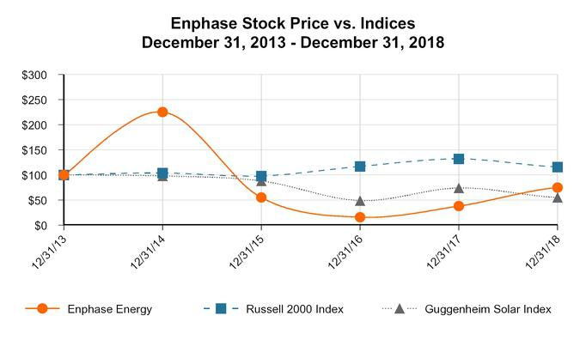

 |  | December 31, |  |  | December 31, |  |  | December 31, |  | December 31, |  | December 31, |  | December 31,
 |  | 2013 |  |  | 2014 |  |  | 2015 |  | 2016 |  | 2017 |  | 2018
Enphase Energy, Inc. | $ | 100 |  | $ | 225 |  | $ | 55 | $ | 16 | $ | 38 | $ | 75
Russell 2000 Index | $ | 100 |  | $ | 104 |  | $ | 98 | $ | 117 | $ | 132 | $ | 116
Guggenheim Solar Index | $ | 100 |  | $ | 98 |  | $ | 88 | $ | 49 | $ | 74 | $ | 55

– 36 –

Table of Contents

Item 6. Selected Consolidated Financial Data

The information set forth below for the five years ended December 31, 2018 is not necessarily indicative of results of future operations, and should be read in conjunction with Item 7. “Management’s Discussion and Analysis of Financial Condition and Results of Operations,” and the consolidated financial statements and related notes thereto included in Item 8. “Financial Statements and Supplementary Data,” of this Annual Report on Form 10-K to fully understand the factors that may affect the comparability of the information presented below.

 |  |  |  |  |  |  |  |  | Years Ended December 31,
 |  |  |  |  | 2018* |  |  |  | 2017 |  |  | 2016 |  |  |  | 2015 |  |  | 2014
 |  |  |  |  |  |  |  |  | (in thousands, except per share data)
Consolidated Statement of Operations Data:
Net revenues |  |  | $ |  | 316,159 | $ |  |  | 286,166 |  | $ | 322,591 |  |  | $ | 357,249 | $ |  | 343,904
Cost of revenues |  |  |  |  | 221,714 |  |  |  | 230,123 |  |  | 264,583 |  |  |  | 249,032 |  |  | 230,861
Gross profit |  |  |  |  | 94,445 |  |  |  | 56,043 |  |  |  | 58,008 |  |  | 108,217 |  |  | 113,043
Operating expenses:
Research and development |  |  |  |  | 32,587 |  |  |  | 33,157 |  |  |  | 50,703 |  |  | 50,819 |  |  | 45,386
Sales and marketing |  |  |  |  | 27,047 |  |  |  | 23,126 |  |  |  | 38,810 |  |  | 45,877 |  |  | 41,003
General and administrative |  |  |  |  | 29,086 |  |  |  | 22,221 |  |  |  | 27,418 |  |  | 30,830 |  |  | 31,083
Restructuring and other charges |  |  |  |  | 4,129 |  |  |  | 16,917 |  |  |  | 3,777 |  |  | — |  |  | —
Total operating expenses |  |  |  |  | 92,849 |  |  |  | 95,421 |  |  | 120,708 |  |  |  | 127,526 |  |  | 117,472
Income (loss) from operations |  |  |  |  | 1,596 |  |  |  | (39,378) |  |  |  | (62,700) |  |  | (19,309) |  |  | (4,429)
Other income (expense), net:
Interest expense |  |  |  |  | (9,635) |  |  |  | (7,936) |  |  |  | (2,773) |  |  | (501) |  |  | (1,863)
Other income (expense) |  |  |  |  | (2,190) |  |  |  | 1,973 |  |  |  | (514) |  |  | (893) |  |  | (994)
Total other expense, net |  |  |  |  | (11,825) |  |  |  | (5,963) |  |  |  | (3,287) |  |  | (1,394) |  |  | (2,857)
Loss before income taxes |  |  |  |  | (10,229) |  |  |  | (45,341) |  |  |  | (65,987) |  |  | (20,703) |  |  | (7,286)
Benefit from (provision for) income taxes |  |  |  |  | (1,398) |  |  |  | 149 |  |  |  | (1,475) |  |  | (1,379) |  |  | (766)
Net loss attributable to common stockholders |  |  |  | $ | (11,627) |  |  | $ | (45,192) |  | $ |  | (67,462) |  | $ | (22,082) |  | $ | (8,052)
Net loss per share attributable to common stockholders,
basic and diluted |  |  |  | $ | (0.12) |  |  | $ | (0.54) |  | $ |  | (1.34) |  | $ | (0.49) |  | $ | (0.19)
Shares used in computing net loss per share attributable |  |  |  |  | 99,619 |  |  |  | 82,939 |  |  |  | 50,519 |  |  | 44,632 |  |  | 42,903
to common stockholders, basic and diluted |  |  |  |  | 99,619 |  |  |  | 82,939 |  |  |  | 50,519 |  |  | 44,632 |  |  | 42,903
 |  |  |  |  |  |  |  |  | As of December 31,
 |  |  | 2018* |  |  | 2017 |  |  |  |  | 2016 |  |  |  |  | 2015 |  |  | 2014
 |  |  |  |  |  |  |  |  | (in thousands)
Consolidated Balance Sheet Data:
Cash and cash equivalents |  | $ | 106,237 |  | $ | 29,144 |  |  | $ |  |  | 17,764 | $ |  |  | 28,452 | $ |  | 42,032
Total assets |  |  | 339,937 |  |  | 169,147 |  |  |  |  | 163,576 |  |  |  |  | 165,528 |  |  | 152,192
Warranty obligations |  |  | 31,294 |  |  | 29,816 |  |  |  |  |  | 31,414 |  |  |  | 30,547 |  |  | 33,940
Debt |  |  | 109,783 |  |  | 49,751 |  |  |  |  |  | 33,900 |  |  |  | 17,000 |  |  | —
Total stockholders’ equity (deficit) |  |  | 7,776 |  |  | (9,126) |  |  |  |  |  | 1,300 |  |  |  | 41,449 |  |  | 46,952
Additional Data:
Working capital |  | $ | 75,141 |  | $ | 38,705 |  |  | $ |  |  | 35,092 | $ |  |  | 48,920 | $ |  | 56,190
Gross margin percentage |  |  | 29.9 |  | % | 19.6 |  |  | % |  |  | 18.0 | % |  |  | 30.3 % |  |  | 32.9 %

- Amounts include the impact of the adoption of Accounting Standards Codification (“ASC”) No. 606, “Revenue Recognition,” on January 1, 2018. See Note 3, “Revenue Recognition” (“ASC 606” or “Topic 606”) of the notes to consolidated financial statements included in Item 8 of this Form 10-K.

– 37 –

Table of Contents

Item 7. Management’s Discussion and Analysis of Financial Condition and Results of Operations

Forward-Looking Statements

The following discussion and analysis of our financial condition and results of operations should be read together with our consolidated financial statements and related notes appearing elsewhere in this Annual Report on Form 10-K. This discussion contains forward-looking statements reflecting our current expectations and involves risks and uncertainties. In some cases, you can identify forward-looking statements by terminology such as “may,” “will,” “should,” “expect,” “plan,” “anticipate,” “believe,” “estimate,” “predict,” “intend,” “potential” or “continue” or the negative of these terms or other comparable terminology. For example, statements regarding our expectations as to future financial performance, expense levels and liquidity sources are forward-looking statements. Our actual results and the timing of events may differ materially from those discussed in our forward-looking statements as a result of various factors, including those discussed below and those discussed in the section entitled “Risk Factors” and elsewhere in this report.

Overview and 2018 Highlights

We are a global energy technology company, delivering smart, easy-to-use solutions that connect solar generation, storage and communications management on one intelligent platform. We revolutionized solar with our microinverter technology and produce the world’s only truly integrated solar-plus-storage solution. We have shipped more than 19 million microinverters, representing over 4 gigawatts of solar PV generating capacity, and more than 855,000 Enphase residential and commercial systems have been deployed in over 125 countries.

We sell our solutions primarily to distributors who resell them to solar installers. We also sell directly to large installers, OEMs, strategic partners and homeowners. Over the last three years, revenues generated from the U.S. market have represented 69% to 80% of our total revenue.

Our first commercial shipment occurred in mid-2008. Our net revenues were $316.2 million, $286.2 million and $322.6 million for 2018, 2017 and 2016, respectively. We incurred net losses of $11.6 million, $45.2 million and $ 67.5 million for 2018, 2017 and 2016, respectively. As of December 31, 2018, we had $106.2 million in cash and cash equivalents and working capital of $75.1 million.

Our 2018 priorities included focusing on customer service and achieving our financial operating model. Quality and customer service are the cornerstones of our strategy and were instrumental in our turnaround in financial performance in 2018. We began by focusing on call center metrics in the U.S., Europe and Australia, and reduced the average wait time from over 10 minutes in 2017 to approximately 2 minutes by the end of 2018. We introduced self-service tools such as the Service-On-The-Go™ that allow our installers and partners to submit requests from their phone in less than 60 seconds.

Our financial operating model sets gross margin, operating expense and operating income targets expressed as a percentage of net revenue. Our financial operating model explicitly focuses on profitability rather than market share. We are pleased with the progress towards achieving our financial operating model targets for gross margin, operating expenses and operating income, which we achieved through a combination of disciplined planning and rigorous execution.

The launch of IQ 7 worldwide, the smallest, lightest and most powerful microinverter we have ever made, was a key factor in improving gross margin. Every region of the world where our products are sold is now using this seventh-generation microinverter. In the fourth quarter of 2018, 84% of our microinverter shipments were IQ 7. We systematically rolled out high-power and high-efficiency variants of the IQ 7 microinverters in 2018. Selling these variants simultaneously improved gross margin and delivered a better price per watt for the installer.

As of December 31, 2018, we had $106.2 million in cash, as compared to $29.1 million as of December 31, 2017. In February 2018, we raised $20.0 million through a private placement of common stock and also reached an agreement with our lender to defer approximately 50% of the principal payments due in 2018 under our term loans. The amount deferred in 2018 was amortized over the remaining term of the loan. On January 28, 2019, we repaid in full the remaining principal amount of the term loans of $39.5 million plus accrued interest and fees. In August 2018, we sold $65.0 million aggregate principal amount of convertible senior notes due 2023 in a private placement and received net proceeds of $ 62.4 million, after deducting the underwriters’ fees and other issuance costs. See Note 11. “Debt,” and Note 13. “Sale of Common Stock,” of the notes to consolidated financial statements included in Item 8 of this Form 10-K for further information.

– 38 –

Table of Contents

On August 9, 2018, we completed the purchase of assets primarily relating to SunPower’s microinverter business (the “Business”). Upon the closing of the transactions under the APA on August 9, 2018, we acquired intellectual property, technology and other assets primarily relating to the Business and assumed certain intellectual property and customer relationship of the Business for the following consideration:

- $25.0 million payable in cash; and (ii) 7.5 million shares of our common stock issued to SunPower at closing. In addition, as conditions to the closing, we and SunPower entered into (i) a MSA under which SunPower is obligated to exclusively procure module level power electronics and related equipment for use in the U.S. residential market from us for a period of five years and (ii) a stockholders agreement to establish certain SunPower rights and obligations related to the shares issued, including SunPower’s right to appoint one person to our board of directors, certain additional transfer restrictions on the shares, and voting, standstill and other undertakings by SunPower. See Note 20. “Acquisition,” of the notes to consolidated financial statements included in Item 8 of this Form 10-K for further information.

2019 Outlook

We believe our solid execution in 2018 positions us well to take advantage of future growth opportunities, and we need to maintain our focus in order to capitalize on such opportunities. Our top three priorities for 2019 are customer experience, improvement of internal business processes and continued focus on the vectors for profitable top line growth.

Customer Experience. Quality and Customer Service constitute customer experience. On the service front, our installer, distributor and module partners are our first line of association with our ultimate customer, the homeowner and business user. Our goals are to partner better with these service providers so that we can provide exceptional serve to our homeowner. We are convinced that continued customer experience improvements can be a competitive advantage for us.

Improve Internal Business Processes. There are three critical business processes we are focusing on this year: Operational Business Process for streamlining the Quote to Cash Cycle; New Product Business Process for launching new product predictably; and Human Resource Business Process for talent management. These processes are critical in improving every aspect of our company for sustainable long-term profitable growth.

Profitable Top Line Growth. Our four vectors for our goal of achieving profitable top line growth are IQ 7 regional expansion, high-power and high-performance products, ACMs, and Ensemble Solar and Storage technology.

- Our IQ 7 transition is nearly complete. Component shortages in 2018 limited our ability to meet customer demand, and we expect these shortages to alleviate in 2019 allowing us to fully realize the financial benefits of this product in the second half of 2019.

- We expect to introduce high-power products, including IQ 7A, which cater to 375-450W DC panels, much like the IQ 7+ and IQ 7X which cater to 325-400W DC panels in 2019. In early 2019, we have started sampling the IQ 7A product in limited quantities to one of our lead customers.

- Enphase Energized ACMs represent a significant part of our strategy to achieve profitable top line growth. This plug and play solution allow installers to be more competitive through improved logistics, reduced installation time, faster inspection and training. In the fourth quarter of 2018, we began volume shipments of our IQ 7XS™, with a continued ramp in 2019.

- Ensemble Solar and Storage technology represents a complete system that provides homeowners with new levels of choice and energy independence. We expect to release Ensemble grid-agnostic products in a phased manner starting in the fourth quarter of 2019. While there will be limited financial contribution from Ensemble in 2019, we will be preparing the market, aligning customers and educating homeowners for an expected robust 2020 with this technology.

Components of Consolidated Statements of Operations

Net Revenues

We primarily generate net revenues from sales of our solutions and related accessories, which can include our AC Battery storage systems, our Envoy communications gateway and Enlighten cloud-based monitoring service as well as other accessories.

– 39 –

Table of Contents

Our revenue is affected by changes in the volume and average selling prices of our solutions and related accessories, supply and demand, sales incentives, and competitive product offerings. Our revenue growth is dependent on our ability to compete effectively in the marketplace by remaining cost competitive, developing and introducing new products that meet the changing technology and performance requirements of our customers, the diversification and expansion of our revenue base, and our ability to market our products in a manner that increases awareness for microinverter technology and differentiates us in the marketplace.

Cost of Revenues and Gross Profit

Cost of revenues is comprised primarily of product costs, warranty, manufacturing personnel and logistics costs, freight costs, depreciation and amortization of test equipment and hosting services costs. Our product costs are impacted by technological innovations, such as advances in semiconductor integration and new product introductions, economies of scale resulting in lower component costs, and improvements in production processes and automation. Certain costs, primarily personnel and depreciation and amortization of test equipment, are not directly affected by sales volume.

We outsource our manufacturing to third-party contract manufacturers and generally negotiate product pricing with them on a quarterly basis. We believe our contract manufacturing partners have sufficient production capacity to meet the anticipated demand for our products for the foreseeable future. However, shortages in the supply of certain key raw materials could adversely affect our ability to meet customer demand for our products. We contract with third parties, including one of our contract manufacturers, to serve as our logistics providers by warehousing and delivering our products in the U.S., Europe and Asia.

Gross profit may vary from quarter to quarter and is primarily affected by our average selling prices, product cost, product mix, warranty costs and sales volume fluctuations resulting from seasonality.

Operating Expenses

Operating expenses consist of research and development, sales and marketing, general and administrative and restructuring expenses. Personnel-related costs are the most significant component of each of these expense categories other than restructuring expense and include salaries, benefits, payroll taxes, sales commissions, incentive compensation and stock-based compensation.

Research and development expense include personnel-related expenses, third-party design and development costs, testing and evaluation costs, depreciation expense and other indirect costs. Research and development employees are primarily engaged in the design and development of power electronics, semiconductors, powerline communications, networking and software functionality, and storage. We devote substantial resources to research and development programs that focus on enhancements to, and cost efficiencies in, our existing products and timely development of new products that utilize technological innovation to drive down product costs, improve functionality, and enhance reliability. We intend to continue to invest appropriate resources in our research and development efforts because we believe they are critical to maintaining our competitive position.

Sales and marketing expense include personnel-related expenses, travel, trade shows, marketing, customer support and other indirect costs. We expect to continue to make the necessary investments to enable us to execute our strategy to increase our market penetration geographically and enter into new markets by expanding our customer base of distributors, large installers, OEMs and strategic partners. We currently offer solutions targeting the residential and commercial markets in the U.S., Canada, Mexico and Central American markets, Europe, Australia, New Zealand, India and certain other Asian markets. We expect to continue to expand the geographic reach of our product offerings and explore new sales channels in addressable markets in the future.

General and administrative expense include personnel-related expenses for our executive, finance, human resources, information technology and legal organization, facilities costs, and fees for professional services. Fees for professional services consist primarily of outside legal, accounting and information technology consulting costs.

– 40 –

Table of Contents

Restructuring charges are the net charges resulting from restructuring initiatives implemented in 2016‑2017 (the “2016 Plan”) and 2018 (the “2018 Plan”) to improve operational performance and reduce overall operating expenses. Under the 2016 Plan, costs included in restructuring primarily consisted of fees paid to management consultants engaged to assist us in making organizational and structural changes to improve operational efficiencies and reduce expenses, severance for workforce reduction actions, non-cash charges related to the disposition of assets and impairment of property and equipment, and the establishment of lease loss reserves. The net charge for the 2016 Plan included a gain on the divestiture of our services business. Charges related to our 2016 Plan were largely completed in 2017. Under the 2018 Plan, costs included in restructuring primarily consisted of employee severance and one-time benefits, workforce reorganization charges, non-cash charges related to impairment of property and equipment, and the establishment of lease loss reserves. See Note 10. “Restructuring,” of the notes to consolidated financial statements included in Item 8 of this Form 10-K for additional information.

Other Expense, Net

Other expense, net primarily consists of interest expense and commitment fees under our term loans and convertible notes, and non-cash interest expense related to the amortization of deferred financing costs. Other expense, net also includes gains or losses upon conversion of foreign currency transactions into U.S. dollars.

Income Tax Benefit (Provision)

We are subject to income taxes in the countries where we sell our products. Historically, we have primarily been subject to taxation in the U.S. because we have sold the majority of our products to customers in the U.S. As we have expanded the sale of products to customers outside the U.S., we have become subject to taxation based on the foreign statutory rates in the countries where these sales took place. As sales in foreign jurisdictions increase in the future, our effective tax rate may fluctuate accordingly. As of December 31, 2018, due to the history of losses we have generated in the U.S. since inception, we believe that it is more-likely-than-not that all of our U.S. and state deferred tax assets will not be realized.

Summary Consolidated Statements of Operations

The following table sets forth a summary of our consolidated statements of operations for the periods presented (in thousands):

 |  |  | Years Ended December 31,
 |  |  | 2018* |  |  | 2017 |  |  | 2016
Net revenues |  | $ | 316,159 |  | $ | 286,166 |  | $ | 322,591
Cost of revenues |  |  | 221,714 |  |  | 230,123 |  |  | 264,583
Gross profit |  |  | 94,445 |  |  | 56,043 |  |  | 58,008
Operating expenses:
Research and development |  |  | 32,587 |  |  | 33,157 |  |  | 50,703
Sales and marketing |  |  | 27,047 |  |  | 23,126 |  |  | 38,810
General and administrative |  |  | 29,086 |  |  | 22,221 |  |  | 27,418
Restructuring charges |  |  | 4,129 |  |  | 16,917 |  |  | 3,777
Total operating expenses |  |  | 92,849 |  |  | 95,421 |  |  | 120,708
Income (loss) from operations |  |  | 1,596 |  |  | (39,378) |  |  | (62,700)
Other expense, net |  |  | (11,825) |  |  | (5,963) |  |  | (3,287)
Loss before income taxes |  |  | (10,229) |  |  | (45,341) |  |  | (65,987)
Income tax benefit (provision) |  |  | (1,398) |  |  | 149 |  |  | (1,475)
Net loss |  | $ | (11,627) |  | $ | (45,192) |  | $ | (67,462)

- Amounts include the impact of the adoption of Accounting Standards Codification (“ASC”) No. 606, “Revenue Recognition,” on January 1, 2018. See Note 3, “Revenue Recognition” (“ASC 606” or “Topic 606”) of the notes to consolidated financial statements included in Item 8 of this Form 10-K.

– 41 –

Table of Contents

Comparison of 2018, 2017 and 2016

Net Revenues

 |  |  | Years Ended |  |  |  |  |  |  |  |  | Years Ended
 |  |  | December 31, |  |  |  |  | Change in |  |  |  | December 31, |  |  |  |  | Change in
 |  |  | 2018* |  | 2017 |  |  | $ | % |  |  | 2017 |  | 2016 |  |  | $ | %
 |  |  |  |  |  |  |  | (In thousands, except percentages)
Net revenues |  | $ | 316,159 | $ | 286,166 |  | $ | 29,993 | 10% $ |  |  | 286,166 | $ | 322,591 |  | $ | (36,425) | (11) %

- Amounts include the impact of the adoption of Accounting Standards Codification (“ASC”) No. 606, “Revenue Recognition,” on January 1, 2018. See Note 3, “Revenue Recognition” (“ASC 606” or “Topic 606”) of the notes to consolidated financial statements included in Item 8 of this Form 10-K.

2018 Compared to 2017. Net revenues increased by 10% in 2018, as compared to 2017, due primarily to an increase in the average selling price per inverter combined with $ 5.3 million of revenue earned under a joint development agreement. We sold 2.8 million microinverter units in 2018, as compared to 2.9 million units in the same period in 2017. The impact of the lower sales volume was more than offset by an increase in average selling price per microinverter due to the transition to our IQ series of microinverters and pricing management. See Note 3. “Revenue Recognition,” of the notes to consolidated financial statements.

2017 Compared to 2016. Net revenues decreased by 11% to $286.2 million in 2017, as compared to 2016. The number of microinverter units sold decreased by 6% to approximately 2.9 million units in 2017 in part due to our efforts to improve gross margins, which included foregoing low-margin sales. Net revenues decreased year-over-year primarily due to the lower volume combined with a decline in the average selling prices of our products. The decrease in net revenues was partially offset by the recognition of $2.2 million of deferred revenue resulting from a change in estimate of the service period related to sales of our Envoy product.

Cost of Revenues and Gross Margin

 |  |  | Years Ended |  |  |  |  |  |  |  |  | Years Ended
 |  |  | December 31, |  |  |  |  | Change in |  |  |  | December 31, |  |  |  |  | Change in
 |  |  | 2018* |  | 2017 |  |  | $ | % |  |  | 2017 |  | 2016 |  |  | $ | %
 |  |  |  |  |  |  |  | (In thousands, except percentages)
Cost of revenues |  | $ | 221,714 | $ | 230,123 |  | $ | (8,409) | (4)% $ |  |  | 230,123 | $ | 264,583 |  | $ | (34,460) | (13)%
Gross profit |  |  | 94,445 |  | 56,043 |  |  | 38,402 | 69 % |  |  | 56,043 |  | 58,008 |  |  | (1,965) | (3)%
Gross margin |  |  | 29.9% |  | 19.6% |  |  |  |  |  |  | 19.6% |  | 18.0%

- Amounts include the impact of the adoption of Accounting Standards Codification (“ASC”) No. 606, “Revenue Recognition,” on January 1, 2018. See Note 3, “Revenue Recognition” (“ASC 606” or “Topic 606”) of the notes to consolidated financial statements included in Item 8 of this Form 10-K.

2018 Compared to 2017. Cost of revenues decreased by 4% in 2018, as compared to 2017, primarily due to an 11% decrease in the average product cost. Gross margin increased by 10.3 percentage points for 2018, as compared to 2017. The increase in gross margin was primarily attributable to increased product margins as a result of the transition to our IQ 7 microinverter as well as our other product cost management efforts. The improvement in margin due to the $5.3 million in revenue under a joint development arrangement was offset by an increase in other cost of goods sold, including increased expedite fees and logistics costs associated with supply constraints due to industry wide component shortages. Our ability to reduce product costs and the timing of product cost reductions relative to declines in the selling prices of our products can have a significant impact on our gross margin.

2017 Compared to 2016. Cost of revenues decreased by 13% in 2017, as compared to 2016, and was primarily attributable to the transition in 2017 to our next generation IQ microinverters, which have a lower cost profile than the previous generation, as well as the decline in sales volume. Gross margin increased by 1.6 percentage points to 19.6% in 2017, as compared to 18.0% in 2016. The primary drivers of the gross margin increase were lower warranty expense and logistics costs as a percentage of net revenues in 2017 as compared to 2016.

– 42 –

Table of Contents

Research and Development

 |  | Years Ended |  |  |  |  |  |  |  |  | Years Ended
 |  | December 31, |  |  |  |  | Change in |  |  |  | December 31, |  |  |  |  | Change in
 |  | 2018 |  | 2017 |  |  | $ | % |  |  | 2017 |  | 2016 |  |  | $ | %
 |  |  |  |  |  |  | (In thousands, except percentages)
Research and
development | $ | 32,587 | $ | 33,157 |  | $ | (570) | (2)% $ |  |  | 33,157 | $ | 50,703 |  | $ | (17,546) | (35)%
Percentage of net
revenues |  | 10% |  | 12% |  |  |  |  |  |  | 12% |  | 16%

2018 Compared to 2017. Research and development expense decreased by $0.6 million in 2018, as compared to the same period in

2017. The decrease is due to lower personnel-related expenses, equipment costs and professional expenses associated with the development, introduction and qualification of new products. The decrease was partially offset by higher engineering expenses. The decrease in personnel-related expenses was primarily due to a cumulative decrease in labor costs associated with moving certain functions to lower cost locations as part of restructuring actions taken in 2017 and 2018. The decrease in personnel-related expenses was partially offset by higher bonus compensation, stock-based compensation expense and travel expenses. The amount of research and development expenses may fluctuate from period to period due to the differing levels and stages of development activity.

2017 Compared to 2016. Research and development expenses decreased by $17.5 million in 2017, as compared to 2016. The decrease was primarily due to the implementation of our restructuring initiative that eliminated non-core projects resulting in an $11.5 million reduction in research and development personnel related expenses and a $5.9 million reduction in lab parts, product prototypes and professional fees.

Sales and Marketing

 |  | Years Ended |  |  |  |  |  |  |  |  | Years Ended
 |  | December 31, |  |  |  |  | Change in |  |  |  | December 31, |  |  |  |  | Change in
 |  | 2018 |  | 2017 |  |  | $ | % |  |  | 2017 |  | 2016 |  |  | $ | %
 |  |  |  |  |  |  | (In thousands, except percentages)
Sales and marketing | $ | 27,047 | $ | 23,126 |  | $ | 3,921 | 17% $ |  |  | 23,126 | $ | 38,810 |  | $ | (15,684) | (40)%
Percentage of net
revenues |  | 9% |  | 8% |  |  |  |  |  |  | 8% |  | 12%

2018 Compared to 2017. Sales and marketing expense increased by $3.9 million in 2018, as compared to 2017. The increase was primarily due to higher personnel related expenses, professional fees, equipment costs, advertising and marketing expenses and bad debt expenses. The increase was partially offset by lower facilities costs. The increase in personnel-related expenses include higher stock-based compensation expense, payroll expenses due to increasing our sales team and recruiting fees. The increase in personnel-related expenses was partially offset by lower spending on contractors and temporary employees, bonus compensation and benefits.

2017 Compared to 2016. Sales and marketing expenses decreased by $15.7 million in 2017, as compared to 2016. The decrease was primarily due to the implementation of our restructuring initiative resulting in an $ 8.5 million decrease in compensation costs as a result of lower headcount and a $1.2 million decrease in travel and entertainment expenses as a result of cost savings initiatives. Bad debt expense was reduced by $2.6 million in 2017 as compared to 2016, and advertising and professional fees were reduced by $2.8 million.

– 43 –

Table of Contents

General and Administrative

 |  | Years Ended |  |  |  |  |  |  |  |  | Years Ended
 |  | December 31, |  |  |  |  | Change in |  |  |  | December 31, |  |  |  |  | Change in
 |  | 2018 |  | 2017 |  |  | $ | % |  |  | 2017 |  | 2016 |  |  | $ | %
 |  |  |  |  |  |  | (In thousands, except percentages)
General and
administrative | $ | 29,086 | $ | 22,221 |  | $ | 6,865 | 31% $ |  |  | 22,221 | $ | 27,418 |  | $ | (5,197) | (19)%
Percentage of net
revenues |  | 9% |  | 8% |  |  |  |  |  |  | 8% |  | 8%

2018 Compared to 2017. General and administrative expense increased by $6.9 million in 2018, as compared to 2017. The increase was primarily due to higher personnel-related expenses, additional consulting and advisory fees due to our first year of SOX compliance efforts, $1.8 million paid to resolve a dispute with a supplier, and $0.8 million of acquisition-related expenses. The increase was partially offset by lower legal fees and equipment costs. The increase in personnel-related expenses was primarily attributable to higher stock-based compensation expense, higher spending on contractors and temporary employees, salary and bonus compensation and travel expenses. The increase in personnel-related expenses was partially offset by lower employee recruitment costs.

2017 Compared to 2016. General and administrative expenses decreased by $5.2 million in 2017, as compared to 2016. The decrease was primarily due to the implementation of our restructuring initiative that eliminated non-core projects resulting in a $4.9 million reduction in general and administrative personnel related expenses, a $0.8 million reduction in facilities related expenses and a $1.0 million reduction in depreciation expense as a result of a lower fixed asset base. These decreases were partially offset by a $1.7 million increase in accounting and legal fees.

Restructuring and Other Charges

 |  | Years Ended |  |  |  |  |  |  |  |  | Years Ended
 |  | December 31, |  |  |  |  | Change in |  |  |  | December 31, |  |  |  |  | Change in
 |  | 2018 |  | 2017 |  |  | $ | % |  |  | 2017 |  | 2016 |  |  | $ | %
 |  |  |  |  |  |  | (In thousands, except percentages)
Restructuring charges $ |  | 4,129 | $ | 16,917 |  | $ | (12,788) | (76)% $ |  |  | 16,917 | $ | 3,777 |  | $ | 13,140 | 348%
Percentage of net
revenues |  | 1% |  | 6% |  |  |  |  |  |  | 6% |  | 1%

2018 Compared to 2017. We implemented a restructuring plan in the third quarter of 2018 to lower our operating expenses. This plan included a realignment of our global workforce to lower cost locations and a relocation of our corporate headquarters. Restructuring charges for 2018 primarily included $2.2 million in cash-based severance and related benefits, $1.6 million in charges for assets impairment, and $0.3 million for lease loss reserves. We expect to incur additional restructuring charges in the near-term under this restructuring plan.

2017 Compared to 2016. We implemented a restructuring plan in the third quarter of 2016 to lower our operating expenses and cost of revenues that included reductions in our global workforce and the elimination of certain non-core projects. In 2017 we engaged a management consulting firm to assist us in making organizational and structural changes to improve operational efficiencies and reduce expenses.
Restructuring charges in 2017 include $12.1 million of consulting services, $2.8 million in cash-based severance and related benefits and $2.0 million in charges for asset impairments and lease loss reserves.

– 44 –

Table of Contents

Other Income (Expense), Net

 |  | Years Ended |  |  |  |  |  |  |  |  | Years Ended
 |  | December 31, |  |  |  |  | Change in |  |  |  | December 31, |  |  |  |  | Change in
 |  | 2018 |  | 2017 |  |  | $ | % |  |  | 2017 |  | 2016 |  |  | $ | %
 |  |  |  |  |  |  | (In thousands, except percentages)
Other expense, net | $ | (11,825) | $ | (5,963) |  | $ | (5,862) | 98% $ |  |  | (5,963) | $ | (3,287) |  | $ | (2,676) | 81%

2018 Compared to 2017. Other expense, net for 2018 includes $10.7 million of interest expense related to our term loan and convertible notes and a $2.5 million loss due foreign currency exchange and remeasurement, partially offset by $1.1 million of interest income related to higher cash balances and $0.4 million of valuation adjustments on our term loan.

2017 Compared to 2016. Other expense increased by $2.7 million in 2017, as compared to 2016, primarily due to a $5.2 million increase in net interest expense, which was partially offset by a $2.5 million increase in other income related to foreign exchange rates.

Income Tax Benefit (Provision)

 |  | Years Ended |  |  |  |  |  |  |  |  | Years Ended
 |  | December 31, |  |  |  |  | Change in |  |  |  | December 31, |  |  |  |  | Change in
 |  | 2018 |  | 2017 |  |  | $ | % |  |  | 2017 |  | 2016 |  |  | $ | %
 |  |  |  |  |  |  | (In thousands, except percentages)
Income tax benefit
(provision) | $ | (1,398) | $ | 149 |  | $ | (1,547) | ** $ |  |  | 149 | $ | (1,475) |  | $ | 1,624 | (110)%
Effective tax rate |  | (13.67)% |  | 0.33% |  |  |  |  |  |  | 0.33% |  | (2.24)%

- Not meaningful

2018 Compared to 2017. On December 22, 2017, the U.S. enacted the Tax Cuts and Jobs Act (the “Act”), which significantly changed U.S. tax law. The Act lowered our U.S. statutory federal income tax rate from 35% to 21% effective January 1, 2018, while also imposing a deemed repatriation tax on previously deferred foreign income. By operation of law, we applied a U.S. statutory federal income tax rate of 21% for 2018. The effective tax rate in 2018 of (13.67)% was lower than the 2018 statutory U.S. federal income tax rate due primarily to Global Low-Taxed Intangible Income (“GILTI”) inclusion, foreign taxes and compensation deduction limitations. The change in effective tax rate in 2018, compared to 2017, was primarily due to changes in valuation allowances, and foreign taxes having a greater impact on the effective tax rate and an increase in non-deductible expenses, both a result of the Act.

The income tax provision of $1.4 million in 2018, compared to the income tax benefit of $0.1 million in 2017, was primarily due to increased foreign taxes and decreased benefit from tax reform.

2017 Compared to 2016. The Company’s effective tax rates of 0.33% and (2.24)% in 2017 and 2016, respectively, differed from the statutory rate of 34% in 2017 and 2016, due primarily to changes in valuation allowance needs, foreign taxes and impact of tax reform in 2017. The income tax benefit of $0.1 million in 2017, compared to the income tax provision of $1.5 million in 2016, was primarily due to changes in foreign taxes and benefit from tax reform in 2017.

Liquidity and Capital Resources

Sources of Liquidity

As of December 31, 2018, we had $106.2 million in cash and cash equivalents and working capital of $75.1 million. Cash and cash equivalents held in the U.S. were $93.7 million and consisted primarily of U.S. Government money market mutual funds and non-interest-bearing checking deposits, with the remainder held in various foreign subsidiaries. We consider amounts held outside the U.S. to be accessible and have provided for the estimated U.S. income tax liability associated with our foreign earnings.

– 45 –

Table of Contents

Convertible Debt. In August 2018, we sold $65.0 million aggregate principal amount of convertible senior notes due 2023 (the “Convertible Notes”). The Notes are senior, unsecured and bear interest at a rate of 4.0% per year, payable semi-annually on February 1 and August 1 of each year, beginning on February 1, 2019. The Convertible Notes will mature on August 1, 2023, unless earlier repurchased by us or converted at the option of the holders. We may not redeem the Convertible Notes prior to the maturity date, and no sinking fund is provided for the Notes. As of December 31, 2018, $ 65.0 million aggregate principal amount of the Notes was outstanding. See Note 11. “Debt,” of the notes to consolidated financial statements included in Item 8 of this Form 10-K.

In February 2018, we entered into a securities purchase agreement with an investor pursuant to which we, in a private placement, issued and sold to the investor 9,523,809 shares of our common stock, at a price per share of $2.10, resulting in gross proceeds of $20.0 million.

Term Loans. In July 2016, we entered into a loan and security agreement with lenders that are affiliates of Tennenbaum Capital Partners, LLC, which was subsequently amended and modified in 2017 and 2018 (“Term Loans”). As of December 31, 2018, we have

$41.5 million outstanding on our term loans. As of December 31, 2018, we were in compliance with all financial and other covenants under the term loan agreement. On January 28, 2019, we repaid in full the remaining principal amount of the Term Loans of $39.5 million plus accrued interest and fees. See Note 11. “Debt,” of the notes to consolidated financial statements included in Item 8 of this Form 10-K for further discussion on the Term Loans.

We believe that our existing cash and cash equivalents and cash flows from our operating activities will be sufficient to meet our anticipated cash needs for at least the next 12 months.

Cash Flows. The following table summarizes our cash flows for the periods presented (in thousands):

 |  |  | Years Ended December 31,
 |  | 2018 |  |  |  | 2017 |  |  | 2016
Net cash provided by (used in) operating activities | $ | 16,132 | $ |  |  | (28,442) |  | $ | (32,953)
Net cash used in investing activities |  | (19,151) |  |  |  | (4,121) |  |  | (11,795)
Net cash provided by financing activities |  | 80,614 |  |  |  | 43,297 |  |  | 34,375

Cash Flows from Operating Activities

For 2018, net cash provided by operating activities of $ 16.1 million was primarily due to adjustments for non-cash items more than offsetting the net loss of $11.6 million. The net cash provided from changes in operating assets and liabilities in 2018 was a $23.1 million increase in accounts payable and accrued liabilities, a $9.7 million decrease in inventory and a $ 1.5 million increase in warranty obligations. Offsetting the cash provided was a $13.5 million increase in accounts receivable, a $10.0 million increase in intangible assets related to our acquisition of SunPower’s microinverter business, a $6.1 million decrease in deferred revenues and a $3.1 million increase in contract assets.

For 2017, net cash used in operating activities was $28.4 million, primarily resulted from a net loss of $45.2 million. The net loss was partially offset by non-cash charges including stock-based compensation of $6.7 million, depreciation and amortization of $9.0 million, asset impairment and non-cash restructuring charges of $1.1 million, and a provision for doubtful accounts of $0.5 million. Changes in net operating assets and liabilities used cash of $1.4 million.

The primary uses of cash from changes in net operating assets and liabilities in 2017 were a $6.5 million decrease in accounts payable and accrued liabilities, a $4.8 million increase in accounts receivable and a $1.6 million decrease in warranty obligations. Offsetting these uses of cash was a decrease in inventory of $6.0 million and an increase in deferred revenue of $5.3 million.

For 2016, net cash used in operating activities was $33.0 million, primarily resulted from a net loss of $67.5 million. The net loss was partially offset by non-cash charges including stock-based compensation of $10.3 million, depreciation and amortization of $10.6 million, asset impairment and restructuring charges of $3.2 million, and an increase in the provision for doubtful accounts of $3.1 million. In addition, the effect of changes in net operating assets and liabilities provided cash of $7.2 million.

– 46 –

Table of Contents

The primary sources of cash from changes in net operating assets and liabilities in 2016 were an $11.3 million increase in deferred revenue related to our Enlighten service and deferred product revenue, an $8.8 million decrease in inventory, and an $8.9 million increase in accounts payable and accrued liabilities. Offsetting these sources of cash was an increase in accounts receivable of $18.0 million and an increase in other assets of $4.8 million. The increase in accounts receivable was due to higher sales in the fourth quarter of 2016 as compared to the same period in 2015, and the increase in other assets was primarily attributable to an increase in customer financing receivables.

Cash Flows from Investing Activities

For 2018, net cash used in investing activities of $19.2 million primarily resulted from a $15.0 million payment related to the acquisition of SunPower’s microinverter business and $4.2 million for purchases of test and assembly equipment and capitalized costs related to internal-use software.

For 2017, net cash used in investing activities of $ 4.1 million primarily resulted from purchases of test and assembly equipment, license fees for certain technology related to ASIC development and capitalized costs related to internal-use software.

For 2016, net cash used in investing activities of $11.8 million primarily resulted from purchases of test and assembly equipment, capitalized costs related to internal-use software and license fees for certain technology related to ASIC development, partially offset by $1.1 million in proceeds from the sale of our services business.

Cash Flows from Financing Activities

For 2018, net cash provided by financing activities of $ 80.6 million primarily consisted of $62.4 million in net proceeds from issuance of convertible debt, $19.8 million in net proceeds from a private securities placement, $5.6 million in net proceeds from the sale of certain long-term financing receivables and $2.8 million in proceeds from exercises of stock options, partially offset by debt payments totaling $10.0 million.

For 2017, net cash provided by financing activities of $43.3 million primarily consisted of $24.2 million additional net proceeds from amending our term loan with TCP and $27.0 million in net proceeds from the issuance of common stock and $2.8 million in proceeds from the sale of certain financing receivables offset by the $10.1 million repayment associated with the termination of our revolving credit facility with Wells Fargo Bank.

For 2016, net cash provided by financing activities of $34.4 million primarily consisted of $24.2 million net proceeds from our term loan and $17.8 million in proceeds from the issuance of common stock offset by $6.9 million net reduction in borrowings under our Revolver and $0.7 million in debt issuance and equity offering costs.

– 47 –

Table of Contents

Contractual Obligations

The following table summarizes our outstanding contractual obligations as of December 31, 2018:

 |  |  |  |  |  |  | Payments Due by Period
 |  |  | Total |  |  | Less Than 1 Year |  |  |  | 2-3 Years |  |  | 4-5 Years |  | More Than 5 Years
 |  |  |  |  |  |  |  |  |  | (in thousands)
Operating leases |  | $ | 13,631 |  | $ | 3,284 | $ |  |  | 6,340 |  | $ | 2,755 |  | $ | 1,252
Term loans ⁽¹⁾ |  |  | 41,524 |  |  | 25,317 |  |  |  | 16,207 |  |  | — |  |  | —
Estimated interest and fees related to term
loans ⁽¹⁾ |  |  | 5,965 |  |  | 4,445 |  |  |  | 1,520 |  |  | — |  |  | —
Convertible Note due 2023 principal and interest |  |  | 78,000 |  |  | 2,600 |  |  |  | 5,200 |  |  | 70,200 |  |  | —
Purchase obligations ⁽²⁾ |  |  | 41,104 |  |  | 41,104 |  |  |  | — |  |  | — |  |  | —
Total |  | $ | 180,224 |  | $ | 76,750 | $ |  |  | 29,267 |  | $ | 72,955 |  | $ | 1,252

- On January 28, 2019, we repaid in full the remaining principal amount of the Term Loans of $39.5 million plus accrued interest and fees. See Note 11. “Debt,” of the notes to consolidated financial statements included in Item 8 of this Form 10-K.

- Purchase obligations include amounts related to component inventory that our primary contract manufacturer procures on our behalf in accordance with our production forecast as well as other inventory related purchase commitments. The timing of purchases in future periods could differ materially from estimates presented above due to fluctuations in demand requirements related to varying sales levels as well as changes in economic conditions.

As of 2018, the liability recorded for uncertain tax positions, including associated interest and penalties, was approximately $1.3 million. Since the ultimate amount and timing of cash settlements cannot be predicted due to the high degree of uncertainty, liabilities for uncertain tax positions are excluded from the contractual obligations table. See Note 15. “Income Taxes,” of the notes to consolidated financial statements included in Item 8 of this Form 10-K.

Off-Balance Sheet Arrangements

As of December 31, 2018, we did not have any off-balance sheet arrangements, as defined in Item 303(a)(4)(ii) of SEC Regulation S-K.

Critical Accounting Policies

The preparation of our consolidated financial statements and related notes requires us to make judgments, estimates and assumptions that affect the reported amounts of assets, liabilities, revenue and expenses, and related disclosure of contingent assets and liabilities. We have based our estimates on historical experience and on various other assumptions that are believed to be reasonable under the circumstances, the results of which form the basis for making judgments about the carrying values of assets and liabilities that are not readily apparent from other sources. Actual results may differ from these estimates under different assumptions or conditions.

For a description of our significant accounting policies, see Note 2. “Summary of Significant Accounting Policies,” of the notes to consolidated financial statements included in Item 8 of this Form 10-K. An accounting policy is considered to be critical if it requires an accounting estimate to be made based on assumptions about matters that are highly uncertain at the time the estimate is made, and if different estimates that reasonably could have been used, or changes in the accounting estimates that are reasonably likely to occur periodically, could materially impact the consolidated financial statements. We believe the following critical accounting policies reflect the more significant estimates and assumptions used in the preparation of our consolidated financial statements.

Revenue Recognition

We generate revenue from sales of our solutions, which include microinverter units and related accessories, an Envoy communications gateway, the cloud-based Enlighten monitoring service, and AC Battery storage solutions to distributors, large installers, OEMs and strategic partners.

– 48 –

Table of Contents

On January 1, 2018, we adopted Accounting Standards Codification (“ASC”) No. 606, “Revenue Recognition” (“ASC 606” or “Topic 606”) and applied the modified retrospective method to all contracts that were not completed as of January 1, 2018. The most significant impacts upon adoption of Topic 606 were how we account for revenue related to our Envoy communications device and related Enlighten service and the timing of when certain sales incentives are recognized. The full consideration for these products represents a single performance obligation and is deferred and recognized over the estimated service period.

Revenues are recognized when control of the promised goods or services are transferred to our customers in an amount that reflects the consideration that is expected to be received in exchange for those goods or services. We generate all of our revenues from contracts with our customers. A description of principal activities from which we generate revenues are as follows.

- Products Delivered at a Point in Time. We sell our products to customers in accordance with the terms of the related customer contracts. We generate revenues from sales of our solutions, which include microinverter units and related accessories, an Envoy communications gateway and Enlighten service, communications accessories and AC Battery storage solutions to distributors, large installers, OEMs and strategic partners. Microinverter units, microinverter accessories, and AC Battery storage solutions are delivered to customers at a point in time, and we recognize revenue for these products when we transfer control of the product to the customer, which is generally upon shipment.

- Products Delivered Over Time. The sale of an Envoy communications gateway includes our Enlighten cloud-based monitoring service. The full consideration for these products represents a single performance obligation and is deferred at the sale date and recognized over the estimated service period. We also sell certain communication accessories that are delivered over time. The revenue from these products is recognized over the related service period.

We previously sold Envoy communications device to certain customers under a long-term financing arrangement. Under this financing arrangement, we net the unbilled receivables against deferred revenue.

We record certain contra revenue promotions as variable consideration and recognizes these promotions at the time the related revenue is recorded.

We record upfront contract acquisition costs, such as sales commissions, to be capitalized and amortized over the estimated life of the asset. For contracts that have a duration of less than one year, we follow the Topic 606 practical expedient and expense these costs when incurred. Commissions related to our sale of monitoring hardware and service are capitalized and amortized over the period of the associated revenue.

See Note 3. “Revenue Recognition,” of the notes to consolidated financial statements included in Item 8 of this Form 10-K for additional information related to revenue recognition.

Inventory

Inventory is valued at the lower of cost or market. Market is current replacement cost (by purchase or by reproduction, dependent on the type of inventory). In cases where market exceeds net realizable value (i.e., estimated selling price less reasonably predictable costs of completion and disposal), inventories are stated at net realizable value. Market is not considered to be less than net realizable value reduced by an allowance for an approximately normal profit margin. We determine cost on a first-in first-out basis. Certain factors could affect the realizable value of its inventory, including customer demand and market conditions. Management assesses the valuation on a quarterly basis and writes down the value for any excess and obsolete inventory based upon expected demand, anticipated sales price, effect of new product introductions, product obsolescence, customer concentrations, product merchantability and other factors. Inventory write-downs are equal to the difference between the cost of inventories and market. The impact of changes in the inventory valuation allowance for 2018, 2017 and 2016 were not material.

– 49 –

Table of Contents

Warranty Obligations

Microinverters Sold Through December 31, 2013

Our warranty accrual provides for the replacement of microinverter units that fail during the product’s warranty term (15 years for first and second generation microinverters and up to 25 years for third and fourth generation microinverters). On a quarterly basis, we employ a consistent, systematic and rational methodology to assess the adequacy of our warranty liability. This assessment includes updating all key estimates and assumptions for each generation of product, based on historical results, trends and the most current data available as of the filing date. The key estimates and assumptions used in the warranty liability are thoroughly reviewed by management on a quarterly basis. The key estimates used by us to estimate our warranty liability are: (1) the number of units expected to fail over time (i.e., failure rate); (2) the number of failed units expected to result in warranty claims over time (i.e., claim rate); and (3) the per unit cost of replacement units, including outbound shipping and limited labor costs, expected to be incurred to replace failed units over time (i.e., replacement cost).

Estimated Failure Rates — Our Quality and Reliability department has primary responsibility to determine the estimated failure rates for each generation of microinverter. To establish initial failure rate estimates for each generation of microinverter, our quality engineers use a combination of industry standard Mean Time Between Failure (“MTFB”) estimates for individual components contained in that generation of microinverters, third party data collected on similar equipment deployed in outdoor environments similar to those in which our microinverters are installed, and rigorous long term reliability and accelerated life cycle testing which simulates the service life of the microinverter in a short period of time. As units are deployed into operating environments, we continue to monitor product performance through our Enlighten monitoring platform. It typically takes three to nine months between the date of sale and date of end-user installation. Consequently, our ability to monitor actual failures of units sold similarly lags by three to nine months. When a microinverter fails and is returned, we perform diagnostic root cause failure analysis to understand and isolate the underlying mechanism(s) causing the failure. We then use the results of this analysis (combined with the actual, cumulative performance data collected on those units prior to failure through Enlighten) to draw conclusions with respect to how or if the identified failure mechanism(s) will impact the remaining units deployed in the installed base.

Estimated Claim Rates — Warranty claim rate estimates are based upon assumptions with respect to expected customer behavior over the warranty period. As the vast majority of our microinverters have been sold to end users for residential applications, we believe that warranty claim rates will be affected by changes over time in residential home ownership because we expect that subsequent homeowners are less likely to file claims than the homeowners who originally purchase the microinverters.

Estimated Replacement Costs — Three factors are considered in our analysis of estimated replacement cost: (1) the estimated cost of replacement microinverters; (2) the estimated cost to ship replacement microinverters to end users; and (3) the estimated labor reimbursement expected to be paid to third party installers performing replacement services for the end user. Because our warranty provides for the replacement of defective microinverters over long periods of time (between 15 and 25 years, depending on the generation of product purchased), the estimated per unit cost of current and future product generations is considered in the estimated replacement cost. Estimated costs to ship replacement units are based on observable, market-based shipping costs paid by us to third party freight carriers. We have a separate program that allows third-party installers to claim fixed-dollar reimbursements for labor costs they incur to replace failed microinverter units for a limited time from the date of original installation. Included in our estimated replacement cost is an analysis of the number of fixed-dollar labor reimbursements expected to be claimed by third party installers over the limited offering period.

In addition to the key estimates noted above, we also compare actual warranty results to expected results and evaluate any significant differences. We may make additional adjustments to the warranty provision based on performance trends or other qualitative factors. If actual failure rates, claim rates, or replacement costs differ from our estimates in future periods, changes to these estimates may be required, resulting in increases or decreases in our warranty obligations. Such increases or decreases could be material.

– 50 –

Table of Contents

Fair Value Option for Microinverters Sold Since January 1, 2014

Our warranty obligations related to microinverters sold since January 1, 2014 provide us the right, but not the requirement, to assign our warranty obligations to a third-party. Under ASC 825, “Financial Instruments” (also referred to as the “fair value option”), an entity may choose to elect the fair value option for such warranties at the time it first recognizes the eligible item. We made an irrevocable election to account for all eligible warranty obligations associated with microinverters sold since January 1, 2014 at fair value. This election was made to reflect the underlying economics of the time value of money for an obligation that will be settled over an extended period of up to 25 years.

We estimate the fair value of warranty obligations by calculating the warranty obligations in the same manner as for sales prior to January 1, 2014 and applying an expected present value technique to that result. The expected present value technique, an income approach, converts future amounts into a single current discounted amount. In addition to the key estimates of failure rates, claim rates and replacement costs, we used certain inputs that are unobservable and significant to the overall fair value measurement. Such additional assumptions included compensation comprised of a profit element and risk premium required of a market participant to assume the obligation and a discount rate based on our credit-adjusted risk-free rate. See Note 9. “Fair Value Measurements,” of the notes to consolidated financial statements included in Item 8 of this Form 10-K for additional information.

Business Combinations

Assets acquired and liabilities assumed as part of a business acquisition are generally recorded at their fair value at the date of acquisition. The excess of purchase price over the fair value of assets acquired and liabilities assumed is recorded as goodwill. Determining fair value of identifiable assets, particularly intangibles, and liabilities acquired also requires us to make estimates, which are based on all available information and in some cases assumptions with respect to the timing and amount of future revenues and expenses associated with an asset. Accounting for business acquisitions requires us to make judgments as to whether a purchase transaction is a multiple element contract, meaning that it includes other transaction components. This judgment and determination affect the amount of consideration paid that is allocable to assets and liabilities acquired in the business purchase transaction.

Adoption of New and Recently Issued Accounting Pronouncements

Refer to Note 2. “Summary of Significant Accounting Policies” of the notes to consolidated financial statements included in Item 8 of this Form 10-K for a discussion of adoption of new and recently issued accounting pronouncements.

Item 7A. Quantitative and Qualitative Disclosures About Market Risk

Foreign Currency Exchange Risk

We operate and conduct business in foreign countries where our foreign entities use the local currency as their respective functional currency and, as a result, are exposed to movements in foreign currency exchange rates. More specifically, we face foreign currency exposure primarily from the effect of fluctuating exchange rates on payables and receivables relating to transactions that are denominated in Euros, Indian Rupee and Australian and New Zealand Dollars. These payables and receivables primarily arise from sales to customers and intercompany transactions. We also face currency exposure that arises from translating the results of our European, Indian, Australian and New Zealand operations, including sales and marketing and research and development expenses, to the U.S. dollar at exchange rates that have fluctuated from the beginning of a reporting period.

We have utilized foreign currency forward contracts to reduce the impact of foreign currency fluctuations related to anticipated cash receipts from expected future revenues denominated in Euros and intercompany transaction gains or losses. The contracts we enter into typically have maturities of less than one year. We do not enter into derivative financial instruments for trading or speculative purposes. Any foreign currency forward contracts are accounted for as derivatives whereby the fair value of the contracts is reported as other current assets or current liabilities, and gains and losses resulting from changes in the fair value are reported in other income (expense), net, in the accompanying consolidated statements of operations. We were not party to any foreign currency contracts as of December 31, 2017, and we did not enter into any foreign currency forward contracts during 2018.

– 51 –

Table of Contents

As of December 31, 2018 and 2017, we had no outstanding foreign currency forward contracts with maturities of less than one year. In each year ended December 31, 2018 and 2017, we recorded no net gains related to foreign currency forward contracts. In year ended December 31, 2016, we recorded $0.1 million net gains related to foreign currency forward contracts.

– 52 –

Table of Contents

Item 8. Financial Statements and Supplementary Data

ENPHASE ENERGY, INC.

INDEX TO CONSOLIDATED FINANCIAL STATEMENTS

AS OF DECEMBER 31, 2018 AND 2017,

AND FOR THE YEARS ENDED DECEMBER 31, 2018, 2017 AND 2016

 | Page
Report of Independent Registered Public Accounting Firm | 54
Consolidated Balance Sheets | 56
Consolidated Statements of Operations | 57
Consolidated Statements of Comprehensive Loss | 58
Consolidated Statements of Cash Flows | 59
Consolidated Statements of Stockholders’ Equity (Deficit) | 60
Notes to Consolidated Financial Statements | 61
Selected Unaudited Quarterly Financial Information | 96

– 53 –

Table of Contents

REPORT OF INDEPENDENT REGISTERED PUBLIC ACCOUNTING FIRM

To the Stockholders and Board of Directors of Enphase Energy, Inc.:

Opinion on the Financial Statements

We have audited the accompanying consolidated balance sheets of Enphase Energy, Inc. and subsidiaries (the “Company”) as of December 31, 2018 and 2017, the related consolidated statements of operations, comprehensive loss, stockholders’ equity, and cash flows for each of the three years in the period ended December 31, 2018, and the related notes (collectively referred to as the “financial statements”). In our opinion, the financial statements present fairly, in all material respects, the financial position of the Company as of December 31, 2018 and 2017, and the results of its operations and its cash flows for each of the three years in the period ended December 31, 2018, in conformity with accounting principles generally accepted in the United States of America.

We have also audited, in accordance with the standards of the Public Company Accounting Oversight Board (United States) (PCAOB), the Company’s internal control over financial reporting as of December 31, 2018, based on criteria established in Internal Control - Integrated Framework (2013) issued by the Committee of Sponsoring Organizations of the Treadway Commission and our report dated March 15, 2019, expressed an unqualified opinion on the Company’s internal control over financial reporting.

Change in Accounting Principle

As discussed in Note 2 to the financial statements, effective January 1, 2018, the Company adopted Revenue From Contracts With Customers (Topic 606), using the modified retrospective approach.

Basis for Opinion

These financial statements are the responsibility of the Company’s management. Our responsibility is to express an opinion on the Company’s financial statements based on our audits. We are a public accounting firm registered with the Public Company Accounting Oversight Board (United States) (PCAOB) and are required to be independent with respect to the Company in accordance with the U.S. federal securities laws and the applicable rules and regulations of the Securities and Exchange Commission and the PCAOB.

We conducted our audits in accordance with the standards of the PCAOB. Those standards require that we plan and perform the audit to obtain reasonable assurance about whether the financial statements are free of material misstatement, whether due to error or fraud. Our audits included performing procedures to assess the risks of material misstatement of the financial statements, whether due to error or fraud, and performing procedures that respond to those risks. Such procedures included examining, on a test basis, evidence regarding the amounts and disclosures in the financial statements. Our audits also included evaluating the accounting principles used and significant estimates made by management, as well as evaluating the overall presentation of the financial statements. We believe that our audits provide a reasonable basis for our opinion.

/s/ DELOITTE & TOUCHE LLP

San Francisco, California

March 15, 2019

We have served as the Company’s auditor since 2010.

– 54 –

Table of Contents

REPORT OF INDEPENDENT REGISTERED PUBLIC ACCOUNTING FIRM

To the Stockholders and Board of Directors of Enphase Energy, Inc.:

Opinion on Internal Control over Financial Reporting

We have audited the internal control over financial reporting of Enphase Energy, Inc. and subsidiaries (the “Company”) as of December 31, 2018, based on criteria established in Internal Control - Integrated Framework (2013) issued by the Committee of Sponsoring Organizations of the Treadway Commission (COSO). In our opinion, the Company maintained, in all material respects, effective internal control over financial reporting as of December 31, 2018, based on criteria established in Internal Control - Integrated Framework (2013) issued by COSO.

We have also audited, in accordance with the standards of the Public Company Accounting Oversight Board (United States) (PCAOB), the consolidated financial statements as of and for the year ended December 31, 2018, of the Company and our report dated March 15, 2019 expressed an unqualified opinion on those financial statements and included an explanatory paragraph regarding the Company’s adoption of a new accounting standard.

Basis for Opinion

The Company’s management is responsible for maintaining effective internal control over financial reporting and for its assessment of the effectiveness of internal control over financial reporting, included in the accompanying Management’s Report on Internal Control over Financial Reporting. Our responsibility is to express an opinion on the Company’s internal control over financial reporting based on our audit. We are a public accounting firm registered with the PCAOB and are required to be independent with respect to the Company in accordance with the U.S. federal securities laws and the applicable rules and regulations of the Securities and Exchange Commission and the PCAOB.

We conducted our audit in accordance with the standards of the PCAOB. Those standards require that we plan and perform the audit to obtain reasonable assurance about whether effective internal control over financial reporting was maintained in all material respects. Our audit included obtaining an understanding of internal control over financial reporting, assessing the risk that a material weakness exists, testing and evaluating the design and operating effectiveness of internal control based on the assessed risk, and performing such other procedures as we considered necessary in the circumstances. We believe that our audit provides a reasonable basis for our opinion.

Definition and Limitations of Internal Control over Financial Reporting

A company's internal control over financial reporting is a process designed to provide reasonable assurance regarding the reliability of financial reporting and the preparation of financial statements for external purposes in accordance with generally accepted accounting principles. A company's internal control over financial reporting includes those policies and procedures that (1) pertain to the maintenance of records that, in reasonable detail, accurately and fairly reflect the transactions and dispositions of the assets of the company; (2) provide reasonable assurance that transactions are recorded as necessary to permit preparation of financial statements in accordance with generally accepted accounting principles, and that receipts and expenditures of the company are being made only in accordance with authorizations of management and directors of the company; and (3) provide reasonable assurance regarding prevention or timely detection of unauthorized acquisition, use, or disposition of the company's assets that could have a material effect on the financial statements.

Because of its inherent limitations, internal control over financial reporting may not prevent or detect misstatements. Also, projections of any evaluation of effectiveness to future periods are subject to the risk that controls may become inadequate because of changes in conditions, or that the degree of compliance with the policies or procedures may deteriorate.

/s/ DELOITTE & TOUCHE LLP

San Francisco, California

March 15, 2019

– 55 –

Table of Contents

ENPHASE ENERGY, INC.

CONSOLIDATED BALANCE SHEETS

(In thousands, except par value)

ASSETS

Current assets:

Cash and cash equivalents $

Accounts receivable, net of allowances of $2,138 and $2,378 at December 31, 2018 and December 31, 2017, respectively

Inventory

Prepaid expenses and other assets

Total current assets

Property and equipment, net

Intangible assets, net

Goodwill

Other assets

Total assets $

LIABILITIES AND STOCKHOLDERS’ EQUITY

Current liabilities:

Accounts payable $

Accrued liabilities

Deferred revenues, current

Warranty obligations, current (includes $4,288 and $2,240 measured at fair value at December 31, 2018 and December 31, 2017, respectively)

Debt, current

Total current liabilities

Long-term liabilities:

Deferred revenues, noncurrent

Warranty obligations, noncurrent (includes $7,469 and $7,551 measured at fair value at December 31, 2018 and December 31, 2017, respectively)

Other liabilities

Debt, noncurrent

Total liabilities

Commitments and contingent liabilities (Note 12)

Stockholders’ equity (deficit):

Preferred stock, $0.00001 par value, 10,000 shares authorized; none issued and outstanding

Common stock, $0.00001 par value, 150,000 shares and 125,000 shares authorized; and 107,035 and 85,914 shares issued and outstanding at December 31, 2018 and December 31, 2017, respectively

Additional paid-in capital

Accumulated deficit

Accumulated other comprehensive income (loss)

Total stockholders’ equity (deficit)

Total liabilities and stockholders’ equity (deficit) $

See Notes to Consolidated Financial Statements.

December 31,

2018 2017

106,237 | $ | 29,144
78,938 |  | 65,346
16,267 |  | 25,999
20,860 |  | 9,957
222,302 |  | 130,446
20,998 |  | 26,483
35,306 |  | 515
24,783 |  | 3,664
36,548 |  | 8,039
339,937 | $ | 169,147
48,794 | $ | 28,747
29,010 |  | 22,447
33,119 |  | 15,691
8,083 |  | 7,427
28,155 |  | 17,429
147,161 |  | 91,741
76,911 |  | 29,941
23,211 |  | 22,389
3,250 |  | 1,880
81,628 |  | 32,322
332,161 |  | 178,273
— |  | —
1 |  | 1
353,335 |  | 287,256
(346,302) |  | (295,727)

- (656)

7,776(9,126)

339,937 $ 169,147

– 56 –

Table of Contents

ENPHASE ENERGY, INC.

CONSOLIDATED STATEMENTS OF OPERATIONS

(In thousands, except per share data)

 |  | Years Ended December 31,
 |  | 2018 |  |  | 2017 |  |  | 2016
Net revenues | $ | 316,159 |  | $ | 286,166 |  | $ | 322,591
Cost of revenues |  | 221,714 |  |  | 230,123 |  |  | 264,583
Gross profit |  | 94,445 |  |  | 56,043 |  |  | 58,008
Operating expenses:
Research and development |  | 32,587 |  |  | 33,157 |  |  | 50,703
Sales and marketing |  | 27,047 |  |  | 23,126 |  |  | 38,810
General and administrative |  | 29,086 |  |  | 22,221 |  |  | 27,418
Restructuring charges |  | 4,129 |  |  | 16,917 |  |  | 3,777
Total operating expenses |  | 92,849 |  |  | 95,421 |  |  | 120,708
Income (loss) from operations |  | 1,596 |  |  | (39,378) |  |  | (62,700)
Other expense, net
Interest expense |  | (9,635) |  |  | (7,936) |  |  | (2,773)
Other income (expense) |  | (2,190) |  |  | 1,973 |  |  | (514)
Total other expense, net |  | (11,825) |  |  | (5,963) |  |  | (3,287)
Loss before income taxes |  | (10,229) |  |  | (45,341) |  |  | (65,987)
Income tax benefit (provision) |  | (1,398) |  |  | 149 |  |  | (1,475)
Net loss | $ | (11,627) |  | $ | (45,192) |  | $ | (67,462)
Net loss per share:
Basic and diluted | $ | (0.12) |  | $ | (0.54) |  | $ | (1.34)
Shares used in per share calculation:
Basic and diluted |  | 99,619 |  |  | 82,939 |  |  | 50,519

See Notes to Consolidated Financial Statements.

– 57 –

Table of Contents

ENPHASE ENERGY, INC.

CONSOLIDATED STATEMENTS OF COMPREHENSIVE LOSS

(In thousands)

 |  | Years Ended December 31,
 |  | 2018 |  |  | 2017 |  |  | 2016
Net loss | $ | (11,627) |  | $ | (45,192) |  | $ | (67,462)
Other comprehensive income (loss):
Foreign currency translation adjustments |  | 1,398 |  |  | (364) |  |  | (82)
Comprehensive loss | $ | (10,229) |  | $ | (45,556) |  | $ | (67,544)

See Notes to Consolidated Financial Statements.

– 58 –

Table of Contents

ENPHASE ENERGY, INC.

CONSOLIDATED STATEMENTS OF CASH FLOWS

(In thousands)

 |  | Years Ended December 31,
 |  | 2018 |  |  | 2017 |  |  | 2016
Cash flows from operating activities:
Net loss | $ | (11,627) |  | $ | (45,192) |  | $ | (67,462)
Adjustments to reconcile net loss to net cash provided by (used in) operating activities:
Depreciation and amortization |  | 9,667 |  |  | 9,004 |  |  | 10,638
Provision for doubtful accounts |  | 711 |  |  | 476 |  |  | 3,097
Asset impairment |  | 1,601 |  |  | 1,681 |  |  | 3,190
Gain on business divestiture |  | — |  |  | — |  |  | (640)
Amortization of debt issuance costs |  | 2,701 |  |  | 1,673 |  |  | 145
Stock-based compensation |  | 11,432 |  |  | 6,727 |  |  | 10,326
Deferred income tax expense (benefit) |  | 123 |  |  | (1,394) |  |  | 651
Changes in operating assets and liabilities:
Accounts receivable |  | (13,515) |  |  | (4,803) |  |  | (18,017)
Inventory |  | 9,732 |  |  | 5,961 |  |  | 8,840
Prepaid expenses and other assets |  | (3,130) |  |  | (1,227) |  |  | (4,759)
Intangible assets |  | (10,000) |  |  | — |  |  | —
Accounts payable, accrued and other liabilities |  | 23,082 |  |  | (5,078) |  |  | 8,897
Warranty obligations |  | 1,478 |  |  | (1,598) |  |  | 867
Deferred revenues |  | (6,123) |  |  | 5,328 |  |  | 11,274
Net cash provided by (used in) operating activities |  | 16,132 |  |  | (28,442) |  |  | (32,953)
Cash flows from investing activities:
Purchases of property and equipment |  | (4,151) |  |  | (4,121) |  |  | (12,167)
Purchases of intangible assets |  | — |  |  | — |  |  | (678)
Business divestitures |  | — |  |  | — |  |  | 1,050
Acquisition |  | (15,000) |  |  | — |  |  | —
Net cash used in investing activities |  | (19,151) |  |  | (4,121) |  |  | (11,795)
Cash flows from financing activities:
Proceeds from issuance of common stock, net of issuance costs |  | 19,766 |  |  | 26,425 |  |  | 16,142
Proceeds from debt, net of issuance costs |  | 68,024 |  |  | 26,442 |  |  | 23,989
Proceeds from borrowings under revolving credit facility |  | — |  |  | — |  |  | 10,000
Principal payments on debt |  | (9,976) |  |  | — |  |  | —
Payments under revolving credit facility |  | — |  |  | (10,100) |  |  | (16,900)
Proceeds from issuance of common stock under employee stock plans |  | 2,800 |  |  | 530 |  |  | 1,144
Net cash provided by financing activities |  | 80,614 |  |  | 43,297 |  |  | 34,375
Effect of exchange rate changes on cash |  | (502) |  |  | 646 |  |  | (315)
Net increase (decrease) in cash and cash equivalents |  | 77,093 |  |  | 11,380 |  |  | (10,688)
Cash and cash equivalents—Beginning of period |  | 29,144 |  |  | 17,764 |  |  | 28,452
Cash and cash equivalents—End of period | $ | 106,237 |  | $ | 29,144 |  | $ | 17,764
Supplemental cash flow disclosure:
Cash paid for interest | $ | 6,343 |  | $ | 5,816 |  | $ | 2,704
Cash paid for income taxes | $ | 775 |  | $ | 909 |  | $ | 1,146
Supplemental disclosures of non-cash investing and financing activities:
Acquisition funded by issuance of common stock | $ | 19,219 |  | $ | — |  | $ | —
Offering and loan costs included in accrued liabilities | $ | — |  | $ | — |  | $ | 518
Purchases of fixed assets included in accounts payable | $ | 895 |  | $ | 551 |  | $ | 700

See Notes to Consolidated Financial Statements.

– 59 –

Table of Contents

ENPHASE ENERGY, INC.

CONSOLIDATED STATEMENTS OF STOCKHOLDERS’ EQUITY (DEFICIT)

(In thousands)

 | Common Stock |  |  |  |  |  |  |  |  |  |  |  | Accumulated
 |  |  |  |  |  | Additional |  |  |  |  |  |  | Other |  |  | Total
 |  |  |  |  |  |  | Paid-In |  | Accumulated |  |  |  | Comprehensive |  | Stockholders’
 | Shares |  |  | Amount |  |  | Capital |  |  | Deficit |  |  | Income (Loss) |  | Equity (Deficit)
BALANCE—December 31, 2015 | 45,821 |  | $ | — |  | $ | 224,732 |  | $ | (183,073) |  | $ | (210) |  | $ | 41,449
Issuance of common stock under employee stock plans | 1,498 |  |  | 1 |  |  | 1,144 |  |  | — |  |  | — |  |  | 1,145
Issuance of common stock, net of offering costs | 14,950 |  |  | — |  |  | 15,924 |  |  | — |  |  | — |  |  | 15,924
Stock-based compensation | — |  |  | — |  |  | 10,326 |  |  | — |  |  | — |  |  | 10,326
Net loss | — |  |  | — |  |  | — |  |  | (67,462) |  |  | — |  |  | (67,462)
Foreign currency translation adjustment | — |  |  | — |  |  | — |  |  | — |  |  | (82) |  |  | (82)
BALANCE—December 31, 2016 | 62,269 |  |  | 1 |  |  | 252,126 |  |  | (250,535) |  |  | (292) |  |  | 1,300
Issuance of common stock under employee stock plans | 1,752 |  |  | — |  |  | 531 |  |  | — |  |  | — |  |  | 531
Issuance of common stock, net of offering costs | 21,893 |  |  | — |  |  | 26,425 |  |  | — |  |  | — |  |  | 26,425
Issuance of warrants | — |  |  | — |  |  | 1,447 |  |  | — |  |  | — |  |  | 1,447
Stock-based compensation | — |  |  | — |  |  | 6,727 |  |  | — |  |  | — |  |  | 6,727
Net loss | — |  |  | — |  |  | — |  |  | (45,192) |  |  | — |  |  | (45,192)
Foreign currency translation adjustment | — |  |  | — |  |  | — |  |  | — |  |  | (364) |  |  | (364)
BALANCE—December 31, 2017 | 85,914 |  |  | 1 |  |  | 287,256 |  |  | (295,727) |  |  | (656) |  |  | (9,126)
Cumulative-effect adjustment to accumulated deficit
related to the adoption of ASC 606 (see Note 3) | — |  |  | — |  |  | — |  |  | (38,948) |  |  | — |  |  | (38,948)
Issuance of common stock under employee stock plans | 3,185 |  |  | — |  |  | 2,806 |  |  | — |  |  | — |  |  | 2,806
Issuance of common stock, net of offering costs | 9,524 |  |  | — |  |  | 19,766 |  |  | — |  |  | — |  |  | 19,766
Issuance of common stock related to acquisition | 7,500 |  |  | — |  |  | 32,319 |  |  | — |  |  | — |  |  | 32,319
Exercise of warrants | 912 |  |  | — |  |  | — |  |  | — |  |  | — |  |  | —
Stock-based compensation | — |  |  | — |  |  | 11,188 |  |  | — |  |  | — |  |  | 11,188
Net loss | — |  |  | — |  |  | — |  |  | (11,627) |  |  | — |  |  | (11,627)
Foreign currency translation adjustment | — |  |  | — |  |  | — |  |  | — |  |  | 1,398 |  |  | 1,398
BALANCE—December 31, 2018 | 107,035 |  | $ | 1 |  | $ | 353,335 |  | $ | (346,302) |  | $ | 742 |  | $ | 7,776

See Notes to Consolidated Financial Statements.

– 60 –

Table of Contents

ENPHASE ENERGY, INC.

NOTES TO CONSOLIDATED FINANCIAL STATEMENTS

1. DESCRIPTION OF BUSINESS AND BASIS OF PRESENTATION

Description of Business

Enphase Energy, Inc. (the “Company”) is a global energy technology company, delivering smart, easy-to-use solutions that connect solar generation, storage and communications management on one intelligent platform. The Company revolutionized solar with its microinverter technology and produce the world’s only truly integrated solar-plus-storage solution.

Basis of Presentation and Consolidation

The accompanying consolidated financial statements are prepared in accordance with accounting principles generally accepted in the United States (“U.S. GAAP”). The consolidated financial statements include the accounts of the Company and its wholly-owned subsidiaries. All intercompany balances and transactions have been eliminated in consolidation.

Use of Estimates

The preparation of the Company’s consolidated financial statements in conformity with U.S. GAAP requires management to make estimates and assumptions that affect the reported amounts of assets and liabilities, disclosure of contingent assets and liabilities at the date of the financial statements and the reported amounts of income and expenses during the reporting period. These estimates are based on information available as of the date of the financial statements; therefore, actual results could differ materially from management’s estimates using different assumptions or under different conditions.

2. SUMMARY OF SIGNIFICANT ACCOUNTING POLICIES

Revenue Recognition

The Company generates revenue from sales of its solutions, which include microinverter units and related accessories, an Envoy communications gateway, the cloud-based Enlighten monitoring service, and AC Battery storage solutions to distributors, large installers, original equipment manufacturers (“OEMs”) and strategic partners.

On January 1, 2018, the Company adopted Accounting Standards Codification (“ASC”) No. 606, “Revenue Recognition” (“ASC 606” or “Topic 606”) and applied the modified retrospective method to all contracts that were not completed as of January 1, 2018. The most significant impacts upon adoption of Topic 606 were how the Company accounts for revenue related to its Envoy™ communications device and related Enphase Enlighten Software™, or Enlighten, service and the timing of when certain sales incentives are recognized. The full consideration for these products represents a single performance obligation and is deferred and recognized over the estimated service period.

Revenues are recognized when control of the promised goods or services are transferred to the Company’s customers in an amount that reflects the consideration that is expected to be received in exchange for those goods or services. The Company generates all of its revenues from contracts with its customers. A description of principal activities from which the Company generates revenues follows.

- Products Delivered at a Point in Time. The Company sells its products to customers in accordance with the terms of the related customer contracts. The Company generates revenues from sales of its solutions, which include microinverter units and related accessories, an Envoy communications gateway and Enlighten service, communications accessories and AC Battery™ storage solutions to distributors, large installers, OEMs and strategic partners. Microinverter units, microinverter accessories, and AC Battery storage solutions are delivered to customers at a point in time, and the Company recognizes revenue for these products when the Company transfers control of the product to the customer, which is generally upon shipment.

– 61 –

Table of Contents

ENPHASE ENERGY, INC.

NOTES TO CONSOLIDATED FINANCIAL STATEMENTS

- Products Delivered Over Time. The sale of an Envoy communications gateway includes the Company’s Enlighten cloud-based monitoring service. The full consideration for these products represents a single performance obligation and is deferred at the sale date and recognized over the estimated service period. The Company also sells certain communication accessories that are delivered over time. The revenue from these products is recognized over the related service period.

The Company previously sold its Envoy communications device to certain customers under a long-term financing arrangement. Under this financing arrangement, the Company nets the unbilled receivables against deferred revenue.

The Company records certain contra revenue promotions as variable consideration and recognizes these promotions at the time the related revenue is recorded.

The Company records upfront contract acquisition costs, such as sales commissions, to be capitalized and amortized over the estimated life of the asset. For contracts that have a duration of less than one year, the Company follows the Topic 606 practical expedient and expenses these costs when incurred. Commissions related to the Company’s sale of monitoring hardware and service are capitalized and amortized over the period of the associated revenue.

See Note 3. “Revenue Recognition,” for additional information related to revenue recognition.

Cost of Revenues

The Company includes the following in cost of revenues: product costs, warranty, manufacturing personnel and logistics costs, freight costs, inventory write-downs, hosting services costs related to the Company’s Enlighten service offering, and depreciation and amortization of manufacturing test equipment. A description of principal activities from which the Company recognizes cost of revenue is as follows.

- Products Delivered at a Point in Time. Cost of revenue from these products is recognized when the Company transfers control of the product to the customer, which is generally upon shipment.

- Products Delivered Over Time. Cost of revenue from these products is recognized over the related service period.

Cash and Cash Equivalents

The Company considers all highly liquid investments, such as certificates of deposit and money market instruments with maturities of three months or less at the time of acquisition to be cash equivalents. For all periods presented, its cash balances consist of amounts held in non-interest-bearing deposits and money market accounts.

Fair Value of Financial Instruments

The carrying amounts of the Company’s cash and cash equivalents, accounts receivable, accounts payable and accrued liabilities approximate fair value because of the short maturity of those instruments.

Accounts Receivables and Contract Assets

The Company receives payments from customers based upon contractual billing schedules. Accounts receivable are recorded when the right to consideration becomes unconditional. Contract assets include deferred product costs and commissions associated with the deferred revenue and will be amortized along with the associated revenue.

– 62 –

Table of Contents

ENPHASE ENERGY, INC.

NOTES TO CONSOLIDATED FINANCIAL STATEMENTS

Allowance for Doubtful Accounts

The Company maintains allowances for doubtful accounts for uncollectible accounts receivable. Management estimates anticipated losses from doubtful accounts based on days past due, collection history and the financial health of customers. The following table sets forth activities in the allowance for doubtful accounts for the periods indicated (in thousands):

 |  |  |  |  | December 31,
 | 2018 |  |  |  | 2017 |  |  | 2016
Balance, at beginning of year | $ | 2,378 |  | $ | 2,921 |  | $ | 1,808
Net charges to expenses |  | 711 |  |  | 476 |  |  | 3,097
Write-offs, net of recoveries |  | (951) |  |  | (1,019) |  |  | (1,984)
Balance, at end of year | $ | 2,138 |  | $ | 2,378 |  | $ | 2,921

Inventory

Inventory is valued at the lower of cost or market. Market is current replacement cost (by purchase or by reproduction, dependent on the type of inventory). In cases where market exceeds net realizable value (i.e., estimated selling price less reasonably predictable costs of completion and disposal), inventories are stated at net realizable value. Market is not considered to be less than net realizable value reduced by an allowance for an approximately normal profit margin. The Company determines cost on a first-in first-out basis. Management assesses the valuation on a quarterly basis and writes down the value for any excess and obsolete inventory based upon expected demand, anticipated sales price, effect of new product introductions, product obsolescence, customer concentrations, product merchantability and other factors. Inventory write-downs are equal to the difference between the cost of inventories and market.

Long-Lived Assets

Property and equipment are stated at cost less accumulated depreciation. Cost includes amounts paid to acquire or construct the asset as well as any expenditure that substantially adds to the value of or significantly extends the useful life of an existing asset. Repair and maintenance costs are expensed as incurred. Depreciation and amortization are computed using the straight-line method over the estimated useful lives of the assets, which range from 3 to 10 years. Leasehold improvements are amortized over the shorter of the lease term or expected useful life of the improvements.

Internally used software, whether purchased or developed, is capitalized at cost and amortized on a straight-line basis over its estimated useful life. Costs associated with internally developed software are expensed until the point at which the project has reached the development stage. Subsequent additions, modifications or upgrades to internal-use software are capitalized only to the extent that they provide additional functionality. Software maintenance and training costs are expensed in the period in which they are incurred. The capitalization of software requires judgment in determining when a project has reached the development stage and the period over which the Company expects to benefit from the use of that software.

Property, plant and equipment, including capitalized software costs, are reviewed for impairment whenever events or changes in circumstances indicate that the carrying amount of an asset (asset group) may not be recoverable. An impairment loss would be recognized when the carrying amount of an asset exceeds the estimated undiscounted future cash flows expected to result from the use of the asset and its eventual disposition. The amount of the impairment loss to be recorded is calculated by the excess of the asset’s carrying value over its fair value. Fair value is generally determined using a discounted cash flow analysis. The Company recorded asset impairment charges for specific assets that were no longer in use of approximately $1.6 million, $0.8 million and $2.6 million for the years ended 2018, 2017 and 2016, respectively. The fair value of the remaining assets is in excess of the carrying value.

– 63 –

Table of Contents

ENPHASE ENERGY, INC.

NOTES TO CONSOLIDATED FINANCIAL STATEMENTS

Business Combinations

Assets acquired and liabilities assumed as part of a business acquisition are generally recorded at their fair value at the date of acquisition. The excess of purchase price over the fair value of assets acquired and liabilities assumed is recorded as goodwill. Determining fair value of identifiable assets, particularly intangibles, and liabilities acquired also requires the Company to make estimates, which are based on all available information and in some cases assumptions with respect to the timing and amount of future revenues and expenses associated with an asset. Accounting for business acquisitions requires the Company to make judgments as to whether a purchase transaction is a multiple element contract, meaning that it includes other transaction components. This judgment and determination affect the amount of consideration paid that is allocable to assets and liabilities acquired in the business purchase transaction.

Goodwill

Goodwill results from the purchase consideration paid in excess of the fair value of the net assets recorded in connection with a business acquisition. Goodwill is not amortized but is assessed for potential impairment at least annually during the fourth quarter of each fiscal year or between annual tests if an event occurs or circumstances change that would indicate the carrying amount may be impaired. Goodwill is tested at the reporting unit level, which the Company has determined to be the same as the entity as a whole (entity level). Once goodwill has been assigned to a reporting unit, it is no longer associated with a particular acquisition; therefore, all of the activities within a reporting unit, whether acquired or organically grown, are available to support the goodwill value. Based on management’s goodwill impairment tests, there was no impairment of goodwill in any of the years presented.

Intangible Assets

Intangible assets include patents and other purchased intangible assets. Intangible assets with finite live are amortized on a straight-line basis, with estimated useful lives ranging from 3 to 9 years. Indefinite-lived intangible assets are tested for impairment annually and are also tested for impairment between annual tests if an event occurs or circumstances change that would indicate that the carrying amount may be impaired. Intangible assets with finite live are tested for impairment whenever events or circumstances indicate that the carrying amount of an asset (asset group) may not be recoverable. An impairment loss is recognized when the carrying amount of an asset exceeds the estimated undiscounted cash flows used in determining the fair value of the asset. The amount of the impairment loss to be recorded is calculated by the excess of the asset’s carrying value over its fair value. Fair value is generally determined using a discounted cash flow analysis. There was no impairment of intangible assets in any of the years presented.

Contract Liabilities

Contract liabilities are recorded as deferred revenue on the accompanying consolidated balance sheets and include payments received in advance of performance obligations under the contract and are realized when the associated revenue is recognized under the contract.

Warranty Obligations

Microinverters Sold Through December 31, 2013

The Company’s warranty accrual provides for the replacement of microinverter units that fail during the product’s warranty term (15 years for first and second generation microinverters and up to 25 years for third and fourth generation microinverters). On a quarterly basis, the Company employs a consistent, systematic and rational methodology to assess the adequacy of its warranty liability. This assessment includes updating all key estimates and assumptions for each generation of product, based on historical results, trends and the most current data available as of the filing date. The key estimates and assumptions used in the warranty liability are thoroughly reviewed by management on a quarterly basis. The key estimates used by the Company to estimate its warranty liability are: (1) the number of units expected to fail over time (i.e., failure rate); (2) the number of failed units expected to result in warranty claims over time (i.e., claim rate); and (3) the per unit cost of replacement units, including outbound shipping and limited labor costs, expected to be incurred to replace failed units over time (i.e., replacement cost).

– 64 –

Table of Contents

ENPHASE ENERGY, INC.

NOTES TO CONSOLIDATED FINANCIAL STATEMENTS

Estimated Failure Rates — The Company’s Quality and Reliability department has primary responsibility to determine the estimated failure rates for each generation of microinverter. To establish initial failure rate estimates for each generation of microinverter, the Company’s quality engineers use a combination of industry standard Mean Time Between Failure (“MTBF”) estimates for individual components contained in its microinverters, third party data collected on similar equipment deployed in outdoor environments similar to those in which the Company’s microinverters are installed, and rigorous long term reliability and accelerated life cycle testing which simulates the service life of the microinverter in a short period of time. As units are deployed into operating environments, the Company continues to monitor product performance through its Enlighten monitoring platform. It typically takes three to nine months between the date of sale and date of end-user installation. Consequently, the Company’s ability to monitor actual failures of units sold similarly lags by three to nine months. When a microinverter fails and is returned, the Company performs diagnostic root cause failure analysis to understand and isolate the underlying mechanism(s) causing the failure. The Company then uses the results of this analysis (combined with the actual, cumulative performance data collected on those units prior to failure through Enlighten) to draw conclusions with respect to how or if the identified failure mechanism(s) will impact the remaining units deployed in the installed base.

Estimated Claim Rates — Warranty claim rate estimates are based upon assumptions with respect to expected customer behavior over the warranty period. As the vast majority of the Company’s microinverters have been sold to end users for residential applications, the Company believes that warranty claim rates will be affected by changes over time in residential home ownership because the Company expects that subsequent homeowners are less likely to file claims than the homeowners who originally purchase the microinverters.

Estimated Replacement Costs — Three factors are considered in the Company’s analysis of estimated replacement cost: (1) the estimated cost of replacement microinverters; (2) the estimated cost to ship replacement microinverters to end users; and (3) the estimated labor reimbursement expected to be paid to third party installers performing replacement services for the end user. Because the Company’s warranty provides for the replacement of defective microinverters over long periods of time (between 15 and 25 years, depending on the generation of product purchased), the estimated per unit cost of current and future product generations is considered in the estimated replacement cost. Estimated costs to ship replacement units are based on observable, market-based shipping costs paid by the Company to third party freight carriers. The Company has a separate program that allows third-party installers to claim fixed-dollar reimbursements for labor costs they incur to replace failed microinverter units for a limited time from the date of original installation. Included in the Company’s estimated replacement cost is an analysis of the number of fixed-dollar labor reimbursements expected to be claimed by third party installers over the limited offering period.

In addition to the key estimates noted above, the Company also compares actual warranty results to expected results and evaluates any significant differences. Management may make additional adjustments to the warranty provision based on performance trends or other qualitative factors. If actual failure rates, claim rates, or replacement costs differ from the Company’s estimates in future periods, changes to these estimates may be required, resulting in increases or decreases in the Company’s warranty obligations. Such increases or decreases could be material.

Fair Value Option for Microinverters Sold Since January 1, 2014

The Company’s warranty obligations related to microinverters sold since January 1, 2014 provide the Company the right, but not the requirement, to assign its warranty obligations to a third-party. Under ASC 825, “Financial Instruments” (also referred to as “fair value option”), an entity may choose to elect the fair value option for such warranties at the time it first recognizes the eligible item. The Company made an irrevocable election to account for all eligible warranty obligations associated with microinverters sold since January 1, 2014 at fair value. This election was made to reflect the underlying economics of the time value of money for an obligation that will be settled over an extended period of up to 25 years.

– 65 –

Table of Contents

ENPHASE ENERGY, INC.

NOTES TO CONSOLIDATED FINANCIAL STATEMENTS

The Company estimates the fair value of warranty obligations by calculating the warranty obligations in the same manner as for sales prior to January 1, 2014 and applying an expected present value technique to that result. The expected present value technique, an income approach, converts future amounts into a single current discounted amount. In addition to the key estimates of failure rates, claim rates and replacement costs, the Company used certain inputs that are unobservable and significant to the overall fair value measurement. Such additional assumptions included compensation comprised of a profit element and risk premium required of a market participant to assume the obligation and a discount rate based on the Company’s credit-adjusted risk-free rate. See Note 9. “Fair Value Measurements,” for additional information.

Warranty obligations initially recorded at fair value at the time of sale will be subsequently re-measured to fair value at each reporting date. In addition, the fair value of the liability will be accreted over the corresponding term of the warranty of up to 25 years using the interest method.

Warranty for Other Products

The Company offers a 5‑year warranty for its Envoy communications gateway and a 10‑year warranty on its AC Battery storage solution. The warranties provide the Company with the right, but not the obligation, to assign its warranty obligations to a third-party. As such, warranties for Envoy and AC Battery storage solution products are accounted for under the fair value method of accounting.

Research and Development Costs

The Company expenses research and development costs as incurred.

Stock-Based Compensation

Share-based payments are required to be recognized in the Company’s consolidated statements of operations based on their fair values and the estimated number of shares expected to vest. The Company measures stock-based compensation expense for all share-based payment awards, including stock options made to employees and directors, based on the estimated fair values on the date of the grant. The fair value of stock options granted is estimated using the Black-Scholes option valuation model. The fair value of restricted stock units granted is determined based on the price of the Company’s common stock on the date of grant. The fair value of non-market‑based performance stock units granted is determined based on the date of grant or when achievement of performance is probable. The fair value of market‑based performance stock units granted is determined using a Monte‑Carlo model based on the date of grant or when achievement of performance is probable.

Stock-based compensation for stock options and restricted stock units (“RSUs”) is recognized on a straight-line basis over the requisite service period. Stock-based compensation for performance stock units (“PSUs”) without market conditions is recognized when the performance condition is probable of being achieved, and then on a graded basis over the requisite service period. Stock-based compensation for PSUs with market conditions is recognized on a straight-line basis over the requisite service period. Additionally, the Company estimates its forfeiture rate annually based on historical experience and revise the estimates of forfeiture in subsequent periods if actual forfeitures differ from those estimates.

Comprehensive Income (Loss)

Comprehensive income (loss) consists of two components, net income (loss) and other comprehensive income (loss). Other comprehensive income (loss) refers to gains and losses that are recorded as an element of stockholders’ equity but are excluded from net income (loss). The Company’s other comprehensive income (loss) consists of foreign currency translation adjustments for all periods presented.

Income Taxes

The Company records income taxes using the asset and liability method, which requires the recognition of deferred tax assets and liabilities for the expected tax consequences of temporary differences between the tax bases of assets and liabilities for financial reporting purposes and amounts recognized for income tax purposes. In estimating future tax consequences, generally all expected future events other than enactments or changes in the tax law or rates are considered. Valuation allowances are provided when necessary to reduce deferred tax assets to the amount expected to be realized.

– 66 –

Table of Contents

ENPHASE ENERGY, INC.

NOTES TO CONSOLIDATED FINANCIAL STATEMENTS

The Company operates in various tax jurisdictions and is subject to audit by various tax authorities. The Company follows accounting for uncertainty in income taxes which requires that the tax effects of a position be recognized only if it is “more likely than not” to be sustained based solely on its technical merits as of the reporting date. The Company considers many factors when evaluating and estimating its tax positions and tax benefits, which may require periodic adjustments and which may not accurately anticipate actual outcomes.

Recently Adopted Accounting Pronouncements

In May 2014, the Financial Accounting Standards Board (“FASB”) issued Accounting Standards Update No. (“ASU”) 2014-09, “Revenue from Contracts with Customers,” amending revenue recognition guidance and requiring more detailed disclosures to enable users of financial statements to understand the nature, amount, timing, and uncertainty of revenue and cash flows arising from contracts with customers. The amended guidance, herein referred to as ASC 606 or Topic 606. The Company has adopted Topic 606 effective January 1, 2018, using the modified retrospective transition method. The Company recognized the cumulative effect of applying the new revenue standard as an adjustment to the opening balance of retained earnings on January 1, 2018. The comparative information has not been restated and continues to be reported under the accounting standards in effect for the period presented. See Note 2. “Summary of Significant Accounting Policies,” and Note 3. “Revenue Recognition,” for additional accounting policy and transition disclosures.

In January 2016, the FASB issued ASU 2016-01, “Recognition and Measurement of Financial Assets and Financial Liabilities,” which amends certain aspects of recognition, measurement, presentation, and disclosure of financial instruments. Changes to the current guidance include the accounting for equity investments, the presentation and disclosure requirements for financial instruments, and the assessment of valuation allowance on deferred tax assets related to available-for-sale securities. In addition, ASU 2016-01 establishes an incremental recognition and disclosure requirement related to the presentation of fair value changes of financial liabilities for which the fair value option has been elected. Under this guidance, an entity would be required to separately present in other comprehensive income the portion of the total fair value change attributable to instrument-specific credit risk as opposed to reflecting the entire amount in earnings. The Company’ adoption of ASU 2016-01 in the first quarter of 2018 did not have a material impact on the consolidated financial statements.

In August 2016, the FASB issued ASU 2016-15, “Statement of Cash Flows (Topic 230): Classification of Certain Cash Receipts and Cash Payments.” ASU 2016-15 provides amendments that address eight specific cash flow classification issues for which there exists diversity in practice: Debt prepayment or debt extinguishment costs; settlement of zero-coupon debt instruments or other debt instruments with coupon interest rates that are insignificant in relation to the effective interest rate of the borrowing; contingent consideration payments made after a business combination; proceeds from the settlement of insurance claims; proceeds from the settlement of corporate-owned life insurance policies, including bank-owned life insurance policies; distributions received from equity method investees; beneficial interests in securitization transactions; and separately identifiable cash flows and application of the predominance principle. The Company’s retrospective adoption of ASU 2016-15 in the first quarter of 2018 did not have a material effect on the Company’s consolidated financial statements.

In November 2016, the FASB issued ASU 2016-18, “Statement of Cash Flows,” which requires companies to include amounts generally described as restricted cash and restricted cash equivalents in cash and cash equivalents when reconciling beginning-of-period and end-of-period total amounts shown on the statement of cash flows. The Company’s retrospective adoption of ASU 2016-18 in the first quarter of 2018 did not have a material impact on the consolidated financial statements.

In May 2017, the FASB issued ASU 2017-09, “Compensation - Stock Compensation.” ASU 2017-09 was issued to provide clarity and reduce both 1) diversity in practice and 2) cost and complexity when applying the guidance in Topic 718 to a change in the terms or conditions of a share-based payment award. ASU 2017-09 provides guidance about which changes to the terms or conditions of a share-based payment award require an entity to apply modification accounting under Topic 718. The standard, which was adopted in the first quarter of 2018, did not have a material impact on the consolidated financial statements.

– 67 –

Table of Contents

ENPHASE ENERGY, INC.

NOTES TO CONSOLIDATED FINANCIAL STATEMENTS

Recently Issued Accounting Pronouncements Not Yet Effective

In February 2016, the FASB issued ASU 2016-02, “Leases” (“ASU 2016-02”). The guidance will require lessees to recognize all leases, with certain exceptions, on their balance sheets, whether operating or financing, while continuing to recognize the expenses on their income statements in a manner similar to current practice. The guidance states that a lessee would recognize a lease liability for the obligation to make lease payments and a right-to-use asset for the right to use the underlying asset for the lease term. The guidance will be effective for the Company beginning January 1, 2019 and early adoption is permitted. The Company will adopt ASU 2016-02 on January 1, 2019 and intends to elect the available practical expedients upon adoption. Upon adoption, the Company expects the consolidated balance sheet to include a right of use asset and a corresponding lease liability related to substantially all of the Company’s lease arrangements. We are currently evaluating the impact ASU 2016-02 will have on the Company’s consolidated financial statements and related disclosures.

In June 2018, the FASB issued ASU 2018-07, “Compensation - Stock Compensation: Improvements to Non-employee Share-Based Payment Accounting.” ASU 2018-07 was issued to provide to provide guidance on share-based payments granted to non-employees in exchange for goods or services used or consumed in an entity’s own operations and supersedes the guidance in ASC 505-50, “Equity-Based Payments to Non-Employees.” ASU 2018-07 aligns much of the guidance on measuring and classifying non-employee awards with that of awards to employees, specifically 1) equity-classified non-employee share-based payment awards are no longer measured at the earlier of the date at which a commitment for performance; 2) aligns accounting for non-employee share-based payment awards with performance conditions with accounting for employee share-based payment awards under Topic 718 by requiring entities to consider the probability of satisfying performance conditions; 3) eliminates the reassessment of classification upon vesting and instead, requires the non-employee share-based payment awards to continue to be subject to Topic 718 unless they are modified after the good has been delivered, the service has been rendered, or any other conditions necessary to earn the right to benefit from the instruments have been satisfied, and the non-employee is no longer providing goods or services, consistent with the treatment of employee awards; and 4) allows entities to make an award-by-award election to use either the expected term (consistent with employee share-based payment awards) or the contractual term for non-employee awards. The guidance is effective for annual periods beginning after December 15, 2018, and interim periods within those annual periods. Early adoption is permitted, including in an interim period for which financial statements have not been issued, but not before an entity adopts

ASC 606. The Company adopted ASU 2018-07 on January 1, 2019 on a modified retrospective basis and does not expect the adoption of ASU 2018-07 to have a material impact to accumulated deficit upon adoption.

In August 2018, the FASB issued ASU 2018-15, “Customer’s Accounting for Implementation Costs Incurred in a Cloud Computing Arrangement That Is a Service Contract,” to reduce diversity in practice in accounting for the costs of implementing cloud computing arrangements that are service contracts. ASU 2018-15 allows entities to apply the guidance in the ASC 350-40, “Intangibles–Goodwill and Other–Internal-Use Software,” to determine which implementation costs are eligible to be capitalized as assets in a cloud computing arrangement that is considered a service contract. ASU 2018-15 is effective for fiscal years beginning after December 15, 2019, and interim periods within those fiscal years. Early adoption is permitted, including adoption in any interim period. Entities have the option to apply the guidance prospectively to all implementation costs incurred after the date of adoption or retrospectively and are required to make certain disclosures in the interim and annual period of adoption. The Company is currently evaluating the impact this update will have on its consolidated financial statements.

3. REVENUE RECOGNITION

On January 1, 2018, the Company adopted Topic 606 and applied the modified retrospective method to all contracts that were not completed as of January 1, 2018. Results for reporting periods beginning after January 1, 2018 are presented under Topic 606, while prior period amounts are not adjusted and continue to be reported under the accounting standards in effect in the prior period. The Company recorded a net reduction to opening equity of $38.9 million on January 1, 2018 for the cumulative effect of adopting Topic 606. The impact to net revenues from the adoption of Topic 606 for the year ended December 31, 2018 was a net increase of $2.3 million.

– 68 –

Table of Contents

ENPHASE ENERGY, INC.

NOTES TO CONSOLIDATED FINANCIAL STATEMENTS

Changes in accounting policies as a result of adopting Topic 606 and nature of goods

The most significant impacts upon adoption of Topic 606 were how the Company accounts for revenue related to its Envoy communications device and related Enlighten service and the timing of when certain sales incentives are recognized. Under ASC 605, “Revenue Recognition,” the Company’s Envoy communications device and Enlighten service were considered two units of accounting, and the portion of the consideration related to the hardware was recognized at the time of sale with the remaining consideration deferred and recognized over the estimated service period. Under ASC 606 the full consideration for these products represents a single performance obligation and is deferred and recognized over the estimated service period. This treatment resulted in a gross increase to deferred revenue of $77.5 million, an increase in deferred costs of $43.4 million and a net increase in accumulated deficit of $34.1 million upon adoption of ASC 606.

The Company previously sold its Envoy communications device to certain customers under a long-term financing arrangement. Under ASC 605, this arrangement resulted in the recording of both deferred revenue and unbilled receivables on the Company’s consolidated balance sheets. The Company’s opening entries related to ASC 606 included the netting of approximately $6.4 million of unbilled receivables against deferred revenue. Thus, the $77.5 million increase to deferred revenue noted above was partially offset by a $6.4 million reclassification of unbilled receivables to deferred revenue.

Under ASC 605 the Company recorded certain contra revenue promotions at the later of the date revenue was recognized or the date at which the promotional offer was extended. Under ASC 606 all such contra revenue programs are treated as variable consideration and recognized at the time the related revenue is recorded. This change in timing resulted in an increase in accrued liabilities of approximately $5.6 million and an increase to accumulated deficit of the same amount upon adoption of ASC 606. This change in timing is not expected to have a material impact in subsequent periods.

Topic 606 requires upfront contract acquisition costs, such as sales commissions, to be capitalized and amortized over the estimated life of the asset. For contracts that have a duration of less than one year, the Company follows the Topic 606 practical expedient and expenses these costs when incurred. Commissions related to the Company’s sale of monitoring hardware and service are capitalized and amortized over the period of the associated revenue, which is 6.5 years. This treatment resulted in an increase in deferred costs of approximately $0.8 million and a decrease in accumulated deficit of the same amount upon adoption of ASC 606.

Revenues are recognized when control of the promised goods or services are transferred to the Company’s customers in an amount that reflects the consideration that is expected to be received in exchange for those goods or services. The Company generates all of its revenues from contracts with its customers. A description of principal activities from which the Company generates revenues follows.

Products Delivered at a Point in Time. The Company sells its products to customers in accordance with the terms of the related customer contracts. The Company generates revenues from sales of its solutions, which include microinverter units and related accessories, an Envoy communications gateway and Enlighten service, communications accessories and AC Battery storage solutions to distributors, large installers, OEMs and strategic partners. Microinverter units, microinverter accessories, and AC Battery storage solutions are delivered to customers at a point in time, and in accordance with Topic 606, the Company recognizes revenue for these products when the Company transfers control of the product to the customer, which is generally upon shipment.

Products Delivered Over Time. The sale of an Envoy communications gateway includes the Company’s Enlighten cloud-based monitoring service. Under Topic 606 the full consideration for these products represents a single performance obligation and is deferred at the sale date and recognized ratably over the estimated service period, which is 6.5 years.

The Company also sells certain communication accessories that are delivered over time. The revenue from these products is recognized over the related service period, which is typically 5 or 12 years.

– 69 –

Table of Contents

ENPHASE ENERGY, INC.

NOTES TO CONSOLIDATED FINANCIAL STATEMENTS

Disaggregation of Revenue

The Company has one business activity, which is the design, manufacture and sale of solutions for the solar photovoltaic (“PV”) industry. The following table provides information about disaggregated revenue by primary geographical market and timing of revenue recognition for the Company’s single product line (in thousands):

Primary geographical markets:

United States

International

Total

Timing of revenue recognition:

Products delivered at a point in time

Products and services delivered over time

Total

December 31, 2018

- 219,600

96,559

- 316,159

- 270,778

45,381

- 316,159

Contract Balances

As of December 31, 2018, receivables, and contract assets and contract liabilities from contracts with customers consist of the following (in thousands):

 | December 31, 2018
Receivables | $ | 78,938
Short-term contract assets (Prepaid expenses and other assets) |  | 13,516
Long-term contract assets (Other assets) |  | 34,148
Short-term contract liabilities (Deferred revenues) |  | 33,119
Long-term contract liabilities (Deferred revenues) |  | 76,911

The Company receives payments from customers based upon contractual billing schedules. Accounts receivable are recorded when the right to consideration becomes unconditional. Contract assets include deferred product costs and commissions associated with the deferred revenue and will be amortized along with the associated revenue. The Company had no asset impairment charges related to contract assets in the year ended December 31, 2018. Contract liabilities are recorded as deferred revenue on the accompanying consolidated balance sheets and include payments received in advance of performance obligations under the contract and are realized when the associated revenue is recognized under the contract.

Significant changes in the balances of contract liabilities (deferred revenues) and contract assets (prepaid expenses and other assets)

during the period are as follows (in thousands):

 | Contract Liabilities
 | Balance on January 1, 2018 |  | $ | 116,830
 | Revenue recognized |  |  | (45,381)
 | Increase due to billings |  |  | 38,581
 | Balance as of December 31, 2018 |  | $ | 110,030
 | Contract Assets
 | Balance on January 1, 2018 |  | $ | 47,862
 | Amount recognized |  |  | (14,964)
 | Increase |  |  | 14,766
 | Balance as of December 31, 2018 |  | $ | 47,664

– 70 –

Table of Contents

ENPHASE ENERGY, INC.

NOTES TO CONSOLIDATED FINANCIAL STATEMENTS

Remaining Performance Obligations

The following table includes estimated revenue expected to be recognized in future periods related to performance obligations that are unsatisfied or partially unsatisfied at the end of the reporting period (in thousands).

 |  |  | December 31,
Years |  |  | 2018
2019 |  | $ | 33,119
2020 |  |  | 26,303
2021 |  |  | 20,124
2022 |  |  | 15,084
2023 |  |  | 9,282
Thereafter |  |  | 6,118
Total |  | $ | 110,030

Practical Expedients and Exemptions

The Company generally expenses sales commissions related to products delivered at a point in time when the commissions are incurred because the amortization period would have been less than one year. The Company records these costs as sales and marketing expense. The Company expenses shipping and handling costs as incurred.

Impact of Adoption of Topic 606

In accordance with Topic 606, the disclosure of the impact of adoption to the Company’s consolidated statements of operations and consolidated balance sheets was as follows (in thousands):

 |  | Year Ended December 31, 2018
 |  |  |  |  |  |  | Without Adoption of
 |  | As Reported |  |  | Adjustments |  |  | Topic 606
Net revenues | $ | 316,159 |  | $ | (2,251) |  | $ | 313,908
Cost of revenues |  | 221,714 |  |  | (13) |  |  | 221,701
Gross profit |  | 94,445 |  |  | (2,238) |  |  | 92,207
Operating expenses:
Research and development |  | 32,587 |  |  | — |  |  | 32,587
Sales and marketing |  | 27,047 |  |  | (117) |  |  | 26,930
General and administrative |  | 29,086 |  |  | — |  |  | 29,086
Restructuring charges |  | 4,129 |  |  | — |  |  | 4,129
Total operating expenses |  | 92,849 |  |  | (117) |  |  | 92,732
Income (loss) from operations |  | 1,596 |  |  | (2,121) |  |  | (525)
Other expense, net
Interest expense |  | (9,635) |  |  | — |  |  | (9,635)
Other expense |  | (2,190) |  |  | — |  |  | (2,190)
Total other expense, net |  | (11,825) |  |  | — |  |  | (11,825)
Loss before income taxes |  | (10,229) |  |  | (2,121) |  |  | (12,350)
Income tax provision |  | (1,398) |  |  | — |  |  | (1,398)
Net loss | $ | (11,627) |  | $ | (2,121) |  | $ | (13,748)
Net loss per share:
Basic and diluted | $ | (0.12) |  | $ | (0.02) |  | $ | (0.14)
Shares used in per share calculation:
Basic and diluted |  | 99,619 |  |  | — |  |  | 99,619

– 71 –

Table of Contents

ENPHASE ENERGY, INC.

NOTES TO CONSOLIDATED FINANCIAL STATEMENTS

 |  |  |  | December 31, 2018
 |  |  |  |  |  |  | Without Adoption of
 |  | As Reported |  |  | Adjustments |  |  | Topic 606
Prepaid expenses and other | $ | 20,860 |  | $ | (10,788) |  | $ | 10,072
Other assets |  | 36,548 |  |  | (28,766) |  |  | 7,782
Accrued liabilities |  | 29,010 |  |  | (4,257) |  |  | 24,753
Deferred revenues, current |  | 33,119 |  |  | (20,800) |  |  | 12,319
Deferred revenues, noncurrent |  | 76,911 |  |  | (50,044) |  |  | 26,867
Accumulated deficit |  | (346,302) |  |  | 35,547 |  |  | (310,755)

4. INVENTORY

Inventory as of December 31, 2018 and 2017 consists of the following (in thousands):

 |  | December 31,
 |  | 2018 |  |  | 2017
Raw materials | $ | 970 |  | $ | 2,341
Finished goods |  | 15,297 |  |  | 23,658
Total inventory | $ | 16,267 |  | $ | 25,999

5. PROPERTY AND EQUIPMENT, NET

As of December 31, 2018 and 2017, property and equipment consist of the following (in thousands):

 | Estimated Useful |  |  | December 31,
 | Life (Years) |  |  | 2018 |  |  | 2017
Equipment and machinery | 3-10 |  | $ | 43,566 |  | $ | 41,148
Furniture and fixtures | 5-10 |  |  | 2,239 |  |  | 2,188
Computer equipment | 3-5 |  |  | 2,958 |  |  | 2,627
Capitalized software costs | 3-5 |  |  | 12,114 |  |  | 11,749
Leasehold improvements | 3-10 |  |  | 8,482 |  |  | 8,537
Construction in process |  |  |  | 3,536 |  |  | 4,672
Total |  |  |  | 72,895 |  |  | 70,921
Less accumulated depreciation and amortization |  |  |  | (51,897) |  |  | (44,438)
Property and equipment, net |  |  | $ | 20,998 |  | $ | 26,483

Depreciation expense for property and equipment for the years ended December 31, 2018, 2017 and 2016 was $8.3 million, $8.6 million and $10.0 million, respectively.

As of December 31, 2018 and 2017, unamortized capitalized software costs were $0.7 million and $1.1 million, respectively.

– 72 –

Table of Contents

ENPHASE ENERGY, INC.

NOTES TO CONSOLIDATED FINANCIAL STATEMENTS

6. GOODWILL AND INTANGIBLE ASSETS

The following table presents the details of the Company’s goodwill and purchased intangible assets as of December 31, 2018 and 2017 (in thousands):

 |  |  |  |  | December 31, 2018 |  |  |  |  |  |  |  |  |  | December 31, 2017
 |  |  |  |  |  |  |  | Accumulated |  |  |  |  |  |  |  |  | Accumulated
 |  | Gross |  |  | Additions |  |  | Amortization |  |  | Net |  |  | Gross |  |  | Amortization |  |  | Net
Goodwill | $ | 3,664 |  | $ | 21,119 |  | $ | — |  | $ | 24,783 |  | $ | 3,664 | $ |  | — |  | $ | 3,664
Intangible assets:
Other indefinite-lived intangibles | $ | 286 |  | $ | — |  | $ | — |  | $ | 286 |  | $ | 286 | $ |  | — |  | $ | 286
Intangible assets with finite live:
Patents and licensed technology |  | 1,665 |  |  | — |  |  | (1,665) |  |  | — |  |  | 1,665 |  |  | (1,436) |  |  | 229
Developed technology |  | — |  |  | 13,100 |  |  | (909) |  |  | 12,191 |  |  | — |  |  | — |  |  | —
Customer relationships |  | — |  |  | 23,100 |  |  | (271) |  |  | 22,829 |  |  | — |  |  | — |  |  | —
Total purchased intangible | $ | 1,951 |  | $ | 36,200 |  | $ | (2,845) |  | $ | 35,306 |  | $ | 1,951 | $ |  | (1,436) |  | $ | 515
assets | $ | 1,951 |  | $ | 36,200 |  | $ | (2,845) |  | $ | 35,306 |  |  |  |  |  |  |  | $ | 515

In July 2014, the Company purchased certain patents related to system interconnection and photovoltaic AC module construction. The patents were amortized over their legal life of 3 years. In October 2015, the Company licensed certain technology related to application specific integrated circuits (“ASIC”) development for a 3‑year term, which is also its estimated useful life. As of December 31, 2018, these patents were fully amortized.

In August 2018, the Company acquired certain finite-lived intangible assets in its acquisition of SunPower Corporation’s (“SunPower”) microinverter business pursuant to an Asset Purchase Agreement (“APA”), primarily developed technology and customer relationships. See Note 20. “Acquisition,” for additional information related to this acquisition.

Amortization expense related to finite-lived intangible assets for the years ended December 31, 2018, 2017 and 2016 was $1.4 million, $0.4 million and $0.7 million, respectively. Amortization expense of $1.4 million for the year ended December 31, 2018 includes $0.3 million as a reduction to revenue, related to customer relationships.

7. ACCRUED LIABILITIES

As of December 31, 2018 and 2017 accrued liabilities consists of the following (in thousands):

 |  | December 31,
 |  | 2018 |  |  | 2017
Salaries, commissions, incentive compensation and benefits | $ | 4,107 |  | $ | 3,608
Customer rebates and sales incentives |  | 8,527 |  |  | 8,988
Freight |  | 7,286 |  |  | 3,853
Other |  | 9,090 |  |  | 5,998
Total accrued liabilities | $ | 29,010 |  | $ | 22,447

– 73 –

Table of Contents

ENPHASE ENERGY, INC.

NOTES TO CONSOLIDATED FINANCIAL STATEMENTS

8. WARRANTY OBLIGATIONS

The Company’s warranty activities during the years ended December 31, 2018, 2017 and 2016 were as follows (in thousands):

 |  | Years Ended December 31,
 |  | 2018 |  |  | 2017 |  |  | 2016
Warranty obligations, beginning of period | $ | 29,816 |  | $ | 31,414 |  | $ | 30,547
Accruals for warranties issued during period |  | 3,040 |  |  | 3,797 |  |  | 4,130
Changes in estimates |  | 6,515 |  |  | (732) |  |  | 2,562
Settlements |  | (8,579) |  |  | (7,037) |  |  | (8,523)
Increase due to accretion expense |  | 1,989 |  |  | 2,053 |  |  | 1,772
Other |  | (1,487) |  |  | 321 |  |  | 926
Warranty obligations, end of period |  | 31,294 |  |  | 29,816 |  |  | 31,414
Less current portion |  | (8,083) |  |  | (7,427) |  |  | (8,596)
Noncurrent | $ | 23,211 |  | $ | 22,389 |  | $ | 22,818

The Company sold approximately 1.0 million first and second generation microinverters from 2008 through mid-2012. The Company has sold approximately 3.9 million third generation microinverters since mid-2012 through mid-2015. The Company has sold approximately

10.7 million of its fourth generation microinverters, which were introduced in mid-2013 and are still being sold. The Company began selling its IQ series microinverters in 2017, sales of which totaled approximately 3.5 million units.

Changes in Estimates

On a quarterly basis, the Company uses the best and most complete underlying information available, following a consistent, systematic and rational methodology to determine its warranty obligations. The Company considers all available evidence to assess the reasonableness of all key assumptions underlying its estimated warranty obligations for each generation of microinverter. The changes in estimates discussed below resulted from consideration of new or additional information becoming available and subsequent developments. Changes in estimates included in the table above were comprised of the following:

2018

In 2018, the Company recorded a $0.9 million increase to warranty expense related to cost increases primarily for backwards compatibility cables, supply constrained inventory components as well as tariffs. The Company also recorded additional warranty expense of $3.3 million based on continuing analysis of field performance data and diagnostic root-cause failure analysis primarily relating to its second and third generation products. In addition, the Company recorded an increase of $2.1 million related to increased estimated claim rates and an increase to warranty expense of $0.2 million for labor reimbursement costs expected to be paid to third party installers performing replacement services. These increases were partially offset by a $1.5 million reduction to warranty expense, presented as “Other” in the table above, related to changes in the discount rates for fair value accounting.

2017

In 2017, primarily in the fourth quarter, the Company recorded the impact of further product-cost reduction initiatives for its sixth generation microinverters, which are backwards compatible with previous microinverter generations and will be used to fulfill future warranty obligations for all microinverter generations in the field. This resulted in a $2.2 million decrease to warranty expense related to estimated future replacement costs. The Company also recorded, primarily in the third quarter, a decrease to warranty expense of $1.9 million for labor reimbursement costs expected to be paid to third party installers performing replacement services for its second‑generation product as a result of a change in its reimbursement policy. In addition, the Company recorded additional warranty expense of $3.9 million based on continuing analysis of field performance data and diagnostic root-cause failure analysis primarily relating to its second‑generation product.

– 74 –

Table of Contents

ENPHASE ENERGY, INC.

NOTES TO CONSOLIDATED FINANCIAL STATEMENTS

2016

In 2016, primarily in the fourth quarter, the Company recorded the impact of product-cost reduction initiatives for its sixth generation microinverters, which are backwards compatible with previous microinverter generations and will be used to fulfill future warranty obligations for all microinverter generations in the field. This resulted in a $2.1 million decrease to warranty expense related to estimated future replacement costs. This decrease was offset by an increase to warranty expense of $1.5 million for an increase in labor reimbursement costs expected to be paid to third party installers performing replacement services for its second‑generation product. In addition, the Company recorded additional warranty expense of $3.0 million based on continuing analysis of field performance data and diagnostic root-cause failure analysis primarily relating to its second‑generation product.

9. FAIR VALUE MEASUREMENTS

The accounting guidance defines fair value as the price that would be received from selling an asset or paid to transfer a liability in an orderly transaction between market participants at the measurement date. When determining the fair value measurements for assets and liabilities recorded at fair value, the Company considers the principal or most advantageous market in which it would transact and considers assumptions that market participants would use when pricing the asset or liability, such as inherent risk, transfer restrictions, and risk of nonperformance.

The fair value hierarchy requires an entity to maximize the use of observable inputs and minimize the use of unobservable inputs when measuring fair value. An asset’s or liability’s categorization within the fair value hierarchy is based upon the lowest level of input that is significant to the fair value measurement. Three levels of inputs may be used to measure fair value:

- Level 1—Valuations based on quoted prices in active markets for identical assets or liabilities that the Company is able to access. Since valuations are based on quoted prices that are readily and regularly available in an active market, valuation of such assets or liabilities do not entail a significant degree of judgment.

- Level 2—Valuations based on one or more quoted prices in markets that are not active or for which all significant inputs are observable, either directly or indirectly.

- Level 3—Valuations based on inputs that are unobservable and significant to the overall fair value measurement.

The following table presents the Company’s liabilities that were measured at fair value on a recurring basis and its categorization within the fair value hierarchy at December 31, 2018 and 2017 (in thousands):

 | Fair Value |  |  | Years Ended December 31,
 | Hierarchy |  |  | 2018 |  |  | 2017
Warranty obligations | Level 3 |  | $ | 11,757 |  | $ | 9,791
Third party option to purchase receivables at a discount | Level 3 |  |  | — |  |  | 700

Fair Value Option for Warranty Obligations Related to Microinverters Sold Since January 1, 2014

The Company estimates the fair value of warranty obligations by calculating the warranty obligations in the same manner as for sales prior to January 1, 2014 and applying an expected present value technique to that result. The expected present value technique, an income approach, converts future amounts into a single current discounted amount. In addition to the key estimates of failure rates, claim rates and replacement costs, the Company used certain Level 3 inputs which are unobservable and significant to the overall fair value measurement.

Such additional assumptions included a discount rate based on the Company’s credit-adjusted risk-free rate and compensation comprised of a profit element and risk premium required of a market participant to assume the obligation.

– 75 –

Table of Contents

ENPHASE ENERGY, INC.

NOTES TO CONSOLIDATED FINANCIAL STATEMENTS

The following table provides information regarding changes in nonfinancial liabilities related to the Company’s warranty obligations measured at fair value on a recurring basis using significant unobservable inputs (Level 3) for the periods indicated (in thousands):

 |  | Years Ended December 31,
 |  | 2018 |  |  | 2017 |  |  | 2016
Balance at beginning of period | $ | 9,791 |  | $ | 10,332 |  | $ | 6,182
Accruals for warranties issued during period |  | 3,040 |  |  | 3,591 |  |  | 4,091
Changes in estimates |  | 2,455 |  |  | (4,551) |  |  | (1,616)
Settlements |  | (4,030) |  |  | (1,956) |  |  | (1,023)
Increase due to accretion expense |  | 1,989 |  |  | 2,053 |  |  | 1,772
Other |  | (1,488) |  |  | 322 |  |  | 926
Balance at end of period | $ | 11,757 |  | $ | 9,791 |  | $ | 10,332

Third Party Option to Purchase Receivables at a Discount

The Company entered into an agreement with a third party in the fourth quarter of 2017 to sell certain current and future receivables at a discount. The buyer had the option to purchase certain additional future receivables at various fixed discounts. This option was valued using the discounted cash flow methodology based on the counterparty credit-adjusted-risk-free rate and recorded as a liability. As of December 31, 2018, all purchases relating to this option had been made, and the liability has been relieved. As of December 31, 2017, $0.7 million relating to this option was recorded as a liability with corresponding offset to debt on the Company’s consolidated balance sheets.

Quantitative and Qualitative Information about Level 3 Fair Value Measurements

As of December 31, 2018, the significant unobservable inputs used in the fair value measurement of the Company’s liabilities designated as Level 3 are as follows:

 |  |  |  |  |  | Percent Used
Item Measured at Fair Value |  | Valuation Technique |  | Description of Significant Unobservable Input |  | (Weighted-Average)
Warranty obligations for |  |  |  | Profit element and risk premium |  | 16.25%
microinverters sold since |  | Discounted cash flows |  | Credit-adjusted risk-free rate |  | 18.75%
January 1, 2014 |  |  |  |  |  | 18.75%

As of December 31, 2017, the significant unobservable inputs used in the fair value measurement of the Company’s liabilities designated as Level 3 are as follows:

Item Measured at Fair Value

Warranty obligations for microinverters sold since January 1, 2014

Third party option to purchase receivables at a discount

 |  |  |  | Percent Used
Valuation Technique |  | Description of Significant Unobservable Input |  | (Weighted-Average)
Discounted cash flows |  | Profit element and risk premium |  | 17%
Discounted cash flows |  | Credit-adjusted risk-free rate |  | 17%
Discounted cash flows |  | Counter party credit-adjusted risk-free rate |  | 4%


– 76 –

Table of Contents

ENPHASE ENERGY, INC.

NOTES TO CONSOLIDATED FINANCIAL STATEMENTS

Sensitivity of Level 3 Inputs - Warranty Obligations

Each of the significant unobservable inputs is independent of the other. The profit element and risk premium are estimated based on requirements of a third-party participant willing to assume the Company’s warranty obligations. The credit‑adjusted risk‑free rate (“discount rate”) is determined by reference to the Company’s own credit standing at the fair value measurement date. Increasing the profit element and risk premium input by 100 basis points would result in a $0.1 million increase to the liability. Decreasing the profit element and risk premium by 100 basis points would result in a $0.1 million reduction of the liability. Increasing the discount rate by 100 basis points would result in a $0.4 million reduction of the liability. Decreasing the discount rate by 100 basis points would result in a $0.5 million increase to the liability.

10. RESTRUCTURING

 |  |  | Years Ended December 31,
 | 2018 |  |  |  |  | 2017 |  |  | 2016
Redundancy and employee severance and benefit arrangements | $ | 2,228 | $ |  |  | 2,827 |  | $ | 1,263
Asset impairments |  | 1,601 |  |  |  | 522 |  |  | 2,575
Consultants engaged in restructuring activities |  | — |  |  |  | 12,100 |  |  | —
Lease loss reserves |  | 300 |  |  |  | 1,468 |  |  | 579
Gain on business divestiture |  | — |  |  |  | — |  |  | (640)
Total restructuring | $ | 4,129 | $ |  |  | 16,917 |  | $ | 3,777

2018 Plan

In the third quarter of 2018, the Company began implementing restructuring actions (the “2018 Plan”) to lower its operating expenses. The restructuring actions include reorganization of the Company’s global workforce, elimination of certain non-core projects and consolidation of facilities. The Company expects to complete this restructuring in 2019.

The following table presents the details of the Company’s restructuring charges under the 2018 Plan for the periods indicated (in thousands):

 |  | Year Ended
 | December 31, 2018
Redundancy and employee severance and benefit arrangements | $ | 2,228
Asset impairments |  | 1,636
Lease loss reserves |  | 340
Total restructuring | $ | 4,204

The following table provides information regarding changes in the Company’s 2018 Plan accrued restructuring balance for the periods indicated (in thousands):

 |  |  |  |  | Lease Loss
 |  | Redundancy and |  |  | Reserves and
 | Employee Severance |  |  |  | Contractual
 |  | and Benefits |  |  | Obligations |  |  | Total
Charges | $ | 2,228 |  | $ | 340 |  | $ | 2,568
Cash payments |  | (1,336) |  |  | (61) |  |  | (1,397)
Non-cash settlement and other |  | 12 |  |  | 9 |  |  | 21
Balance as of December 31, 2018 | $ | 904 |  | $ | 288 |  | $ | 1,192

– 77 –

Table of Contents

ENPHASE ENERGY, INC.

NOTES TO CONSOLIDATED FINANCIAL STATEMENTS

2016 Plan

In the third quarter of 2016, the Company began implementing restructuring actions (the “2016 Plan”) to lower its operating expenses. The restructuring actions have included reductions in the Company’s global workforce, the elimination of certain non-core projects, consolidation of office space at the Company’s corporate headquarters and the engagement of management consultants to assist the Company in making organizational and structural changes to improve operational efficiencies and reduce expenses. The Company substantially completed its restructuring activities under the 2016 Plan in 2017.

The following table presents the details of the Company’s restructuring charges under the 2016 Plan for the periods indicated (in thousands):

 |  | Years Ended December 31,
 | 2018 |  |  |  | 2017 |  |  | 2016
Employee severance and benefit arrangements | $ | — |  | $ | 2,827 |  | $ | 1,263
Asset impairments |  | (35) |  |  | 522 |  |  | 2,575
Consultants engaged in restructuring activities |  | — |  |  | 12,100 |  |  | —
Lease loss reserves and contract termination costs |  | (40) |  |  | 1,468 |  |  | 579
Gain on business divestiture |  | — |  |  | — |  |  | (640)
Total restructuring | $ | (75) |  | $ | 16,917 |  | $ | 3,777

The following table provides information regarding the computation of the Company’s gain on business divestiture included in restructuring and other (in thousands) for the year ended December 31, 2016:

Consideration | $ | 1,375
Identifiable assets |  | (979)
Contingent consideration |  | 244
Gain on business divestiture | $ | 640

The following table provides information regarding changes in the Company’s 2016 Plan accrued restructuring balance for the periods indicated (in thousands):

 |  |  |  |  | Lease Loss
 |  |  |  |  | Reserves and
 | Employee Severance |  |  |  | Contractual
 |  | and Benefits |  |  | Obligations |  |  | Total
Balance as of December 31, 2016 | $ | 198 |  | $ | 484 |  | $ | 682
Charges |  | 2,827 |  |  | 13,568 |  |  | 16,395
Cash payments |  | (2,796) |  |  | (12,958) |  |  | (15,754)
Balance as of December 31, 2017 |  | 229 |  |  | 1,094 |  |  | 1,323
Charges and adjustments |  | — |  |  | (40) |  |  | (40)
Cash payments and receipts, net |  | (229) |  |  | 537 |  |  | 308
Balance as of December 31, 2018 | $ | — |  | $ | 1,591 |  | $ | 1,591

– 78 –

Table of Contents

ENPHASE ENERGY, INC.

NOTES TO CONSOLIDATED FINANCIAL STATEMENTS

11. DEBT

Long-term debt was comprised of the following at December 31, 2018 and 2017 (in thousands):

 |  | December 31,
 |  | 2018 |  |  | 2017
Convertible Notes due 2023 | $ | 65,000 |  | $ | —
Less unamortized issuance costs |  | (2,361) |  |  | —
Carrying amount of Convertible Notes due 2023 |  | 62,639 |  |  | —
Term loan |  | 41,524 |  |  | 50,000
Less unamortized discount and issuance costs |  | (1,059) |  |  | (2,111)
Carrying amount of term loan |  | 40,465 |  |  | 47,889
Sale of long-term financing receivable recorded as debt |  | 6,679 |  |  | 2,562
Less value of future purchase option |  | — |  |  | (700)
Carrying amount of sale of long-term financing receivable recorded as debt |  | 6,679 |  |  | 1,862
Total carrying amount of debt |  | 109,783 |  |  | 49,751
Less current portion term loan |  | (25,417) |  |  | (15,715)
Less current portion of long-term financing receivable recorded as debt |  | (2,738) |  |  | (1,714)
Long-term debt | $ | 81,628 |  | $ | 32,322

Convertible Notes

In August 2018, the Company sold $60.0 million aggregate principal amount of convertible senior notes due 2023 (the “Convertible Notes”) in a private placement. Additionally, an individual who is a member of the Company’s Board of Directors and a stockholder, Thurman John Rodgers, purchased $5.0 million aggregate principal amount of convertible senior notes due 2023 (the “Affiliate Notes” and together with the Convertible Notes, the “Notes”) in a concurrent private placement. The Company received net proceeds of $62.4 million, after deducting the underwriters’ fees of approximately $2.0 million and other issuance costs of approximately $0.6 million.

The Notes are senior, unsecured and bear interest at a rate of 4.0% per year, payable semi-annually on February 1 and August 1 of each year, beginning on February 1, 2019. The Notes will mature on August 1, 2023, unless earlier repurchased by the Company or converted at the option of the holders. The Company may not redeem the Notes prior to the maturity date, and no sinking fund is provided for the Notes.

The Notes are convertible, at a holder’s election, in multiples of $1,000 principal amount, into shares of the Company’s common stock based on the applicable conversion rate. The initial conversion rate for the Notes is 180.0180 shares of common stock per $ 1,000 principal amount of Notes (which is equivalent to an initial conversion price of approximately $5.5600 per share). The conversion rate and the corresponding conversion price are subject to adjustment upon the occurrence of certain events but will not be adjusted for any accrued and unpaid interest. Holders of the Notes who convert their Notes in connection with a make-whole fundamental change (as defined in the Indenture entered into in connection with the Convertible Notes) are, under certain circumstances, entitled to an increase in the conversion rate. Additionally, in the event of a fundamental change, holders of the Notes may require the Company to repurchase all or a portion of their Notes at a price equal to 100% of the principal amount of Notes, plus any accrued and unpaid interest, including any additional interest to, but excluding, the repurchase date. Holders may convert all or any portion of their Notes at their option at any time prior to the close of business on the business day immediately preceding the maturity date, in multiples of $1,000 principal amount.

As of December 31, 2018, there were unamortized issuance costs and debt discounts of approximately $2.4 million, which were recorded as a direct deduction from the Notes on the consolidated balance sheets.

– 79 –

Table of Contents

ENPHASE ENERGY, INC.

NOTES TO CONSOLIDATED FINANCIAL STATEMENTS

Term Loan

In July 2016, the Company entered into a Loan and Security Agreement (the “Original Term Loan Agreement”) with lenders that are affiliates of Tennenbaum Capital Partners, LLC (the “Lenders” or “TCP”). Under the agreement, the Lenders committed to advance a term loan in an aggregate principal amount of up to $ 25.0 million with a maturity date of July 1, 2020. The Company borrowed the entire $25.0 million of term loan commitments on the loan closing date. Monthly payments due through June 30, 2017 were interest only, followed by consecutive equal monthly payments of principal plus accrued interest that were to begin on July 1, 2017 and continue through the maturity date. The term loan provided for an interest rate per annum equal to the higher of (i) 10.25% or (ii) LIBOR plus 9.5625%, subject to a 1.0% reduction if the Company achieves minimum levels of Revenue and EBITDA (each as defined in the Original Term Loan Agreement) for the twelve-consecutive month period ending June 30, 2017 as set forth in the Original Term Loan Agreement. In addition, the Company paid a commitment fee of

3.3% of the loan amount upon closing and a closing fee of 10.0% of the loan amount is payable in four equal installments at each anniversary of the closing date. The Company could elect to prepay the loan by incurring a prepayment fee between 1% and 3% of the principal amount of the term loan depending on the timing and circumstances of prepayment.

In February 2017, the Company entered into an Amended and Restated Loan and Security Agreement (the “Loan Agreement”) that amended and restated the Original Term Loan Agreement. The Loan Agreement provides for a $25.0 million secured term loan to the Company (the “New Term Loan”), which is in addition to the $ 25.0 million secured term loan borrowed by the Company under the Original Term Loan Agreement (together with the “New Term Loan” the “Term Loans”). The New Term Loan had the same July 1, 2020 maturity date that was applicable to the Original Term Loan Agreement. The New Term Loan was fully drawn at closing, with approximately $ 10.3 million of the proceeds used to repay existing combined principal and interest due under the Company’s Revolver with Wells Fargo Bank N.A. (“Wells Fargo”). Upon the repayment of loans under the Wells Fargo Revolver, the Wells Fargo Revolving Credit Agreement was terminated. The Company used the remainder of the proceeds from the New Term Loan for general corporate purposes.

Monthly payments under the Term Loans through February 28, 2018 were interest only, followed by consecutive equal monthly payments of principal plus accrued interest beginning on March 1, 2018 and continuing through the maturity date. Interest on the Term Loans was the greater of (a) 10.3125%, and (b) a fluctuating rate of interest per annum equal to the three-month LIBOR Rate (rounded up to the nearest 1/16th of one percent) plus 9.25%. In addition, the Company paid a commitment fee of 3.0% of the New Term Loan amount upon closing and a closing fee of 4.0% of the New Term Loan amount, which is payable with the closing fee under the Original Term Loan Agreement in four equal installments at each anniversary of the closing date of the Original Term Loan Agreement. The Company may elect to prepay the Term Loans by incurring a prepayment fee between 1% and 3% of the principal amount of the Term Loans depending on the timing and circumstances of prepayment.

On February 28, 2018, the Company entered into a Second Amendment to the Term Loans. The Second Amendment decreased the amount of principal repayments required under the Loan Agreement by 50% for the period from March 1, 2018 through December 31, 2018 and provided that the Company shall not prepay any part of the Term Loans during that same period without the Collateral Agent’s prior written consent.

The Term Loans were secured by a first-priority security interest on substantially all assets of the Company; provided, however, that the security interest in the Company’s intellectual property may be released if the Company satisfies certain requirements. The Company’s obligations under the Term Loans were not guaranteed by any of the Company’s existing subsidiaries, nor have any existing subsidiaries of the Company pledged any of their assets to secure the Term Loans.

– 80 –

Table of Contents

ENPHASE ENERGY, INC.

NOTES TO CONSOLIDATED FINANCIAL STATEMENTS

The Loan Agreement required that (i) at all times from the closing date to and including March 31, 2018, the Company, and any future guarantors, have Unrestricted Cash (as defined in the Loan Agreement) of at least $10.0 million; (ii) at all times from the closing date to and including March 31, 2018, that the aggregate amount of Consolidated Unrestricted Cash, plus the value of Consolidated Receivables, plus the value of Consolidated Inventory (each as defined in the Loan Agreement) divided by the outstanding principal amount of Term Loans, shall equal or exceed 1.5; and (iii) at all times from April 1, 2018 and thereafter, that the aggregate amount of Consolidated Unrestricted Cash, plus the value of Consolidated Receivables, plus the value of Consolidated Inventory divided by the outstanding principal amount of Term Loans, shall equal or exceed 1.75. In addition, the Loan Agreement was subject to customary affirmative and negative covenants including restrictions on creation of liens, dispositions of assets, mergers, changing the nature of its business and dividends and other distributions, in each case subject to certain exceptions. The Loan Agreement also contained certain customary events of default including, but not limited to, failure to pay interest, principal and fees or other amounts when due, material breach of any representation or warranty, covenant defaults, cross defaults to other material indebtedness, events of bankruptcy and the occurrence of a material adverse change (as defined in the agreement) to the Company’s business. The Term Loan Agreement offered TCP customary rights and remedies in any event of default, including the ability to declare all amounts outstanding immediately due and payable.

As of December 31, 2018, the estimated schedule of principal payments due on the Term Loans was as follows (in thousands):

 |  |  | Principal
Year Due |  |  | Payments
2019 |  | $ | 25,317
2020 |  |  | 16,207
Total |  | $ | 41,524

On January 28, 2019, the Company repaid in full the remaining principal amount of the Term Loans of $39.5 million plus accrued interest and fees.

Warrants

In connection with the New Term Loan, the Company issued to the Lenders warrants to purchase an aggregate of approximately

1.2 million shares of the Company’s Common Stock at an exercise price of $1.05 per share. The warrants have a term of seven years and

contain a “cashless exercise” feature that allows the holder to exercise the warrant without a cash payment upon the terms set forth therein.

The Company estimated the fair value of the warrants by using the Black-Scholes approach and the following assumptions: stock price of $1.56 per share; strike price of $1.05 per share; volatility of 85.9%, risk-free rate of 2.23%; dividend yield of 0%; and a term of seven years. The resulting fair value was used to allocate the proceeds from the Term Loan between liability and equity components.

The Company classified the warrants as equity and allocated the proceeds from the New Term Loan and warrants using the relative fair value method. Using this method, the Company allocated $1.4 million to the warrants, which was recorded as equity. This amount represents debt discount that will be amortized to interest expense over the term of the loan. The Lenders converted the warrants into approximately 0.9 million shares of the Company’s common stock in a cashless exercise in the first quarter of 2018.

– 81 –

Table of Contents

ENPHASE ENERGY, INC.

NOTES TO CONSOLIDATED FINANCIAL STATEMENTS

Sale of Long-Term Financing Receivables

The Company entered into an agreement with a third party in the fourth quarter of 2017 to sell certain current and future receivables at a discount. In December 2017, the third party made an initial purchase of receivables that resulted in net proceeds to the Company of

$2.8 million. This transaction was recorded as debt on the accompanying consolidated balance sheets, and the debt balance will be relieved by January 2019 as the underlying receivables are settled. During the year ended December 31, 2018, the third party made three additional purchases of receivables that resulted in total net proceeds to the Company of $5.6 million. These transactions were recorded as debt on the accompanying consolidated balance sheets, and the total associated debt balance will be relieved by September 2021 as the underlying receivables are settled. After the initial purchase, the buyer had the option to purchase certain additional future receivables at various fixed discounts. This option was valued at $0.7 million and was recorded as a liability with a corresponding offset to debt as of December 31, 2017. As of December 31, 2018, all purchases relating to this option had been made, and the liability has been relieved. See Note 9. “Fair Value Measurements,” for additional information.

Revolving Credit Facility

The Company had a $50.0 million revolving credit facility (the “Revolver”) with Wells Fargo Bank, N.A. that was entered into in November 2012. The Revolver was fully repaid and terminated in February 2017.

12. COMMITMENTS AND CONTINGENT LIABILITIES

Operating Leases

The Company leases office facilities under noncancelable operating leases that expire on various dates through 2028. The terms of the lease agreements generally provide for rental payments on a graduated basis, and certain leases require the Company to pay its portion of executory costs such as taxes, insurance, and operating expenses. The Company recognizes rent expense on a straight-line basis over the lease term.

Rent expense for the years ended December 31, 2018, 2017 and 2016 was $3.2 million, $2.8 million and $3.8 million, respectively.

The Company’s minimum lease payments under noncancelable operating leases, exclusive of executory costs, as of December 31, 2018 are as follows (in thousands):

 |  | Minimum Lease
 |  | Payments
Fiscal year due:
2019 | $ | 3,738
2020 |  | 3,532
2021 |  | 3,276
2022 |  | 1,810
2023 |  | 945
Thereafter |  | 1,252
Total operating lease minimum payments |  | 14,553
Sublease income to be recognized in the future under noncancelable subleases |  | (922)
Net operating leases | $ | 13,631

Purchase Obligations

The Company has contractual obligations related to component inventory that its primary contract manufacturer procures on its behalf in accordance with its production forecast as well as other inventory related purchase commitments. As of December 31, 2018, these purchase obligations totaled approximately $41.1 million.

– 82 –

Table of Contents

ENPHASE ENERGY, INC.

NOTES TO CONSOLIDATED FINANCIAL STATEMENTS

Contingencies

From time-to-time, the Company may be involved in litigation relating to claims arising out of its operations. The Company is not currently involved in any material legal proceedings; however, the Company may be involved in material legal proceedings in the future. Such matters are subject to uncertainty and there can be no assurance that such legal proceedings will not have a material adverse effect on its business, results of operations, financial position or cash flows.

13. SALE OF COMMON STOCK

In February 2018, the Company entered into a Securities Purchase Agreement with an investor pursuant to which the Company, in a private placement, issued and sold to the investor 9.5 million shares of the Company’s common stock at a price per share of $2.10, for gross proceeds of $20.0 million.

In January 2017, the Company completed a private placement of securities that resulted in the issuance of approximately 10.8 million shares of common stock and gross proceeds of $10.0 million.

In December 2016, the Company entered into an At Market Issuance Sales Agreement (ATM) under which it could sell shares of its common stock up to a gross aggregate offering price of $17.0 million. During the three months ended March 31, 2017 the Company sold approximately 11.1 million shares of common stock under the ATM and received net proceeds of approximately $16.6 million.

- STOCK-BASED COMPENSATION Description of Equity Incentive Plans

2006 Plan

Under the Company’s 2006 Equity Incentive Plan (the “2006 Plan”), equity awards granted generally vest over a 4‑year period from the date of grant with a contractual term of up to 10 years. As of December 31, 2018, there were 1.6 million shares of options outstanding under the 2006 Plan. No further stock options or other stock awards may be granted under the 2006 Plan.

2011 Plan

Under the 2011 Equity Incentive Plan (the “2011 Plan”), the Company could initially issue up to 2,643,171 shares of its common stock pursuant to stock options, stock appreciation rights (“SARS”), restricted stock awards (“RSA”), RSUs, PSUs, and other forms of equity compensation, or collectively, stock awards, all of which may be granted to employees, including officers, and to non-employee directors and consultants. Options granted under the 2011 Plan before August 1, 2012 generally expire 10 years after the grant date and options granted thereafter generally expire 7 years after the grant date. Equity awards granted under the 2011 Plan generally vest over a 4-year period from the date of grant based on continued employment. The number of shares of the Company’s common stock authorized for issuance under the 2011 Plan automatically increases on each January 1 by 4.5% of the total number of shares of the Company’s common stock outstanding on December 31 of the preceding calendar year, or such lesser number of shares of common stock as determined by the board of directors. As of December 31, 2018, 1,319,960 shares remained available for issuance pursuant to future grants under the 2011 Plan. On January 31, 2019, the shares available for issuance under the 2011 Plan automatically increased by 4,816,556 shares.

– 83 –

Table of Contents

ENPHASE ENERGY, INC.

NOTES TO CONSOLIDATED FINANCIAL STATEMENTS

2011 Employee Stock Purchase Plan

The 2011 Employee Stock Purchase Plan (“ESPP”) became effective immediately upon the execution and delivery of the underwriting agreement for the Company’s initial public offering on March 29, 2012. The ESPP authorized the issuance of 669,603 shares of the Company’s common stock pursuant to purchase rights granted to employees. The number of shares of common stock reserved for issuance will automatically increase, on each January 1, by a lesser of (i) 330,396 shares of the Company’s common stock or (ii) 1.0% of the total number of shares of the Company’s common stock outstanding on December 31 of the preceding calendar year, as determined by the Company’s board of directors. At the Annual Meeting of Stockholders held on May 18, 2017 the Company’s stockholders approved a one-time amendment to the Company’s ESPP to increase the aggregate number of shares available for purchase by 400,000 shares and to increase the annual automatic minimum increase in shares reserved for issuance from 330,396 to 700,000 shares effective January 1, 2018. As of December 31, 2018, 551,203 shares remained available for future issuance under the ESPP. On January 31, 2019, the shares available for issuance under the ESPP automatically increased by 700,000 shares.

The ESPP is implemented by concurrent offering periods and each offering period may contain up to four interim purchase periods. In general, offering periods consists of the 24-month periods commencing on each May 15 and November 15 of a calendar year.

Generally, all full-time employees, including executive officers, are eligible to participate in the ESPP. The ESPP permits eligible employees to purchase the Company’s common stock through payroll deductions, which may not exceed 15% of the employee’s total compensation subject to certain limits. Stock may be purchased under the plan at a price equal to 85% of the fair market value of the Company’s stock on either the date of purchase or the first day of an offering period, whichever is lower. A two‑year look-back feature in the Company’s ESPP causes an offering period to reset if the fair value of the Company’s common stock on a purchase date is less than that on the initial offering date for that offering period. The reset feature, when triggered, will be accounted for as a modification to the original offering, resulting in additional expense to be recognized over the 24-month period of the new offering. During any calendar year, participants may not purchase shares of common stock having a value greater than $25,000, based on the fair market value per share of the common stock at the beginning of an offering period.

Valuation of Equity Awards

Stock Options

The fair value of each option granted was estimated on the date of grant using the Black-Scholes option-pricing model with the following assumptions:

- Expected term—The expected term of the option awards represents the period of time between the grant date of the option awards and the date the option awards are either exercised, converted or canceled, including an estimate for those option awards still outstanding. The Company used the simplified method, as permitted by the SEC for companies with a limited history of stock option exercise activity, to determine the expected term for its option grants.

- Expected volatility—The expected volatility was calculated based on the Company’s historical stock prices, supplemented as necessary with historical volatility of the common stock of several peer companies with characteristics similar to those of the Company.

- Risk-free interest rate—The risk-free interest rate was based on the U.S. Treasury yield curve in effect at the time of grant and with a maturity that approximated the Company’s expected term.

- Dividend yield—The dividend yield was based on the Company’s dividend history and the anticipated dividend payout over its expected term.

– 84 –

Table of Contents

ENPHASE ENERGY, INC.

NOTES TO CONSOLIDATED FINANCIAL STATEMENTS

The following table presents the weighted-average grant date fair value of options granted for the periods presented and the assumptions used to estimate those values using a Black-Scholes option pricing model:

 |  |  | Years Ended December 31,
 | 2018 |  |  |  | 2017 |  |  |  | 2016
Weighted average grant date fair value | $ | 2.83 | $ |  | 0.76 |  |  | $ | 1.29
Expected term (in years) |  | 4.0 |  |  | 4.4 |  |  |  | 4.5
Expected volatility |  | 88.5% |  |  | 83.9% |  |  |  | 80.0%
Annual risk-free rate of return |  | 2.6% |  |  | 1.8% |  |  |  | 1.1%
Dividend yield |  | —% |  |  | —% |  |  |  | —%

Restricted Stock Units

The fair value of the Company’s RSU awards granted is based upon the closing price of the Company’s stock price on the date of grant.

Performance Stock Units

The fair value of the Company’s non-market PSU awards granted was based upon the closing price of the Company’s stock price on the date of grant. The fair value of awards of the Company’s PSU awards containing market conditions was determined using a Monte Carlo simulation model based upon the terms of the conditions, the expected volatility of the underlying security, and other relevant factors.

Stock-based Compensation Expense

Stock-based compensation expense for all stock-based awards expected to vest is measured at fair value on the date of grant and recognized ratably over the requisite service period. The following table summarizes the components of total stock-based compensation expense included in the consolidated statements of operations for the periods presented (in thousands):

 |  |  | Years Ended December 31,
 |  | 2018 |  |  |  | 2017 |  |  | 2016
Cost of revenues | $ | 1,071 | $ |  |  | 1,072 |  | $ | 1,188
Research and development |  | 2,940 |  |  |  | 2,573 |  |  | 3,879
Sales and marketing |  | 3,074 |  |  |  | 1,157 |  |  | 2,144
General and administrative |  | 4,347 |  |  |  | 1,925 |  |  | 3,115
Total | $ | 11,432 | $ |  |  | 6,727 |  | $ | 10,326

The following table summarizes the various types of stock-based compensation expense for the periods presented (in thousands):

 |  |  | Years Ended December 31,
 |  | 2018 |  |  |  | 2017 |  |  | 2016
Stock options, RSUs, and PSUs | $ | 10,691 | $ |  |  | 5,559 |  | $ | 8,384
Employee stock purchase plan |  | 741 |  |  |  | 1,168 |  |  | 1,942
Total | $ | 11,432 | $ |  |  | 6,727 |  | $ | 10,326

As of December 31, 2018, there was approximately $17.1 million of total unrecognized stock-based compensation expense related to unvested equity awards expected to be recognized over a weighted-average period of 2.5 years.

No income tax benefit has been recognized relating to stock-based compensation expense and no tax benefits have been realized from exercised stock options for the three years ended December 31, 2018.

– 85 –

Table of Contents

ENPHASE ENERGY, INC.

NOTES TO CONSOLIDATED FINANCIAL STATEMENTS

Equity Awards Activity

Stock Options

The following is a summary of stock option activity for the three years ended December 31, 2018 (in thousands, except per share data):

 |  |  |  |  |  |  | Weighted-
 |  |  |  |  |  |  | Average
 |  |  |  |  | Weighted- |  | Remaining
 |  | Number of |  |  | Average |  | Contractual |  |  | Aggregate
 |  | Shares |  |  | Exercise Price |  | Term |  |  | Intrinsic
 |  | Outstanding |  |  | per Share |  | (in years) |  |  | Value ⁽¹⁾
Outstanding at December 31, 2015 |  | 8,170 | $ |  | 5.36
Granted |  | 2,440 |  |  | 2.12
Exercised |  | (375) |  |  | 0.39 |  |  |  | $ | 729
Canceled |  | (1,505) |  |  | 6.01
Outstanding at December 31, 2016 |  | 8,730 |  |  | 4.55
Granted |  | 4,500 |  |  | 1.22
Exercised |  | (425) |  |  | 0.51 |  |  |  |  | 544
Canceled |  | (4,379) |  |  | 6.91
Outstanding at December 31, 2017 |  | 8,426 |  |  | 1.77
Granted |  | 213 |  |  | 4.43
Exercised |  | (1,346) |  |  | 1.75 |  |  |  |  | 5,096
Canceled |  | (521) |  |  | 2.94
Outstanding at December 31, 2018 |  | 6,772 |  |  | 1.76 |  | 4.2 |  | $ | 21,547
Vested and expected to vest at December 31, 2018
 |  | 6,772 |  |  | 1.76 |  | 4.2 |  | $ | 21,547
Exercisable at December 31, 2018 |  | 4,645 |  |  | 1.87 |  | 3.5 |  | $ | 14,670

- The intrinsic value of options exercised is based upon the value of the Company’s stock at exercise. The intrinsic value of options outstanding, vested and expected to vest, and exercisable as of December 31, 2018 is based on the closing price of the Company’s stock fair value on December 31, 2018 or the earlier of the last trading day prior to December 31, 2018, if December 31, 2018 is a non-trading day. The Company’s stock fair value used in this computation was $4.73 per share.

The following table summarizes information about stock options outstanding at December 31, 2018:

 |  |  |  | Options Outstanding |  |  |  |  | Options Exercisable
 |  |  |  | Weighted-
 |  |  |  | Average |  |  | Weighted- |  |  |  |  | Weighted-
 |  | Number of |  | Remaining |  |  | Average |  | Number of |  |  | Average
 |  | Shares |  | Life |  |  | Exercise |  | Shares |  |  | Exercise
Range of Exercise Prices |  | (in thousands) |  | (in years) |  |  | Price |  | (in thousands) |  |  | Price
$0.27 —– $0.79 |  | 1,551 | 2.9 |  |  | $ | 0.49 |  | 1,349 | $ |  | 0.45
$0.79 —– $1.29 |  | 1,352 | 5.9 |  |  |  | 1.22 |  | 433 |  |  | 1.21
$1.31 —– $1.31 |  | 1,751 | 5.3 |  |  |  | 1.31 |  | 1,167 |  |  | 1.31
$1.37 —– $2.61 |  | 1,388 | 3.0 |  |  |  | 1.87 |  | 1,150 |  |  | 1.86
$2.76 —– $12.57 |  | 730 | 3.6 |  |  |  | 6.32 |  | 546 |  |  | 7.15
Total |  | 6,772 | 4.2 |  |  |  | 1.76 |  | 4,645 |  |  | 1.87

– 86 –

Table of Contents

ENPHASE ENERGY, INC.

NOTES TO CONSOLIDATED FINANCIAL STATEMENTS

Restricted Stock Units

The following is a summary of RSU activity for the three years ended December 31, 2018 (in thousands, except per share data):

 |  |  |  |  |  |  | Weighted-
 |  |  |  |  | Weighted- |  | Average
 |  |  |  |  | Average |  | Remaining
 |  | Number of |  |  | Fair Value |  | Contractual |  |  | Aggregate
 |  | Shares |  |  | per Share at |  | Term |  |  | Intrinsic
 |  | Outstanding |  |  | Grant Date |  | (in years) |  |  | Value ⁽¹⁾
Outstanding at December 31, 2015 |  | 1,313 | $ |  | 9.31
Granted |  | 54 |  |  | 1.99
Vested |  | (464) |  |  | 9.06 |  |  |  | $ | 875
Canceled |  | (297) |  |  | 8.32
Outstanding at December 31, 2016 |  | 606 |  |  | 9.33
Granted |  | 5,418 |  |  | 1.46
Vested |  | (885) |  |  | 3.81 |  |  |  |  | 932
Canceled |  | (1,634) |  |  | 1.90
Outstanding at December 31, 2017 |  | 3,505 |  |  | 2.03
Granted |  | 3,152 |  |  | 4.45
Vested |  | (1,399) |  |  | 2.75 |  |  |  |  | 6,657
Canceled |  | (906) |  |  | 2.17
Outstanding at December 31, 2018 |  | 4,352 |  |  | 3.52 |  | 1.4 |  | $ | 20,586
Expected to vest at December 31, 2018 |  | 4,351 |  |  | 3.52 |  | 1.4 |  | $ | 20,581

- The intrinsic value of RSUs vested is based upon the value of the Company’s stock when vested. The intrinsic value of RSUs outstanding and expected to vest as of December 31, 2018 is based on the closing price of the Company’s stock on December 31, 2018 or the earlier of the last trading day prior to December 31, 2018, if December 31, 2018 is a non-trading day. The Company’s stock fair value used in this computation was $4.73 per share.

On April 3, 2017, the Company commenced a Tender Offer (the “Offer”) to exchange out of the money stock options for RSUs. The Offer expired on May 1, 2017. Pursuant to the Offer, the Company accepted elections to exchange options to purchase 2,362,470 shares of common stock and issued replacement awards of RSUs for 733,559 shares of common stock. As the transaction approximated a value-for-value exchange, it did not have a material impact on the Company’s stock-based compensation expense.

– 87 –

Table of Contents

ENPHASE ENERGY, INC.

NOTES TO CONSOLIDATED FINANCIAL STATEMENTS

Performance Stock Units

The following is a summary of PSU activity for the year ended December 31, 2018 (in thousands, except per share data):

 |  |  |  |  |  |  | Weighted-
 |  |  |  |  | Weighted- |  | Average
 |  |  |  |  | Average |  | Remaining
 |  | Number of |  |  | Fair Value |  | Contractual |  |  | Aggregate
 |  | Shares |  |  | per Share at |  | Term |  |  | Intrinsic
 |  | Outstanding |  |  | Grant Date |  | (in years) |  |  | Value ⁽¹⁾
Outstanding at December 31, 2017 |  | —
Granted |  | 1,477 | $ |  | 4.65
Vested |  | —
Canceled |  | (147)
Outstanding at December 31, 2018 |  | 1,330 |  |  | 4.66 |  | 0.3 |  | $ | 6,291
Expected to vest at December 31, 2018 |  | 1,330 |  |  | 4.66 |  | 0.3 |  | $ | 6,291

- The intrinsic value of PSUs vested is based upon the value of the Company’s stock when vested. The intrinsic value of PSUs outstanding and expected to vest as of December 31, 2018 is based on the closing price of the Company’s stock on December 31, 2018 or the earlier of the last trading day prior to December 31, 2018, if December 31, 2018 is a non-trading day. The Company’s stock fair value used in this computation was $4.73 per share.

Stock-based compensation expense is measured at the grant date based on the fair value of the award. During the second quarter of 2018 the Company issued PSU grants of 1.44 million shares, of which 720 thousand shares include market conditions. Each grantee is granted a target award of PSUs and may earn between 0% and 150% of the target award depending on the Company’s performance against the performance goals. The grant date fair value of PSUs without market conditions is recognized as expense when the performance condition is probable of being achieved, and then on a graded basis over the requisite service period. The grant date fair value of PSUs with market conditions is recognized as expense on a straight-line basis over the requisite service period. The weighted average estimated fair value of the PSUs without market conditions was $ 4.57 per share, and the weighted average estimated fair value of the PSUs with market conditions, based on the Monte Carlo model, was $4.54 per share.

Employee Stock Purchase Plan

A summary of ESPP activity for the years presented is as follows: (in thousands, except per share data):

 |  |  | Years Ended December 31,
 | 2018 |  |  |  |  | 2017 |  |  | 2016
Proceeds from common stock issued under ESPP | $ | 397 | $ |  |  | 313 |  | $ | 999
Shares of common stock issued |  | 439 |  |  |  | 478 |  |  | 659
Weighted-average price per share | $ | 0.90 | $ |  |  | 0.65 |  | $ | 1.52

15. INCOME TAXES

The domestic and foreign components of loss before income taxes consisted of the following (in thousands):

 |  | Years Ended December 31,
 |  | 2018 |  |  | 2017 |  |  | 2016
United States | $ | (14,322) |  | $ | (47,882) |  | $ | (67,631)
Foreign |  | 4,093 |  |  | 2,541 |  |  | 1,644
Loss before income taxes | $ | (10,229) |  | $ | (45,341) |  | $ | (65,987)

– 88 –

Table of Contents

ENPHASE ENERGY, INC.

NOTES TO CONSOLIDATED FINANCIAL STATEMENTS

The provision for (benefit from) income taxes for the years presented is as follows (in thousands):

 |  | Years Ended December 31,
 |  | 2018 |  |  | 2017 |  |  | 2016
Current:
Federal | $ | — |  | $ | — |  | $ | —
State |  | 42 |  |  | 21 |  |  | 36
Foreign |  | 1,233 |  |  | 1,224 |  |  | 785
 |  | 1,275 |  |  | 1,245 |  |  | 821
Deferred:
Federal |  | (35) |  |  | (1,092) |  |  | 594
State |  | (21) |  |  | (21) |  |  | 59
Foreign |  | 179 |  |  | (281) |  |  | 1
 |  | 123 |  |  | (1,394) |  |  | 654
Provision for (benefit from) income taxes | $ | 1,398 |  | $ | (149) |  | $ | 1,475

A reconciliation of the provision for (benefit from) income taxes and the amount computed by applying the statutory federal income tax rate of 21% in 2018 and 34% in 2017 and 2016 to loss before income taxes for the years presented is as follows (in thousands):

 |  | Years Ended December 31,
 | 2018 |  |  |  | 2017 |  |  | 2016
Income tax benefit at statutory federal rate | $ | (2,148) |  | $ | (15,416) |  | $ | (22,435)
State taxes, net of federal benefit |  | 17 |  |  | (64) |  |  | 63
Change in valuation allowance |  | 8,198 |  |  | (20,571) |  |  | 21,370
Foreign tax rate and tax law differential |  | 313 |  |  | (133) |  |  | 27
Tax credits |  | (378) |  |  | (382) |  |  | (1,179)
Stock-based compensation |  | (953) |  |  | 761 |  |  | 1,775
Other permanent items |  | 235 |  |  | 479 |  |  | 776
Other nondeductible/nontaxable items |  | (5,112) |  |  | 930 |  |  | 920
Uncertain tax positions |  | 107 |  |  | 106 |  |  | 158
Tax law changes |  | — |  |  | 34,141 |  |  | —
GILTI |  | 917 |  |  | — |  |  | —
Section 162(m) |  | 202 |  |  | — |  |  | —
Provision for (benefit from) income taxes | $ | 1,398 |  | $ | (149) |  | $ | 1,475

– 89 –

Table of Contents

ENPHASE ENERGY, INC.

NOTES TO CONSOLIDATED FINANCIAL STATEMENTS

A summary of significant components of the Company’s deferred tax assets and liabilities as of December 31, 2018 and 2017 is as follows (in thousands):

 |  | December 31,
 |  | 2018 |  |  | 2017
Deferred tax assets:
Allowances and reserves | $ | 10,022 |  | $ | 9,748
Net operating loss and tax credit carryforwards |  | 71,568 |  |  | 66,243
Stock-based compensation |  | 3,662 |  |  | 2,528
Deferred revenue |  | 19,562 |  |  | 7,210
Fixed assets and intangibles |  | 3,836 |  |  | 4,369
Sec. 163(j) interest carryforward |  | 2,064 |  |  | —
Other |  | 2,084 |  |  | 278
Subtotal |  | 112,798 |  |  | 90,376
Less valuation allowance |  | (98,631) |  |  | (88,789)
Total deferred tax assets, net of valuation allowance |  | 14,167 |  |  | 1,587
Deferred tax liabilities:
Goodwill |  | (1,070) |  |  | (992)
Unremitted foreign earnings |  | (16) |  |  | (10)
Deferred cost of goods sold |  | (12,655) |  |  | —
Total deferred tax liabilities |  | (13,741) |  |  | (1,002)
Net deferred tax asset | $ | 426 |  | $ | 585

Accounting for income taxes requires that companies assess whether valuation allowances should be established against their deferred tax assets based on consideration of all available evidence, both positive and negative, using a “more likely than not” standard. This assessment considers, among other matters, the nature, frequency and amount of recent losses, the duration of statutory carryforward periods, and tax planning strategies. In making such judgments, significant weight is given to evidence that can be objectively verified. Due to the history of losses the Company has generated in the U.S. since inception, the Company believes that it is more-likely-than-not that all of its U.S. and state deferred tax assets will not be realized as of December 31, 2018. Therefore, the Company has maintained a full valuation allowance on its U.S. and state deferred tax assets at December 31, 2018; this is an increase of $ 9.8 million. Should the Company determine that it would be able to realize its deferred tax assets in the foreseeable future, an adjustment to the deferred tax assets may cause a material increase to income in the period such determination is made. Significant management judgment is required in determining the period in which the reversal of a valuation allowance should occur.

On December 22, 2017, H.R. 1 (the “Act”) was enacted and included broad tax reforms. The Act reduced the U.S. corporate tax rate from 35% to 21% effective January 1, 2018. The rate change resulted in a $28.3 million reduction in the Company’s 2017 deferred tax asset balance from 2016. Tax law changes created the ability for federal indefinite lived assets to be generated in the years following 2017. As such, an income tax benefit was recorded to reduce the domestic indefinite lived liability that is now partially offset by indefinite lived deferred tax assets. The Company has elected to treat taxes on Global Intangible Low Tax Income (“GILTI”) as period costs. The Act also imposed a deemed repatriation of foreign earnings previously considered deferred for U.S. tax purposes. The Company had previously recorded a deferred tax liability for such unremitted earnings that were not considered permanently reinvested in the foreign jurisdictions. As of December 31, 2017, the Company has recognized the previously deferred federal liability in accordance with the Act. As of December 31, 2018, the Company continues to include deferred tax liabilities for potential future tax consequences of remitting such earnings, such as foreign withholding and state taxes.

The Company has net operating loss carryforwards for federal and California income tax purposes of approximately $193.4 million and $101.2 million, respectively, as of December 31, 2018. The federal and state net operating loss carryforwards, if not utilized, will expire beginning in 2028.

– 90 –

Table of Contents

ENPHASE ENERGY, INC.

NOTES TO CONSOLIDATED FINANCIAL STATEMENTS

The Company has approximately $11.8 million of federal research credit and $12.1 million of state research credit carryforwards. The federal credits begin to expire in 2026 and the state credits can be carried forward indefinitely.

Utilization of some of the federal and state net operating loss and credit carryforwards are subject to annual limitations due to the “change in ownership” provisions of the Internal Revenue Code of 1986 and similar state provisions. The Company has completed a Section 382 analysis through December 31, 2018, which indicated no such change has occurred through December 31, 2018.

The accounting for uncertain tax positions prescribes a recognition threshold and measurement attribute for the financial statement recognition and measurement of a tax position taken or expected to be taken in a tax return. The Company is required to recognize in the financial statements the impact of a tax position, if that position is more-likely-than-not of being sustained on audit, based on the technical merits of the position. The Company recorded a net charge for unrecognized tax benefits in 2018 of $0.2 million.

The Company does not have any tax positions for which it is reasonably possible the total amount of gross unrecognized tax benefits will increase or decrease over the next year. The unrecognized tax benefits may increase or change during the next year for items that arise in the ordinary course of business.

A tabular reconciliation of the total amounts of unrecognized tax benefits for the years presented is as follows (in thousands):

 |  | Years Ended December 31,
 | 2018 |  |  |  | 2017 |  |  | 2016
Unrecognized tax benefits—at beginning of year | $ | 6,106 |  | $ | 6,016 |  | $ | 5,482
Decreases in balances related to tax positions taken in prior years |  | — |  |  | (135) |  |  | —
Increases in balances related to tax positions taken in current year |  | 329 |  |  | 306 |  |  | 571
Lapses in statutes of limitations |  | (110) |  |  | (81) |  |  | (37)
Unrecognized tax benefits—at end of year | $ | 6,325 |  | $ | 6,106 |  | $ | 6,016

The Company includes interest and penalties related to unrecognized tax benefits within the benefit from (provision for) income taxes. As of years ended December 31, 2018 and 2017, the total amount of gross interest and penalties accrued in each year was immaterial. Both the unrecognized tax benefits and the associated interest and penalties that are not expected to result in payment or receipt of cash within one year are classified as other non-current liabilities in the consolidated balance sheets. In connection with tax matters, the Company’s interest and penalty expense recognized in 2018, 2017 and 2016 in the consolidated statement of operations was immaterial.

The Company’s tax returns continue to remain effectively subject to examination by U.S. federal authorities for the years 2006 through 2018 and by California state authorities for the years 2006 through 2018 due to use and carryovers of net operating losses and credits.

16. CONCENTRATION OF CREDIT RISK AND MAJOR CUSTOMERS

The Company is potentially subject to financial instrument concentration of credit risk through its cash and cash equivalents and accounts receivable. The Company places its cash and cash equivalents with high quality institutions and performs periodic evaluations of their relative credit standing.

Accounts receivable can be potentially exposed to a concentration of credit risk with its major customers. As of December 31, 2018, amounts due from two customers represented approximately 22% and 13% of the total accounts receivable balance. As of December 31, 2017, amounts due from one customer represented 22% of the total accounts receivable balance.

In 2018, one customer accounted for approximately 19% of total net revenues. In 2017, two customers accounted for approximately 15% and 11% of total net revenues. In 2016, one customer accounted for approximately 18% of total net revenues.

– 91 –

Table of Contents

ENPHASE ENERGY, INC.

NOTES TO CONSOLIDATED FINANCIAL STATEMENTS

17. NET LOSS PER SHARE

Basic net loss per share is computed by dividing net loss by the weighted average number of shares of common stock outstanding during the period. Diluted loss per share is computed in a similar manner, but it also includes the effect of potential common shares outstanding during the period, when dilutive. Potential common shares include outstanding in-the-money stock options, RSUs, PSUs, shares to be purchased under the Company’s ESPP, warrants to purchase common stock, and the Notes. The dilutive effect of potentially dilutive common shares is reflected in diluted earnings per share by application of the treasury stock method. To the extent these potential common shares are antidilutive, they are excluded from the calculation of diluted net loss per share.

The following table presents the computation of basic and diluted net loss per share for the periods presented (in thousands, except per share data):

 |  | Years Ended December 31,
 |  | 2018 |  |  | 2017 |  |  | 2016
Numerator:
Net loss | $ | (11,627) |  | $ | (45,192) |  | $ | (67,462)
Denominator:
Weighted average common shares outstanding |  | 99,619 |  |  | 82,939 |  |  | 50,519
Net loss per share, basic and diluted | $ | (0.12) |  | $ | (0.54) |  | $ | (1.34)

As the Company incurred a net loss for all periods presented, potential dilutive securities from employee stock options, RSUs, PSUs, shares to be purchased under the Company’s ESPP, warrants to purchase common stock, and the Notes have been excluded from the diluted net loss per share computations because the effect of including such shares would have been anti-dilutive.

The following outstanding shares of common stock equivalents were excluded from the calculation of the diluted net loss per share attributable to common stockholders because their effect would have been anti-dilutive (in thousands):

 |  | Years Ended December 31,
 | 2018 |  |  | 2017 |  |  | 2016
Employee stock options | 7,710 | 8,433 |  |  |  |  | 8,981
RSUs and PSUs | 5,273 | 3,029 |  |  |  |  | 906
Warrants to purchase common stock | — | 1,083 |  |  |  |  | —
Convertible notes | 11,701 |  |  | — |  |  | —
Total | 24,684 | 12,545 |  |  |  |  | 9,887

18. SEGMENT AND GEOGRAPHIC INFORMATION

The Company’s chief operating decision maker is the Chief Executive Officer. The Chief Executive Officer reviews financial information presented on a consolidated basis. The Company has one business activity, which entails the design, development, manufacture and sale of solutions for the solar photovoltaic industry. There are no segment managers who are held accountable for operations, operating results or plans for levels or components below the consolidated unit level. Accordingly, management has determined that the Company has a single operating and reportable segment.

– 92 –

Table of Contents

ENPHASE ENERGY, INC.

NOTES TO CONSOLIDATED FINANCIAL STATEMENTS

The following tables present net revenues (based on the destination of shipments) and long-lived assets by geographic region as of and for the periods presented (in thousands):

Net Revenues

 |  |  | Years Ended December 31,
 |  | 2018 |  |  |  | 2017 |  |  |  |  | 2016
United States | $ | 219,600 | $ |  |  | 199,565 |  |  | $ |  | 259,080
International |  | 96,559 |  |  |  | 86,601 |  |  |  |  | 63,511
Total | $ | 316,159 | $ |  |  | 286,166 |  |  | $ |  | 322,591
Long-Lived Assets
 |  |  |  |  |  | December 31,
 |  |  |  |  |  | 2018 |  |  |  |  | 2017
United States |  |  | $ |  |  | 13,146 |  |  | $ |  | 16,899
China |  |  |  |  |  | 5,504 |  |  |  |  | 7,164
Other |  |  |  |  |  | 2,348 |  |  |  |  | 2,420
Total |  |  | $ |  |  | 20,998 |  |  | $ |  | 26,483

19. RELATED PARTY

In August 2018, the Company and SunPower, which at December 31, 2018, holds 7.5 million shares of the Company’s common stock,

as well as the ability to appoint a board member to the Company’s board of directors, entered into a Master Supply Agreement (“MSA”).

Pursuant to the terms of the MSA, the Company becomes the exclusive supplier of module level power electronics (“MLPEs”) for SunPower’s

residential business in U.S. for a period of five years. Revenue recognized under the MSA for the year ended December 31, 2018 was

$12.4 million. At December 31, 2018, the Company had account receivables of $10.3 million from SunPower. There are no special terms or

payment arrangements under the MSA. See Note 20. “Acquisition,” for additional information related to this MSA.

In August 2018, a member of the Company’s board of directors and a stockholder, Thurman John Rodgers, purchased $5.0 million aggregate principal amount of the Notes in a concurrent private placement. As of December 31, 2018, $5.0 million aggregate principal amount of the Notes were outstanding. See Note 11. “Debt,” for additional information related to this purchase.

20. ACQUISITION

On August 9, 2018, the Company completed its acquisition of SunPower’s microinverter business pursuant to an APA by which the Company acquired certain assets and liabilities of SunPower relating to the research and development and manufacturing of microinverters. The acquisition was accounted for as a business combination and, accordingly, the total purchase price was allocated to the preliminary net tangible and intangible assets and liabilities based on their preliminary fair values on the acquisition date.

In conjunction with the APA, the Company entered into an MSA with SunPower. Pursuant to the terms of the MSA, the Company becomes the exclusive supplier of MLPEs for SunPower’s residential business in the U.S. for a period of five years. The resulting customer relationship intangible is accounted for as a distinct transaction from the acquired business.

The acquisition date fair value of the consideration transferred was approximately $57.3 million, which consisted of the following (in thousands):

Cash consideration | $ | 25,000
Common stock issued |  | 32,319
Total | $ | 57,319

– 93 –

Table of Contents

ENPHASE ENERGY, INC.

NOTES TO CONSOLIDATED FINANCIAL STATEMENTS

The fair value of the Company’s 7.5 million shares of common stock issued, valued at $ 32.3 million, was determined based on the closing market price of the Company’s common stock on the acquisition date, less a discount of 14% to 30% (depending on the year) for lack of marketability as the shares issued are subject to a restriction that limits their trade or transfer with a lock-up period of six months and restrictions on the number of shares that can be transferred by SunPower in each six-month period following the lock-up period.

The following table summarizes the preliminary estimated fair values of the assets acquired and liabilities assumed at the acquisition date (in thousands):

Intangible assets | $ | 36,200
Goodwill |  | 21,119
Net assets acquired | $ | 57,319

The excess of the consideration paid over the fair values assigned to the assets acquired and liabilities assumed represents the goodwill resulting from the acquisition. The $ 21.1 million of goodwill recognized is attributable primarily to the benefits the Company expects to derive from enhanced scale and efficiency to better serve its markets. Goodwill is expected to be deductible over the next 15 years for income tax purposes.

The fair values assigned to tangible and identifiable intangible assets acquired are based on management’s estimates and assumptions. The fair values of assets acquired are preliminary and may be subject to change within the measurement period as the fair value assessments are finalized.

The following table shows the fair value of the separately identifiable intangible assets at the time of acquisition and the period over which each intangible asset will be amortized:

 |  | Preliminary fair
 |  | value |  | Useful life
 |  | (in thousands) |  | (in years)
Developed technology | $ | 13,100 | 6
Customer relationship |  | 23,100 | 9
Total identifiable intangible assets | $ | 36,200

The developed technology acquired is embedded in the microinverters that SunPower sells to its customers. The Company already has developed microinverter technology and the Company will supply its microinverters to SunPower through the term of the MSA. The Company does not intend to actively use the developed technology acquired from SunPower but does plan to hold the developed technology to prevent others from using it. Therefore, the Company will account for the developed technology as a defensive intangible asset. The Company expects to realize the benefits of the developed technology over the period of time in which the Company will supply microinverters to SunPower. The Company does expect changes in microinverter technology during the life of the customer relationship with SunPower and expects to benefit from preventing competitors’ access to the technology over a period of six years, therefore, the Company will amortize the value of the developed technology intangible asset over a period of six years.

The SunPower microinverter business’ contributions to revenue and income for the period from the date of acquisition to December 31, 2018 were not material. The MSA was negotiated together with the APA and provides the Company with the exclusive right to supply SunPower with MLPEs for a period of five years, with options for renewals. The exclusivity arrangement extends throughout the term of the MSA, which comprises all of the expected cash flows from the customer relationship intangible asset, and was a condition to, and was an essential part of the acquisition of the microinverter business by the Company. As the fair value ascribed to the customer relationship intangible asset represents payments to a customer, the Company will amortize the value of the customer relationship intangible asset as a reduction to revenue using a pattern of economic benefit method over a useful life of nine years.

– 94 –

Table of Contents

ENPHASE ENERGY, INC.

NOTES TO CONSOLIDATED FINANCIAL STATEMENTS

The table below shows estimated fair values of the assets acquired funded by cash and issuance of common stock at the acquisition date (in thousands):

 |  | Cash Purchase |  |  | Issuance of |  |  |  |  | % of Total
 |  | Price |  |  | Common Stock |  | Total Consideration |  |  | Consideration
Developed technology and goodwill | $ | 15,000 |  | $ | 19,219 |  | $ | 34,219 |  | 60%
Customer relationship |  | 10,000 |  |  | 13,100 |  |  | 23,100 |  | 40%
Total consideration | $ | 25,000 |  | $ | 32,319 |  | $ | 57,319 |  | 100%

The Company allocated $10.0 million of the $25.0 million paid of the cash purchase price to cash flows from operating activities and the remaining $15.0 million to cash used in investing activities in the consolidated statements of cash flows for the year ended December 31, 2018. The allocation was based on the valuation of the customer relationship relative to the overall consideration. In addition, the Company disclosed $19.2 million from issuance of common stock and $15.0 million of cash purchase price paid for the developed technology and goodwill as investing activities in the consolidated statements of cash flows for the year ended December 31, 2018.

During 2018, total acquisition-related costs were approximately $0.8 million, which were included in general and administrative expenses.

The Company determined it is impractical to include such pro forma information given the difficulty in obtaining the historical financial information for the SunPower microinverter business as the business was part of SunPower and did not have discrete financial information prior to the acquisition. Inclusion of such information would require the Company to make estimates and assumptions regarding the acquired business historical financial results that the Company believes may ultimately prove inaccurate.

– 95 –

Table of Contents

SELECTED UNAUDITED QUARTERLY FINANCIAL INFORMATION

The following tables show a summary of the Company’s quarterly financial information for each of the four quarters of 2018 and 2017 (in thousands, except per share data):

 |  |  |  |  |  | Year Ended December 31, 2018*
 |  |  | March 31 |  |  | June 30 |  |  | September 30 |  |  | December 31
Net revenues |  | $ | 69,972 |  | $ | 75,896 |  | $ | 78,002 |  | $ | 92,289
Cost of revenues |  |  | 51,657 |  |  | 53,195 |  |  | 52,738 |  |  | 64,124
Gross profit |  |  | 18,315 |  |  | 22,701 |  |  | 25,264 |  |  | 28,165
Operating expenses:
Research and development |  |  | 7,620 |  |  | 9,462 |  |  | 8,165 |  |  | 7,340
Sales and marketing |  |  | 6,227 |  |  | 6,828 |  |  | 7,375 |  |  | 6,617
General and administrative |  |  | 6,943 |  |  | 6,969 |  |  | 7,510 |  |  | 7,664
Restructuring charges |  |  | — |  |  | — |  |  | 2,588 |  |  | 1,541
Total operating expenses |  |  | 20,790 |  |  | 23,259 |  |  | 25,638 |  |  | 23,162
Income (loss) from operations |  |  | (2,475) |  |  | (558) |  |  | (374) |  |  | 5,003
Other expense, net |  |  | (2,418) |  |  | (2,841) |  |  | (2,848) |  |  | (3,718)
Income (loss) before income taxes |  |  | (4,893) |  |  | (3,399) |  |  | (3,222) |  |  | 1,285
Provision for income taxes |  |  | (235) |  |  | (339) |  |  | (248) |  |  | (576)
Net income (loss) |  | $ | (5,128) |  | $ | (3,738) |  | $ | (3,470) |  | $ | 709
Net income (loss) per share, basic |  | $ | (0.06) |  | $ | (0.04) |  | $ | (0.03) |  | $ | 0.01
Net income (loss) per share, diluted |  | $ | (0.06) |  | $ | (0.04) |  | $ | (0.03) |  | $ | 0.01

- Amounts include the impact of the adoption of Accounting Standards Codification (“ASC”) No. 606, “Revenue Recognition,” on January 1, 2018. See Note 3, “Revenue Recognition” (“ASC 606” or “Topic 606”) of the notes to consolidated financial statements included in Item 8 of this Form 10-K.

 |  |  |  |  | Year Ended December 31, 2017
 |  | March 31 |  |  | June 30 |  |  | September 30 |  |  | December 31
Net revenues | $ | 54,751 |  | $ | 74,704 |  | $ | 77,038 |  | $ | 79,674
Cost of revenues |  | 47,703 |  |  | 61,157 |  |  | 60,577 |  |  | 60,685
Gross profit |  | 7,048 |  |  | 13,547 |  |  | 16,461 |  |  | 18,989
Operating expenses:
Research and development |  | 9,605 |  |  | 7,947 |  |  | 7,397 |  |  | 8,208
Sales and marketing |  | 6,458 |  |  | 6,274 |  |  | 5,453 |  |  | 4,940
General and administrative |  | 5,833 |  |  | 4,964 |  |  | 5,441 |  |  | 5,983
Restructuring charges |  | 7,247 |  |  | 3,609 |  |  | 4,071 |  |  | 1,991
Total operating expenses |  | 29,143 |  |  | 22,794 |  |  | 22,362 |  |  | 21,122
Loss from operations |  | (22,095) |  |  | (9,247) |  |  | (5,901) |  |  | (2,133)
Other expense, net |  | (1,079) |  |  | (1,992) |  |  | (1,137) |  |  | (1,755)
Loss before income taxes |  | (23,174) |  |  | (11,239) |  |  | (7,038) |  |  | (3,888)
Income tax benefit (provision) |  | (131) |  |  | (854) |  |  | 184 |  |  | 948
Net loss | $ | (23,305) |  | $ | (12,093) |  | $ | (6,854) |  | $ | (2,940)
Net loss per share, basic and diluted | $ | (0.30) |  | $ | (0.14) |  | $ | (0.08) |  | $ | (0.03)

– 96 –

Table of Contents

Item 9. Changes in and Disagreements with Accountants on Accounting and Financial Disclosure

None.

Item 9A. Controls and Procedures

Evaluation of Disclosure Controls and Procedures

We carried out an evaluation required by the Exchange Act, under the supervision and with the participation of our principal executive officer and principal financial officer, of the effectiveness of the design and operation of our disclosure controls and procedures, as defined in Rule 13a-15(e) of the Exchange Act, as of the end of the period covered by this report. Based on this evaluation, our principal executive officer and principal financial officer concluded that our disclosure controls and procedures were effective to provide reasonable assurance that information required to be disclosed by us in the reports that we file or submit under the Exchange Act is recorded, processed, summarized and reported within the time periods specified in the Securities and Exchange Commission’s rules and forms and to provide reasonable assurance that such information is accumulated and communicated to our management, including our principal executive officer and principal financial officer, as appropriate to allow timely decisions regarding required disclosures.

Management’s Report on Internal Control over Financial Reporting

Management is responsible for establishing and maintaining adequate internal control over financial reporting in providing reasonable assurance regarding the reliability of financial reporting and the preparation of financial statements for external purposes in accordance with generally accepted accounting principles, as defined in Rule 13a-15(f) of the Exchange Act. Management has assessed the effectiveness of our internal control over financial reporting as of December 2018 based on criteria set forth in Internal Control – Integrated Framework issued by the Committee of Sponsoring Organizations of the Treadway Commission (2013). As a result of this assessment, management concluded that, as of December 2018, our internal control over financial reporting was effective. The Company’s independent registered public accounting firm, Deloitte & Touche LLP, has issued an audit report on our internal control over financial reporting, which appears in Part II, Item 8 of this Form 10-K.

Changes in Internal Control over Financial Reporting

There were no changes in our internal control over financial reporting that occurred during the most recent quarter ended December 2018 that materially affected, or are reasonably likely to materially affect, our internal control over financial reporting.

Limitations on Controls

Our disclosure controls and procedures and internal control over financial reporting are designed to provide reasonable assurance of achieving their objectives as specified above. Management does not expect, however, that our disclosure controls and procedures or our internal control over financial reporting will prevent or detect all errors and fraud. Any control system, no matter how well designed and operated, is based upon certain assumptions and can provide only reasonable, not absolute, assurance that its objectives will be met. Further, no evaluation of controls can provide absolute assurance that misstatements due to error or fraud will not occur or that all control issues and instances of fraud, if any, within the Company have been detected.

Item 9B. Other Information

None.

– 97 –

Table of Contents

PART III

Item 10. Directors, Executive Officers and Corporate Governance

The information required regarding our directors is incorporated by reference from the information contained in the section entitled “Proposal 1-Election of Directors” in our definitive Proxy Statement for the 2019 Annual Meeting of Stockholders (our “Proxy Statement”), a copy of which will be filed with the Securities and Exchange Commission on or before April 30, 2019.

The information required regarding our executive officers is incorporated by reference from the information contained in the section entitled “Management” in our Proxy Statement.

The information required regarding Section 16(a) beneficial ownership reporting compliance is incorporated by reference from the information contained in the section entitled “Section 16(a) Beneficial Ownership Reporting Compliance” in our Proxy Statement.

The information required with respect to procedures by which security holders may recommend nominees to our board of directors, and the composition of our Audit Committee, and whether we have an “audit committee financial expert,” is incorporated by reference from the information contained in the section entitled “Information Regarding the Board of Directors and Corporate Governance” in our Proxy Statement.

Code of Conduct

We have a written code of conduct that applies to all our executive officers, directors and employees. Our Code of Conduct is available on our website at http://investor.enphase.com/corporate-governance.cfm. A copy of our Code of Conduct may also be obtained free of charge by writing to our Secretary, Enphase Energy, Inc., 47281 Bayside Parkway, Fremont, CA 94538. If we make any substantive amendments to our Code of Conduct or grant any waiver from a provision of the Code of Conduct to any executive officer or director, we intend to promptly disclose the nature of the amendment or waiver on our website.

Item 11. Executive Compensation

The information required regarding the compensation of our directors and executive officers is incorporated by reference from the information contained in the sections entitled “Executive Compensation,” “Director Compensation” and “Compensation Committee Interlocks and Insider Participation” in our Proxy Statement.

Item 12. Security Ownership of Certain Beneficial Owners and Management and Related Stockholder Matters

The information required regarding security ownership of our 5% or greater stockholders and of our directors and executive officers is incorporated by reference from the information contained in the section entitled “Security Ownership of Certain Beneficial Owners and Management” in our Proxy Statement.

Equity Compensation Plan Information

The information required regarding securities authorized for issuance under our equity compensation plans is incorporated by reference from the information contained in the section entitled “Equity Compensation Plan Information” in our Proxy Statement.

Item 13. Certain Relationships and Related Transactions, and Director Independence

The information required regarding related transactions is incorporated herein by reference from the information contained in the section entitled “Transactions With Related Persons” and, with respect to director independence, the section entitled “Proposal 1-Election of Directors” in our Proxy Statement.

Item 14. Principal Accounting Fees and Services

The information required is incorporated by reference from the information contained in the sections entitled “Principal Accountant Fees and Services” and “Pre-Approval Policies and Procedures” in the section entitled “Proposal 3-Ratification of Selection of Independent Registered Public Accounting Firm” in our Proxy Statement.

– 98 –

Table of Contents

PART IV

Item 15. Exhibits, Financial Statement Schedules

Consolidated Financial Statements

The information concerning our consolidated financial statements, and Report of Independent Registered Public Accounting Firm required by this Item is incorporated by reference herein to the section of this Annual Report on Form 10-K in Item 8, Consolidated Financial Statements and Supplementary Data.

No schedules are provided because they are not applicable, not required under the instructions, or the requested information is shown in the financial statements or related notes thereto.

Exhibits

Exhibit

Number

2.1

3.1

3.2

3.3

3.4

4.1

4.2

4.3

10.1⁺

10.2⁺

10.3⁺

10.4⁺

10.5

Exhibit Description

Asset Purchase Agreement Among SunPower Corporation and Enphase Energy, Inc. dated June 12, 2018.

Amended and Restated Certificate of Incorporation of Enphase Energy, Inc.

Certificate of Amendment of the Amended and Restated Certificate of Incorporation of Enphase Energy, Inc.

Certificate of Amendment of the Amended and Restated Certificate of Incorporation of Enphase Energy, Inc.

Amended and Restated Bylaws of Enphase Energy, Inc.

Specimen Common Stock Certificate of Enphase Energy, Inc.

Indenture, dated August 17, 2018, between Enphase Energy, Inc.

and U.S. Bank National Association.

Form of 4.00% Convertible Senior Note due 2023 (included in Exhibit 4.2).

Form of Indemnification Agreement by and between Enphase Energy, Inc. and each of its directors and officers.

2006 Equity Incentive Plan, as amended, and related documents.

2011 Equity Incentive Plan, as amended, and forms of agreement thereunder.

2011 Employee Stock Purchase Plan, as amended.

Redwood Business Park NNN Lease by and between Enphase Energy, Inc. and Sequoia Center LLC, dated June 3, 2011 (1400 North McDowell Boulevard), as amended.

 |  |  | Incorporation by Reference
 |  |  |  |  |  |  |  |  | Filed
Form |  | SEC File No. |  |  | Exhibit |  | Filing Date |  | Herewith
8-K |  | 001-35480 | 2.1 |  |  |  | 6/12/2018
8-K |  | 001-35480 | 3.1 |  |  |  | 4/6/2012
10-Q |  | 001-35480 | 3.1 |  |  |  | 8/9/2017
10-Q |  | 001-35480 | 2.1 |  |  |  | 8/6/2018
S-1/A |  | 333-174925 | 3.5 |  |  |  | 3/12/2012
S-1/A |  | 333-174925 | 4.1 |  |  |  | 3/12/2012
8-K |  | 001-35480 | 4.1 |  |  |  | 8/17/2018
8-K |  | 001-35480 | 4.1 |  |  |  | 8/17/2018
S-1/A |  | 333-174925 | 10.1 |  |  |  | 8/24/2011
S-8 |  | 333-181382 | 99.1 |  |  |  | 5/14/2012
S-8 |  | 333-181382 | 99.2 |  |  |  | 5/14/2012
DEF 14A |  | 001-35480 |  |  | Appendix A |  | 3/31/2017
S-1 |  | 333-174925 | 10.14 |  |  |  | 6/15/2011

First Amendment to Redwood Business Park NNN Lease (1400

10.6 North McDowell Blvd), between Enphase Energy, Inc. & Sequoia Center LLC dated January 12, 2012.

Second Amendment to Redwood Business Park NNN Lease

10.7 (1400 North McDowell Blvd), between Enphase Energy, Inc. & Sequoia Center LLC dated January 13, 2014.

10-K | 001-35480 | 10.8 | 3/4/2015
10-K | 001-35480 | 10.9 | 3/4/2015

– 99 –

Table of Contents

Exhibit
Number |  | Exhibit Description
 |  | Third Amendment to Redwood Business Park NNN Lease (1400
10.8 |  | North McDowell Blvd), between Enphase Energy, Inc. & Sequoia
 |  | Center LLC dated September 25, 2014.
 |  | Fourth Amendment to Redwood Business Park NNN Lease
10.9 |  | (1400 North McDowell Blvd), between Enphase Energy, Inc. &
 |  | Sequoia Center LLC dated December 30, 2014.
 |  | Redwood Business Park NNN Lease by and between Enphase
10.10 |  | Energy, Inc. and Sequoia Center LLC, dated June 3, 2011 (1420
 |  | North McDowell Boulevard), as amended.
 |  | First Amendment to Redwood Business Park NNN Lease (1420
10.11 |  | North McDowell Blvd), between Enphase Energy, Inc. & Sequoia
 |  | Center LLC dated January 12, 2012.
 |  | Second Amendment to Redwood Business Park NNN Lease
10.12 |  | (1420 North McDowell Blvd), between Enphase Energy, Inc. &
 |  | Sequoia Center LLC, dated July 3, 2012.
 |  | Third Amendment to Redwood Business Park NNN Lease (1420
10.13 |  | North McDowell Blvd), between Enphase Energy, Inc. & Sequoia
 |  | Center LLC dated May 14, 2014.
 |  | Cooperation Agreement “AC cabling system for solar micro-
10.14† |  | inverter” by and among Enphase Energy, Inc., and Phoenix
 |  | Contact GmbH & Co. KG and Phoenix Contact USA, Inc., dated
 |  | December 7, 2010.
 |  | Amendment No. 2 to the Cooperation Agreement and
10.15 |  | Amendment No. 1 by and among Enphase Energy, Inc., Phoenix
10.15 |  | Contact GmbH & Co. KG and Phoenix Contact USA, Inc., dated
 |  | September 1, 2016.
 |  | Flextronics Logistics Services Agreement by and between
10.16 |  | Enphase Energy, Inc. and Flextronics America, LLC, dated May
 |  | 1, 2009.
 |  | Amendment #1 to the Flextronics Logistics Services Agreement,
10.17 |  | by and between Enphase Energy, Inc. and Flextronics America,
 |  | LLC, dated July 28, 2016.
 |  | Flextronics Manufacturing Services Agreement by and between
10.18 |  | Enphase Energy, Inc. and Flextronics Industrial, Ltd., dated
 |  | March 1, 2009, as amended.
 |  | Master Development and Production Agreement by and between
10.19 |  | Enphase Energy, Inc. and Fujitsu Microelectronics America, Inc.,
 |  | dated August 19, 2009.
 |  | License and Technology Transfer Agreement by and between
10.20 |  | Enphase Energy, Inc. and Ariane Controls, Inc., dated December
 |  | 21, 2007.
 |  | Software License Agreement by and between PVI Solutions, Inc.
10.21 |  | (subsequently known as Enphase Energy, Inc.) and DCD, Digital
 |  | Core Design, dated May 8, 2007, as amended.
10.22 |  | Master License Agreement between Enphase Energy, Inc. and
10.22 |  | Flextronics Industrial, Ltd., dated June 9, 2017.
10.23⁺ |  | Non-employee Director Compensation Policy.
10.24⁺ |  | Offer Letter by and between Enphase Energy, Inc. and David
 |  | Ranhoff, dated December 1, 2017.

 |  |  | Incorporation by Reference
 |  |  |  |  |  |  |  |  | Filed
Form |  | SEC File No. |  |  | Exhibit |  | Filing Date |  | Herewith
10-K |  | 001-35480 | 10.10 |  |  |  | 3/4/2015
10-K |  | 001-35480 | 10.11 |  |  |  | 3/4/2015
S-1 |  | 333-174925 | 10.15 |  |  |  | 6/15/2011
10-K |  | 001-35480 | 10.13 |  |  |  | 3/4/2015
10-Q |  | 001-35480 | 10.40 |  |  |  | 11/13/2012
10-K |  | 001-35480 | 10.15 |  |  |  | 3/4/2015
S-1 |  | 333-174925 | 10.16 |  |  |  | 6/15/2011
10-Q |  | 001-35480 | 10.3 |  |  |  | 11/2/2016
S-1 |  | 333-174925 | 10.17 |  |  |  | 6/15/2011
10-Q |  | 001-35480 | 10.4 |  |  |  | 11/2/2016
S-1 |  | 333-174925 | 10.18 |  |  |  | 6/15/2011
10-Q |  | 001-35480 | 10.1 |  |  |  | 5/6/2015
S-1 |  | 333-174925 | 10.20 |  |  |  | 6/15/2011
S-1 |  | 333-174925 | 10.21 |  |  |  | 6/15/2011
10-Q |  | 001-35480 | 10.1 |  |  |  | 8/9/2017
10-Q |  | 001-35480 | 10.28 |  |  |  | 5/8/2013
8-K |  | 001-35480 | 10.1 |  |  |  | 12/5/2017

– 100 –

Table of Contents

Exhibit
Number |  | Exhibit Description
10.25⁺ |  | 2018 Performance Bonus Program Summary.
10.26⁺ |  | Severance and Change in Control Benefit Plan.
10.27† |  | Supply Agreement, by and between Enphase Energy, Inc. and
 |  | Dow Corning Corporation, dated April 22, 2014.
10.28† |  | First Amendment to the Supply Agreement, by and between
 |  | Enphase Energy, Inc. and Dow Corning Corporation, dated
 |  | August 1, 2014.
10.29† |  | Second Amendment to the Supply Agreement, by and between
 |  | Enphase Energy, Inc. and Dow Corning Corporation, dated
 |  | August 1, 2014.
 |  | Loan and Security Agreement by and among Enphase Energy,
 |  | Inc., Tennenbaum Special Situations Fund IX, LLC, the lenders
10.30 |  | identified on the signature pages thereto and Obsidian Agency
 |  | Services, Inc., as administrative agent and collateral agent for the
 |  | lenders, dated July 8, 2016.
 |  | First Amendment to Loan and Security Agreement, by and
 |  | among Enphase Energy, Inc., Tennenbaum Special Situations
10.31 |  | Fund IX, LLC, the lenders identified on the signature pages
10.31 |  | thereto and Obsidian Agency Services, Inc., as administrative
 |  | agent and collateral agent for the lenders, dated December 30,
 |  | 2016.
 |  | Amended and Restated Loan and Security Agreement, by and
 |  | among Enphase Energy, Inc., the lenders party thereto, Cortland
10.32 |  | Capital Market Services LLC, as administrative agent, and
 |  | Obsidian Agency Services, Inc., as collateral agent, dated
 |  | February 10, 2017.
 |  | Form of Warrant under Amended and Restated Loan and
 |  | Security Agreement, by and among Enphase Energy, Inc., the
10.33 |  | lenders party thereto, Cortland Capital Market Services LLC, as
 |  | administrative agent, and Obsidian Agency Services, Inc., as
 |  | collateral agent, dated February 10, 2017.

 |  |  | Incorporation by Reference
 |  |  |  |  |  |  |  |  | Filed
Form |  | SEC File No. |  |  | Exhibit |  | Filing Date |  | Herewith
8-K |  | 001-35480 | 10.1 |  |  |  | 3/9/2018
10-Q |  | 001-35480 | 10.50 |  |  |  | 5/8/2013
10-Q |  | 001-35480 | 10.2 |  |  |  | 8/5/2015
10-Q |  | 001-35480 | 10.3 |  |  |  | 8/5/2015
10-Q |  | 001-35480 | 10.4 |  |  |  | 8/5/2015
10-Q |  | 001-35480 | 10.2 |  |  |  | 11/2/2016
10-K |  | 001-35480 | 10.37 |  |  |  | 3/16/2017
10-K |  | 001-35480 | 10.38 |  |  |  | 3/16/2017
10-K |  | 001-35480 | 10.39 |  |  |  | 3/16/2017


 | Securities Purchase Agreement, by and among Enphase Energy,
10.34 | Inc. and the purchasers identified on Exhibit A thereto, dated | 8-K | 001-35480 | 10.1 | 1/10/2017
 | January 9, 2017.
 | Second Amendment to Amended and Restated Loan and
 | Security Agreement by and among Enphase Energy Inc., each
10.35 | Lender identified, and Obsidian Agency Services, Inc., as | 8-K | 001-35480 | 10.1 | 3/5/2018
 | collateral agent for Lenders and Cortland Capital Market Services
 | LLC, dated February 28, 2018.

Security Agreement by and among Enphase Energy, Inc. and

10.36 Flextronics Industrial, LTD and Flextronics Americas, LLC, dated December 30, 2016.

Securities Purchase Agreement by and among Enphase Energy

10.37 Inc., and the purchasers identified on Exhibit A thereto, dated February 4, 2018.

10.38⁺ | Offer Letter by and between Enphase Energy, Inc. and Eric
 | Branderiz, dated December 1, 2018.

Purchase Agreement, dated August 14, 2018, by and between

10.39 Enphase Energy, Inc. and Credit Suisse Securities (USA) LLC, as representative of the several Initial Purchasers named therein.

10-K | 001-35480 | 10.41 | 3/16/2017
8-K | 001-35480 | 10.1 | 2/5/2018
10-Q | 001-35480 | 10.1 | 8/6/2018
8-K | 001-35480 | 10.1 | 8/17/2018

– 101 –

Table of Contents

Exhibit
Number |  | Exhibit Description
 |  | Securities Purchase Agreement, dated August 14, 2018, by and
10.40 |  | between Enphase Energy, Inc. and the Rodgers Massey
 |  | Revocable Trust dtd 4/4/11.
10.41 |  | 2019 Performance Bonus Program Summary.
10.42 |  | Stockholders Agreement, dated as of August 9, 2018, by and
10.42 |  | between Enphase Energy, Inc. and SunPower Corporation.
10.43† |  | Master Supply Agreement, dated August 9, 2018, between
 |  | Enphase Energy, Inc. and SunPower Corporation.
10.44† |  | Amendment No. 1 to Master Supply Agreement, dated
 |  | December 10, 2018, by and between Enphase Energy, Inc. and
 |  | SunPower Corporation.
10.45 |  | Bayside Parkway Lease by and between Enphase Energy, Inc.
10.45 |  | and Dollinger Bayside Associates, dated April 12, 2018.
21.1 |  | List of Subsidiaries of the Registrant
23.1 |  | Consent of Deloitte & Touche LLP, Independent Registered
23.1 |  | Public Accounting Firm

24.1 | Power of Attorney (incorporated by reference to the signature
24.1 | page of this Annual Report on Form 10-K).
31.1 | Certification of Chief Executive Officer pursuant to Rule 13a-
31.1 | 14(a)/15d-14(a).
31.2 | Certification of Chief Financial Officer pursuant to Rule 13a-
31.2 | 14(a)/15d-14(a).

 |  |  | Incorporation by Reference
 |  |  |  |  |  |  |  |  | Filed
Form |  | SEC File No. |  |  | Exhibit |  | Filing Date |  | Herewith
8-K |  | 001-35480 | 10.2 |  |  |  | 8/17/2018
8-K |  | 001-35480 | 10.1 |  |  |  | 2/6/2019
SC 13D |  | 005-86790 |  |  | SC 13D |  | 8/20/2018
SC 13D |  | 005-86790 |  |  | SC 13D |  | 8/20/2018
10-K |  | 001-34166 | 10.74 |  |  |  | 2/14/2019

X

X

X

X

X

X

 | Certification of Chief Executive Officer and Chief Financial Officer
32.1* | pursuant to 18 U.S.C. Section 1350 as Adopted Pursuant to | X
 | Section 906 of the Sarbanes-Oxley Act of 2002.
101.INS | XBRL Instance Document. | X
101.SCH | XBRL Taxonomy Extension Schema Document. | X
101.CAL | XBRL Taxonomy Extension Calculation Linkbase Document. | X
101.DEF | XBRL Taxonomy Extension Definition Linkbase Document. | X
101.LAB | XBRL Taxonomy Extension Label Linkbase Document. | X
101.PRE | XBRL Taxonomy Extension Presentation Document. | X

- Management compensatory plan or arrangement.

- Confidential treatment has been granted for certain portions of this exhibit. Omitted information has been filed separately with the Securities and Exchange Commission.

- The certifications attached as Exhibit 32.1 accompany this quarterly report on Form 10-K pursuant to 18 U.S.C. Section 1350, as adopted pursuant to Section 906 of the Sarbanes-Oxley Act of 2002, and shall not be deemed “filed” by Enphase Energy, Inc. for purposes of Section 18 of the Securities Exchange Act of 1934, as amended.

Item 16. Form 10-K Summary

Not Applicable

– 102 –

Table of Contents

SIGNATURES

Pursuant to the requirements of Section 13 or 15(d) of the Securities Exchange Act of 1934, the registrant has duly caused this report to be signed on its behalf by the undersigned, thereunto duly authorized on March 15, 2019.

Enphase Energy, Inc.

By: /s/ BADRINARAYANAN KOTHANDARAMAN

Badrinarayanan Kothandaraman

President and Chief Executive Officer

POWER OF ATTORNEY

KNOW ALL PERSONS BY THESE PRESENTS, that each person whose signature appears below constitutes and appoints Badrinarayanan Kothandaraman and Eric Branderiz, jointly and severally, as his true and lawful attorneys-in-fact and agents, with full power of substitution and resubstitution, for him and in his name, place and stead, in any and all capacities, to sign any and all amendments to this Annual Report on Form 10-K and to file the same, with all exhibits thereto, and other documents in connection therewith, with the Securities and Exchange Commission, granting unto said attorneys-in-fact and agents full power and authority to do and perform each and every act and thing requisite or necessary to be done in and about the premises hereby ratifying and confirming all that said attorneys-in-fact and agents, or his substitute or substitutes, may lawfully do or cause to be done by virtue hereof.

Pursuant to the requirements of the Securities Exchange Act of 1934, this report has been signed below by the following persons on behalf of the registrant and in the capacities on the dates indicated.

Signature |  | Title |  | Date
/s/ BADRINARAYANAN KOTHANDARAMAN |  | President and Chief Executive Officer |  | March 15, 2019
Badrinarayanan Kothandaraman |  | (Principal Executive Officer)
/s/ ERIC BRANDERIZ |  | Vice President and Chief Financial Officer |  | March 15, 2019
Eric Branderiz |  | (Principal Financial Officer)
/s/ MANDY YANG |  | Vice President, Chief Accounting Officer and Treasurer |  | March 15, 2019
Mandy Yang |  | (Principal Accounting Officer)
/s/ STEVEN J. GOMO |  | Director |  | March 15, 2019
Steven J. Gomo
/s/ BENJAMIN KORTLANG |  | Director |  | March 15, 2019
Benjamin Kortlang
/s/ RICHARD MORA |  | Director |  | March 15, 2019
Richard Mora
/s/ THURMAN JOHN RODGERS |  | Director |  | March 15, 2019
Thurman John Rodgers

– 103 –

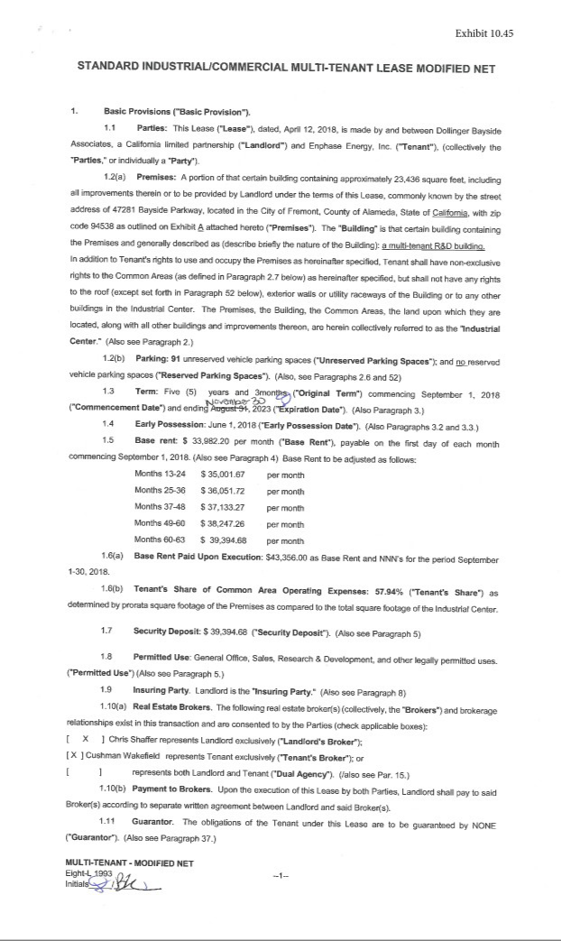

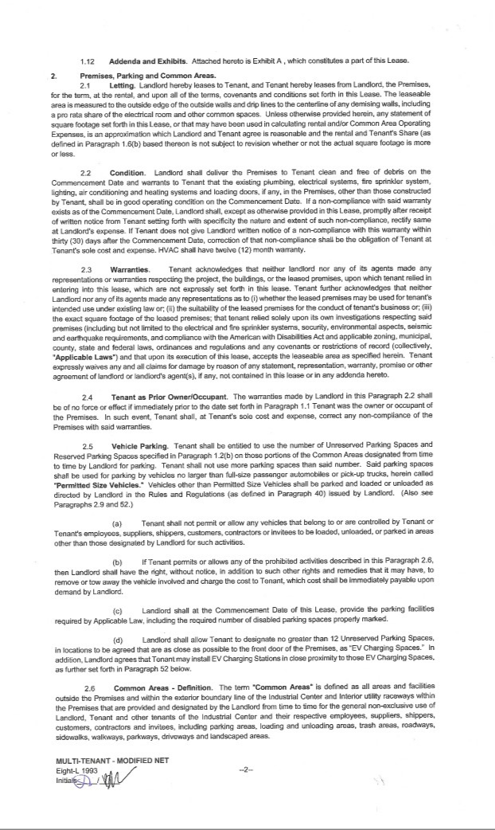

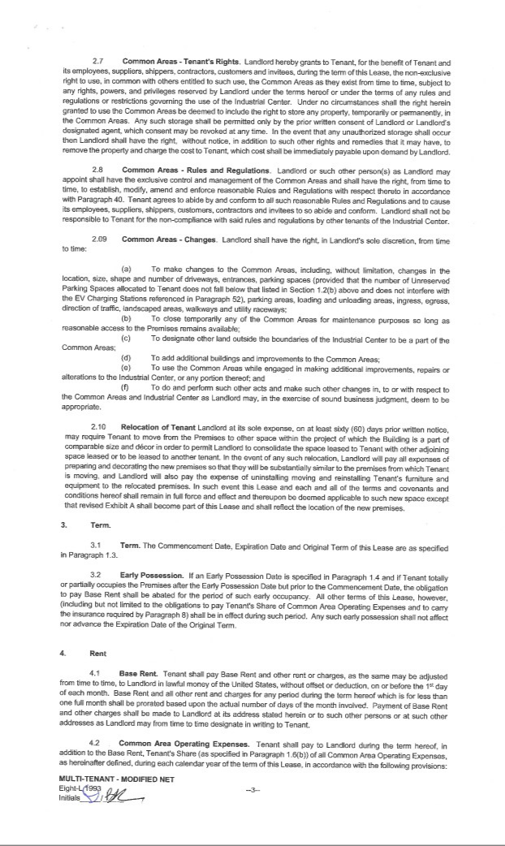

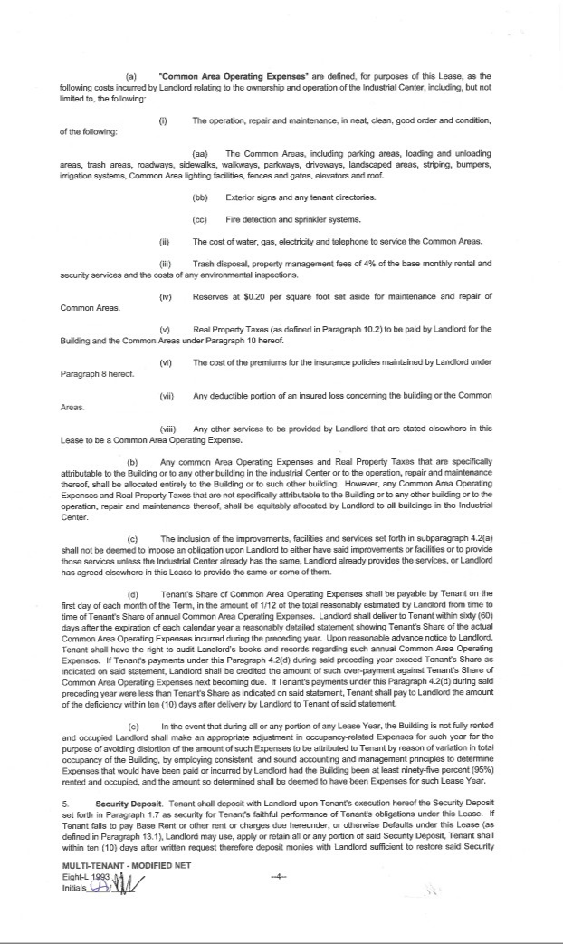

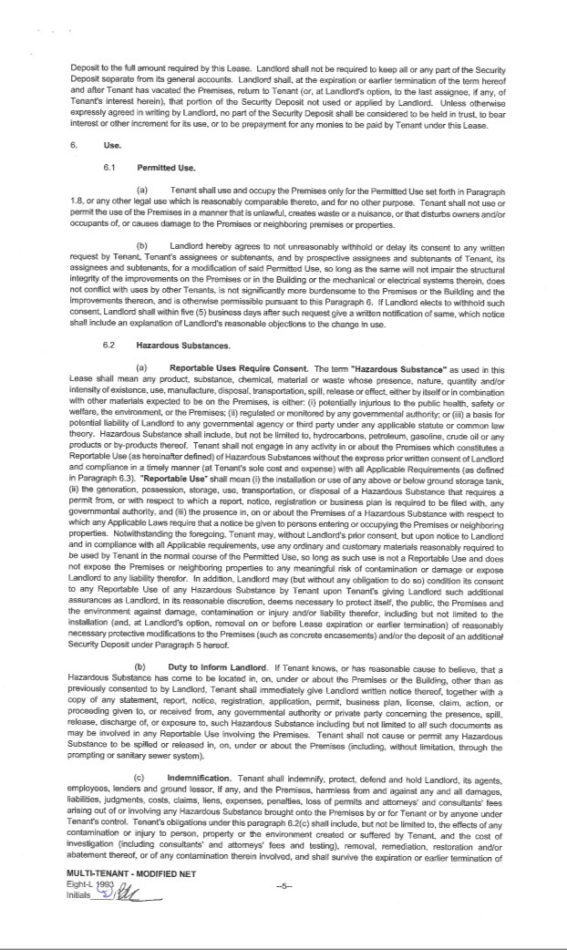

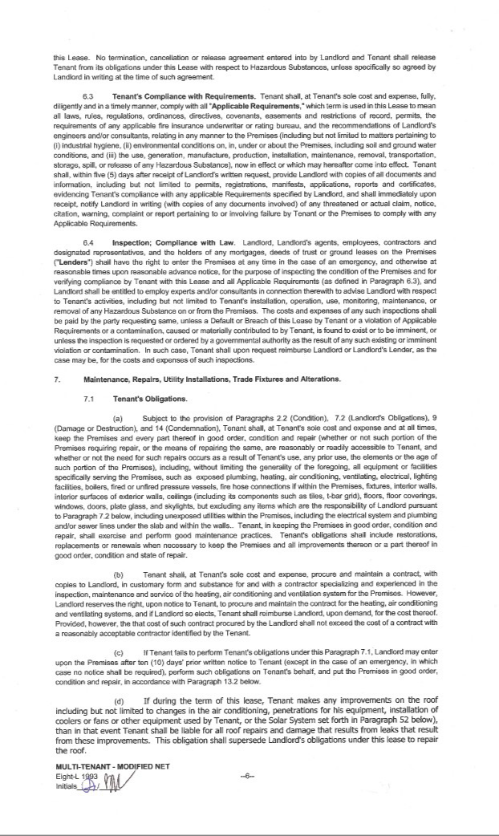

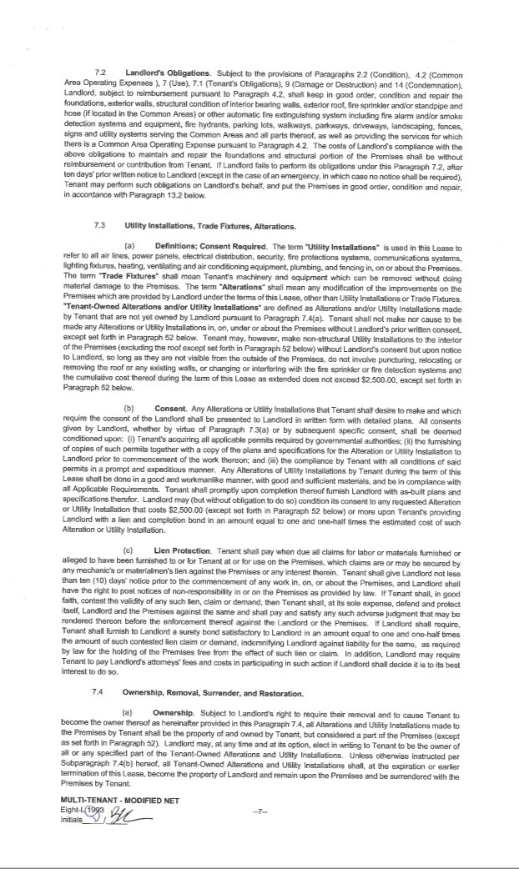

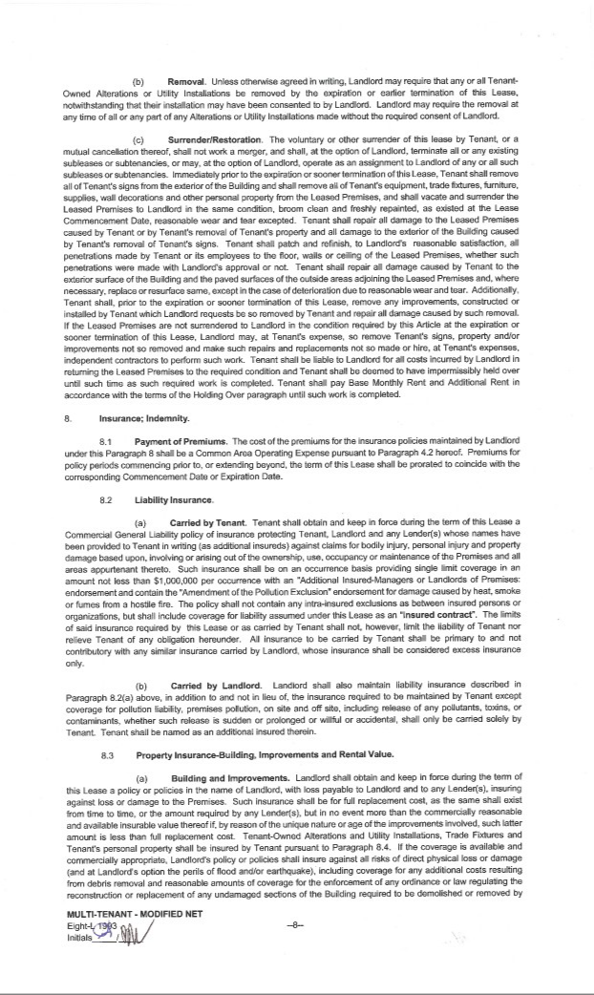

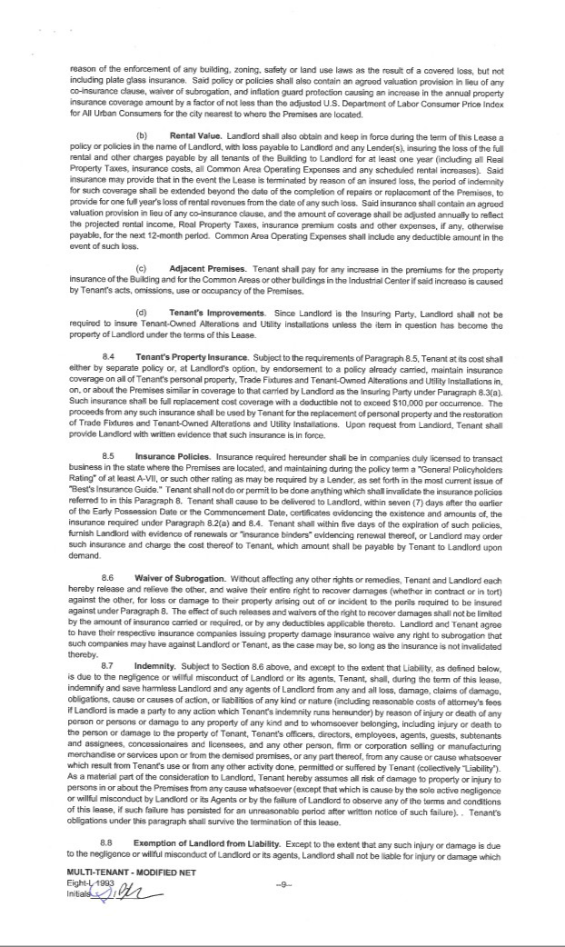

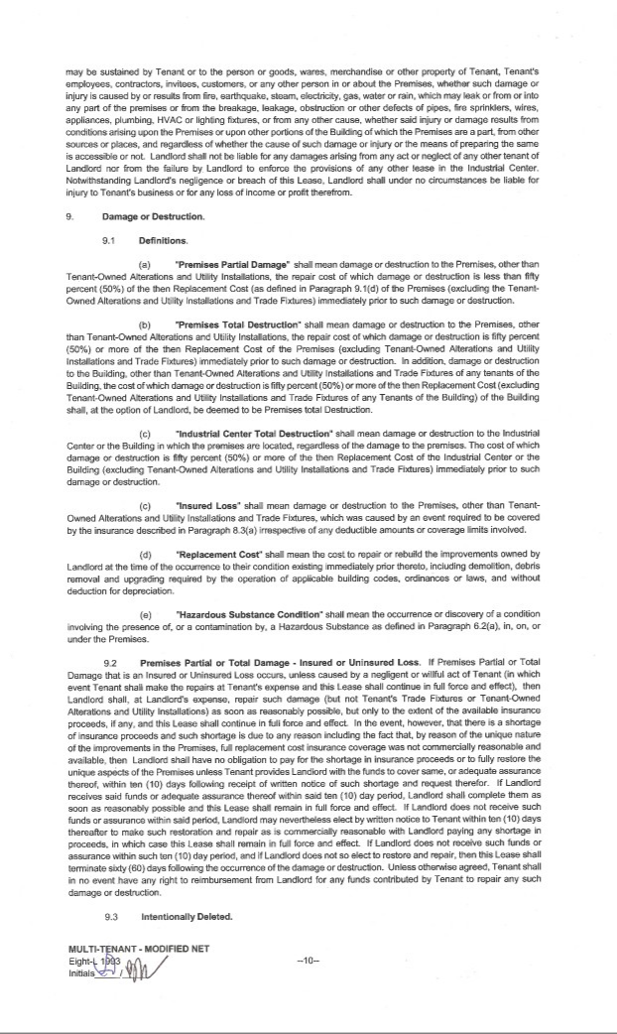

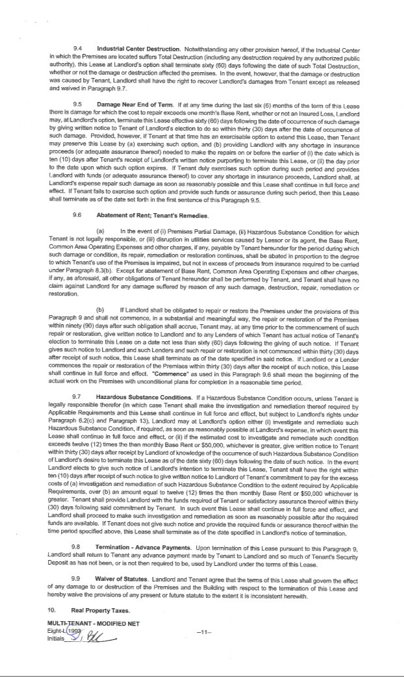

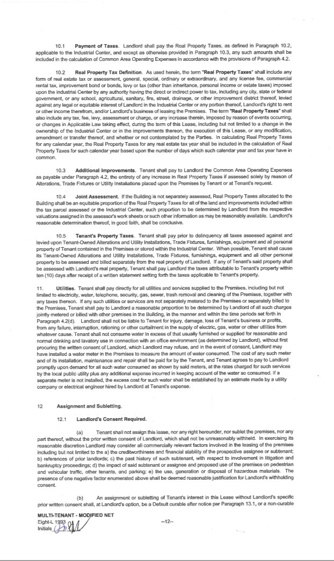

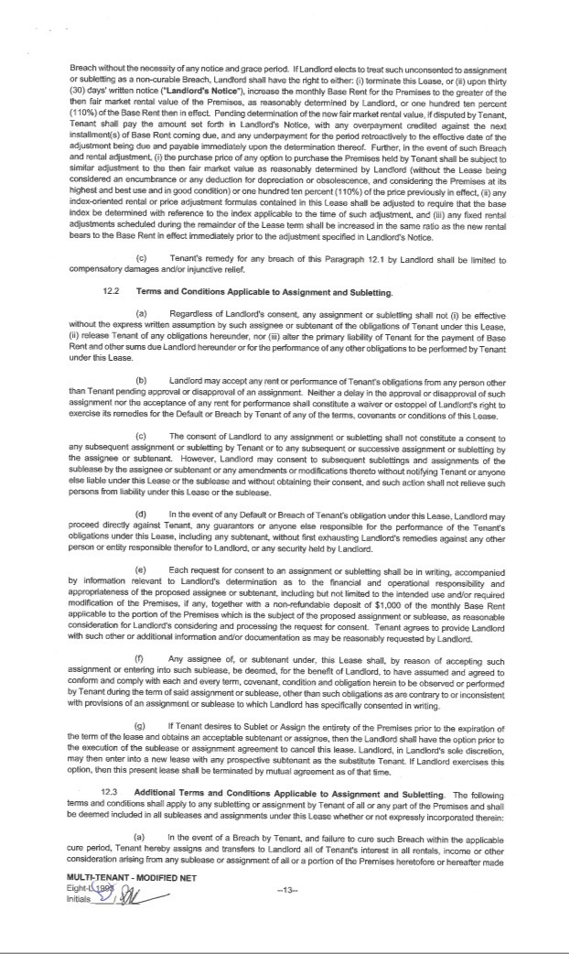

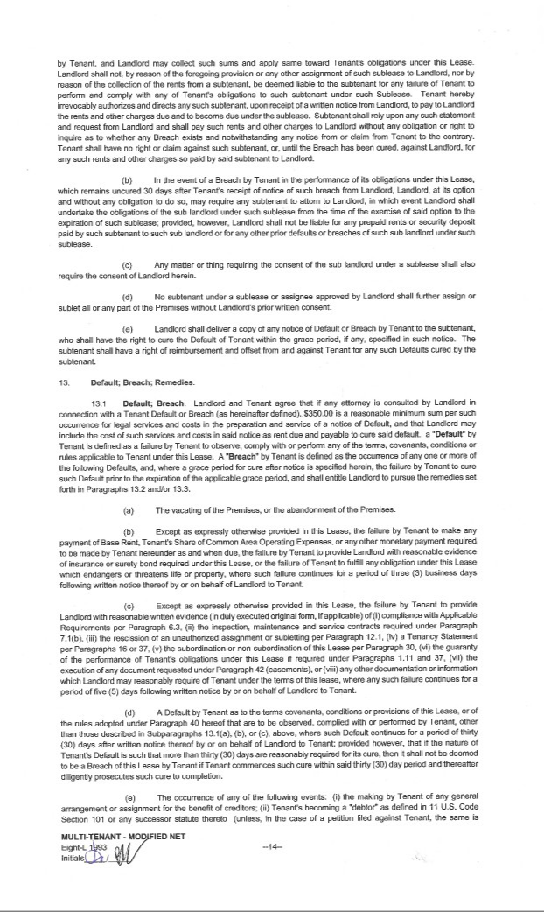

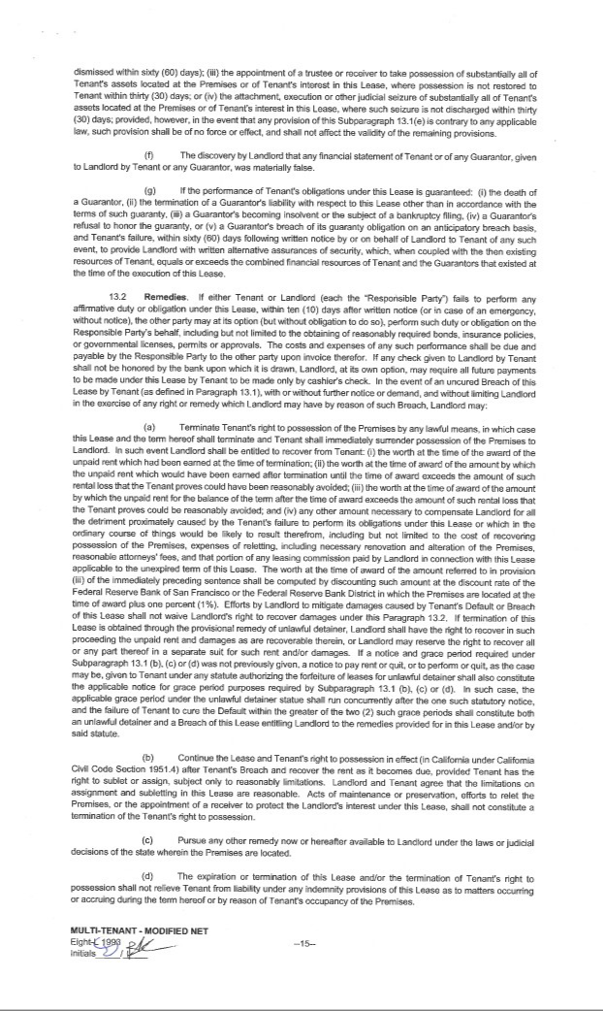

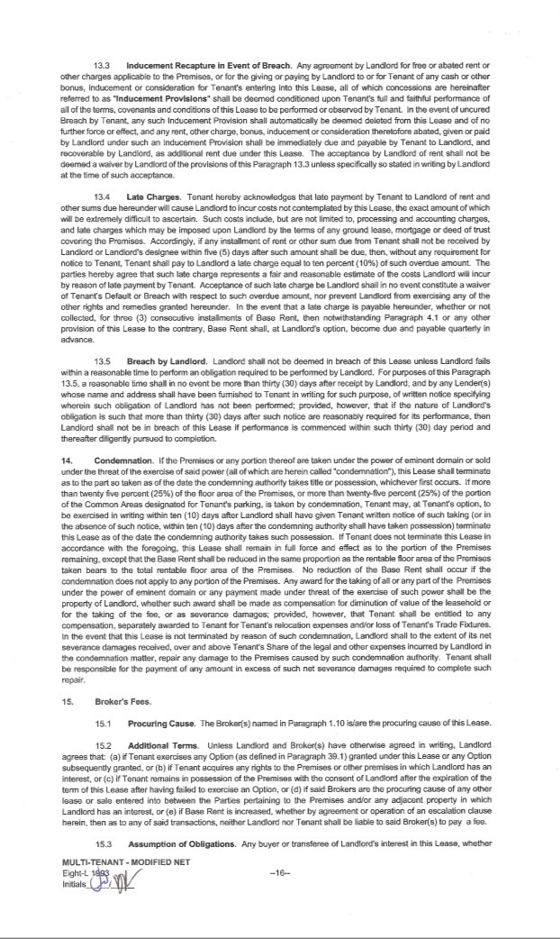

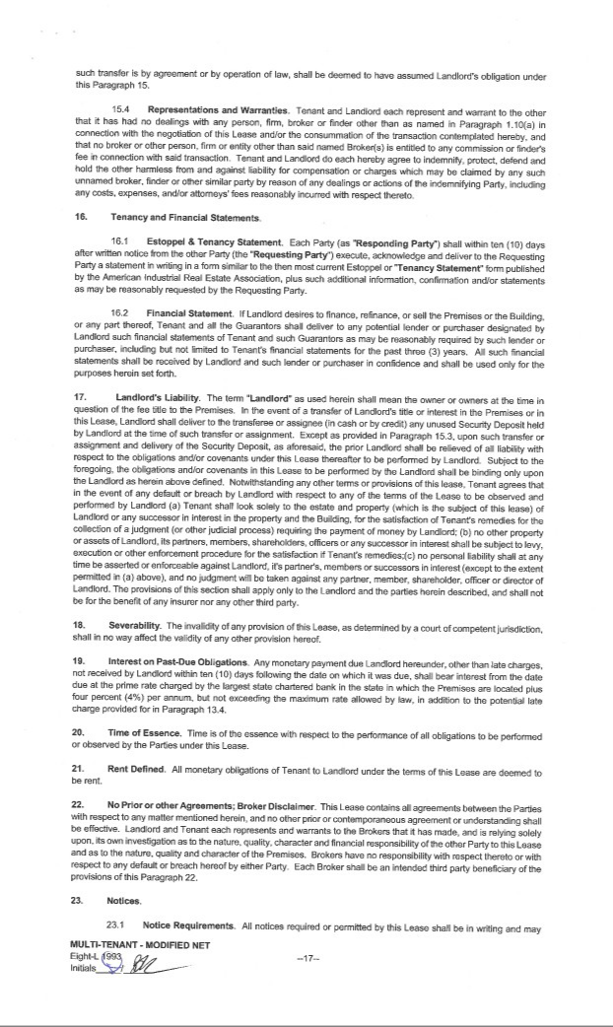

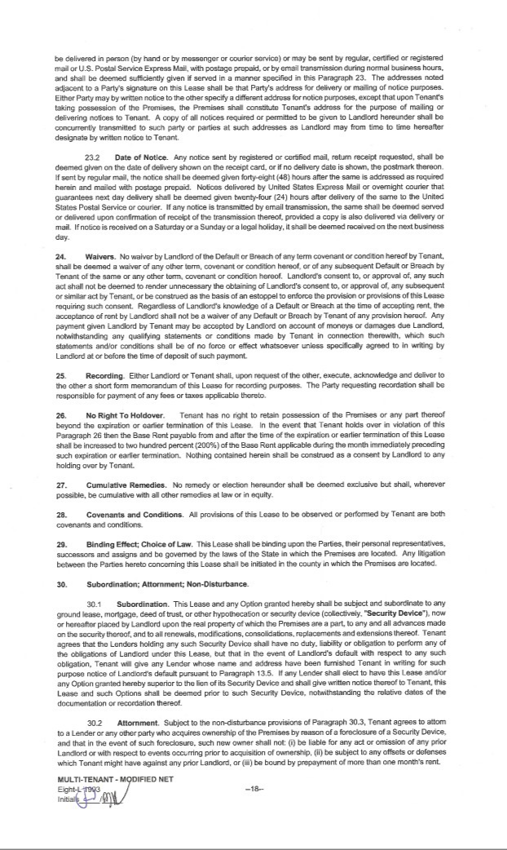

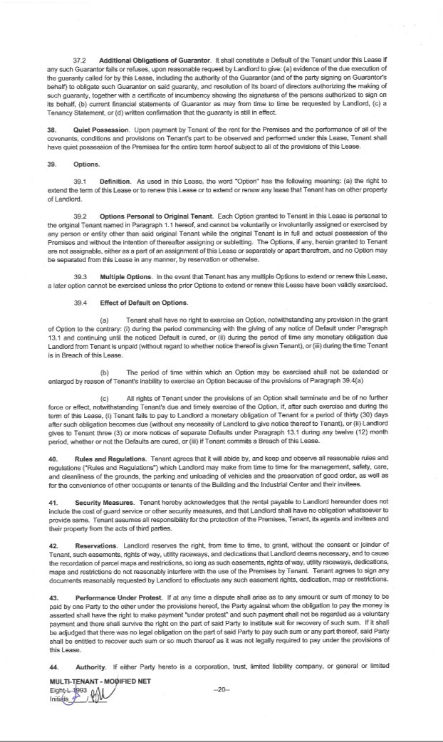

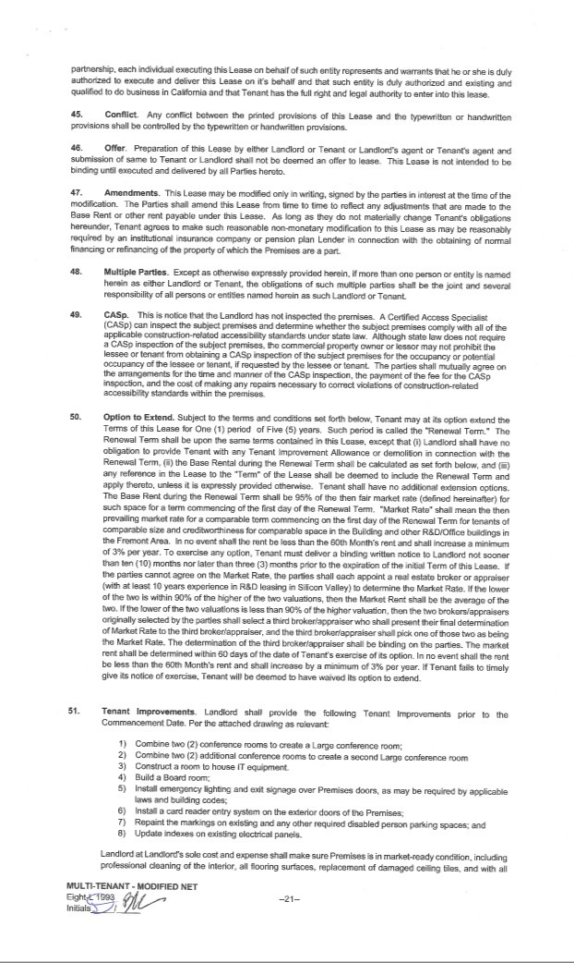

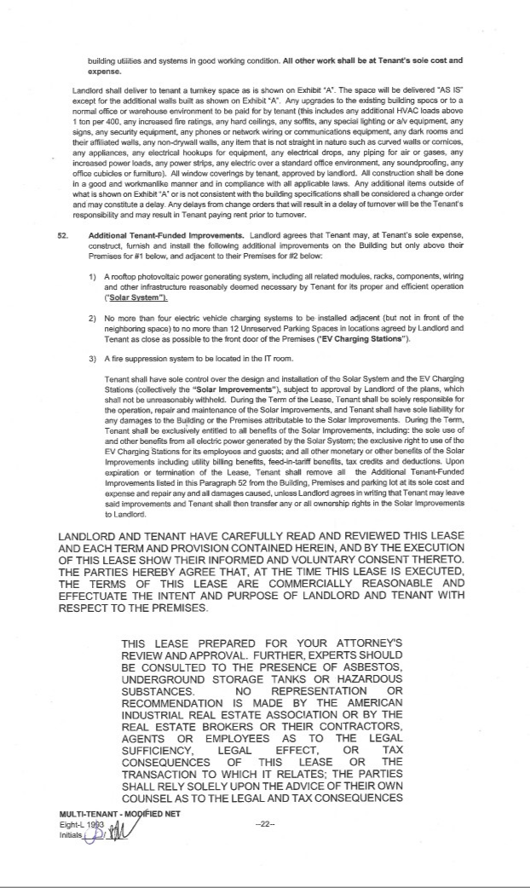

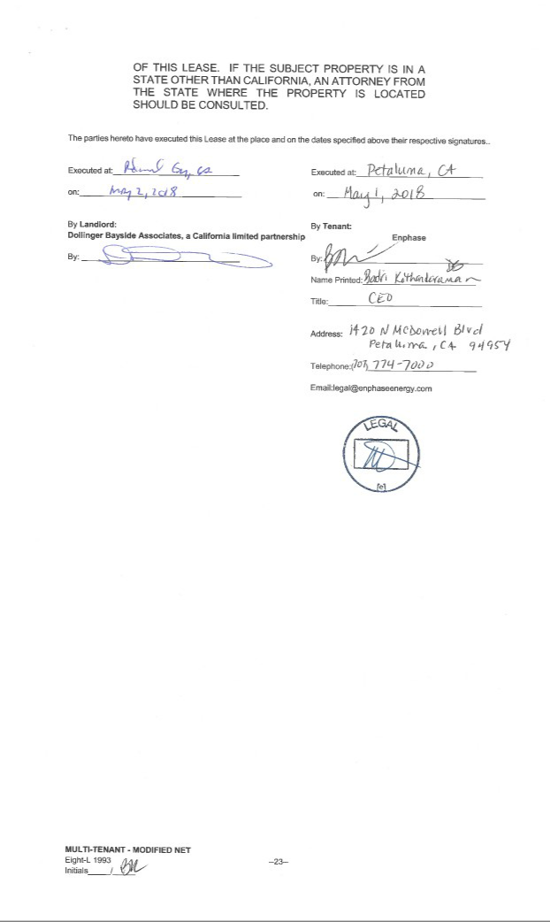

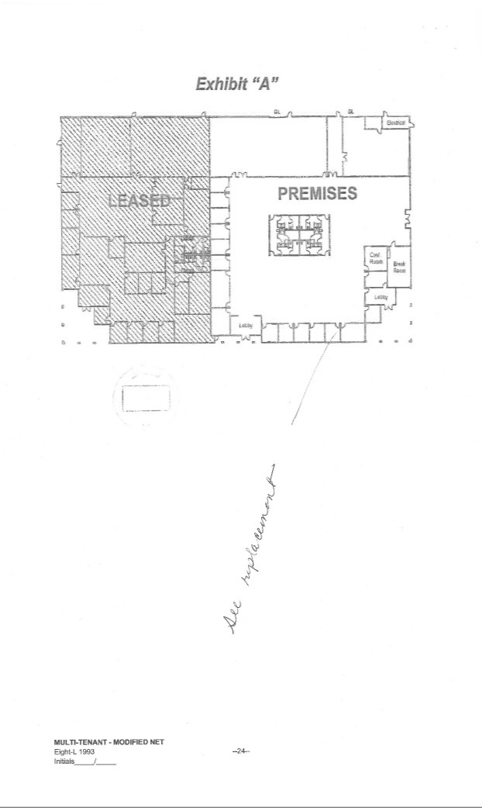

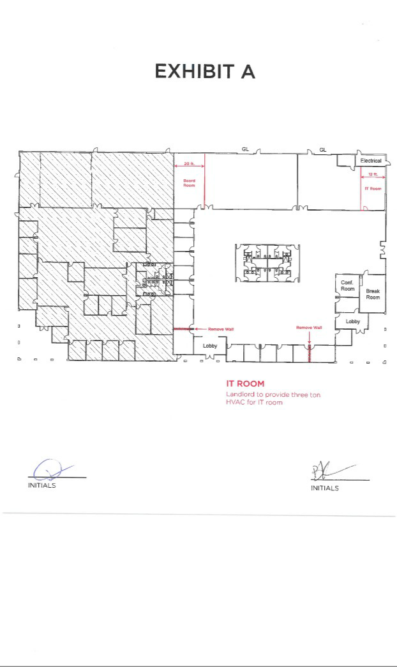



Exhibit 21.1

SUBSIDIARIES OF REGISTRANT

Enphase Energy Australia Pty. Ltd., an Australian corporation.

Enphase Energy Canada, Inc., a Canadian corporation.

Enphase Energy S.A.S., a French corporation.

Enphase Energy NL B.V., a Dutch private limited liability company.

Enphase Energy New Zealand Limited, a New Zealand corporation.

Enphase International LLC, a Delaware corporation.

Enphase Solar Energy Private Limited, an Indian private company.

Exhibit 23.1

CONSENT OF INDEPENDENT REGISTERED PUBLIC ACCOUNTING FIRM

We consent to the incorporation by reference in Registration Statement Nos. 333-216886, 333-209315 and 333-195694 on Form S-3 and Registration Statement Nos. 333-216986, 333-210037, 333-202630, 333-194749, 333-187057, and 333-181382 on Form S-8 of our report dated March 15, 2019, relating to (1) the 2018 financial statements of Enphase Energy, Inc. (which report expresses an unqualified opinion and includes an explanatory paragraph relating to the Company’s adoption of a new accounting standard), and (2) the effectiveness of the Enphase Energy Inc.’s internal control over financial reporting as of December 31, 2018, appearing in this Annual Report on Form 10-K of Enphase Energy, Inc. for the year ended December 31, 2018.

/s/ DELOITTE & TOUCHE LLP

San Francisco, California

March 15, 2019

Exhibit 31.1

CERTIFICATION

I, Badrinarayanan Kothandaraman, certify that:

- I have reviewed this Form 10-K of Enphase Energy, Inc.;

- Based on my knowledge, this report does not contain any untrue statement of a material fact or omit to state a material fact necessary to make the statements made, in light of the circumstances under which such statements were made, not misleading with respect to the period covered by this report;

- Based on my knowledge, the financial statements, and other financial information included in this report, fairly present in all material respects the financial condition, results of operations and cash flows of the registrant as of, and for, the periods presented in this report;

- The registrant’s other certifying officer(s) and I are responsible for establishing and maintaining disclosure controls and procedures (as defined in Exchange Act Rules 13a-15(e) and 15d-15(e)) and internal control over financial reporting (as defined in Exchange Act Rules
13a-15(f) and 15(d)-15(f)) for the registrant and have:

  - designed such disclosure controls and procedures, or caused such disclosure controls and procedures to be designed under our supervision, to ensure that material information relating to the registrant, including its consolidated subsidiaries, is made known to us by others within those entities, particularly during the period in which this report is being prepared;

  - designed such internal control over financial reporting, or caused such internal control over financial reporting to be designed under our supervision, to provide reasonable assurance regarding the reliability of financial reporting and the preparation of financial statements for external purposes in accordance with generally accepted accounting principles;

  - evaluated the effectiveness of the registrant's disclosure controls and procedures and presented in this report our conclusions about the effectiveness of the disclosure controls and procedures, as of the end of the period covered by this report based on such evaluation; and

  - disclosed in this report any change in the registrant's internal control over financial reporting that occurred during the registrant's most recent fiscal quarter (the registrant's fourth fiscal quarter in the case of an annual report) that has materially affected, or is reasonably likely to materially affect, the registrant's internal control over financial reporting; and

- The registrant’s other certifying officer(s) and I have disclosed, based on our most recent evaluation of internal control over financial reporting, to the registrant’s auditors and the audit committee of the registrant’s board of directors (or persons performing the equivalent functions):

  - All significant deficiencies and material weaknesses in the design or operation of internal control over financial reporting which are reasonably likely to adversely affect the registrant’s ability to record, process, summarize and report financial information; and

  - Any fraud, whether or not material, that involves management or other employees who have a significant role in the registrant’s internal control over financial reporting.

Date: March 15, 2019

/s/ BADRINARAYANAN KOTHANDARAMAN

Badrinarayanan Kothandaraman

President and Chief Executive Officer
(Principal Executive Officer)

Exhibit 31.2

CERTIFICATION

I, Eric Branderiz, certify that:

- I have reviewed this Form 10-K of Enphase Energy, Inc.;

- Based on my knowledge, this report does not contain any untrue statement of a material fact or omit to state a material fact necessary to make the statements made, in light of the circumstances under which such statements were made, not misleading with respect to the period covered by this report;

- Based on my knowledge, the financial statements, and other financial information included in this report, fairly present in all material respects the financial condition, results of operations and cash flows of the registrant as of, and for, the periods presented in this report;

- The registrant’s other certifying officer(s) and I are responsible for establishing and maintaining disclosure controls and procedures (as defined in Exchange Act Rules 13a-15(e) and 15d-15(e)) and internal control over financial reporting (as defined in Exchange Act Rules
13a-15(f) and 15(d)-15(f)) for the registrant and have:

  - designed such disclosure controls and procedures, or caused such disclosure controls and procedures to be designed under our supervision, to ensure that material information relating to the registrant, including its consolidated subsidiaries, is made known to us by others within those entities, particularly during the period in which this report is being prepared;

  - designed such internal control over financial reporting, or caused such internal control over financial reporting to be designed under our supervision, to provide reasonable assurance regarding the reliability of financial reporting and the preparation of financial statements for external purposes in accordance with generally accepted accounting principles;

  - evaluated the effectiveness of the registrant's disclosure controls and procedures and presented in this report our conclusions about the effectiveness of the disclosure controls and procedures, as of the end of the period covered by this report based on such evaluation; and

  - disclosed in this report any change in the registrant's internal control over financial reporting that occurred during the registrant's most recent fiscal quarter (the registrant's fourth fiscal quarter in the case of an annual report) that has materially affected, or is reasonably likely to materially affect, the registrant's internal control over financial reporting; and

- The registrant’s other certifying officer(s) and I have disclosed, based on our most recent evaluation of internal control over financial reporting, to the registrant’s auditors and the audit committee of the registrant’s board of directors (or persons performing the equivalent functions):

  - All significant deficiencies and material weaknesses in the design or operation of internal control over financial reporting which are reasonably likely to adversely affect the registrant’s ability to record, process, summarize and report financial information; and

  - Any fraud, whether or not material, that involves management or other employees who have a significant role in the registrant’s internal control over financial reporting.

Date: March 15, 2019

/s/ ERIC BRANDERIZ

Eric Branderiz

Vice President and Chief Financial Officer
(Principal Financial Officer)

Exhibit 32.1

CERTIFICATION

Pursuant to the requirement set forth in Rule 13a-14(b) of the Securities Exchange Act of 1934, as amended, (the “Exchange Act”) and Section 1350 of Chapter 63 of Title 18 of the United States Code (18 U.S.C. §1350), Badrinarayanan Kothandaraman, President and Chief Executive Officer of Enphase Energy, Inc. (the “Company”), and Eric Branderiz, Vice President and Chief Financial Officer of the Company, each hereby certifies that, to the best of his or her knowledge:

- The Company’s Annual Report on Form 10-K for the period ended December 31, 2018, to which this Certification is attached as Exhibit 32.1 (the “Periodic Report”), fully complies with the requirements of Section 13(a) or Section 15(d) of the Exchange Act; and

- The information contained in the Periodic Report fairly presents, in all material respects, the financial condition and results of operations of the Company.

In Witness Whereof, the undersigned have set their hands hereto as of the 15th day of March, 2019.

/s/ BADRINARAYANAN KOTHANDARAMAN |  | /s/ ERIC BRANDERIZ
Badrinarayanan Kothandaraman |  | Eric Branderiz
President and Chief Executive Officer |  | Vice President and Chief Financial Officer

This certification accompanies the Form 10-K to which it relates, is not deemed filed with the Securities and Exchange Commission and is not to be incorporated by reference into any filing of Enphase Energy, Inc. under the Securities Act of 1933, as amended, or the Securities Exchange Act of 1934, as amended (whether made before or after the date of the Form 10-K), irrespective of any general incorporation language contained in such filing.

