UNITED STATES

SECURITIES AND EXCHANGE COMMISSION

Washington, D.C. 20549

Form 10-Q

(Mark One)

- QUARTERLY REPORT PURSUANT TO SECTION 13 OR 15(d) OF THE SECURITIES EXCHANGE ACT OF 1934 For the quarterly period ended June 30, 2019

or

- TRANSITION REPORT PURSUANT TO SECTION 13 OR 15(d) OF THE SECURITIES EXCHANGE ACT OF 1934

For the transition period from | to
Commission File Number: 001-35480


 |  |  |  | Enphase Energy, Inc.
 |  |  |  | (Exact name of registrant as specified in its charter)
Delaware |  |  |  |  |  |  | 20-4645388
(State or other jurisdiction of incorporation or organization) |  |  |  |  |  |  | (I.R.S. Employer Identification No.)
 |  |  |  | 47281 Bayside Parkway
 |  |  |  | Fremont, CA 94538
 |  |  | (Address of principal executive offices, including zip code)
 |  | (707) 774-7000
 |  |  |  | (Registrant’s telephone number, including area code)
 |  |  |  | Not Applicable
 |  | (Former name, former address and former fiscal year, if changed since last report)
Securities registered pursuant to Section 12(b) of the Act:
Title of each class |  |  |  | Trading Symbol(s) |  |  |  | Name of each exchange on which registered
Common Stock, $0.00001 par value per share |  |  |  | ENPH |  |  |  | NASDAQ Global Market

Indicate by check mark whether the registrant (1) has filed all reports required to be filed by Section 13 or 15(d) of the Securities Exchange Act of 1934 during the preceding 12 months (or for such shorter period that the registrant was required to file such reports), and (2) has been subject to such filing requirements for the past 90 days. Yes ☒ No ☐

Indicate by check mark whether the registrant has submitted electronically every Interactive Data File required to be submitted pursuant to Rule 405 of Regulation S-T (§232.405 of this chapter) during the preceding 12 months (or for such shorter period that the registrant was required to submit such files). Yes ☒ No ☐

Indicate by check mark whether the registrant is a large accelerated filer, an accelerated filer, a non-accelerated filer, a smaller reporting company, or an “emerging growth company.” See the definitions of “large accelerated filer,” “accelerated filer, ” “smaller reporting company,” and “emerging growth company” in Rule 12b-2 of the Exchange Act:

Large accelerated filer | ☐ | Accelerated filer | ☒
Non-accelerated filer | ☐ | Smaller reporting company | ☐
 |  | Emerging growth company | ☐

If an emerging growth company, indicate by check mark if the registrant has elected not to use the extended transition period for complying with any new or revised financial accounting standards provided pursuant to Section 13(a) of the Exchange Act. ☐

Indicate by check mark whether the registrant is a shell company (as defined in Rule 12b-2 of the Exchange Act). Yes ☐ No ☒ As of July 23, 2019, there were 121,974,905 shares of the registrant’s common stock outstanding, $0.00001 par value per share.

ENPHASE ENERGY, INC.

FORM 10-Q FOR THE QUARTERLY PERIOD ENDED JUNE 30, 2019

TABLE OF CONTENTS

 |  | Page
 | PART I. FINANCIAL INFORMATION
Item 1. | Financial Statements (Unaudited) | 1
 | Condensed Consolidated Balance Sheets | 1
 | Condensed Consolidated Statements of Operations | 2
 | Condensed Consolidated Statements of Comprehensive Income (Loss) | 3
 | Condensed Consolidated Statements of Stockholders’ Equity (Deficit) | 4
 | Condensed Consolidated Statements of Cash Flows | 5
 | Notes to Condensed Consolidated Financial Statements | 6
Item 2. | Management’s Discussion and Analysis of Financial Condition and Results of Operations | 25
Item 3. | Quantitative and Qualitative Disclosures About Market Risk | 33
Item 4. | Controls and Procedures | 33
 | PART II. OTHER INFORMATION
Item 1. | Legal Proceedings | 34
Item 1A. | Risk Factors | 34
Item 2. | Unregistered Sales of Equity Securities and Use of Proceeds | 36
Item 3. | Defaults Upon Senior Securities | 36
Item 4. | Mine Safety Disclosures | 36
Item 5. | Other Information | 36
Item 6. | Exhibits | 37
 | Signature | 38

Table of Contents

PART I. FINANCIAL INFORMATION

Item 1. Financial Statements (Unaudited)

ENPHASE ENERGY, INC.

CONDENSED CONSOLIDATED BALANCE SHEETS

(In thousands, except par value)

(Unaudited)

 |  | June 30, |  |  | December 31,
 |  | 2019 |  |  | 2018
ASSETS
Current assets:
Cash and cash equivalents | $ | 205,959 |  | $ | 106,237
Accounts receivable, net |  | 97,537 |  |  | 78,938
Inventory |  | 20,094 |  |  | 16,267
Prepaid expenses and other assets |  | 26,261 |  |  | 20,860
Total current assets |  | 349,851 |  |  | 222,302
Property and equipment, net |  | 21,532 |  |  | 20,998
Operating lease, right of use asset |  | 12,304 |  |  | —
Intangible assets, net |  | 32,943 |  |  | 35,306
Goodwill |  | 24,783 |  |  | 24,783
Other assets |  | 40,105 |  |  | 36,548
Total assets | $ | 481,518 |  | $ | 339,937
LIABILITIES AND STOCKHOLDERS’ EQUITY
Current liabilities:
Accounts payable | $ | 65,989 |  | $ | 48,794
Accrued liabilities |  | 33,536 |  |  | 29,010
Deferred revenues, current |  | 33,577 |  |  | 33,119
Warranty obligations, current |  | 7,468 |  |  | 8,083
Debt, current |  | 3,043 |  |  | 28,155
Total current liabilities |  | 143,613 |  |  | 147,161
Long-term liabilities:
Deferred revenues, noncurrent |  | 82,288 |  |  | 76,911
Warranty obligations, noncurrent |  | 25,526 |  |  | 23,211
Other liabilities |  | 12,930 |  |  | 3,250
Debt, noncurrent |  | 99,890 |  |  | 81,628
Total liabilities |  | 364,247 |  |  | 332,161
Commitments and contingent liabilities (Note 9)
Stockholders’ equity:
Preferred stock, $0.00001 par value, 10,000 shares authorized; none issued and outstanding |  | — |  |  | —
Common stock, $0.00001 par value, 150,000 shares and 150,000 shares authorized; and 121,950 shares and 107,035 shares issued and outstanding at
June 30, 2019 and December 31, 2018, respectively |  | 1 |  |  | 1
Additional paid-in capital |  | 449,802 |  |  | 353,335
Accumulated deficit |  | (332,946) |  |  | (346,302)
Accumulated other comprehensive income |  | 414 |  |  | 742
Total stockholders’ equity |  | 117,271 |  |  | 7,776
Total liabilities and stockholders’ equity | $ | 481,518 |  | $ | 339,937

See Notes to Condensed Consolidated Financial Statements.

Enphase Energy, Inc. | Q2 2019 Form 10-Q | 1

Table of Contents

ENPHASE ENERGY, INC.

CONDENSED CONSOLIDATED STATEMENTS OF OPERATIONS

(In thousands, except per share data)

(Unaudited)

 |  | Three Months Ended |  |  |  |  |  | Six Months Ended
 |  | June 30, |  |  |  |  |  | June 30,
 | 2019 |  |  |  | 2018 |  |  | 2019 |  |  | 2018
Net revenues | $ | 134,094 |  | $ | 75,896 |  | $ | 234,244 |  | $ | 145,868
Cost of revenues |  | 88,775 |  |  | 53,195 |  |  | 155,586 |  |  | 104,851
Gross profit |  | 45,319 |  |  | 22,701 |  |  | 78,658 |  |  | 41,017
Operating expenses:
Research and development |  | 9,604 |  |  | 9,462 |  |  | 18,128 |  |  | 17,082
Sales and marketing |  | 9,054 |  |  | 6,828 |  |  | 16,487 |  |  | 13,055
General and administrative |  | 8,583 |  |  | 6,969 |  |  | 18,463 |  |  | 13,913
Restructuring charges |  | 631 |  |  | — |  |  | 999 |  |  | —
Total operating expenses |  | 27,872 |  |  | 23,259 |  |  | 54,077 |  |  | 44,050
Income (loss) from operations |  | 17,447 |  |  | (558) |  |  | 24,581 |  |  | (3,033)
Other expense, net
Interest income |  | 593 |  |  | 154 |  |  | 804 |  |  | 247
Interest expense |  | (1,351) |  |  | (2,423) |  |  | (5,102) |  |  | (4,809)
Other expense, net |  | (5,480) |  |  | (572) |  |  | (5,961) |  |  | (698)
Total other expense, net |  | (6,238) |  |  | (2,841) |  |  | (10,259) |  |  | (5,260)
Income (loss) before income taxes |  | 11,209 |  |  | (3,399) |  |  | 14,322 |  |  | (8,293)
Provision for income taxes |  | (591) |  |  | (339) |  |  | (939) |  |  | (573)
Net income (loss) | $ | 10,618 |  | $ | (3,738) |  | $ | 13,383 |  | $ | (8,866)
Net income (loss) per share:
Basic | $ | 0.09 |  | $ | (0.04) |  | $ | 0.12 |  | $ | (0.09)
Diluted | $ | 0.08 |  | $ | (0.04) |  | $ | 0.11 |  | $ | (0.09)
Shares used in per share calculation:
Basic |  | 113,677 |  |  | 97,321 |  |  | 110,951 |  |  | 94,026
Diluted |  | 130,737 |  |  | 97,321 |  |  | 129,400 |  |  | 94,026

See Notes to Condensed Consolidated Financial Statements.

Enphase Energy, Inc. | Q2 2019 Form 10-Q | 2

Table of Contents

ENPHASE ENERGY, INC.

CONDENSED CONSOLIDATED STATEMENTS OF COMPREHENSIVE INCOME (LOSS)

(In thousands)

(Unaudited)

 |  | Three Months Ended |  |  |  |  |  | Six Months Ended
 |  | June 30, |  |  |  |  |  | June 30,
 | 2019 |  |  |  | 2018 |  |  | 2019 |  |  | 2018
Net income (loss) | $ | 10,618 |  | $ | (3,738) |  | $ | 13,383 |  | $ | (8,866)
Other comprehensive income (loss):
Foreign currency translation adjustments |  | (249) |  |  | 15 |  |  | (328) |  |  | 303
Comprehensive income (loss) | $ | 10,369 |  | $ | (3,723) |  | $ | 13,055 |  | $ | (8,563)

See Notes to Condensed Consolidated Financial Statements.

Enphase Energy, Inc. | Q2 2019 Form 10-Q | 3

Table of Contents

ENPHASE ENERGY, INC.

CONDENSED CONSOLIDATED STATEMENTS OF STOCKHOLDER’S EQUITY (DEFICIT)

(In thousands)

(Unaudited)

 |  |  | Three Months Ended |  |  |  |  |  | Six Months Ended
 |  |  | June 30, |  |  |  |  |  | June 30,
 |  |  | 2019 |  |  | 2018 |  |  | 2019 |  |  | 2018
Common stock and paid-in capital
Balance, beginning of period |  | $ | 357,024 |  | $ | 309,020 |  | $ | 353,336 |  | $ | 287,257
Cumulative-effect adjustment to additional paid in capital⁽¹⁾ and other |  |  | 1 |  |  | — |  |  | 27 |  |  | —
Common stock issued under equity incentive and stock purchase plans, net |  |  | 223 |  |  | 1,254 |  |  | 532 |  |  | 1,523
Conversion of convertible notes due 2023, net |  |  | 58,857 |  |  | — |  |  | 58,857 |  |  | —
Equity component of convertible notes due 2024, net |  |  | 35,089 |  |  | — |  |  | 35,089 |  |  | —
Cost of convertible notes hedge related to the convertible notes due 2024 |  |  | (36,313) |  |  | — |  |  | (36,313) |  |  | —
Sale of warrants related to the convertible notes due 2024 |  |  | 29,818 |  |  | — |  |  | 29,818 |  |  | —
Issuance of common stock, net |  |  | — |  |  | (152) |  |  | — |  |  | 19,771
Stock-based compensation expense and other |  |  | 5,104 |  |  | 3,657 |  |  | 8,457 |  |  | 5,228
Balance, end of period |  | $ | 449,803 |  | $ | 313,779 |  | $ | 449,803 |  | $ | 313,779
Retained earnings
Balance, beginning of period |  | $ | (343,563) |  | $ | (339,803) |  | $ | (346,302) |  | $ | (295,727)
Cumulative-effect adjustment to accumulated deficit⁽¹⁾ and other |  |  | (1) |  |  | — |  |  | (27) |  |  | (38,948)
Net income (loss) |  |  | 10,618 |  |  | (3,738) |  |  | 13,383 |  |  | (8,866)
Balance, end of period |  | $ | (332,946) |  | $ | (343,541) |  | $ | (332,946) |  | $ | (343,541)
Accumulated other comprehensive income (loss)
Balance, beginning of period |  | $ | 663 |  | $ | (368) |  | $ | 742 |  | $ | (656)
Foreign currency translation adjustments |  |  | (249) |  |  | 15 |  |  | (328) |  |  | 303
Balance, end of period |  | $ | 414 |  | $ | (353) |  | $ | 414 |  | $ | (353)
Total stockholders' equity (deficit), ending balance |  | $ | 117,271 |  | $ | (30,115) |  | $ | 117,271 |  | $ | (30,115)

- Includes the adoption of Accounting Standards Update (“ASU”) 2018-07, “Compensation - Stock Compensation: Improvements to Non-employee Share-Based Payment Accounting” on January 1, 2019 and the adoption of Accounting Standards Codification (“ASC”) No. 606, “Revenue Recognition” on January 1, 2018.

See Notes to Condensed Consolidated Financial Statements.

Enphase Energy, Inc. | Q2 2019 Form 10-Q | 4

Table of Contents

ENPHASE ENERGY, INC.

CONDENSED CONSOLIDATED STATEMENTS OF CASH FLOWS

(In thousands)

(Unaudited)

Six Months Ended

June 30,

 | 2019 |  |  |  | 2018
Cash flows from operating activities:
Net income (loss) | $ | 13,383 |  | $ | (8,866)
Adjustments to reconcile net income (loss) to net cash provided by operating activities:
Depreciation and amortization |  | 7,694 |  |  | 4,469
Provision for doubtful accounts |  | 207 |  |  | 753
Non-cash interest expense |  | 2,266 |  |  | 1,133
Financing fees on extinguishment of debt |  | 2,152 |  |  | —
Fees paid for repurchase and exchange of convertible notes due 2023 |  | 6,000 |  |  | —
Stock-based compensation |  | 8,224 |  |  | 5,860
Changes in operating assets and liabilities:
Accounts receivable |  | (19,104) |  |  | 5,897
Inventory |  | (3,827) |  |  | 8,528
Prepaid expenses and other assets |  | (9,568) |  |  | (1,551)
Accounts payable, accrued and other liabilities |  | 16,805 |  |  | (3,817)
Warranty obligations |  | 1,699 |  |  | 1,826
Deferred revenues |  | 5,904 |  |  | (6,791)
Net cash provided by operating activities |  | 31,835 |  |  | 7,441
Cash flows from investing activities:
Purchases of property and equipment |  | (3,176) |  |  | (1,475)
Net cash used in investing activities |  | (3,176) |  |  | (1,475)
Cash flows from financing activities:
Issuance of convertible notes due 2024, net of issuance costs |  | 128,040 |  |  | —
Purchase of convertible note hedges |  | (36,313) |  |  | —
Sale of warrants |  | 29,819 |  |  | —
Fees paid for repurchase and exchange of convertible notes due 2023 |  | (6,000) |  |  | —
Principal payments and financing fees on debt |  | (45,122) |  |  | (3,129)
Proceeds from issuance of common stock, net of issuance costs |  | — |  |  | 19,923
Proceeds from debt, net of issuance costs |  | — |  |  | 5,580
Proceeds from issuance of common stock under employee stock plans, net |  | 532 |  |  | 1,370
Net cash provided by financing activities |  | 70,956 |  |  | 23,744
Effect of exchange rate changes on cash |  | 107 |  |  | (383)
Net increase in cash and cash equivalents |  | 99,722 |  |  | 29,327
Cash and cash equivalents—Beginning of period |  | 106,237 |  |  | 29,144
Cash and cash equivalents—End of period | $ | 205,959 |  | $ | 58,471
Supplemental disclosures of non-cash investing and financing activities:
Purchases of fixed assets included in accounts payable | $ | 1,194 |  | $ | 112
Accrued interest payable unpaid upon exchange of convertible notes due 2023 | $ | 833 |  | $ | —

See Notes to Condensed Consolidated Financial Statements.

Enphase Energy, Inc. | Q2 2019 Form 10-Q | 5

Table of Contents

ENPHASE ENERGY, INC.

NOTES TO CONDENSED CONSOLIDATED FINANCIAL STATEMENTS

(Unaudited)

- DESCRIPTION OF BUSINESS AND BASIS OF PRESENTATION

Description of Business

Enphase Energy, Inc. (the “Company”) is a global energy technology company. The Company delivers smart, easy-to-use solutions that connect solar generation, storage and management on one intelligent platform. The Company revolutionized the solar industry with its microinverter technology, and produces a fully-integrated solar plus storage solution.

Basis of Presentation and Consolidation

The accompanying condensed consolidated financial statements are presented in accordance with accounting principles generally accepted in the United States (“U.S.”), or GAAP. The condensed consolidated financial statements include the accounts of the Company and its wholly-owned subsidiaries. All intercompany balances and transactions have been eliminated in consolidation. The year-end condensed consolidated balance sheet data was derived from audited financial statements but does not include all disclosures required by accounting principles generally accepted in the U.S. The Company filed audited consolidated financial statements, which included all information and notes necessary for such a complete presentation in conjunction with its Annual Report on Form 10-K filed with the Securities and Exchange Commission (the “SEC”) on March 15, 2019 (“Form 10‑K”).

Unaudited Interim Financial Information

These accompanying unaudited condensed consolidated financial statements have been prepared pursuant to the rules and regulations of the SEC for interim financial reporting. In the opinion of management, these unaudited condensed consolidated financial statements reflect all adjustments, consisting of normal recurring items, considered necessary to present fairly the Company’s financial condition, results of operations, comprehensive income (loss), stockholders’ equity (deficit) and cash flows for the interim periods indicated. The results of operations for the three and six months ended June 30, 2019 are not necessarily indicative of the operating results for the full year.

Use of Estimates

The preparation of financial statements in conformity with GAAP requires management to make estimates and assumptions that affect the reported amounts of assets and liabilities, disclosure of contingent assets and liabilities at the date of the financial statements and the reported amounts of income and expenses during the reporting period. Significant estimates and assumptions reflected in the financial statements include revenue recognition, inventory valuation, accrued warranty obligations, and incremental borrowing rate for right-of-use assets and lease liability. These estimates are based on information available as of the date of the financial statements; therefore, actual results could differ materially from management’s estimates using different assumptions or under different conditions.

Summary of Significant Accounting Policies

Except for the accounting policies for leases, updated as a result of adopting new accounting standard related to leases, there have been no significant changes to the Company’s significant accounting policies in Note 2. “Summary of Significant Accounting Policies,” of the notes to consolidated financial statements included in Item 8 of the Company’s Form 10-K.

Leases

The Company determines if an arrangement is or contains a lease at inception. Operating lease assets represent the Company’s right to use an underlying asset for the lease term and lease liabilities represent the Company’s obligation to make lease payments over the lease term.

Enphase Energy, Inc. | Q2 2019 Form 10-Q | 6

Table of Contents

ENPHASE ENERGY, INC.

NOTES TO CONDENSED CONSOLIDATED FINANCIAL STATEMENTS

(Unaudited)

Operating lease assets and liabilities are recognized based on the present value of the remaining lease payments discounted using the Company’s incremental borrowing rate. Operating lease assets also include initial direct costs incurred and prepaid lease payments, minus any lease incentives. The Company’s lease terms include options to extend or terminate the lease when it is reasonably certain that the Company will exercise that option. Lease expense is recognized on a straight-line basis over the lease term.

The Company combines the lease and non-lease components in determining the operating lease assets and liabilities.

Recently Adopted Accounting Pronouncements

In February 2016, the Financial Accounting Standards Board (“FASB”) issued Accounting Standards Update (“ASU”) 2016-02, “Leases (Topic 842).” ASU 2016-02 requires an entity to recognize a right-of-use asset and lease liability for all leases with terms of more than 12 months. The guidance requires lessees to recognize all leases, with certain exceptions, on their balance sheets, whether operating or financing, while continuing to recognize the expenses on their income statements in a manner similar to current practice. The guidance states that a lessee must recognize a lease liability for the obligation to make lease payments and a right-to-use asset for the right to use the underlying asset for the lease term. On January 1, 2019, the Company adopted ASU 2016-02 using the modified retrospective transition option of applying the new standard at the adoption date for all leases with terms greater than 12 months. The Company elected certain practical expedients upon adoption and as such did not reassess the following: 1) whether any expired or existing contracts are or contain leases; 2) lease classification for any expired or existing leases; 3) initial direct costs for any expired or existing leases; 4) whether existing or expired land easements are or contain leases; and 5) regarding the lease term, from a hindsight perspective, whether or not the Company is reasonably certain to exercise the lease options. However, the Company will evaluate new or modified land easements under the new guidance after the commencement date. The Company also elected the practical expedient to not separate lease and non-lease components. The adoption of ASU 2016-02 on January 1, 2019 resulted in an increase in operating leases, right of use asset of $8.4 million, an increase in other liabilities of $6.8 million, an increase in accrued liabilities and other of $1.5 million and a decrease in other assets of $0.1 million on the Company’s consolidated balance sheets with no impact on the Company’s consolidated statements of operations.

In June 2018, the FASB issued ASU 2018-07, “Compensation - Stock Compensation: Improvements to Non-employee Share-Based Payment Accounting.” ASU 2018-07 was issued to provide guidance on share-based payments granted to non-employees in exchange for goods or services used or consumed in an entity’s own operations and supersedes the guidance in ASC 505-50, “Equity-Based Payments to Non-Employees.” ASU 2018-07 aligns much of the guidance on measuring and classifying non-employee awards with that of awards to employees. The Company adopted ASU 2018-07 on January 1, 2019 using the modified retrospective basis. The adopted standard did not have a material impact on the consolidated financial statements.

Recently Issued Accounting Pronouncements Not Yet Effective

In August 2018, the FASB issued ASU 2018-15, “Customer’s Accounting for Implementation Costs Incurred in a Cloud Computing Arrangement That Is a Service Contract,” to reduce diversity in practice in accounting for the costs of implementing cloud computing arrangements that are service contracts. ASU 2018-15 allows entities to apply the guidance in the ASC 350-40, “Intangibles–Goodwill and Other–Internal-Use Software,” to determine which implementation costs are eligible to be capitalized as assets in a cloud computing arrangement that is considered a service contract. ASU 2018-15 is effective for fiscal years beginning after December 15, 2019, and interim periods within those fiscal years. Early adoption is permitted, including adoption in any interim period. Entities have the option to apply the guidance prospectively to all implementation costs incurred after the date of adoption or retrospectively and are required to make certain disclosures in the interim and annual period of adoption. The Company is currently evaluating the impact this update will have on its consolidated financial statements.

Enphase Energy, Inc. | Q2 2019 Form 10-Q | 7

Table of Contents

ENPHASE ENERGY, INC.

NOTES TO CONDENSED CONSOLIDATED FINANCIAL STATEMENTS

(Unaudited)

2. | REVENUE RECOGNITION
Disaggregated Revenue
 | The Company has one business activity, which is the design, manufacture and sale of solutions for the solar photovoltaic (“PV”) industry. Disaggregated revenue by primary
geographical market and timing of revenue recognition for the Company’s single product line are as follows:
 |  |  | Three Months Ended |  |  |  |  |  |  | Six Months Ended
 |  |  | June 30, |  |  |  |  |  |  | June 30,
 |  |  | 2019 |  |  | 2018 | 2019 |  |  |  |  |  | 2018
 |  |  |  |  |  | (In thousands)
Primary geographical markets:
 | United States | $ | 99,909 |  | $ | 50,258 | $ |  |  | 177,595 |  | $ | 93,388
 | International |  | 34,185 |  |  | 25,638 |  |  |  | 56,649 |  |  | 52,480
 | Total | $ | 134,094 |  | $ | 75,896 | $ |  |  | 234,244 |  | $ | 145,868
Timing of revenue recognition:
 | Products delivered at a point in time | $ | 124,336 |  | $ | 65,937 | $ |  |  | 214,736 |  | $ | 125,308
 | Products and services delivered over time |  | 9,758 |  |  | 9,959 |  |  |  | 19,508 |  |  | 20,560
 | Total | $ | 134,094 |  | $ | 75,896 | $ |  |  | 234,244 |  | $ | 145,868
Contract Balances
 | Receivables, and contract assets and contract liabilities from contracts with customers are as follows:
 |  |  |  |  |  |  |  |  | June 30, |  |  |  | December 31,
 |  |  |  |  |  |  | 2019 |  |  |  |  |  | 2018
 |  |  |  |  |  |  |  |  |  | (In thousands)
Receivables |  |  |  |  |  |  | $ |  |  | 97,537 |  | $ | 78,938
Short-term contract assets (Prepaid expenses and other assets) |  |  |  |  |  |  |  |  |  | 13,900 |  |  | 13,516
Long-term contract assets (Other assets) |  |  |  |  |  |  |  |  |  | 36,418 |  |  | 34,148
Short-term contract liabilities (Deferred revenues) |  |  |  |  |  |  |  |  |  | 33,577 |  |  | 33,119
Long-term contract liabilities (Deferred revenues) |  |  |  |  |  |  |  |  |  | 82,288 |  |  | 76,911

The Company receives payments from customers based upon contractual billing schedules. Accounts receivable are recorded when the right to consideration becomes unconditional. Contract assets include deferred product costs and commissions associated with the deferred revenue and will be amortized along with the associated revenue. The Company had no asset impairment charges related to contract assets in the three and six months ended June 30, 2019. Contract liabilities are recorded as deferred revenue on the accompanying condensed consolidated balance sheets and include payments received in advance of performance obligations under the contract and are realized when the associated revenue is recognized under the contract.

Significant changes in the balances of contract assets (prepaid expenses and other assets) and contract liabilities (deferred revenues) during the period are as follows (in thousands):

Contract Assets
Balance on December 31, 2018 | $ | 47,664
Amount recognized |  | (7,283)
Increase |  | 9,937
Balance as of June 30, 2019 | $ | 50,318

Enphase Energy, Inc. | Q2 2019 Form 10-Q | 8

Table of Contents

 | ENPHASE ENERGY, INC.
 | NOTES TO CONDENSED CONSOLIDATED FINANCIAL STATEMENTS
 | (Unaudited)
Contract Liabilities
Balance on December 31, 2018 | $ |  | 110,030
Revenue recognized |  |  | (19,508)
Increase due to billings |  |  | 25,343
Balance as of June 30, 2019 | $ |  | 115,865

Remaining Performance Obligations

Estimated revenue expected to be recognized in future periods related to performance obligations that are unsatisfied or partially unsatisfied at the end of the reporting period are as follows:

 |  | June 30,
 |  | 2019
 |  | (In thousands)
Fiscal year:
2019 (remaining six months) | $ | 18,305
2020 |  | 29,968
2021 |  | 23,773
2022 |  | 18,741
2023 |  | 12,948
Thereafter |  | 12,130
Total | $ | 115,865

- OTHER FINANCIAL INFORMATION

Accounts Receivable, Net

Accounts receivable, net consist of the following:

June 30, | December 31,
2019 | 2018
 | (In thousands)

Accounts receivable

Allowance for doubtful accounts

Accounts receivable, net

Inventory

Inventory consist of the following:

$ | 99,881 |  | $ | 81,076
 | (2,344) |  |  | (2,138)
$ | 97,537 |  | $ | 78,938

June 30, | December 31,
2019 | 2018
 | (In thousands)

Raw materials | $ | 1,090 |  | $ | 970
Finished goods |  | 19,004 |  |  | 15,297
Total inventory | $ | 20,094 |  | $ | 16,267

Enphase Energy, Inc. | Q2 2019 Form 10-Q | 9

Table of Contents

ENPHASE ENERGY, INC.

NOTES TO CONDENSED CONSOLIDATED FINANCIAL STATEMENTS

(Unaudited)

Accrued Liabilities

Accrued liabilities consist of the following:

 | June 30, |  |  |  | December 31,
 | 2019 |  |  |  | 2018
 |  | (In thousands)
Salaries, commissions, incentive compensation and benefits | $ | 4,559 |  | $ | 4,107
Customer rebates and sales incentives |  | 10,243 |  |  | 8,527
Freight |  | 9,371 |  |  | 7,286
Other |  | 9,363 |  |  | 9,090
Total accrued liabilities | $ | 33,536 |  | $ | 29,010

- GOODWILL AND INTANGIBLE ASSETS

The Company’s goodwill and purchased intangible assets as of June 30, 2019 and December 31, 2018 are as follows:

 |  |  |  |  | June 30, 2019 |  |  |  |  |  |  |  | December 31, 2018
 | Gross |  |  |  | Accumulated Amortization |  |  | Net |  |  | Gross |  | Accumulated Amortization |  |  | Net
 |  |  |  |  |  |  |  | (In thousands)
Goodwill | $ | 24,783 |  | $ | — |  | $ | 24,783 |  | $ | 24,783 | $ | — |  | $ | 24,783
Intangible assets:
Other indefinite-lived
intangibles | $ | 286 |  | $ | — |  | $ | 286 |  | $ | 286 | $ | — |  | $ | 286
Intangible assets with finite
lives:
Patents and licensed
technology |  | 1,665 |  |  | (1,665) |  |  | — |  |  | 1,665 |  | (1,665) |  |  | —
Developed technology |  | 13,100 |  |  | (2,000) |  |  | 11,100 |  |  | 13,100 |  | (909) |  |  | 12,191
Customer relationships |  | 23,100 |  |  | (1,543) |  |  | 21,557 |  |  | 23,100 |  | (271) |  |  | 22,829
Total purchased intangible | $ | 38,151 |  | $ | (5,208) |  | $ | 32,943 |  | $ | 38,151 | $ | (2,845) |  | $ | 35,306
assets | $ | 38,151 |  | $ | (5,208) |  | $ | 32,943 |  |  |  |  |  |  | $ | 35,306

In August 2018, the Company acquired certain finite-lived intangible assets in its acquisition of SunPower Corporation’s (“SunPower”) microinverter business pursuant to an Asset Purchase Agreement (“APA”), primarily developed technology and customer relationships. See Note 20. “Acquisition,” of the notes to consolidated financial statements included in Item 8 of the Company’s Form 10-K for additional information related to this acquisition.

Amortization expense related to finite-lived intangible assets are as follows:

 |  | Three Months Ended |  |  |  |  |  | Six Months Ended
 |  | June 30, |  |  |  |  |  | June 30,
 | 2019 |  |  | 2018 |  |  |  | 2019 |  |  | 2018
 |  |  |  |  | (In thousands)
Developed technology, and patents and licensed technology | $ | 546 |  | $ | 76 |  | $ | 1,092 |  | $ | 152
Customer relationships |  | 635 |  |  | — |  |  | 1,271 |  |  | —
Total amortization expense | $ | 1,181 |  | $ | 76 |  | $ | 2,363 |  | $ | 152

Enphase Energy, Inc. | Q2 2019 Form 10-Q | 10

Table of Contents

ENPHASE ENERGY, INC.

NOTES TO CONDENSED CONSOLIDATED FINANCIAL STATEMENTS

(Unaudited)

Amortization of developed technology, patents and licensed technology is primarily recorded to sales and marketing expense. The developed technology acquired from the Company’s acquisition of SunPower’s microinverter business is embedded in the microinverters that SunPower sells to its customers. The Company does not actively use the developed technology acquired from SunPower and holds the developed technology to prevent others from using it. Accordingly, the Company accounts for the developed technology as a defensive intangible asset and amortizes the associated value over a period of six years from the date of acquisition.

The master service agreement (“MSA”) negotiated with SunPower in August 2018 provides the Company with the exclusive right to supply SunPower with module level power electronics for a period of five years, with options for renewals. The exclusivity arrangement extends throughout the term of the MSA, which comprises all of the expected cash flows from the customer relationship intangible asset, and was a condition to, and was an essential part of the acquisition of SunPower’s microinverter business by the Company. As the fair value ascribed to the customer relationship intangible asset represents payments to a customer, the Company amortizes the value of the customer relationship intangible asset as a reduction to revenue using a pattern of economic benefit method over a useful life of nine years.

- WARRANTY OBLIGATIONS

The Company’s warranty activities were as follows:

 |  | Three Months Ended |  |  |  |  |  | Six Months Ended
 |  | June 30, |  |  |  |  |  | June 30,
 |  | 2019 |  |  | 2018 |  |  | 2019 |  |  | 2018
 |  |  |  |  | (In thousands)
Warranty obligations, beginning of period | $ | 31,042 |  | $ | 30,625 |  | $ | 31,294 |  | $ | 29,816
Accruals for warranties issued during period |  | 1,312 |  |  | 775 |  |  | 2,170 |  |  | 1,533
Changes in estimates |  | 699 |  |  | 1,378 |  |  | 1,503 |  |  | 2,828
Settlements |  | (2,206) |  |  | (2,099) |  |  | (4,502) |  |  | (3,775)
Increase due to accretion expense |  | 550 |  |  | 520 |  |  | 1,101 |  |  | 939
Other |  | 1,597 |  |  | 443 |  |  | 1,428 |  |  | 301
Warranty obligations, end of period |  | 32,994 |  |  | 31,642 |  |  | 32,994 |  |  | 31,642
Less: current portion |  | (7,468) |  |  | (8,275) |  |  | (7,468) |  |  | (8,275)
Noncurrent | $ | 25,526 |  | $ | 23,367 |  | $ | 25,526 |  | $ | 23,367

- FAIR VALUE MEASUREMENTS

The accounting guidance defines fair value as the price that would be received from selling an asset or paid to transfer a liability in an orderly transaction between market participants at the measurement date. When determining the fair value measurements for assets and liabilities recorded at fair value, the Company considers the principal or most advantageous market in which it would transact and considers assumptions that market participants would use when pricing the asset or liability, such as inherent risk, transfer restrictions, and risk of nonperformance.

The fair value hierarchy requires an entity to maximize the use of observable inputs and minimize the use of unobservable inputs when measuring fair value. An asset’s or liability’s categorization within the fair value hierarchy is based upon the lowest level of input that is significant to the fair value measurement. Three levels of inputs may be used to measure fair value:

- Level 1—Valuations based on quoted prices in active markets for identical assets or liabilities that the Company is able to access. Since valuations are based on quoted prices that are readily and regularly available in an active market, valuation of such assets or liabilities do not entail a significant degree of judgment.

- Level 2—Valuations based on one or more quoted prices in markets that are not active or for which all significant inputs are observable, either directly or indirectly.

Enphase Energy, Inc. | Q2 2019 Form 10-Q | 11

Table of Contents

ENPHASE ENERGY, INC.

NOTES TO CONDENSED CONSOLIDATED FINANCIAL STATEMENTS

(Unaudited)

- Level 3—Valuations based on inputs that are unobservable and significant to the overall fair value measurement.

The following table presents the Company’s liabilities that were measured at fair value on a recurring basis and its categorization within the fair value hierarchy.

 | Fair Value |  | June 30, |  |  | December 31,
 | Hierarchy |  | 2019 |  |  | 2018
 |  |  | (In thousands)
Warranty obligations
Current |  | $ | 4,298 |  | $ | 4,288
Non-current |  |  | 10,558 |  |  | 7,469
Total warranty obligations measured at fair value | Level 3 | $ | 14,856 |  | $ | 11,757

Fair Value Option for Warranty Obligations Related to Microinverters Sold Since January 1, 2014

The Company estimates the fair value of warranty obligations by calculating the warranty obligations in the same manner as for sales prior to January 1, 2014 and applying an expected present value technique to that result. The expected present value technique, an income approach, converts future amounts into a single current discounted amount. In addition to the key estimates of failure rates, claim rates and replacement costs, the Company used certain Level 3 inputs which are unobservable and significant to the overall fair value measurement. Such additional assumptions included a discount rate based on the Company’s credit-adjusted risk-free rate and compensation comprised of a profit element and risk premium required of a market participant to assume the obligation.

The following table provides information regarding changes in nonfinancial liabilities related to the Company’s warranty obligations measured at fair value on a recurring basis using significant unobservable inputs (Level 3) for the periods indicated.

 |  | Three Months Ended |  |  |  |  |  | Six Months Ended
 |  | June 30, |  |  |  |  |  | June 30,
 |  | 2019 |  |  | 2018 |  |  | 2019 |  |  | 2018
 |  |  |  |  | (In thousands)
Balance at beginning of period | $ | 12,065 |  | $ | 11,720 |  | $ | 11,757 |  | $ | 9,791
Accruals for warranties issued during period |  | 1,312 |  |  | 775 |  |  | 2,170 |  |  | 1,533
Changes in estimates |  | 519 |  |  | 210 |  |  | 860 |  |  | 1,995
Settlements |  | (1,188) |  |  | (831) |  |  | (2,460) |  |  | (1,722)
Increase due to accretion expense |  | 550 |  |  | 520 |  |  | 1,101 |  |  | 939
Other |  | 1,598 |  |  | 443 |  |  | 1,428 |  |  | 301
Balance at end of period | $ | 14,856 |  | $ | 12,837 |  | $ | 14,856 |  | $ | 12,837

Quantitative and Qualitative Information about Level 3 Fair Value Measurements

As of June 30, 2019 and December 31, 2018, the significant unobservable inputs used in the fair value measurement of the Company’s liabilities designated as Level 3 are as follows:

 |  |  |  |  |  |  | Percent Used
 |  |  |  |  |  |  | (Weighted Average)
 |  |  |  |  |  | June 30, |  |  | December 31,
Item Measured at Fair Value |  | Valuation Technique |  | Description of Significant Unobservable Input |  | 2019 |  |  | 2018
Warranty obligations for microinverters sold since |  | Discounted cash flows |  | Profit element and risk premium |  | 14% | 16%
January 1, 2014 |  |  |  | Credit-adjusted risk-free rate |  | 15% | 19%

Enphase Energy, Inc. | Q2 2019 Form 10-Q | 12

Table of Contents

ENPHASE ENERGY, INC.

NOTES TO CONDENSED CONSOLIDATED FINANCIAL STATEMENTS

(Unaudited)

Sensitivity of Level 3 Inputs - Warranty Obligations

Each of the significant unobservable inputs is independent of the other. The profit element and risk premium are estimated based on requirements of a third-party participant willing to assume the Company’s warranty obligations. The credit‑adjusted risk‑free rate (“discount rate”) is determined by reference to the Company’s own credit standing at the fair value measurement date. Increasing the profit element and risk premium input by 100 basis points would result in a $0.1 million increase to the liability. Decreasing the profit element and risk premium by 100 basis points would result in a $0.1 million reduction of the liability. Increasing the discount rate by 100 basis points would result in a $0.7 million reduction of the liability. Decreasing the discount rate by 100 basis points would result in a $0.8 million increase to the liability.

7. | RESTRUCTURING
 | Restructuring expense consist of the following:
 |  |  | Three Months Ended |  |  |  |  |  | Six Months Ended
 |  |  | June 30, |  |  |  |  |  | June 30,
 |  | 2019 |  |  | 2018 |  |  |  | 2019 |  |  | 2018
 |  |  |  |  |  | (In thousands)
Redundancy and employee severance and benefit arrangements |  | $ | 631 |  | $ | — |  | $ | 1,099 |  | $ | —
Lease loss reserves |  |  | — |  |  | — |  |  | (100) |  |  | —
 | Total restructuring charges | $ | 631 |  | $ | — |  | $ | 999 |  | $ | —

2018 Plan

In the third quarter of 2018, the Company began implementing restructuring actions (the “2018 Plan”) to lower its operating expenses. The restructuring actions include reorganization of the Company’s global workforce, elimination of certain non-core projects and consolidation of facilities. The Company expects to complete this restructuring in 2019.

The following table provides information regarding changes in the Company’s 2018 Plan accrued restructuring balance for the periods indicated.

 |  | Redundancy and
 | Employee Severance and |  |  | Lease Loss Reserves and
 |  | Benefits |  |  | Contractual Obligations |  |  | Total
 |  |  |  |  | (In thousands)
Balance as of December 31, 2018 | $ | 904 |  | $ | 288 |  | $ | 1,192
Charges |  | 1,099 |  |  | — |  |  | 1,099
Cash payments |  | (1,350) |  |  | — |  |  | (1,350)
Non-cash settlement and other |  | (395) |  |  | (288) |  |  | (683)
Balance as of June 30, 2019 | $ | 258 |  | $ | — |  | $ | 258

2016 Plan

In the third quarter of 2016, the Company began implementing restructuring actions (the “2016 Plan”) to lower its operating expenses. The restructuring actions have included reductions in the Company’s global workforce, the elimination of certain non-core projects, consolidation of office space at the Company’s corporate headquarters and the engagement of management consultants to assist the Company in making organizational and structural changes to improve operational efficiencies and reduce expenses. The Company completed its restructuring activities under the 2016 Plan in 2017.

Enphase Energy, Inc. | Q2 2019 Form 10-Q | 13

Table of Contents

ENPHASE ENERGY, INC.

NOTES TO CONDENSED CONSOLIDATED FINANCIAL STATEMENTS

(Unaudited)

The following table provides information regarding changes in the Company’s 2016 Plan accrued restructuring balance for the periods indicated.

Balance as of December 31, 2018

Other ⁽¹⁾

Balance as of June 30, 2019

Lease Loss Reserves and

Contractual Obligations

(In thousands)

- 1,591

(1,591)

- —

- Adoption of ASU 2016-02.

- DEBT

The following table provides information regarding the Company’s long-term debt.

 |  | June 30, |  |  | December 31,
 |  | 2019 |  |  | 2018
 |  | (In thousands)
Convertible notes
Notes due 2024 | $ | 132,000 |  | $ | —
Less: unamortized discount and issuance costs |  | (39,138) |  |  | —
Carrying amount of Notes due 2024 |  | 92,862 |  |  | —
Notes due 2023 |  | 5,000 |  |  | 65,000
Less: unamortized issuance costs |  | (162) |  |  | (2,361)
Carrying amount of Notes due 2023 |  | 4,838 |  |  | 62,639
Term loan |  | — |  |  | 41,524
Less: unamortized discount and issuance costs |  | — |  |  | (1,059)
Carrying amount of term loan |  | — |  |  | 40,465
Sale of long-term financing receivable recorded as debt |  | 5,233 |  |  | 6,679
Total carrying amount of debt |  | 102,933 |  |  | 109,783
Less: current portion term loan |  | — |  |  | (25,417)
Less: current portion of long-term financing receivable recorded as debt |  | (3,043) |  |  | (2,738)
Long-term debt | $ | 99,890 |  | $ | 81,628

Enphase Energy, Inc. | Q2 2019 Form 10-Q | 14

Table of Contents

ENPHASE ENERGY, INC.

NOTES TO CONDENSED CONSOLIDATED FINANCIAL STATEMENTS

(Unaudited)

Convertible Senior Notes due 2024

On June 5, 2019, the Company issued $132.0 million aggregate principal amount of 1.0% convertible senior notes due 2024 (the “Notes due 2024”). The Notes due 2024 are general unsecured obligations and bear interest at an annual rate of 1.0% per year, payable semi-annually on June 1 and December 1 of each year, beginning December 1, 2019. The Notes due 2024 are governed by an indenture between the Company and U.S. Bank National Association, as trustee. The Notes due 2024 will mature on June 1, 2024, unless earlier repurchased by the Company or converted at the option of the holders. The Company may not redeem the notes prior to the maturity date, and no sinking fund is provided for the notes. The Notes due 2024 may be converted, under certain circumstances as described below, based on an initial conversion rate of 48.7781 shares of common stock per $1,000 principal amount (which represents an initial conversion price of $20.5010 per share). The conversion rate for the Notes due 2024 will be subject to adjustment upon the occurrence of certain specified events but will not be adjusted for accrued and unpaid interest. In addition, upon the occurrence of a make-whole fundamental change (as defined in the relevant indenture), the Company will, in certain circumstances, increase the conversion rate by a number of additional shares for a holder that elects to convert its notes in connection with such make-whole fundamental change. The Company received approximately $128.0 million in net proceeds, after deducting the initial purchasers’ discount, from the issuance of the Notes due 2024.

The Notes due 2024 may be converted on any day prior to the close of business on the business day immediately preceding December 1, 2023, in multiples of

$1,000 principal amount, at the option of the holder under any of the following circumstances: (1) during any calendar quarter commencing after the calendar quarter ending on September 30, 2019 (and only during such calendar quarter), if the last reported sale price of the Company’s common stock for at least 20 trading days (whether or not consecutive) during a period of 30 consecutive trading days ending on, and including, the last trading day of the immediately preceding calendar quarter is greater than or equal to $26.6513 (130% of the conversion price) on each applicable trading day; (2) during the five business day period after any five consecutive trading day period (the “measurement period”) in which the “trading price” (as defined in the relevant indenture) per $1,000 principal amount of notes for each trading day of the measurement period was less than 98% of the product of the last reported sale price of the Company’s common stock and the conversion rate on each such trading day; or (3) upon the occurrence of specified corporate events. On and after December 1, 2023 until the close of business on the second scheduled trading day immediately preceding the maturity date of June 1, 2024, holders may convert their notes at any time, regardless of the foregoing circumstances. Upon the occurrence of a fundamental change (as defined in the relevant indenture), holders may require the Company to repurchase all or a portion of their Notes due 2024 for cash at a price equal to 100% of the principal amount of the notes to be repurchased plus any accrued and unpaid interest to, but excluding, the fundamental change repurchase date.

Upon conversion of any of the notes, the Company will pay or deliver, as the case may be, cash, shares of common stock or a combination of cash and common stock, at the Company’s election.

In accounting for the issuance of the Notes due 2024, on June 5, 2019, the Company separated the Notes due 2024 into liability and equity components. The carrying amount of the liability component of approximately $95.6 million was calculated by using a discount rate of 7.75%, which was the Company’s borrowing rate on the date of the issuance of the notes for a similar debt instrument without the conversion feature. The carrying amount of the equity component of approximately $36.4 million, representing the conversion option, was determined by deducting the fair value of the liability component from the par value of the Notes due 2024. The equity component of the Notes due 2024 is included in additional paid-in capital in the condensed consolidated balance sheet and is not remeasured as long as it continues to meet the conditions for equity classification. The difference between the principal amount of the Notes due 2024 and the liability component (the “debt discount”) is amortized to interest expense using the effective interest method over the term of the Notes due 2024.

Enphase Energy, Inc. | Q2 2019 Form 10-Q | 15

Table of Contents

ENPHASE ENERGY, INC.

NOTES TO CONDENSED CONSOLIDATED FINANCIAL STATEMENTS

(Unaudited)

Debt issuance costs for the issuance of the Notes due 2024 were approximately $4.6 million, consisting of initial purchasers' discount and other issuance costs. In accounting for the transaction costs, the Company allocated the total amount incurred to the liability and equity components using the same proportions as the proceeds from the Notes due 2024. Transaction costs attributable to the liability component were approximately $3.3 million, were recorded as debt issuance cost (presented as contra debt in the condensed consolidated balance sheet) and are being amortized to interest expense over the term of the Notes due 2024. The transaction costs attributable to the equity component were approximately $1.3 million and were netted with the equity component in stockholders’ equity. As of June 30, 2019, the unamortized deferred issuance cost for the Notes due 2024 was $3.3 million on the condensed consolidated balance sheet.

The following table presents the total amount of interest cost recognized relating to the Notes due 2024:

 |  | Three Months Ended |  |  | Six Months Ended
 |  | June 30, 2019 |  |  | June 30, 2019
 |  | (In thousands)
Contractual interest expense | $ | 92 |  | $ | 92
Amortization of debt discount |  | 416 |  |  | 416
Amortization of debt issuance costs |  | 45 |  |  | 45
Total interest cost recognized | $ | 553 |  | $ | 553

The effective interest rate on the liability component Notes due 2024 was 7.75% for each of the three and six months ended June 30, 2019, which remain unchanged from the date of issuance. The remaining unamortized debt discount was $35.9 million as of June 30, 2019, will be amortized over approximately 4.9 years.

Convertible Note Hedge and Warrant Transactions

In connection with the offering of the Notes due 2024, the Company entered into privately-negotiated convertible note hedge transactions pursuant to which the Company has the option to purchase a total of approximately 6.4 million shares of its common stock (subject to anti-dilution adjustments), which is the same number of shares initially issuable upon conversion of the notes, at a price of $20.5010 per share, which is the initial conversion price of the Notes due 2024. The total cost of the convertible note hedge transactions was approximately $36.3 million. The convertible note hedge transactions are expected generally to reduce potential dilution to the Company’s common stock upon any conversion of the Notes due 2024 and/or offset any cash payments the Company is required to make in excess of the principal amount of converted notes, as the case may be. As of June 30, 2019, the Company had not purchased any shares under the convertible note hedge transactions. Additionally, the Company separately entered into privately-negotiated warrant transactions (the “warrants”) whereby the Company sold warrants to acquire approximately 6.4 million shares of the Company’s common stock (subject to anti-dilution adjustments) at an initial strike price of $25.2320 per share. The Company received aggregate proceeds of approximately $29.8 million from the sale of the warrants. If the market value per share of the Company’s common stock, as measured under the warrants, exceeds the strike price of the warrants, the warrants will have a dilutive effect on the Company’s earnings per share, unless the Company elects, subject to certain conditions, to settle the warrants in cash. Taken together, the purchase of the convertible note hedges and the sale of the warrants are intended to reduce potential dilution from the conversion of the Notes due 2024 and to effectively increase the overall conversion price from $20.5010 to $25.2320 per share. As of June 30, 2019, the warrants had not been exercised and remained outstanding.

Given that the transactions meet certain accounting criteria, the convertible note hedge transactions and the warrants are recorded in stockholders’ equity, and they are not accounted for as derivatives and are not remeasured each reporting period.

Enphase Energy, Inc. | Q2 2019 Form 10-Q | 16

Table of Contents

ENPHASE ENERGY, INC.

NOTES TO CONDENSED CONSOLIDATED FINANCIAL STATEMENTS

(Unaudited)

Convertible Senior Notes due 2023

In August 2018, the Company sold $65.0 million aggregate principal amount of 4.0% convertible senior notes due 2023 (the “Notes due 2023”) in a private placement. On May 30, 2019, the Company entered into separately and privately negotiated transactions with certain holders of the Notes due 2023 resulting in the repurchase and exchange, as of June 5, 2019, of $60.0 million aggregate principal amount of the notes in consideration for the issuance of 10,801,080 shares of common stock and separate cash payments totaling $6.0 million. As of June 30, 2019, $5.0 million aggregate principal amount of the Notes due 2023 remain outstanding.

The remaining outstanding Notes due 2023 are general unsecured obligations and bear interest at a rate of 4.0% per year, payable semi-annually on February 1 and August 1 of each year. The Notes due 2023 are governed by an indenture between the Company and U.S. Bank National Association, as trustee. The remaining outstanding Notes due 2023 will mature on August 1, 2023, unless earlier repurchased by the Company or converted at the option of the holders. The Company may not redeem the remaining Notes due 2023 prior to the maturity date, and no sinking fund is provided for such notes. The remaining Notes due 2023 are convertible, at a holder’s election, in multiples of $1,000 principal amount, into shares of the Company’s common stock based on the applicable conversion rate. The initial conversion rate for such notes is 180.0180 shares of common stock per $1,000 principal amount of notes (which is equivalent to an initial conversion price of approximately $5.56 per share). The conversion rate and the corresponding conversion price are subject to adjustment upon the occurrence of certain events but will not be adjusted for any accrued and unpaid interest. Holders of the remaining Notes due 2023 who convert their notes in connection with a make-whole fundamental change (as defined in the applicable indenture) are, under certain circumstances, entitled to an increase in the conversion rate. Additionally, in the event of a fundamental change, holders of the remaining Notes due 2023 may require the Company to repurchase all or a portion of their notes at a price equal to 100% of the principal amount of notes, plus any accrued and unpaid interest, including any additional interest to, but excluding, the repurchase date. Holders may convert all or any portion of their Notes due 2023 at their option at any time prior to the close of business on the business day immediately preceding the maturity date, in multiples of $1,000 principal amount.

During the three and six months ended June 30, 2019, the Company recognized $6.0 million inducement cost in other expense, net on the Company’s condensed consolidated statement of operations and reclassed $2.0 million of deferred issuance costs, offset by $0.8 million in accrued interest in additional paid in capital on the Company’s condensed consolidated balance sheet as of June 30, 2019 related to the exchange of $60.0 million aggregate principal amount of the Notes due 2023 consummated by the Company on June 5, 2019.

The following table presents the amount of interest cost recognized relating to the contractual interest coupon and the amortization of debt issuance costs of the Notes due

2023.

 |  | Three Months Ended |  |  | Six Months Ended
 |  | June 30, 2019 |  |  | June 30, 2019
 |  | (In thousands)
Contractual interest expense | $ | 483 |  | $ | 1,133
Amortization of debt issuance costs |  | 96 |  |  | 225
Total interest costs recognized | $ | 579 |  | $ | 1,358

Term Loan

In July 2016, the Company entered into a Loan and Security Agreement (the “Original Term Loan Agreement”) with lenders that are affiliates of Tennenbaum Capital Partners, LLC. In February 2017, the Company entered into an Amended and Restated Loan and Security Agreement (the “Loan Agreement”) that amended and restated the Original Term Loan Agreement. The Loan Agreement provided for a $25.0 million secured term loan to the Company (the “New Term Loan”), which is in addition to the $25.0 million secured term loan borrowed by the Company under the Original Term Loan Agreement (together with the “New Term Loan” the “Term Loans”).

On January 28, 2019, the Company repaid in full the remaining principal amount of the Term Loans of approximately $39.5 million plus accrued interest and fees.

Enphase Energy, Inc. | Q2 2019 Form 10-Q | 17

Table of Contents

ENPHASE ENERGY, INC.

NOTES TO CONDENSED CONSOLIDATED FINANCIAL STATEMENTS

(Unaudited)

- COMMITMENTS AND CONTINGENT LIABILITIES

Operating Leases

The Company leases office facilities under noncancelable operating leases that expire on various dates through 2028, some of which may include options to extend the leases for up to 12 years.

The components of lease expense are presented as follows:

 |  | Three Months Ended |  | Six Months Ended
 |  | June 30, 2019 |  | June 30, 2019
 |  | (In thousands)
Operating lease costs | $ | 564 | $ | 1,063

The components of lease liabilities are presented as follows:

Operating lease liabilities, current (Accrued liabilities)

Operating lease liabilities, noncurrent (Other liabilities)

Total operating lease liabilities

Supplemental lease information:

Weighted average remaining lease term

Weighted average discount rate

June 30,

2019

(In thousands)

- 3,007

11,305

- 14,312

5.9 years

8.6%

Supplemental cash flow and other information related to operating leases, are as follows:

 |  | Three Months Ended |  | Six Months Ended
 |  | June 30, 2019 |  | June 30, 2019
 |  | (In thousands)
Cash paid for amounts included in the measurement of lease liabilities:
Operating cash flows from operating leases | $ | 857 | $ | 1,594
Non-cash investing activities:
Lease liabilities arising from obtaining right-of-use assets | $ | 4,834 | $ | 4,834

Undiscounted cash flows of operating lease liabilities as of June 30, 2019 are as follows:

 |  | Lease Amounts
 |  | (In thousands)
Year:
2019 (remaining six months) | $ | 2,060
2020 |  | 4,193
2021 |  | 4,274
2022 |  | 2,966
2023 |  | 2,231
2024 and thereafter |  | 1,675
Total lease payments |  | 17,399
Less: imputed lease interest |  | (3,087)
Total lease liabilities | $ | 14,312

Enphase Energy, Inc. | Q2 2019 Form 10-Q | 18

Table of Contents

ENPHASE ENERGY, INC.

NOTES TO CONDENSED CONSOLIDATED FINANCIAL STATEMENTS

(Unaudited)

As previously disclosed in the Company’s Form 10-K and under the previous lease accounting standard ASC 840, “Leases,” the aggregate future minimum lease payments under the Company’s noncancelable operating leases, as of December 31, 2018, are as follows:

 |  | Lease Amounts
 |  | (In thousands)
Year:
2019 | $ | 3,738
2020 |  | 3,532
2021 |  | 3,276
2022 |  | 1,810
2023 |  | 945
Thereafter |  | 1,252
Total |  | 14,553
Sublease income to be recognized in the future under noncancelable subleases |  | (922)
Net operating lease minimum payments | $ | 13,631

Litigation

From time-to-time, the Company may be involved in litigation relating to claims arising out of its operations. The Company is not currently involved in any material legal proceedings; however, the Company may be involved in material legal proceedings in the future. Such matters are subject to uncertainty and there can be no assurance that such legal proceedings will not have a material effect on its business, results of operations, financial position or cash flows.

- STOCK-BASED COMPENSATION

Stock-based Compensation Expense

Stock-based compensation expense for all stock-based awards expected to vest is measured at fair value on the date of grant and recognized ratably over the requisite service period. The following table summarizes the components of total stock-based compensation expense included in the condensed consolidated statements of operations for the periods presented.

 |  | Three Months Ended |  |  |  |  |  | Six Months Ended
 |  | June 30, |  |  |  |  |  | June 30,
 | 2019 |  |  | 2018 |  |  | 2019 |  |  |  | 2018
 |  |  |  |  | (In thousands)
Cost of revenues | $ | 386 |  | $ | 417 |  | $ | 617 |  | $ | 615
Research and development |  | 1,128 |  |  | 1,149 |  |  | 1,844 |  |  | 1,767
Sales and marketing |  | 1,360 |  |  | 997 |  |  | 2,359 |  |  | 1,358
General and administrative |  | 1,729 |  |  | 1,725 |  |  | 3,017 |  |  | 2,120
Restructuring |  | 332 |  |  | — |  |  | 387 |  |  | —
Total | $ | 4,935 |  | $ | 4,288 |  | $ | 8,224 |  | $ | 5,860

Enphase Energy, Inc. | Q2 2019 Form 10-Q | 19

Table of Contents

ENPHASE ENERGY, INC.

NOTES TO CONDENSED CONSOLIDATED FINANCIAL STATEMENTS

(Unaudited)

The following table summarizes the various types of stock-based compensation expense for the periods presented.

 |  | Three Months Ended |  |  |  |  |  | Six Months Ended
 |  | June 30, |  |  |  |  |  | June 30,
 | 2019 |  |  |  | 2018 |  |  | 2019 |  |  | 2018
 |  |  |  |  | (In thousands)
Stock options, RSUs, and PSUs | $ | 4,760 |  | $ | 3,975 |  | $ | 7,982 |  | $ | 5,293
Employee stock purchase plan |  | 175 |  |  | 313 |  |  | 242 |  |  | 567
Total | $ | 4,935 |  | $ | 4,288 |  | $ | 8,224 |  | $ | 5,860

As of June 30, 2019, there was approximately $33.2 million of total unrecognized stock-based compensation expense related to unvested equity awards, which are expected to be recognized over a weighted-average period of 2.1 years.

No income tax benefit has been recognized relating to stock-based compensation expense and no tax benefits have been realized from exercised stock options for the three and six months ended June 30, 2019.

Valuation of Equity Awards

Stock Options

The fair value of each option granted was estimated on the date of grant using the Black-Scholes option-pricing model with the following assumptions:

- Expected term—The expected term of the option awards represents the period of time between the grant date of the option awards and the date the option awards are either exercised, converted or canceled, including an estimate for those option awards still outstanding. The Company used the simplified method, as permitted by the SEC for companies with a limited history of stock option exercise activity, to determine the expected term for its option grants.

- Expected volatility—The expected volatility was calculated based on the Company’s historical stock prices, supplemented as necessary with historical volatility of the common stock of several peer companies with characteristics similar to those of the Company.

- Risk-free interest rate—The risk-free interest rate was based on the U.S. Treasury yield curve in effect at the time of grant and with a maturity that approximated the Company’s expected term.

- Dividend yield—The dividend yield was based on the Company’s dividend history and the anticipated dividend payout over its expected term.

The following table presents the weighted-average grant date fair value of options granted for the periods presented and the assumptions used to estimate those values using a Black-Scholes option pricing model.

 |  | Three Months Ended |  |  |  |  |  | Six Months Ended
 |  | June 30, |  |  |  |  |  | June 30,
 | 2019 |  |  | 2018 |  |  | 2019 |  |  |  | 2018
Weighted average grant date fair value | $ | 9.16 |  | $ | 3.51 |  | $ | 9.16 |  | $ | 2.74
Expected term (in years) |  | 3.8 |  |  | 3.8 |  |  | 3.8 |  |  | 4.0
Expected volatility |  | 89.1% |  |  | 89.7% |  |  | 89.1% |  |  | 88.1%
Annual risk-free rate of return |  | 2.1% |  |  | 2.7% |  |  | 2.1% |  |  | 2.6%
Dividend yield |  | —% |  |  | —% |  |  | —% |  |  | —%

Restricted Stock Units

The fair value of the Company’s restricted stock units (“RSU”) awards granted is based upon the closing price of the Company’s stock price on the date of grant.

Enphase Energy, Inc. | Q2 2019 Form 10-Q | 20

Table of Contents

ENPHASE ENERGY, INC.

NOTES TO CONDENSED CONSOLIDATED FINANCIAL STATEMENTS

(Unaudited)

Performance Stock Units

The fair value of the Company’s non-market performance stock units (“PSU”) awards granted was based upon the closing price of the Company’s stock price on the date of grant. The fair value of awards of the Company’s PSU awards containing market conditions was determined using a Monte Carlo simulation model based upon the terms of the conditions, the expected volatility of the underlying security, and other relevant factors.

Equity Awards Activity

Stock Options

The following is a summary of stock option activity.

 |  |  |  |  |  |  | Weighted-
 |  |  |  |  | Weighted- |  | Average
 |  | Number of |  |  | Average |  | Remaining |  |  | Aggregate
 |  | Shares |  |  | Exercise Price |  | Contractual |  |  | Intrinsic
 |  | Outstanding |  |  | per Share |  | Term |  |  | Value ⁽¹⁾
 |  | (In thousands) |  |  |  |  | (Years) |  |  | (In thousands)
Outstanding at December 31, 2018 |  | 6,772 | $ |  | 1.76
Granted |  | 43 |  |  | 14.58
Exercised |  | (2,058) |  |  | 1.15 |  |  |  | $ | 17,481
Canceled |  | (74) |  |  | 5.14
Outstanding at June 30, 2019 |  | 4,683 |  |  | 2.10 |  | 4.8 |  |  | 75,539
Vested and expected to vest at June 30, 2019
 |  | 4,683 |  |  | 2.10 |  | 4.8 |  |  | 75,539
Exercisable at June 30, 2019 |  | 3,048 |  |  | 2.31 |  | 4.5 |  |  | 48,534

- The intrinsic value of options exercised is based upon the value of the Company’s stock at exercise. The intrinsic value of options outstanding, vested and expected to vest, and exercisable as of June 30, 2019 is based on the closing price of the Company’s stock fair value on June 30, 2019 or the earlier of the last trading day prior to June 30, 2019, if June 30, 2019 is a non-trading day. The Company’s stock fair value used in this computation was $18.23 per share.

The following table summarizes information about stock options outstanding at June 30, 2019.

 |  |  |  | Options Outstanding |  |  |  |  | Options Exercisable
 |  |  |  | Weighted- |  | Weighted- |  |  |  |  |  | Weighted-
 |  |  |  | Average |  | Average |  |  |  |  |  | Average
 |  | Number of |  | Remaining |  | Exercise |  |  | Number of |  |  | Exercise
Range of Exercise Prices |  | Shares |  | Life |  | Price |  |  | Shares |  |  | Price
 |  | (In thousands) |  | (Years) |  |  |  |  | (In thousands)
$0.64 —– $1.14 |  | 930 | 5.4 |  |  | $ | 0.84 |  | 603 | $ |  | 0.80
$1.29 —– $1.29 |  | 1,000 | 5.3 |  |  |  | 1.29 |  | 438 |  |  | 1.29
$1.31 —– $1.31 |  | 1,652 | 4.8 |  |  |  | 1.31 |  | 1,192 |  |  | 1.31
$1.37 —– $7.50 |  | 951 | 3.8 |  |  |  | 4.08 |  | 704 |  |  | 4.66
$7.68 —– $14.58 |  | 150 | 3.9 |  |  |  | 11.38 |  | 111 |  |  | 10.25
Total |  | 4,683 | 4.8 |  |  |  | 2.10 |  | 3,048 |  |  | 2.31

Enphase Energy, Inc. | Q2 2019 Form 10-Q | 21

Table of Contents

ENPHASE ENERGY, INC.

NOTES TO CONDENSED CONSOLIDATED FINANCIAL STATEMENTS

(Unaudited)

Restricted Stock Units

The following is a summary of RSU activity.

 |  |  |  |  | Weighted- |  |  | Weighted-
 |  |  |  |  | Average |  |  | Average
 |  | Number of |  |  | Fair Value |  |  | Remaining |  |  | Aggregate
 |  | Shares |  |  | per Share at |  |  | Contractual |  |  | Intrinsic
 |  | Outstanding |  |  | Grant Date |  |  | Term |  |  | Value ⁽¹⁾
 |  | (In thousands) |  |  |  |  |  | (Years) |  |  | (In thousands)
Outstanding at December 31, 2018 |  |  | 4,352 | $ |  | 3.52
Granted |  |  | 1,682 |  |  | 9.07
Vested |  |  | (1,044) |  |  | 3.85 |  |  |  | $ | 11,078
Canceled |  |  | (399) |  |  | 4.62
Outstanding at June 30, 2019 |  |  | 4,591 |  |  | 5.39 |  | 1.4 |  |  | 83,691
Expected to vest at June 30, 2019 |  |  | 4,591 |  |  | 5.39 |  | 1.4 |  |  | 83,691

- The intrinsic value of RSUs vested is based upon the value of the Company’s stock when vested. The intrinsic value of RSUs outstanding and expected to vest as of June 30, 2019 is based on the closing price of the Company’s stock on June 30, 2019 or the earlier of the last trading day prior to June 30, 2019, if June 30, 2019 is a non-trading day. The Company’s stock fair value used in this computation was $18.23 per share.

Performance Stock Units

The following is a summary of PSU activity.

 |  |  |  |  | Weighted- |  |  | Weighted-
 |  |  |  |  | Average |  |  | Average
 |  | Number of |  |  | Fair Value |  |  | Remaining |  |  | Aggregate
 |  | Shares |  |  | per Share at |  |  | Contractual |  |  | Intrinsic
 |  | Outstanding |  |  | Grant Date |  |  | Term |  |  | Value ⁽¹⁾
 |  | (In thousands) |  |  |  |  |  | (Years) |  |  | (In thousands)
Outstanding at December 31, 2018 |  |  | 1,330 | $ |  | 4.66
Granted |  |  | 1,046 |  |  | 9.40
Vested |  |  | (1,026) |  |  | 4.63 |  |  |  | $ | 9,925
Canceled |  |  | (355) |  |  | 4.98
Outstanding at June 30, 2019 |  |  | 995 |  |  | 9.55 |  | 0.7 |  |  | 18,137

- The intrinsic value of PSUs vested is based upon the value of the Company’s stock when vested. The intrinsic value of PSUs outstanding and expected to vest as of June 30, 2019 is based on the closing price of the Company’s stock on June 30, 2019 or the earlier of the last trading day prior to June 30, 2019, if June 30, 2019 is a non-trading day. The Company’s stock fair value used in this computation was $18.23 per share.

- INCOME TAXES

The Company used the discrete tax approach in calculating the tax expense for the three and six months ended June 30, 2019 and 2018 due to the fact that a relatively small change in the Company’s projected pre-tax net income (loss) could result in a volatile effective tax rate. Under the discrete method, the Company determines its tax (expense) benefit based upon actual results as if the interim period was an annual period. The tax provision recorded was primarily related to income taxes attributable to its foreign operations.

Enphase Energy, Inc. | Q2 2019 Form 10-Q | 22

Table of Contents

ENPHASE ENERGY, INC.

NOTES TO CONDENSED CONSOLIDATED FINANCIAL STATEMENTS

(Unaudited)

The Company intends to continue maintaining a full valuation allowance on its deferred tax assets until there is sufficient evidence to support the reversal of all or some portion of these allowances. If the Company continues to maintain profitability, there is a reasonable possibility that, within the next 12 months, sufficient positive evidence may become available to reach a conclusion that a significant portion, or all, of the valuation allowance will no longer be needed. As such, the Company may release a significant portion, or all, of its valuation allowance against its deferred tax assets within the next 12 months. This release, if any, would result in the recognition of certain deferred tax assets and a decrease to income tax expense for the period such release is recorded.

- NET INCOME (LOSS) PER SHARE

Basic net income (loss) per share is computed by dividing net income (loss) by the weighted average number of shares of common stock outstanding during the period. Diluted net income (loss) per share is computed in a similar manner, but it also includes the effect of potential common shares outstanding during the period, when dilutive. Potential common shares include stock options, RSUs, PSUs, shares to be purchased under the Company’s employee stock purchase program (“ESPP”), and the Notes due 2023. The dilutive effect of potentially dilutive common shares is reflected in diluted earnings per share by application of the treasury stock method for stock options, RSUs, PSUs and shares to be purchased under the ESPP, and by application of the if-converted method for the Notes due 2023. To the extent these potential common shares are antidilutive, they are excluded from the calculation of diluted net income (loss) per share.

The following table presents the computation of basic and diluted net income (loss) per share for the periods presented.

 |  | Three Months Ended |  |  |  |  |  | Six Months Ended
 |  | June 30, |  |  |  |  |  | June 30,
 |  | 2019 |  |  | 2018 |  |  | 2019 |  |  | 2018
 |  |  |  |  | (In thousands, except per share data)
Numerator:
Net income (loss) | $ | 10,618 |  | $ | (3,738) |  | $ | 13,383 |  | $ | (8,866)
Notes due 2023 interest and financing costs, net |  | 430 |  |  | — |  |  | 1,006 |  |  | —
Adjusted net income (loss) | $ | 11,048 |  | $ | (3,738) |  | $ | 14,389 |  | $ | (8,866)
Denominator:
Shares used in basic per share amounts:
Weighted average common shares outstanding |  | 113,677 |  |  | 97,321 |  |  | 110,951 |  |  | 94,026
Shares used in diluted per share amounts:
Weighted average common shares outstanding |  | 113,677 |  |  | 97,321 |  |  | 110,951 |  |  | 94,026
Effect of dilutive securities:
Employee stock-based awards |  | 8,326 |  |  | — |  |  | 8,240 |  |  | —
Notes due 2023 |  | 8,734 |  |  | — |  |  | 10,209 |  |  | —
Weighted average common shares outstanding for diluted calculation |  | 130,737 |  |  | 97,321 |  |  | 129,400 |  |  | 94,026
Basic and diluted net income (loss) per share
Net income (loss) per share, basic | $ | 0.09 |  | $ | (0.04) |  | $ | 0.12 |  | $ | (0.09)
Net income (loss) per share, diluted | $ | 0.08 |  | $ | (0.04) |  | $ | 0.11 |  | $ | (0.09)

Enphase Energy, Inc. | Q2 2019 Form 10-Q | 23

Table of Contents

ENPHASE ENERGY, INC.

NOTES TO CONDENSED CONSOLIDATED FINANCIAL STATEMENTS

(Unaudited)

The following outstanding shares of common stock equivalents were excluded from the calculation of the diluted net income (loss) per share attributable to common stockholders because their effect would have been antidilutive.

 |  | Three Months Ended |  |  |  | Six Months Ended
 |  | June 30, |  |  |  | June 30,
2019 |  |  | 2018 |  |  | 2019 | 2018
 |  |  | (In thousands)
Employee stock-based awards |  | 66 | 13,812 |  |  | 77 | 12,949

Diluted earnings per shares for the three and six months ended June 30, 2019 includes the dilutive effect of stock options, RSUs, PSUs, and shares to be purchased under the ESPP, and the Notes due 2023. Certain common stock issuable under stock options, RSUs, PSUs, the Notes due 2024, and warrants issued in conjunction with the Notes due 2024, have been omitted from the diluted net income per share calculation because including such shares would have been antidilutive.

Since the Company has the intent and ability to settle the aggregate principal amount of the Notes due 2024 in cash and any excess in shares of the Company’s common stock, the Company uses the treasury stock method for calculating any potential dilutive effect of the conversion spread on diluted net income per share, if applicable. In order to compute the dilutive effect, the number of shares included in the denominator of diluted net income per share is determined by dividing the conversion spread value of the “in-the-money” Notes due 2024 by the Company’s average share price during the period and including the resulting share amount in the diluted net income per share denominator. The conversion spread will have a dilutive impact on net income per share of common stock when the average market price of the Company’s common stock for a given period exceeds the conversion price of $20.5010 per share for the Notes due 2024. The Company’s weighted average common stock price since the issuance of the Notes due 2024 was below the conversion price, resulting in no impact on diluted net income per share.

Diluted earnings per shares for the three and six months ended June 30, 2018, excludes potential common stock issuable under stock options, RSUs, PSUs, and shares to be purchased under the ESPP, as the Company incurred a net loss during these periods and including such shares would have been antidilutive.

- RELATED PARTY

The Company sells products to SunPower under the August 2018 MSA, which as of June 30, 2019 held 7.5 million shares of the Company’s common stock. Revenue recognized under the MSA for the three and six months ended June 30, 2019 was $16.7 million and $21.2 million, respectively, net of amortization of the customer relationship intangible asset (see Note 4. “Goodwill and Intangible Assets”). At June 30, 2019 and December 31, 2018, the Company had accounts receivable of $14.3 million and $10.3 million, respectively, from SunPower.

Enphase Energy, Inc. | Q2 2019 Form 10-Q | 24

Table of Contents

Item 2. Management’s Discussion and Analysis of Financial Condition and Results of Operations

Forward-Looking Statements

The following discussion and analysis of our financial condition and results of operations should be read together with our condensed consolidated financial statements and related notes appearing elsewhere in this Quarterly Report on Form 10-Q. This discussion contains forward-looking statements reflecting our current expectations and involves risks and uncertainties. In some cases, you can identify forward-looking statements by terminology such as “may,” “will,” “should,” “expect,” “plan,” “anticipate,” “believe,” “estimate,” “predict,” “intend,” “potential” or “continue” or the negative of these terms or other comparable terminology. Such statements, include but are not limited to statements regarding our expectations as to future financial performance, expense levels, liquidity sources, the capabilities and performance of our technology and products and planned changes, timing of new product releases, our business strategies, including anticipated trends, growth and developments in markets in which we target, the anticipated market adoption of our current and future products, performance in operations, including component supply management, product quality and customer service, and the anticipated benefits and risks relating to the transaction with SunPower Corporation. Our actual results and the timing of events may differ materially from those discussed in our forward-looking statements as a result of various factors, including those discussed below and those discussed in the section entitled “Risk Factors” included in this Quarterly Report on Form 10-Q and our Form 10-K.

Overview and 2019 Highlights

We are a global energy technology company. We deliver smart, easy-to-use solutions that connect solar generation, storage and management on one intelligent platform. We revolutionized the solar industry with our microinverter technology, and we produce a fully-integrated solar plus storage solution. We have shipped more than 21 million microinverters, and more than 940,000 Enphase residential and commercial systems have been deployed in 130 countries.

We sell our solutions primarily to distributors who resell them to solar installers. We also sell directly to large installers, original equipment manufacturers (“OEMs”), strategic partners and homeowners.

On January 28, 2019, we repaid in full the remaining principal amount of the Term Loans of approximately $39.5 million plus accrued interest and fees owed to lenders affiliated with Tennenbaum Capital Partners, LLC.

On May 30, 2019, we entered into separately and privately negotiated transactions with certain holders of our 4.0% Convertible Senior Notes due 2023 (“Notes due 2023”) resulting in the repurchase and exchange, as of June 5, 2019, of $60.0 million aggregate principal amount of the notes in consideration for the issuance of 10,801,080 shares of common stock and separate cash payments totaling $6.0 million.

On June 5, 2019, we issued $132.0 million aggregate principal amount of our 1.0% Convertible Senior Notes due 2024 (the “Notes due 2024”) in a private placement. The Notes due 2024 are general unsecured obligations and bear interest at a rate of 1.0% per year, payable semi-annually on June 1 and December 1 of each year, beginning on December 1, 2019. The Notes due 2024 will mature on June 1, 2024, unless earlier repurchased by us or converted at the option of the holders. Further information relating to the Notes due 2024 may be found in Note 8, “Debt,” of the notes to condensed consolidated financial statements included in Part I, Item 1 of this Form 10-Q and below under “Liquidity and Capital Resources.”

Products

Enphase IQ Microinverter System

The Enphase IQ™ microinverter is a key component of the Enphase Home Energy Solution™, which can also include our Envoy™ Communications Gateway with

IQ Combiner+, Enphase Enlighten™, a cloud-based energy management platform, and our Enphase AC Battery™. System owners can use Enphase Enlighten to monitor their home’s solar generation, energy storage and consumption from any web-enabled device.

The Enphase IQ 7 Micro™ and Enphase IQ 7+ Micro™, part of our seventh-generation IQ product family, support high-powered 60-cell and 72-cell solar modules and integrate with alternating current (“AC”) modules.

Enphase Energy, Inc. | Q2 2019 Form 10-Q | 25

Table of Contents

Our IQ 7X™ product addresses 96-cell photovoltaic (“PV”) modules up to 400W direct current (“DC”) and with its 97.5 percent California Energy Commission (“CEC”) efficiency rating, is ideal for integration into high power modules. In the second quarter of 2019, we shipped limited quantities of our new product IQ 7A™ for 72-cell modules in North America. Our second quarter of 2019 U.S. revenue included shipments of our IQ 7XS™ microinverters to SunPower Corporation (“SunPower”). In addition, in the second quarter of 2019, we shipped significant volumes of IQ 7AS™ microinverters to SunPower, which is expected to integrate our IQ 7AS into its 66-cell Next Generation Technology (“NGT”) DC modules.

Our IQ 8™ system is based upon our grid-agnostic “always on” technology called Ensemble. This system has five components: 1) energy generation, which is accomplished with the grid-agnostic microinverter IQ 8; 2) energy storage, which is achieved by the Encharge™ battery with capacities of 3.3 kWh and 10 kWh; 3) an automatic transfer switch called Enpower™; 4) communication and control via the combiner box with the Envoy gateway; and 5) Enlighten, which is the internet of things, or IoT, cloud software. We anticipate introducing Ensemble in a phased manner starting in the fourth quarter of 2019.

Results of Operations

Net Revenues

 |  | Three Months Ended |  |  |  |  |  |  |  |  | Six Months Ended
 |  | June 30, |  |  |  |  | Change in |  |  |  | June 30, |  |  |  |  | Change in
 |  | 2019 |  | 2018 |  |  | $ | % |  |  | 2019 |  | 2018 |  |  | $ | %
 |  |  |  |  |  |  |  | (In thousands, except percentages)
Net revenues | $ | 134,094 | $ | 75,896 |  | $ | 58,198 | 77% $ |  |  | 234,244 | $ | 145,868 |  | $ | 88,376 | 61%

Three months ended June 30, 2019 and 2018

Net revenues increased by 77% for the three months ended June 30, 2019, as compared to the same period in 2018, primarily due to higher unit volume. We sold approximately 1,284,000 microinverter units in the three months ended June 30, 2019, as compared to approximately 675,000 units in the same period in 2018.

Six months ended June 30, 2019 and 2018

Net revenues increased by 61% for the six months ended June 30, 2019, as compared to the same period in 2018, primarily due to higher unit volume. We sold approximately 2,260,000 microinverter units in the six months ended June 30, 2019, as compared to approximately 1,287,000 units in the same period in 2018.

Cost of Revenues and Gross Profit

 |  | Three Months Ended |  |  |  |  |  |  |  |  | Six Months Ended
 |  |  | June 30, |  |  |  | Change in |  |  |  |  | June 30, |  |  |  | Change in
 |  | 2019 |  | 2018 |  |  | $ | % |  |  | 2019 |  | 2018 |  |  | $ | %
 |  |  |  |  |  |  |  | (In thousands, except percentages)
Cost of revenues | $ | 88,775 | $ | 53,195 |  | $ | 35,580 | 67% |  | $ | 155,586 | $ | 104,851 |  | $ | 50,735 | 48%
Gross profit |  | 45,319 |  | 22,701 |  |  | 22,618 | 100% |  |  | 78,658 |  | 41,017 |  |  | 37,641 | 92%
Gross margin |  | 33.8% |  | 29.9% |  |  |  |  |  |  | 33.6% |  | 28.1%

Three months ended June 30, 2019 and 2018

Cost of revenues increased by 67% for the three months ended June 30, 2019, as compared to the same period in 2018, primarily due to higher volume of microinverter units sold and expedited freight costs, partially offset by a decrease in the cost of our products as a result of our cost reduction efforts. Gross margin increased by 3.9 percentage points for the three months ended June 30, 2019, as compared to the same period in 2018. The increase in gross margin was primarily attributable to higher product margins as a result our IQ 7 family of microinverters, which has a lower cost than previous models of microinverters, as well as our overall pricing and cost management efforts. IQ 7 sales represent 98% of our total microinverter sales for the three months ended June 30, 2019, as compared to 23% of our total microinverter sales in in the same period in 2018.

Enphase Energy, Inc. | Q2 2019 Form 10-Q | 26

Table of Contents

Six months ended June 30, 2019 and 2018

Cost of revenues increased by 48% for the six months ended June 30, 2019, as compared to the same period in 2018, primarily due to higher volume of microinverter units sold and expedited freight costs, partially offset by a decrease in the cost of our products as a result of our cost reduction efforts. Gross margin increased by 5.5 percentage points for the six months ended June 30, 2019, as compared to the same period in 2018. The increase in gross margin was primarily attributable to higher product margins as a result our IQ 7 family of microinverters, which has a lower cost than previous models of microinverters, as well as our overall pricing and cost management efforts. IQ 7 sales represent 96% of our total microinverter sales for the six months ended June 30, 2019, as compared to 16% of our total microinverter sales in in the same period in 2018.

Research and Development

 |  | Three Months Ended |  |  |  |  |  |  |  |  | Six Months Ended
 |  | June 30, |  |  |  |  | Change in |  |  |  | June 30, |  |  |  |  | Change in
 |  | 2019 |  | 2018 |  |  | $ | % |  |  | 2019 |  | 2018 |  |  | $ | %
 |  |  |  |  |  |  |  | (In thousands, except percentages)
Research and development | $ | 9,604 | $ | 9,462 |  | $ | 142 | 2% $ |  |  | 18,128 | $ | 17,082 |  | $ | 1,046 | 6%

Three months ended June 30, 2019 and 2018

Research and development expense increased by 2% for the three months ended June 30, 2019, as compared to the same period in 2018. The increase is due to higher expenses associated with the development of our products, personnel-related costs and equipment costs. The increase in personnel-related expenses included higher bonus and travel expenditures, partially offset by lower employee-related costs associated with moving certain functions to lower cost locations as part of restructuring actions taken in 2018 and stock-based compensation expense.

Six months ended June 30, 2019 and 2018

Research and development expense increased by 6% for the six months ended June 30, 2019, as compared to the same period in 2018. The increase is due to higher expenses associated with the development of our products, personnel-related costs and equipment costs. The increase in personnel-related expenses included higher bonus and travel expenditures, partially offset by lower benefit and compensation costs associated with moving certain functions to lower cost locations as part of restructuring actions taken in 2018.

Sales and Marketing

 |  | Three Months Ended |  |  |  |  |  |  |  |  | Six Months Ended
 |  | June 30, |  |  |  |  | Change in |  |  |  | June 30, |  |  |  |  | Change in
 |  | 2019 |  | 2018 |  |  | $ | % |  |  | 2019 |  | 2018 |  |  | $ | %
 |  |  |  |  |  |  |  | (In thousands, except percentages)
Sales and marketing | $ | 9,054 | $ | 6,828 |  | $ | 2,226 | 33% $ |  |  | 16,487 | $ | 13,055 |  | $ | 3,432 | 26%

Three months ended June 30, 2019 and 2018

Sales and marketing expense increased by 33% for the three months ended June 30, 2019 primarily driven by our growth in sales, as compared to the same period in 2018. The increase was primarily due to higher expenses associated with the amortization of developed technology, patents and licensed technology acquired from SunPower, personnel-related costs and outside marketing services. The increase in personnel-related expenses included higher employee compensation, including stock-based compensation, bonus and sales commissions, as well as travel expenses.

Six months ended June 30, 2019 and 2018

Sales and marketing expense increased by 26% for the six months ended June 30, 2019 primarily driven by our growth in sales, as compared to the same period in 2018. The increase was primarily due to higher expenses associated with the amortization of developed technology, patents and licensed technology acquired from SunPower, personnel-related costs and outside marketing services, partially offset by lower bad debt expense. The increase in personnel-related expenses included higher employee compensation, including stock-based compensation, bonus and sales commissions, as well as travel expenses.

Enphase Energy, Inc. | Q2 2019 Form 10-Q | 27

Table of Contents

General and Administrative

 |  | Three Months Ended |  |  |  |  |  |  |  |  | Six Months Ended
 |  | June 30, |  |  |  |  | Change in |  |  |  | June 30, |  |  |  |  | Change in
 |  | 2019 |  | 2018 |  |  | $ | % |  |  | 2019 |  | 2018 |  |  | $ | %
 |  |  |  |  |  |  |  | (In thousands, except percentages)
General and administrative | $ | 8,583 | $ | 6,969 |  | $ | 1,614 | 23% $ |  |  | 18,463 | $ | 13,913 |  | $ | 4,550 | 33%

Three months ended June 30, 2019 and 2018

General and administrative expense increased 23% for the three months ended June 30, 2019, as compared to the same period in 2018. The increase was primarily due to an increase in personnel-related expenses as a result of our business growth, partially offset by acquisition-related costs of $0.4 million in 2018 that did not recur in 2019. The increase in personnel-related expenses included higher employee compensation, including stock-based compensation, bonus and benefit costs.

Six months ended June 30, 2019 and 2018

General and administrative expense increased 33% for the six months ended June 30, 2019, as compared to the same period in 2018. The increase was primarily due to an increase in personnel-related expenses as a result of our business growth and additional consulting and advisory fees due to our first year of being subject to auditor attestation requirements under the Sarbanes-Oxley Act of 2002 for our 2018 audited financial statements, partially offset by $1.8 million paid to resolve a dispute with a supplier and acquisition-related costs of $0.4 million in 2018 that did not recur in 2019. The increase in personnel-related expenses included higher employee compensation, including stock-based compensation, bonus and benefit costs.

Restructuring Charges

 |  | Three Months Ended |  |  |  |  |  |  |  |  |  | Six Months Ended
 |  |  | June 30, |  |  |  |  | Change in |  |  |  | June 30, |  |  |  |  | Change in
 |  | 2019 |  | 2018 |  |  |  | $ | % |  |  | 2019 |  | 2018 |  |  | $ | %
 |  |  |  |  |  |  |  |  | (In thousands, except percentages)
Restructuring charges |  | $ | 631 | $ | — |  | $ | 631 | ** |  | $ | 999 | $ | — |  | $ | 999 | **

- Not meaningful

Three months ended June 30, 2019 and 2018

Restructuring expense for the three months ended June 30, 2019 primarily includes $0.6 million of one-time termination benefits and other employee-related expenses under our 2018 Plan. In the three months ended June 30, 2018, we incurred no restructuring expense.

Six months ended June 30, 2019 and 2018

Restructuring expense for the six months ended June 30, 2019 primarily includes $1.1 million of one-time termination benefits and other employee-related expenses under our 2018 Plan, partially offset by $0.1 million reduction in lease loss reserves. In the six months ended June 30, 2018, we incurred no restructuring expense.

We expect to complete this restructuring in 2019. See Note 7, “Restructuring,” of the notes to condensed consolidated financial statements included in Part I, Item 1 of this Form 10-Q for more information relating to the 2018 Plan.

Enphase Energy, Inc. | Q2 2019 Form 10-Q | 28

Table of Contents

Other Expense, Net

 |  | Three Months Ended |  |  |  |  |  |  |  |  |  |  | Six Months Ended
 |  | June 30, |  |  |  |  |  | Change in |  |  |  |  | June 30, |  |  |  |  |  | Change in
 |  | 2019 |  |  | 2018 |  |  | $ |  | % |  |  | 2019 |  |  | 2018 |  |  | $ |  | %
 |  |  |  |  |  |  |  |  |  | (In thousands, except percentages)
Interest income | $ | 593 |  | $ | 154 |  | $ | 439 |  | 285 % |  | $ | 804 |  | $ | 247 |  | $ | 557 |  | 226%
Interest expense |  | (1,351) |  |  | (2,423) |  |  | 1,072 |  | (44)% |  |  | (5,102) |  |  | (4,809) |  |  | (293) |  | 6%
Other expense, net |  | (5,480) |  |  | (572) |  |  | (4,908) |  | 858 % |  |  | (5,961) |  |  | (698) |  |  | (5,263) |  | 754%
Total other expense, net | $ | (6,238) |  | $ | (2,841) |  | $ | (3,397) |  | 120 % |  | $ | (10,259) |  | $ | (5,260) |  | $ | (4,999) |  | 95%

Three months ended June 30, 2019 and 2018

Interest income of $0.6 million for the three months ended June 30, 2019 increased, as compared to the same period in 2018, primarily due to interest earned on a higher average cash balance.

Interest expense of $1.4 million for the three months ended June 30, 2019 primarily includes interest expense of $0.6 million related to coupon interest incurred and amortization of debt issuance costs associated with our Notes due 2023 as well as $0.6 million related to the accretion of the debt discount, amortization of debt issuance cost and coupon interest incurred associated with our Notes due 2024. Interest expense of $2.4 million for the three months ended June 30, 2018 primarily includes interest expense related to our term loans which were repaid in full on January 28, 2019.

Other expense, net of $5.5 million for the three months ended June 30, 2019, primarily relates to the $6.0 million fees paid for the repurchase and exchange of our Notes due 2023, partially offset by a net gain related to foreign currency exchange and remeasurement of $0.5 million. Other expense, net of $0.6 million for the three months ended June 30, 2018, primarily relates to a net loss related to foreign currency exchange and remeasurement of $0.6 million.

Six months ended June 30, 2019 and 2018

Interest income of $0.8 million the six months ended June 30, 2019 increased, as compared to the same period in 2018, primarily due to interest earned on a higher average cash balance.

Interest expense of $5.1 million for the six months ended June 30, 2019 primarily includes $3.2 million related to the repayment of our term loans, interest expense of

$1.4 million related to coupon interest incurred and amortization of debt issuance costs associated with our Notes due 2023, and $0.6 million related to the accretion of the debt

discount, amortization of debt issuance cost and coupon interest incurred associated with our Notes due 2024. Interest expense of $4.8 million for the six months ended June 30,

2018 primarily includes interest expense related to our term loans.

Other expense, net of $6.0 million for the six months ended June 30, 2019 primarily relates to the $6.0 million fees paid for the repurchase and exchange of our Notes due 2023. Other expense, net for the six months ended June 30, 2018 includes a net loss related to foreign currency exchange and remeasurement of $1.0 million, partially offset by a $0.3 million change in purchase option fair value associated with our long-term financing receivable recorded as debt.

Liquidity and Capital Resources

Sources of Liquidity

As of June 30, 2019, we had $206.0 million in cash and cash equivalents and working capital of $206.2 million. Cash and cash equivalents held in the U.S. were

$188.7 million and consisted primarily of U.S. government money market mutual funds and non-interest-bearing checking deposits, with the remainder held in various foreign

subsidiaries. We consider amounts held outside the U.S. to be accessible and have provided for the estimated U.S. income tax liability associated with our foreign earnings.

Term Loans

On January 28, 2019, we repaid in full the remaining principal amount of the Term Loans of approximately $39.5 million plus accrued interest and fees owed to lenders affiliated with Tennenbaum Capital Partners, LLC.

Enphase Energy, Inc. | Q2 2019 Form 10-Q | 29

Table of Contents

Convertible Notes

Notes due 2023. In August 2018, we issued $65.0 million aggregate principal amount of convertible senior notes in a private placement (“Notes due 2023”). The Notes due 2023 are general unsecured obligations and bear interest at a rate of 4.0% per year, payable semi-annually on February 1 and August 1 of each year, beginning on February 1, 2019. The Notes due 2023 will mature on August 1, 2023, unless earlier repurchased by us or converted at the option of the holders. On May 30, 2019, we entered into separately and privately negotiated transactions with certain holders of the Notes due 2023 resulting in the repurchase and exchange, as of June 5, 2019, of $60.0 million aggregate principal amount of the notes in consideration for the issuance of 10,801,080 shares of common stock and separate cash payments totaling $6.0 million. As of June 30, 2019, we had $5.0 million aggregate principal amount of our Notes due 2023 outstanding.

Notes due 2024. In June 2019, we issued $132.0 million aggregate principal amount of convertible senior notes in a private placement (“Notes due 2024”). The Notes due 2024 are general unsecured obligations and bear interest at a rate of 1.0% per year, payable semi-annually on June 1 and December 1 of each year, beginning on December 1, 2019. The Notes due 2024 will mature on June 1, 2024, unless earlier repurchased by us or converted at the option of the holders at a conversion price of $20.50 per share. As of June 30, 2019, we had $132.0 million aggregate principal amount of our Notes due 2024 outstanding.

The Notes due 2024 may be converted on any day prior to the close of business on the business day immediately preceding December 1, 2023, in multiples of

$1,000 principal amount, at the option of the holder under any of the following circumstances: (1) during any calendar quarter commencing after the calendar quarter ending on September 30, 2019 (and only during such calendar quarter), if the last reported sale price of the our common stock for at least 20 trading days (whether or not consecutive) during a period of 30 consecutive trading days ending on, and including, the last trading day of the immediately preceding calendar quarter is greater than or equal to $26.6513 (130% of the conversion price) on each applicable trading day; (2) during the five business day period after any five consecutive trading day period (the “measurement period”) in which the “trading price” (as defined in the relevant indenture) per $1,000 principal amount of notes for each trading day of the measurement period was less than 98% of the product of the last reported sale price of the our common stock and the conversion rate on each such trading day; or (3) upon the occurrence of specified corporate events. Upon conversion of any of the notes, we will pay or deliver, as the case may be, cash, shares of common stock or a combination of cash and common stock, at our election.

In connection with the offering of the Notes due 2024, we entered into privately-negotiated convertible note hedge transactions in order to reduce the potential dilution to our common stock upon any conversion of the Notes due 2024. The total cost of the convertible note hedge transactions was approximately $36.3 million. Also, concurrently with the offering of the Notes due 2024, we entered into privately-negotiated warrant transactions whereby we issued warrants to acquire shares of our common stock at a strike price of $25.2320 rather than the Notes due 2024 conversion price of $20.5010. We received approximately $29.8 million from the sale of the warrants.

As of July 30, 2019, the holders of the Notes due 2024 were unable to convert the debt into equity, therefore, we had not purchased any shares under the convertible note hedge and the warrants had not been exercised and remain outstanding. If holders of the Notes due 2024 are able to convert the debt to equity, and exercise that right, we have asserted our intent and ability to settle the $132.0 million aggregate principal amount of the Notes due 2024 in cash. See Note 8, “Debt,” of the notes to condensed consolidated financial statements included in Part I, Item 1 of this Form 10-Q for more information relating to the convertible note hedge transactions and warrants.

We believe that our existing cash and cash equivalents and cash flows from our operating activities will be sufficient to meet our anticipated cash needs for at least the next 12 months.

Enphase Energy, Inc. | Q2 2019 Form 10-Q | 30

Table of Contents

Cash Flows. The following table summarizes our cash flows for the periods presented:

Six Months Ended

June 30,

 | 2019 |  |  | 2018
 |  | (In thousands)
Net cash provided by operating activities | $ | 31,835 | $ | 7,441
Net cash used in investing activities |  | (3,176) |  | (1,475)
Net cash provided by financing activities |  | 70,956 |  | 23,744

Cash Flows from Operating Activities

For the six months ended June 30, 2019, net cash provided by operating activities of $31.8 million was primarily attributable to net income of $13.4 million, non-cash charges of $12.4 million, and a one-time charge of $6.0 million and $2.2 million related to inducement costs paid on conversion of $60.0 million aggregate principal amount of the Notes due 2023 and settlement of our Term Loans, respectively. Cash outflow from operating assets and liabilities of $8.1 million. The primary driver of cash outflows from changes in operating assets and liabilities was a $19.1 million increase in accounts receivable due to higher sales, a $9.6 million increase in prepaid expense and other assets due to subscription renewals and other receivables and a $3.8 million increase in inventory due to continued improvement in the management of our supply chain to meet the higher demand, which were partially offset by a $16.8 million increase in accounts payable due to both successful negotiations of our vendor payment terms as well as the timing of vendor payments, a $5.9 million increase in deferred revenues and a $1.7 million increase in warranty obligations.

For the six months ended June 30, 2018, net cash provided by operating activities of $7.4 million was primarily attributable to a net loss of $8.9 million offset by non-cash charges of $12.2 million and net cash inflows from changes in operating assets and liabilities of $4.1 million. Non-cash charges included $5.9 million of stock-based compensation, $4.5 million of depreciation and amortization, $1.1 million of non-cash interest expense and a $0.8 million provision for doubtful accounts. The primary drivers of cash inflows from changes in operating assets and liabilities were a $5.9 million decrease in accounts receivable due to the timing of revenue as well as the impact of cash management efforts and a $8.5 million decrease in inventory due to a combination of supply chain management efforts and the impact of component shortages, which were partially offset by a $3.8 million decrease in accounts payable as a result of lower inventory levels and the timing of vendor payments.

Cash Flows from Investing Activities

For the six months ended June 30, 2019, cash used in investing activities of $3.2 million was primarily from purchases of test and assembly equipment and related facility improvements, and capitalized costs related to internal-use software.

For the six months ended June 30, 2018, cash used in investing activities of $1.5 million was primarily from purchases of test and assembly equipment and capitalized costs related to internal-use software.

Cash Flows from Financing Activities

For the six months ended June 30, 2019, net cash provided by financing activities of $71.0 million was primarily from net proceeds of $128.0 million received from the issuance of our Notes due 2024, $29.8 million from sale of warrants, as well as $0.5 million net proceeds from issuance of common stock under our employee stock incentive program. These proceeds were partially offset by $45.1 million for principal payments on debts and financing fees associated with repayment of our term loan, $36.3 million for purchase of bond hedges related to our Notes due 2024 and $6.0 million attributable to inducement costs incurred for repurchase of our Notes due 2023.

For the six months ended June 30, 2018, net cash provided by financing activities of $23.7 million was primarily from net proceeds of $21.3 million from sales of common stock and net proceeds of $5.6 million from the sale of certain long-term financing receivables. These proceeds were partially offset by a $3.1 million principal payment on our Term Loans.

Enphase Energy, Inc. | Q2 2019 Form 10-Q | 31

Table of Contents

Contractual Obligations

The following table summarizes our outstanding contractual obligations as of June 30, 2019.

 |  |  |  |  |  |  |  | Payments Due by Period
 |  |  |  |  |  | 2019 (remaining six
 |  | Total |  |  |  | months) |  |  | 2020-2021 |  |  | 2022-2023 |  |  | Beyond 2023
 |  |  |  |  |  |  |  |  | (In thousands)
Operating leases |  | $ | 14,312 |  | $ | 1,457 |  | $ | 6,774 |  | $ | 4,574 |  | $ | 1,507
Notes due 2023 principal and interest |  |  | 6,000 |  |  | 200 |  |  | 400 |  |  | 5,400 |  |  | —
Notes due 2024 principal and interest |  |  | 138,600 |  |  | 642 |  |  | 2,640 |  |  | 2,640 |  |  | 132,678
Purchase obligations ⁽¹⁾ |  |  | 55,475 |  |  | 55,475 |  |  | — |  |  | — |  |  | —
Total |  | $ | 214,387 |  | $ | 57,774 |  | $ | 9,814 |  | $ | 12,614 |  | $ | 134,185

- Purchase obligations include amounts related to component inventory that our primary contract manufacturer procures on our behalf in accordance with our production forecast as well as other inventory related purchase commitments. The timing of purchases in future periods could differ materially from estimates presented above due to fluctuations in demand requirements related to varying sales levels as well as changes in economic conditions.

On January 28, 2019, we repaid in full the remaining principal amount of the Term Loans of approximately $39.5 million plus accrued interest and fees owed to lenders affiliated with Tennenbaum Capital Partners, LLC.

On May 30, 2019, we entered into separately and privately negotiated transactions with certain holders of our Notes due 2023 resulting in the repurchase and exchange, as of June 5, 2019, of $60.0 million aggregate principal amount of the notes in consideration for the issuance of 10,801,080 shares of common stock and separate cash payments totaling $6.0 million. As of June 30, 2019, $5.0 million aggregate principal amount of our Notes due 2023 were outstanding. See Note 8, “Debt,” of the notes to condensed consolidated financial statements included in Part I, Item 1 of this Form 10-Q for more information relating to the Notes due 2023.

On June 5, 2019, we issued $132.0 million aggregate principal amount of Notes due 2024 in a private placement. The Notes due 2024 are general unsecured obligations and bear interest at a rate of 1.0% per year, payable semi-annually on June 1 and December 1 of each year, beginning on December 1, 2019. The Notes due 2024 will mature on June 1, 2024, unless earlier repurchased by us or converted at the option of the holders. As of June 30, 2019, $132.0 million aggregate principal amount of our Notes due 2024 were outstanding. See Note 8, “Debt,” of the notes to condensed consolidated financial statements included in Part I, Item 1 of this Form 10-Q for more information relating to the Notes due 2024.

Off-Balance Sheet Arrangements

As of June 30, 2019, we did not have any off-balance sheet arrangements, as defined in Item 303(a)(4)(ii) of SEC Regulation S-K.

Critical Accounting Policies

Our condensed consolidated financial statements are prepared in accordance with accounting principles generally accepted in the U.S., or GAAP. In connection with the preparation of our condensed consolidated financial statements, we are required to make assumptions and estimates about future events and apply judgments that affect the reported amounts of assets, liabilities, revenue, expenses and related disclosures. We base our assumptions, estimates and judgments on historical experience, current trends and other factors that management believes to be relevant at the time our consolidated financial statements are prepared. On a regular basis, we review the accounting policies, assumptions, estimates and judgments to ensure that our condensed consolidated financial statements are presented fairly and in accordance with GAAP. However, because future events and their effects cannot be determined with certainty, actual results could differ from our assumptions and estimates. To the extent that there are material differences between these estimates and actual results, our future financial statement presentation, financial condition, results of operations and cash flows will be affected.

Enphase Energy, Inc. | Q2 2019 Form 10-Q | 32

Table of Contents

We consider an accounting policy to be critical if it requires an accounting estimate to be made based on assumptions about matters that are highly uncertain at the time the estimate is made, and if different estimates that reasonably could have been used, or changes in the accounting estimates that are reasonably likely to occur periodically, could materially impact the condensed consolidated financial statements.

Adoption of New and Recently Issued Accounting Pronouncements

Refer to Note 1. “Summary of Significant Accounting Policies” of the notes to condensed consolidated financial statements included in Part I, Item 1 of this Form 10-Q for a discussion of adoption of new and recently issued accounting pronouncements.

Item 3. Quantitative and Qualitative Disclosures About Market Risk

For quantitative and qualitative disclosures about market risk, see Item 7A, “Quantitative and Qualitative Disclosures About Market Risk” of our Form 10‑K. Our exposures to market risk have not changed materially since December 31, 2018.

Item 4. Controls and Procedures

Evaluation of Disclosure Controls and Procedures

Our management, with the participation of our chief executive officer and chief financial officer, evaluated the effectiveness of our disclosure controls and procedures as of June 30, 2019. The term “disclosure controls and procedures,” as defined in Rules 13a-15(e) and 15d-15(e) under the Securities Exchange Act of 1934, as amended, or the Exchange Act, includes, without limitation, controls and procedures designed to ensure that information required to be disclosed by a company in the reports that it files or submits under the Exchange Act is accumulated and communicated to the company’s management, including its principal executive and principal financial officers, as appropriate to allow timely decisions regarding required disclosure. Based on the evaluation of our disclosure controls and procedures as of June 30, 2019, our chief executive officer and chief financial officer concluded that, as of such date, our disclosure controls and procedures were effective at the reasonable assurance level.

Management recognizes that any controls and procedures, no matter how well designed and operated, can provide only reasonable assurance of achieving their objectives and management necessarily applies its judgment in evaluating the cost-benefit relationship of possible controls and procedures.

Changes in Internal Control

There were no changes in our internal control over financial reporting identified in management’s evaluation pursuant to Rules 13a-15(d) or 15d-15(d) of the Exchange Act during the period covered by this Quarterly Report that materially affected, or are reasonably likely to materially affect, our internal control over financial reporting.

Enphase Energy, Inc. | Q2 2019 Form 10-Q | 33

Table of Contents

PART II. OTHER INFORMATION

Item 1. Legal Proceedings

From time to time, we may be involved in litigation relating to claims arising out of our operations. We are not currently involved in any material legal proceedings, and our management believes there are currently no claims or actions pending against us, the ultimate disposition of which could have a material adverse effect on our operations, financial condition, or cash flows. We may, however, be involved in material legal proceedings in the future. Such matters are subject to uncertainty and there can be no assurance that such legal proceedings will not have a material adverse effect on our business, results of operations, financial position or cash flows.

Item 1A. Risk Factors

Other than described below, there has been no material changes in our risk factors from those disclosed in Part I, Item 1A, in our Form 10‑K.

Conversion of our Convertible Notes may dilute the ownership interest of existing stockholders or may otherwise depress the price of our common stock.

In August 2018, we issued and sold a total of $65.0 million aggregate principal amount of our convertible senior notes due 2023 (the “Notes due 2023”) in a private placement to qualified institutional buyers and an affiliate of the Company. In May 2019, we entered into separately and privately negotiated transactions with certain holders of the Notes due 2023 resulting in the repurchase and exchange of $60.0 million aggregate principal amount of the notes in consideration for the issuance of shares of common stock and separate cash payments. As of June 30, 2019, $5.0 million aggregate principal amount of the Notes due 2023 are outstanding.

In June 2019, we issued and sold a total of $132.0 million aggregate principal amount of our convertible senior notes due 2024 (the “Notes due 2024” and together with the Notes due 2023, the “Convertible Notes”).

The conversion of some or all of the Convertible Notes may dilute the ownership interests of existing stockholders. Any sales in the public market of the common stock issuable upon such conversion could adversely affect prevailing market prices of our common stock. In addition, the existence of the Convertible Notes may encourage short selling by market participants because the conversion of the Convertible Notes could be used to satisfy short positions. In addition, the anticipated conversion of the Convertible Notes into shares of our common stock could depress the price of our common stock.

Servicing our debts requires a significant amount of cash, and we may not have sufficient cash flow from our business to pay our debts.

Our ability to make scheduled payments of the principal of, to pay interest on or to refinance our indebtedness, including the Convertible Notes, depends on our future performance, which is subject to economic, financial, competitive and other factors beyond our control. Our business may not continue to generate cash flow from operations in the future sufficient to service our debts, including the Convertible Notes, and make necessary capital expenditures. If we are unable to generate cash flow, we may be required to adopt one or more alternatives, such as selling assets, restructuring debt or obtaining additional equity capital on terms that may be onerous or highly dilutive. Our ability to refinance our indebtedness, including the Convertible Notes, will depend on the capital markets and our financial condition at such time. We may not be able to engage in any of those activities or engage in these activities on desirable terms, which could result in a default on our debt obligations, including our obligations under the Convertible Notes.

Enphase Energy, Inc. | Q2 2019 Form 10-Q | 34

Table of Contents

We may not have the ability to raise the funds necessary to repurchase the Convertible Notes upon a fundamental change or to repay the Notes due 2023 and the Notes due 2024 at maturity.

Holders of our Notes due 2023 will have the right to require us to repurchase all or a portion of their convertible notes upon the occurrence of a fundamental change at 100% of the principal amount of the Notes due 2023, plus accrued and unpaid interest. Fundamental change is defined in the Notes due 2023 Indenture entered into in connection with the Notes due 2023 financing and consists of events such as an acquisition of a majority of our outstanding common stock, an acquisition of our company or substantially all of our assets, the approval by our stockholders of a plan of liquidation or dissolution, or our common stock no longer being listed on the Nasdaq Global Select Market or the Nasdaq Global Market. Moreover, we will be required to repay the Notes due 2023 in cash at their maturity, unless earlier converted or repurchased. However, we may not have enough available cash or be able to obtain financing at the time we are required to make repurchases of the Notes due 2023 surrendered or repay the Notes due 2023 at maturity.

Similarly, holders of our Notes due 2024 will have the right to require us to repurchase all or a portion of their convertible notes upon the occurrence of a fundamental change at 100% of the principal amount of the Notes due 2024, plus accrued and unpaid interest. Fundamental change is defined in the Notes due 2024 Indenture entered into in connection with the Notes due 2024 financing and consists of events such as an acquisition of a majority of our outstanding common stock, an acquisition of our company or substantially all of our assets, the approval by our stockholders of a plan of liquidation or dissolution, or our common stock no longer being listed on the Nasdaq Global Select Market or the Nasdaq Global Market. We may not have enough available cash or be able to obtain financing at the time we are required to make such repurchase of the Notes due 2024.

If we do not have enough available cash at the time we are required to make the required repurchases of the Convertible Notes, we may be required to undertake one or more actions, such as selling assets, attempting to restructure the Convertible Notes or other debt, or obtaining additional capital on terms that may be onerous or highly dilutive. Any such actions could have a material adverse effect on our business, financial condition or results of operations.

The convertible note hedge and warrant transactions and/or their early termination may affect the value of our common stock.

In connection with the offering of the Notes due 2024, we entered into privately negotiated convertible note hedge transactions pursuant to which we have the option to purchase approximately the same number of shares of our common stock initially issuable upon conversion of the Notes due 2024, at a price approximately the same as the initial conversion price of the Notes due 2024. These transactions are expected to reduce the potential dilution with respect to our common stock upon conversion of the Notes due 2024. Separately, we also entered into privately negotiated warrant transactions to acquire the same number of shares of our common stock initially issuable upon conversion of the Notes due 2024 (subject to customary anti-dilution adjustments) at an initial strike price of approximately $25.23 per share. If the market value per share of our common stock, as measured under the warrants, exceeds the strike price of the warrants, the warrants will have a dilutive effect on the ownership interests of existing stockholders and on our earnings per share, unless we elect, subject to certain conditions, to settle the warrants in cash. However, we may not have enough available cash or be able to obtain financing at the time of settlement.

In addition, the existence of the convertible note hedge and warrant transactions may encourage purchasing and selling share of our common stock, or other of our securities and instruments, in open market and/or privately negotiated transactions in order to modify hedge positions. Any of these activities could adversely affect the value of our common stock and the value of the Notes due 2024.

Enphase Energy, Inc. | Q2 2019 Form 10-Q | 35

Table of Contents

Changes in current accounting methods, standards, or regulations applicable to the Convertible Notes due 2024 could have a material impact on our reported financial results, future financial results, future cash flows, and/or our stock price.

Under Accounting Standards Codification (“ASC”) 470-20, “Debt with Conversion and Other Options,” an entity must separately account for the liability and equity components of convertible debt instruments, such as the Notes due 2024, that may be settled entirely or partially in cash upon conversion, in a manner that reflects the issuer’s economic interest cost. Accordingly, we have included the equity component in the additional paid-in capital section of stockholders’ equity on our consolidated balance sheet at the issuance date, and we have treated the value of the equity component as debt discount for the liability component. We are required to amortize the debt discount as non-cash interest expense over the term of the Notes due 2024, which could adversely affect our reported or future financial results or the trading price of our common stock.

In addition, we use the treasury stock method for convertible debt instruments (such as the Notes due 2024) that may be settled entirely or partly in cash, and the effect of which is that any shares issuable upon conversion of the notes are not included in the calculation of diluted earnings per share except to the extent that the conversion value of such notes exceeds their principal amount. Under the treasury stock method, for diluted earnings per share purposes, the transaction is accounted for as if the number of shares of common stock that would be necessary to settle such excess conversion value, if we elected to settle such excess in shares, are issued. We cannot be sure that the accounting standards in the future will continue to permit use of the treasury stock method. If we are unable to use the treasury stock method in accounting for the shares issuable upon conversion of the Notes due 2024, then our diluted earnings per share will be adversely affected.

Accounting Standards Update (“ASU”) 2016-15, “Statement of Cash Flows (Topic 230): Classification of Certain Cash Receipts and Cash Payments,” clarifies how certain cash receipts and payments should be classified in the statement of cash flows, including the cash settlement for our Notes due 2024. Upon cash settlement, repayment of the principal amount will be bifurcated between cash outflows for operating activities for the portion related to accreted interest attributable to debt discounts arising from the difference between the coupon interest rate and the effective interest rate, and financing activities for the remainder. This will require us to classify the $36.4 million of accreted interest as cash used in operating activities in our consolidated statement of cash flows upon cash settlement, which could adversely affect our future cash flow from operations.

Item 2. Unregistered Sales of Equity Securities and Use of Proceeds

Except as previously disclosed on Form 8-K, there were no unregistered sales of common stock or other equity securities during the three months ended June 30, 2019.

Item 3. Defaults Upon Senior Securities

None.

Item 4. Mine Safety Disclosures

Not applicable.

Item 5. Other

None.

Enphase Energy, Inc. | Q2 2019 Form 10-Q | 36

Table of Contents

Item 6. Exhibits

A list of exhibits filed with this report or incorporated herein by reference is found in the Exhibit Index below.

Incorporation by Reference

Exhibit
Number |  | Exhibit Description
4.1 |  | Indenture, dated June 5, 2019, between Enphase Energy, Inc. and U.S. Bank
4.1 |  | National Association.
4.2 |  | Form of 1.00% Convertible Senior Note due 2024 (included in Exhibit 4.1).
10.1 |  | Purchase Agreement, dated May 30, 2019, by and among Enphase Energy, Inc.,
10.1 |  | Credit Suisse Securities (USA) LLC and Barclays Capital Inc.
10.2 |  | Form of Convertible Note Hedge Transaction Confirmation.
10.3 |  | Form of Warrant Confirmation.
10.4 |  | Offer Letter, dated January 16, 2018, and 2019 Merit Focal Review, dated May 10,
10.4 |  | 2019, to Jeffery McNeil.
31.1 |  | Certification of Chief Executive Officer pursuant to Rule 13a-14(a)/15d-14(a).
31.2 |  | Certification of Chief Financial Officer pursuant to Rule 13a-14(a)/15d-14(a).
 |  | Certification of Chief Executive Officer and Chief Financial Officer pursuant to 18
32.1* |  | U.S.C. Section 1350 as Adopted Pursuant to Section 906 of the Sarbanes-Oxley
 |  | Act of 2002.
 |  | XBRL Instance Document - the instance document does not appear in the
101.INS |  | Interactive Data File because its XBRL tags are embedded within the Inline XBRL
 |  | document.
101.SCH |  | XBRL Taxonomy Extension Schema Document.
101.CAL |  | XBRL Taxonomy Extension Calculation Linkbase Document.
101.DEF |  | XBRL Taxonomy Extension Definition Linkbase Document.
101.LAB |  | XBRL Taxonomy Extension Label Linkbase Document.
101.PRE |  | XBRL Taxonomy Extension Presentation Document.

Form |  | SEC File No. |  | Exhibit |  | Filing Date |  | Filed Herewith
8-K |  | 001-35480 |  | 4.1 |  | 6/5/2019
8-K |  | 001-35480 |  | 4.2 |  | 6/5/2019
8-K |  | 001-35480 |  | 10.1 |  | 6/5/2019
8-K |  | 001-35480 |  | 10.2 |  | 6/5/2019
8-K |  | 001-35480 |  | 10.3 |  | 6/5/2019

X

X

X

X

X

X

X

X

X

- The certifications attached as Exhibit 32.1 accompany this quarterly report on Form 10-Q pursuant to 18 U.S.C. Section 1350, as adopted pursuant to Section 906 of the Sarbanes-Oxley Act of 2002, and shall not be deemed “filed” by Enphase Energy, Inc. for purposes of Section 18 of the Securities Exchange Act of 1934, as amended.

Enphase Energy, Inc. | Q2 2019 Form 10-Q | 37

Table of Contents

SIGNATURE

Pursuant to the requirements of the Securities Exchange Act of 1934, the registrant has duly caused this Quarterly Report on Form 10-Q to be signed on its behalf by the undersigned, thereunto duly authorized.

Dated: July 30, 2019

ENPHASE ENERGY, INC.

By: /s/ Eric Branderiz

Eric Branderiz

Vice President and Chief Financial Officer

(Duly Authorized Officer)

Enphase Energy, Inc. | Q2 2019 Form 10-Q | 38

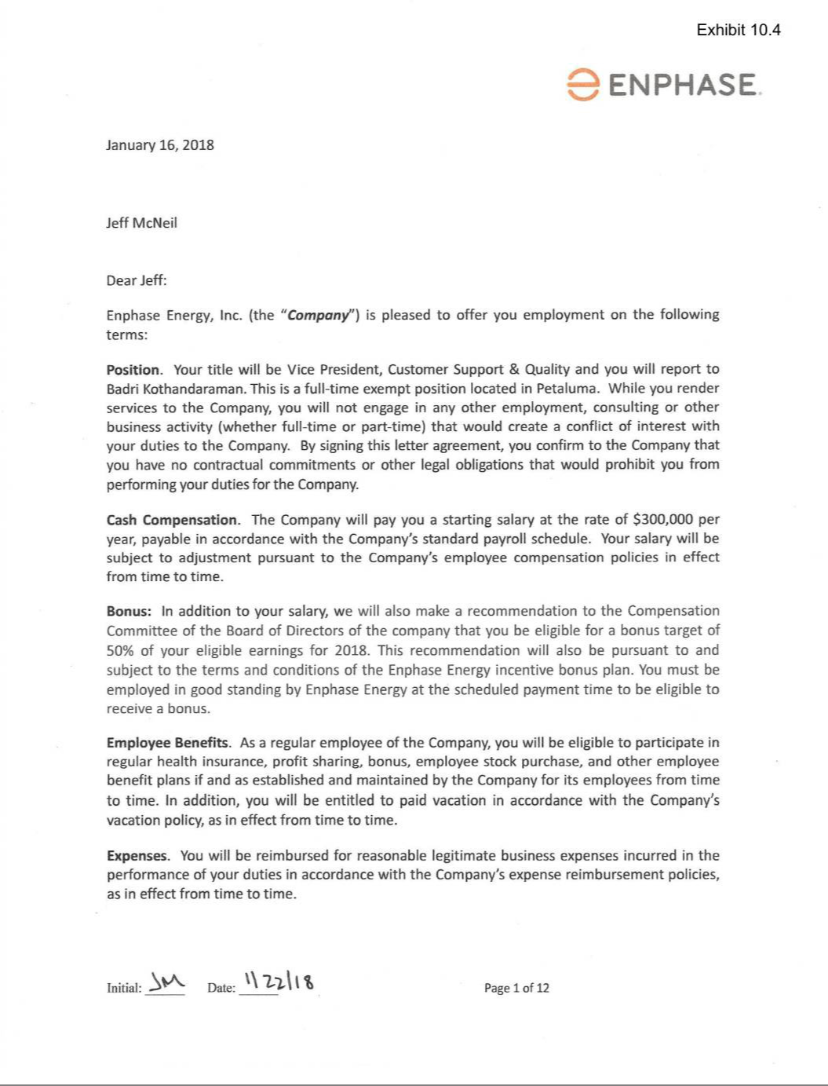

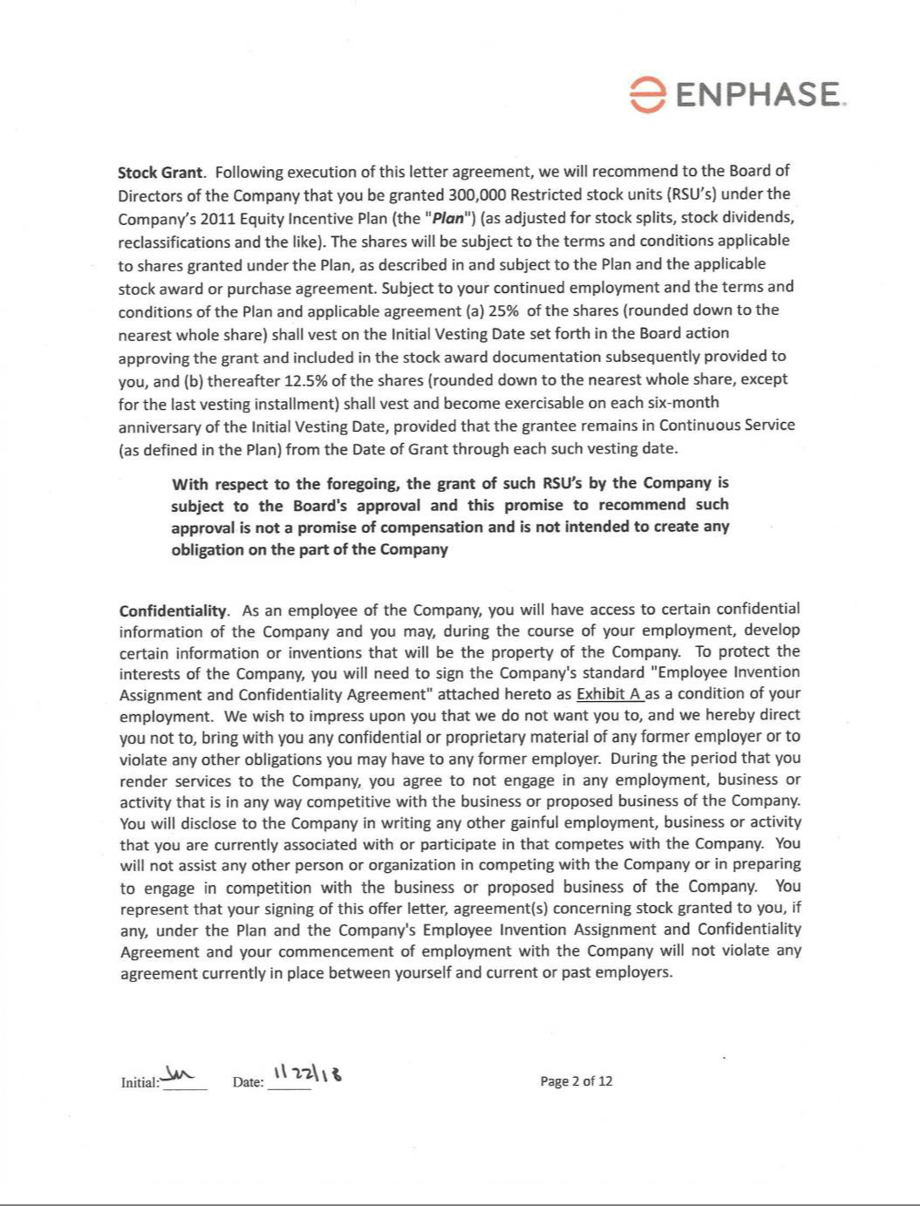

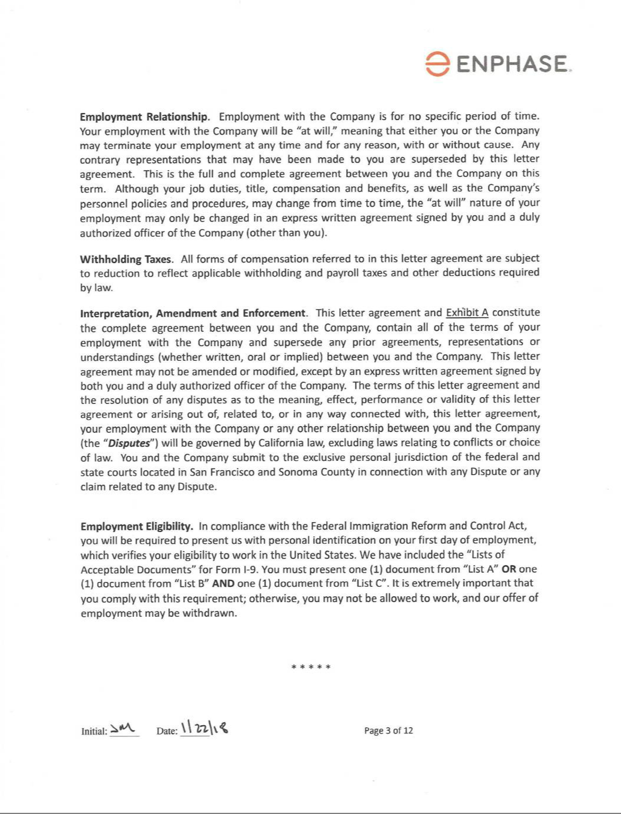

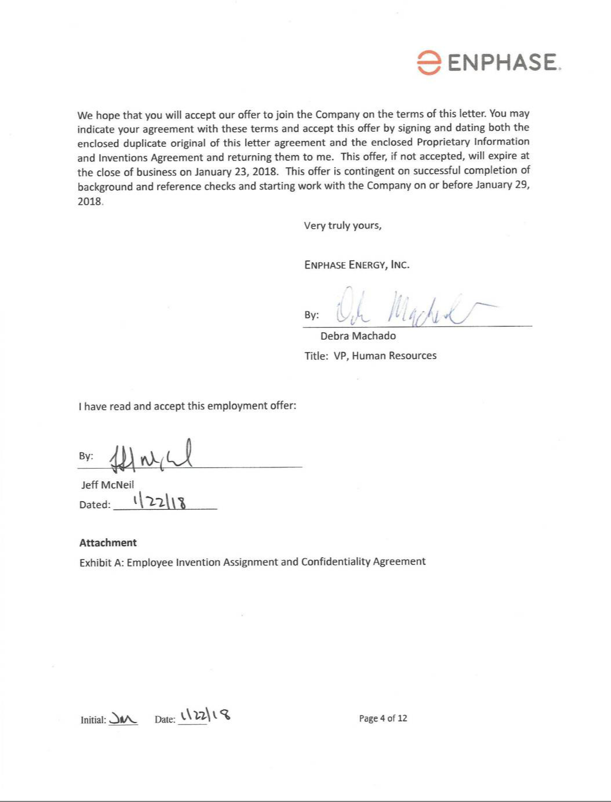

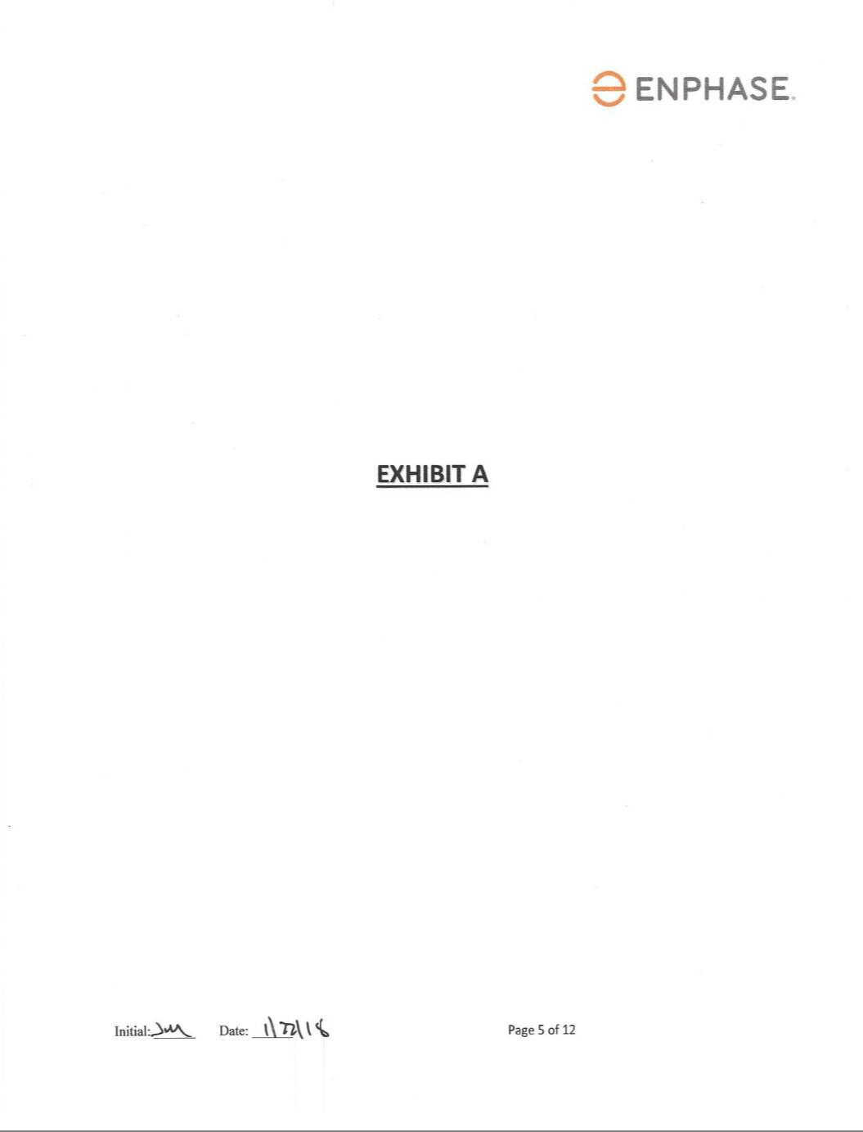

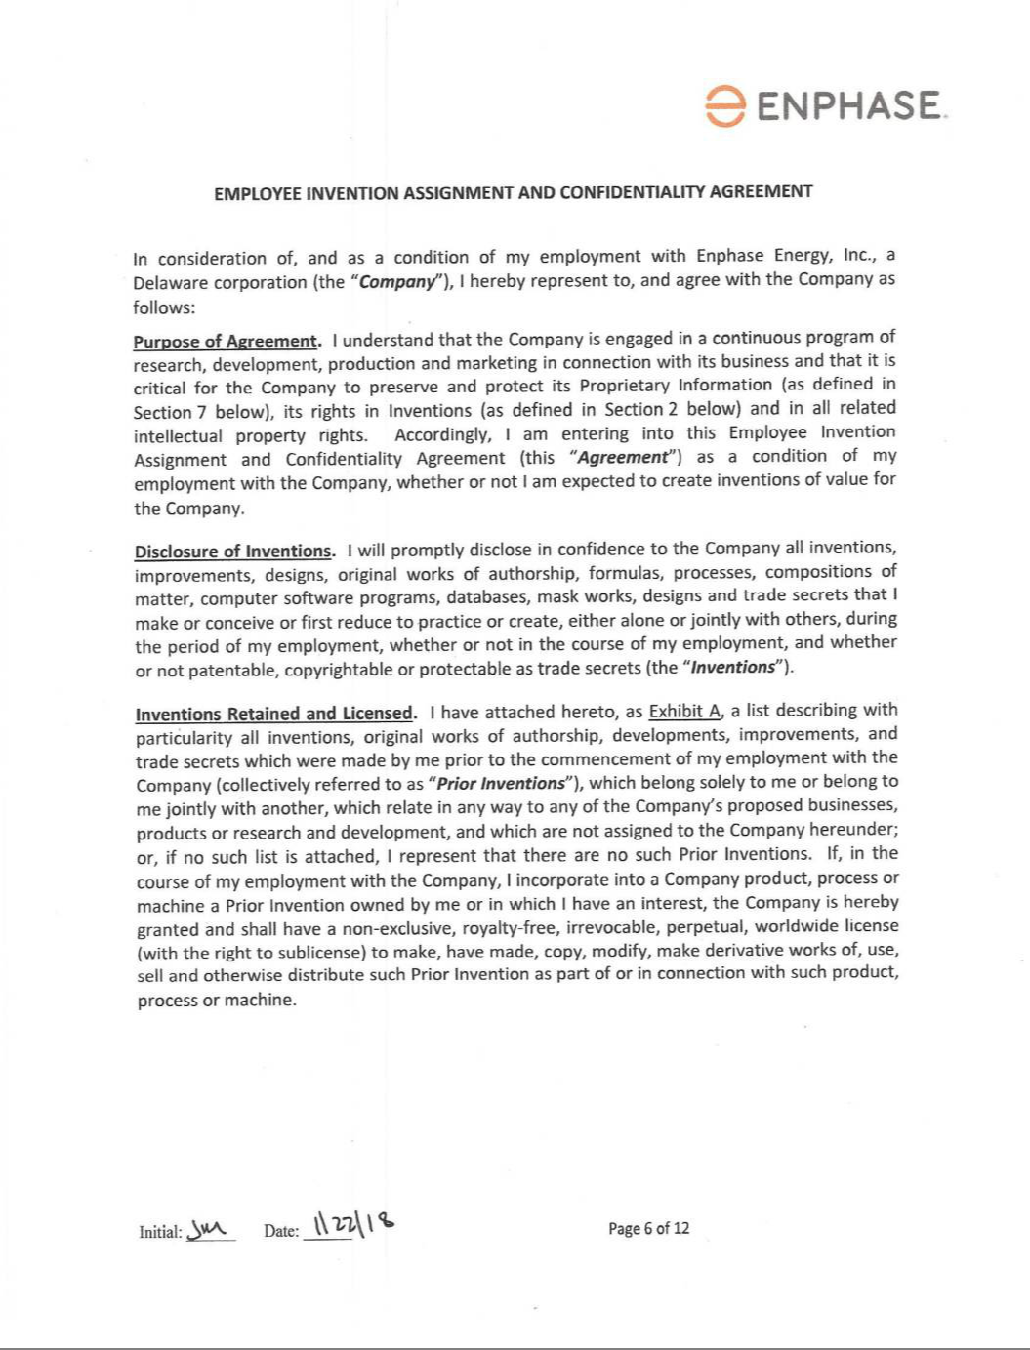

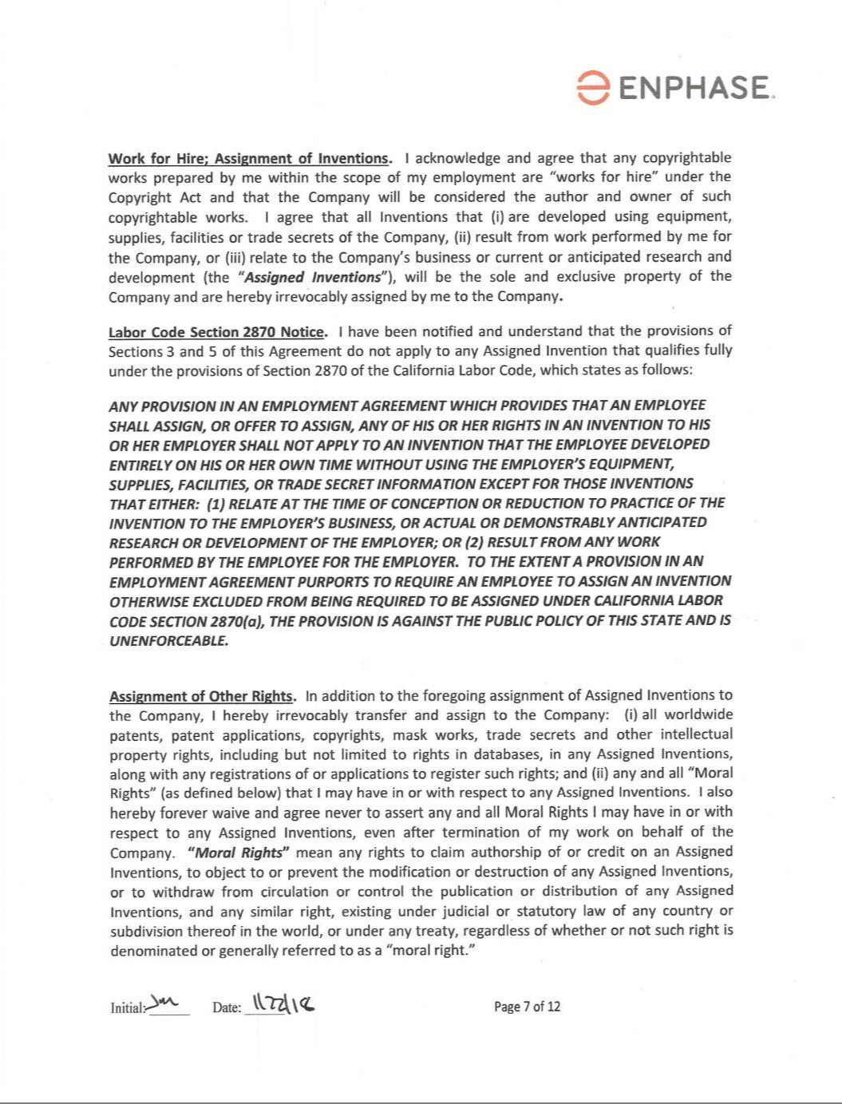

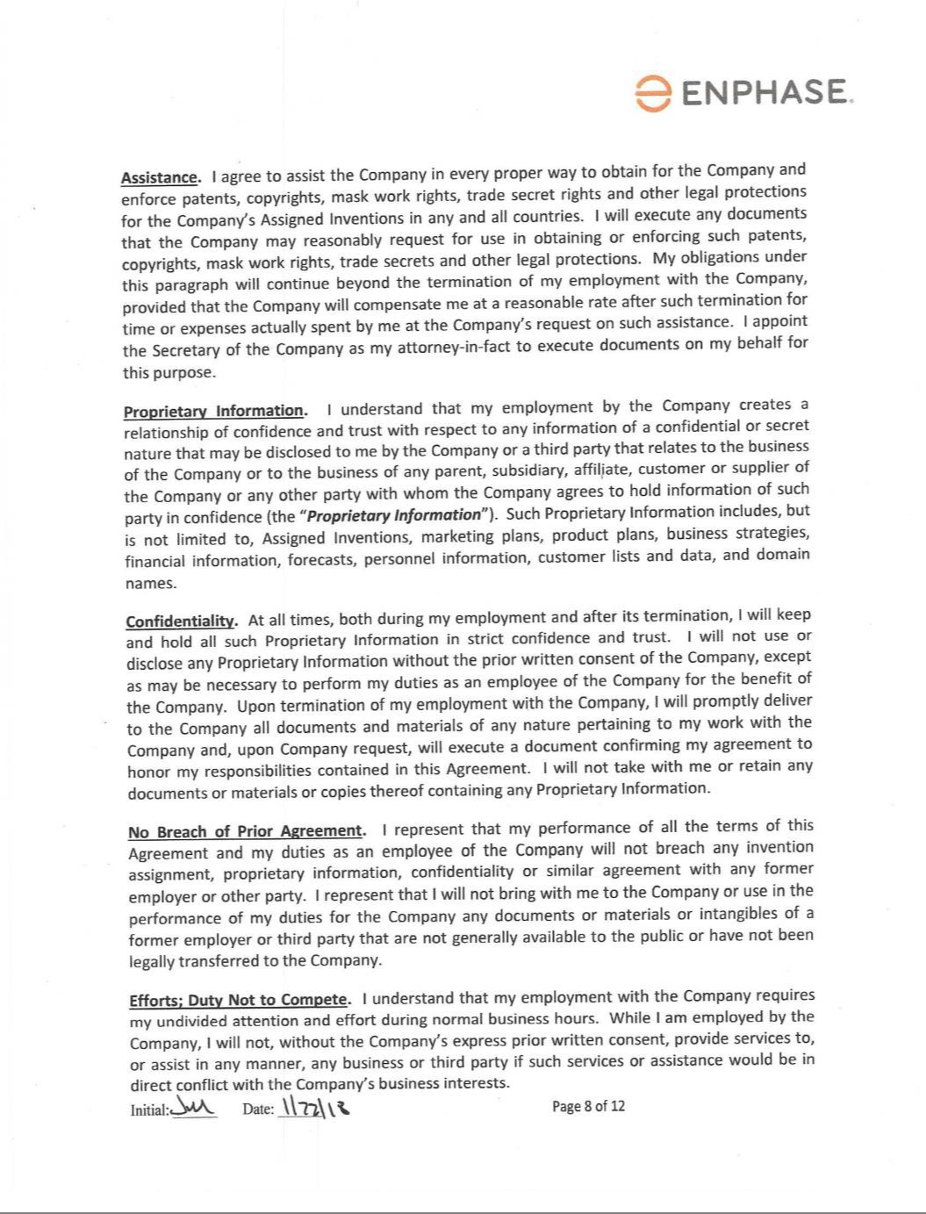

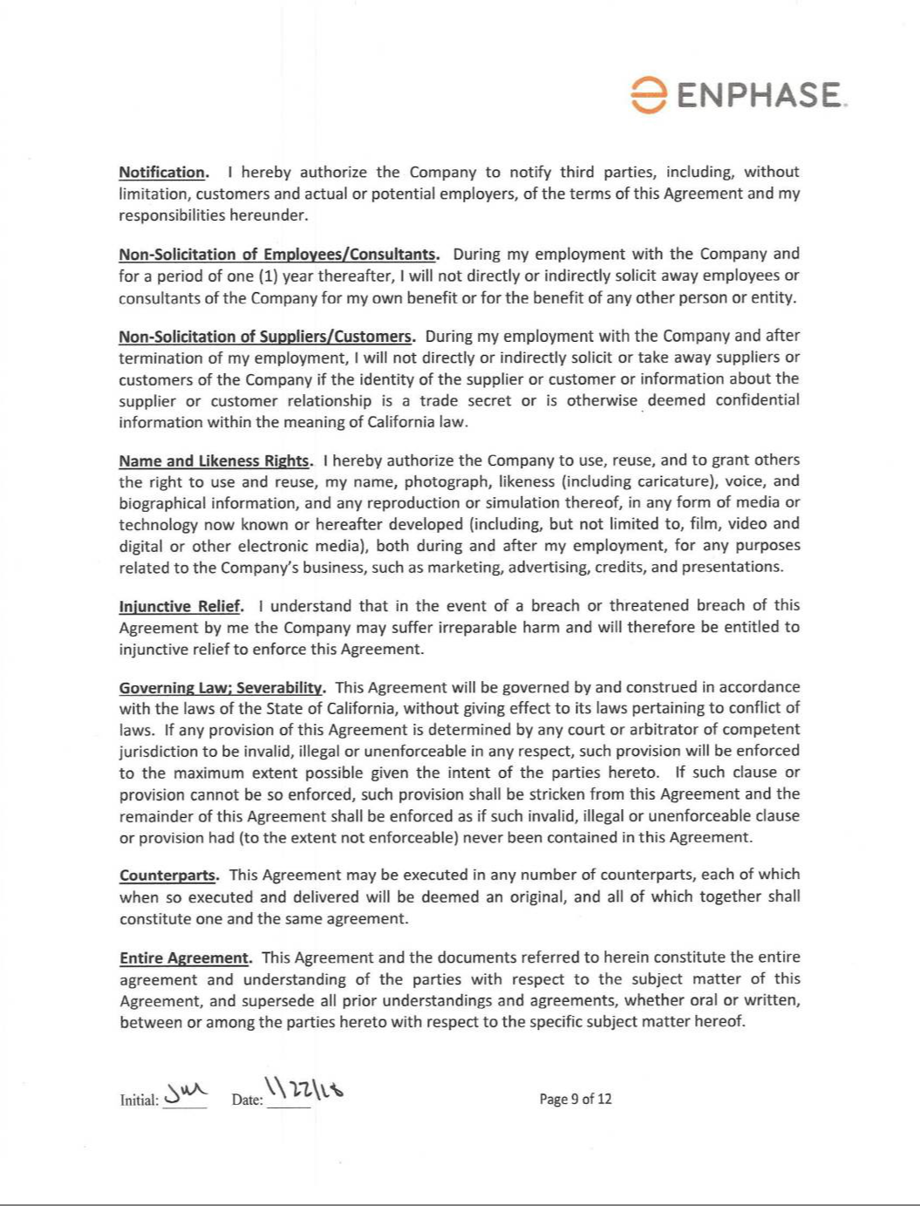

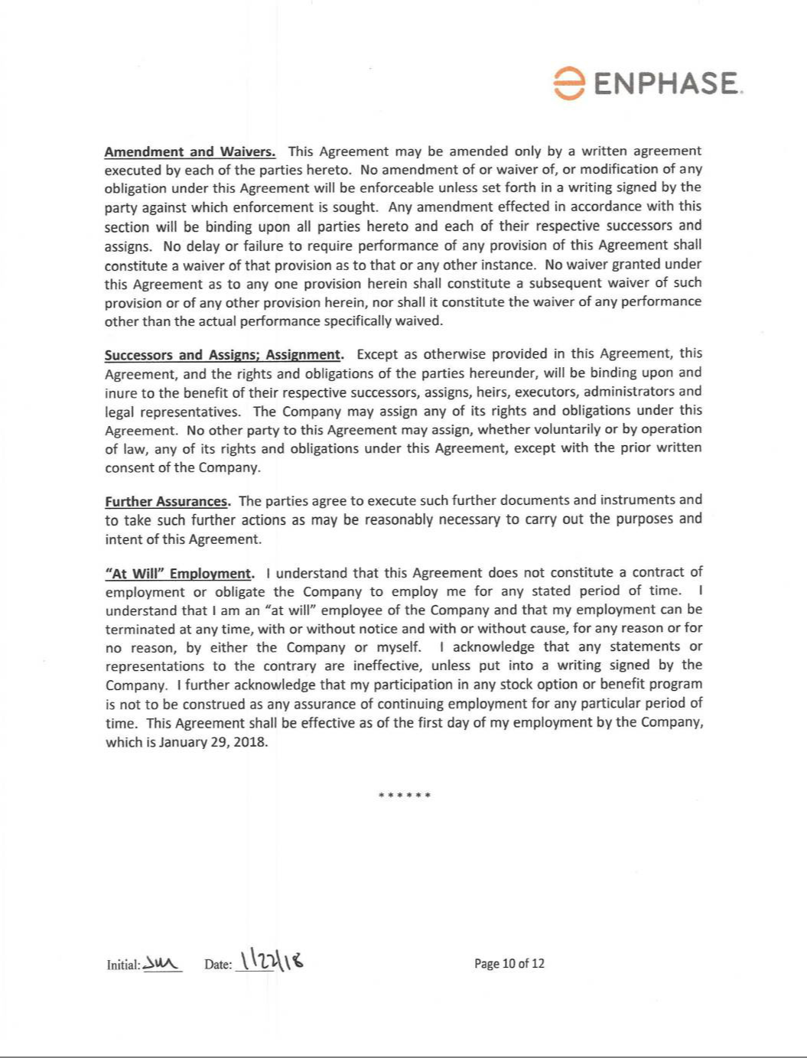

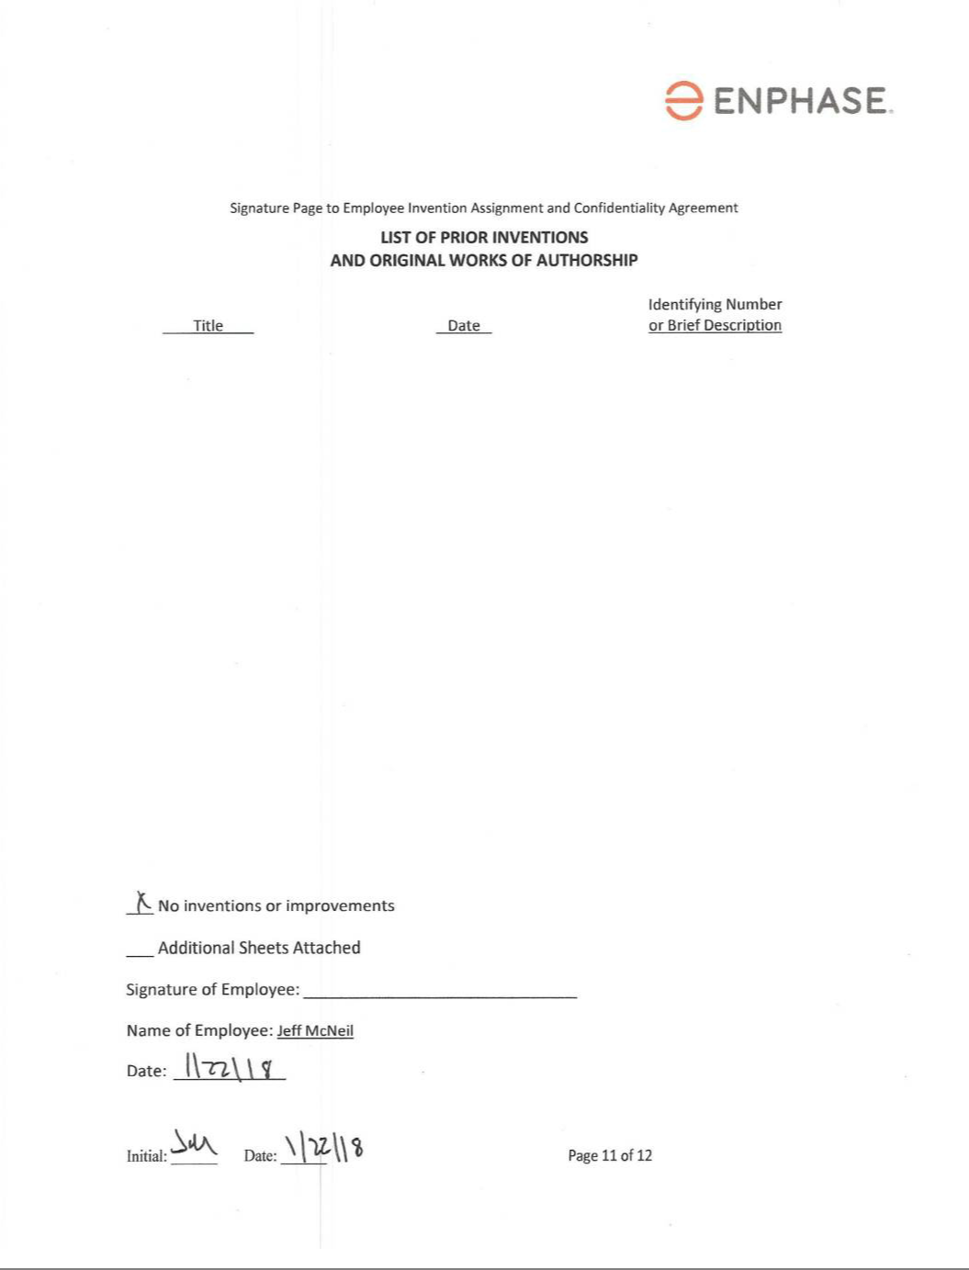

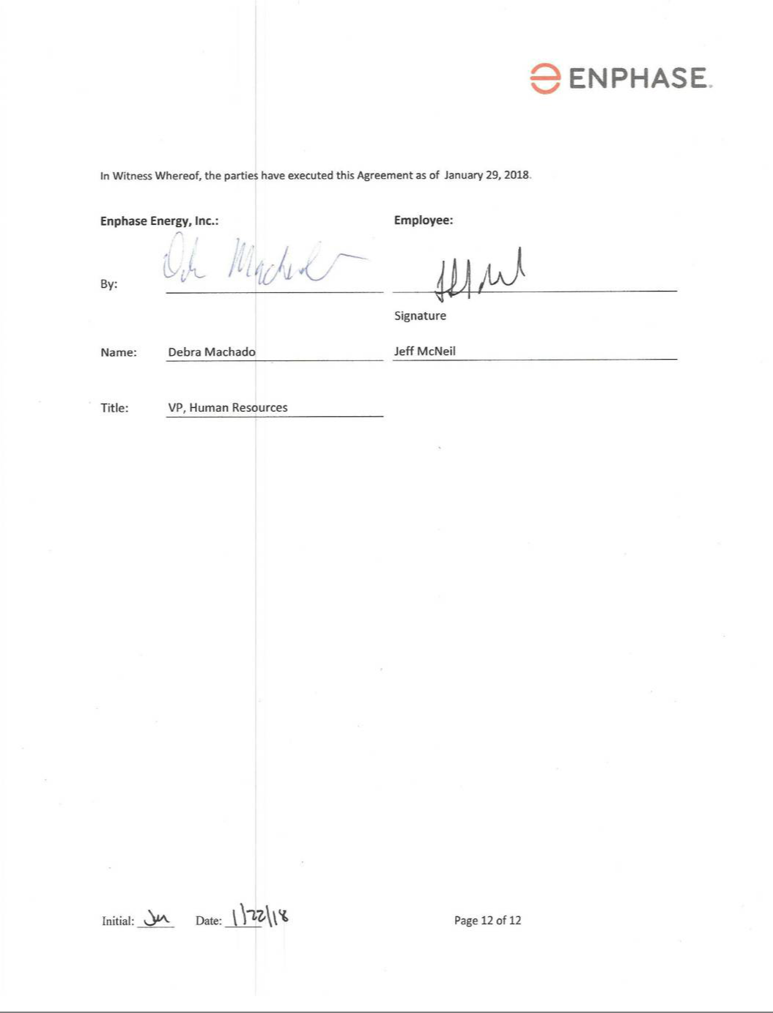

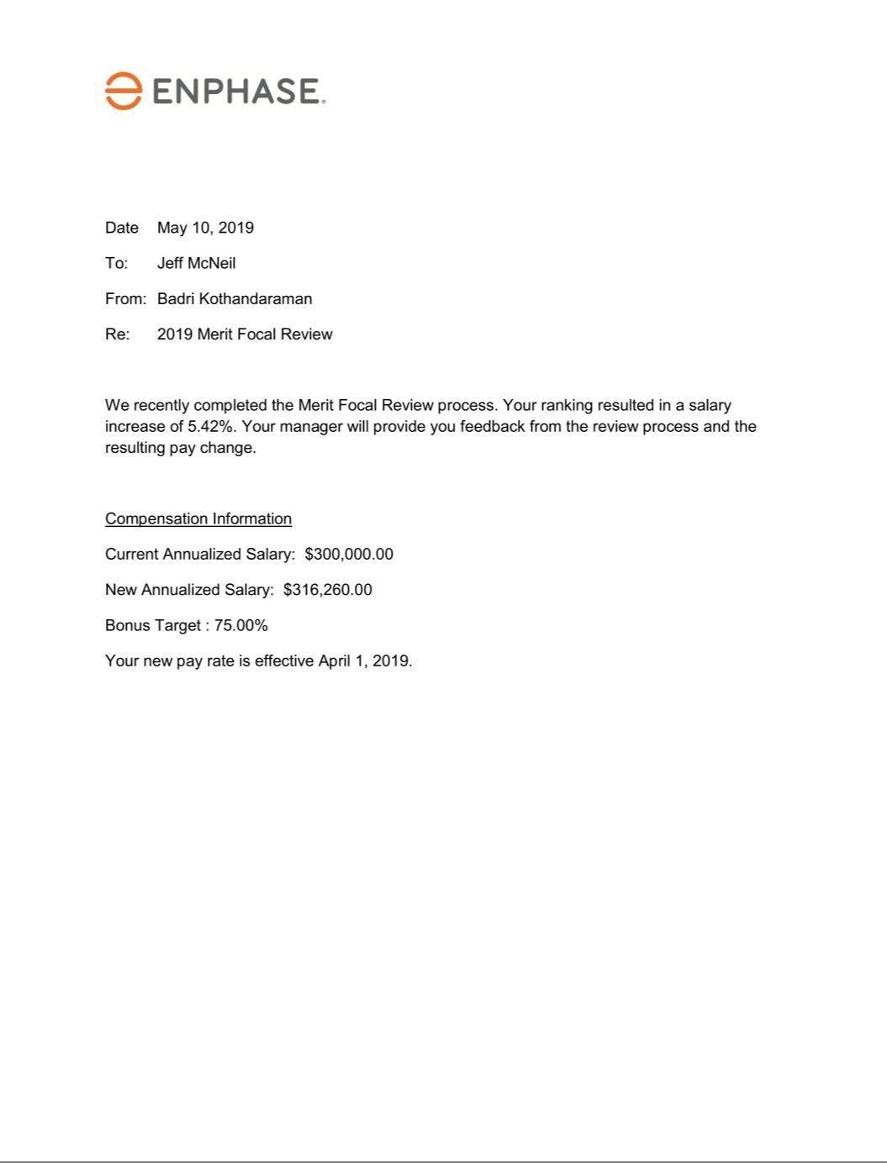

Exhibit 31.1

CERTIFICATION

I, Badrinarayanan Kothandaraman, certify that:

- I have reviewed this Form 10-Q of Enphase Energy, Inc.;

- Based on my knowledge, this report does not contain any untrue statement of a material fact or omit to state a material fact necessary to make the statements made, in light of the circumstances under which such statements were made, not misleading with respect to the period covered by this report;

- Based on my knowledge, the financial statements, and other financial information included in this report, fairly present in all material respects the financial condition, results of operations and cash flows of the registrant as of, and for, the periods presented in this report;

- The registrant’s other certifying officer(s) and I are responsible for establishing and maintaining disclosure controls and procedures (as defined in Exchange Act Rules 13a-15(e) and 15d-15(e)) and internal control over financial reporting (as defined in Exchange Act Rules 13a-15(f) and 15(d)-15(f)) for the registrant and have:

  - designed such disclosure controls and procedures, or caused such disclosure controls and procedures to be designed under our supervision, to ensure that material information relating to the registrant, including its consolidated subsidiaries, is made known to us by others within those entities, particularly during the period in which this report is being prepared;

  - designed such internal control over financial reporting, or caused such internal control over financial reporting to be designed under our supervision, to provide reasonable assurance regarding the reliability of financial reporting and the preparation of financial statements for external purposes in accordance with generally accepted accounting principles;

  - evaluated the effectiveness of the registrant's disclosure controls and procedures and presented in this report our conclusions about the effectiveness of the disclosure controls and procedures, as of the end of the period covered by this report based on such evaluation; and

  - disclosed in this report any change in the registrant's internal control over financial reporting that occurred during the registrant's most recent fiscal quarter (the registrant's fourth fiscal quarter in the case of an annual report) that has materially affected, or is reasonably likely to materially affect, the registrant's internal control over financial reporting; and

- The registrant’s other certifying officer(s) and I have disclosed, based on our most recent evaluation of internal control over financial reporting, to the registrant’s auditors and the audit committee of the registrant’s board of directors (or persons performing the equivalent functions):

  - All significant deficiencies and material weaknesses in the design or operation of internal control over financial reporting which are reasonably likely to adversely affect the registrant’s ability to record, process, summarize and report financial information; and

  - Any fraud, whether or not material, that involves management or other employees who have a significant role in the registrant’s internal control over financial reporting.

Date: July 30, 2019

/s/ BADRINARAYANAN KOTHANDARAMAN

Badrinarayanan Kothandaraman

President and Chief Executive Officer

(Principal Executive Officer)

Exhibit 31.2

CERTIFICATION

I, Eric Branderiz, certify that:

- I have reviewed this Form 10-Q of Enphase Energy, Inc.;

- Based on my knowledge, this report does not contain any untrue statement of a material fact or omit to state a material fact necessary to make the statements made, in light of the circumstances under which such statements were made, not misleading with respect to the period covered by this report;

- Based on my knowledge, the financial statements, and other financial information included in this report, fairly present in all material respects the financial condition, results of operations and cash flows of the registrant as of, and for, the periods presented in this report;

- The registrant’s other certifying officer(s) and I are responsible for establishing and maintaining disclosure controls and procedures (as defined in Exchange Act Rules 13a-15(e) and 15d-15(e)) and internal control over financial reporting (as defined in Exchange Act Rules 13a-15(f) and 15(d)-15(f)) for the registrant and have:

  - designed such disclosure controls and procedures, or caused such disclosure controls and procedures to be designed under our supervision, to ensure that material information relating to the registrant, including its consolidated subsidiaries, is made known to us by others within those entities, particularly during the period in which this report is being prepared;

  - designed such internal control over financial reporting, or caused such internal control over financial reporting to be designed under our supervision, to provide reasonable assurance regarding the reliability of financial reporting and the preparation of financial statements for external purposes in accordance with generally accepted accounting principles;

  - evaluated the effectiveness of the registrant's disclosure controls and procedures and presented in this report our conclusions about the effectiveness of the disclosure controls and procedures, as of the end of the period covered by this report based on such evaluation; and

  - disclosed in this report any change in the registrant's internal control over financial reporting that occurred during the registrant's most recent fiscal quarter (the registrant's fourth fiscal quarter in the case of an annual report) that has materially affected, or is reasonably likely to materially affect, the registrant's internal control over financial reporting; and

- The registrant’s other certifying officer(s) and I have disclosed, based on our most recent evaluation of internal control over financial reporting, to the registrant’s auditors and the audit committee of the registrant’s board of directors (or persons performing the equivalent functions):

  - All significant deficiencies and material weaknesses in the design or operation of internal control over financial reporting which are reasonably likely to adversely affect the registrant’s ability to record, process, summarize and report financial information; and

  - Any fraud, whether or not material, that involves management or other employees who have a significant role in the registrant’s internal control over financial reporting.

Date: July 30, 2019

/s/ ERIC BRANDERIZ

Eric Branderiz

Vice President and Chief Financial Officer

(Principal Financial Officer)

Exhibit 32.1

CERTIFICATION

Pursuant to the requirement set forth in Rule 13a-14(b) of the Securities Exchange Act of 1934, as amended, (the “Exchange Act”) and Section 1350 of Chapter 63 of Title 18 of the United States Code (18 U.S.C. §1350), Badrinarayanan Kothandaraman, President and Chief Executive Officer of Enphase Energy, Inc. (the “Company”), and Eric Branderiz, Vice President and Chief Financial Officer of the Company, each hereby certifies that, to the best of his or her knowledge:

- The Company’s Quarterly Report on Form 10-Q for the period ended June 30, 2019, to which this Certification is attached as Exhibit 32.1 (the “Periodic Report”), fully complies with the requirements of Section 13(a) or Section 15(d) of the Exchange Act; and

- The information contained in the Periodic Report fairly presents, in all material respects, the financial condition and results of operations of the Company.

In Witness Whereof, the undersigned have set their hands hereto as of the 30th day of July, 2019.

/s/ BADRINARAYANAN KOTHANDARAMAN |  | /s/ ERIC BRANDERIZ
Badrinarayanan Kothandaraman |  | Eric Branderiz
President and Chief Executive Officer |  | Vice President and Chief Financial Officer

This certification accompanies the Form 10-Q to which it relates, is not deemed filed with the Securities and Exchange Commission and is not to be incorporated by reference into any filing of Enphase Energy, Inc. under the Securities Act of 1933, as amended, or the Securities Exchange Act of 1934, as amended (whether made before or after the date of the Form 10-Q), irrespective of any general incorporation language contained in such filing.

